**1.1 INTRODUCTION**

Security at various places such as hotels, restaurants, Airports etc. refers to the techniques and methods used in protecting passengers, staff and [aircraft](https://en.wikipedia.org/wiki/Aircraft" \o "Aircraft)which use these placesfrom accidental/malicious harm, crime and other threats. Large numbers of people visit to this places every day. This presents potential targets for terrorism and other forms of crime because of the number of people located in a particular location. To avoid such a type of crime and to maintain security this system is designed.

A QR code is a special type of barcode that can encode information like numbers, letters, and Kanji characters. This tutorial is written for programmers who want to learn how to encode a QR code. The encoding process is complicated, particularly during the step where you generate error correction code words. The tutorial will attempt to explain the entire process in simple terms.

**1.2 BACKGROUND**

The QR code format was created in 1994 by Japanese company Denso-Wave, which is a subsidiary of Toyota that manufactures auto components. The standard is defined in ISO/IEC 18004:2006. The use of QR codes is license-free. The smallest QR codes are 21x21 pixels, and the largest are 177x177. The sizes are called versions. The 21x21 pixel size is version 1, 25x25 is version 2, and so on. The 177x177 size is version 40.

In addition, QR codes include error correction: when you encode the QR code, you also create some redundant data that will help a QR reader accurately read the code even if part of it is unreadable. There are four levels of error correction that you can choose from. The lowest is L, which allows the code to be read even if 7% of it is unreadable. After that is M, which provides 15% error correction, then Q, which provides 25%, and finally H, which provides 30%.

The capacity of a given QR code depends on the version and error correction level, as well as on the type of data that you are encoding. There are four data modes that a QR code can encode: numeric, alphanumeric, binary, or Kanji. The Denso-Wave web site's list of QR versions includes information about how many data bits you can encode in each version.

**1.3 RELEVANCE**

In today’s cutting edge technology scenario, security and authenticity of data is a big challenge. To solve this problem, we propose an innovative method to authenticate the digital documents. Our proposal is a new method, where the Details listed in a sample passport will be encoded in QR Code in encrypted form, so that if an intruder tries to change the text details in Passport still he cannot do that in the QR Code,because the encryption key is unknown to him. The QR code is a primary requirement for an individual by which he can prove himself that he has all rights he is claiming for.

This system refers to the techniques and methods used in protecting passengers, staff and [aircraft](https://en.wikipedia.org/wiki/Aircraft" \o "Aircraft)which use these placesfrom accidental/malicious harm, crime and other threats. Large numbers of people visit to this places every day. This presents potential targets for terrorism and other forms of crime because of the number of people located in a particular location. To avoid such a type of crime and to maintain security this system is designed.

**1.4 ORGANIZATION OF PROJECT REPORT**

The report consists of eight chapters and a reference. Each chapter serves the purpose of describing the various aspects of the project such as basic information of the system, its design and implementation.

1. CHAPTER NO. 1, ‘INTRODUCTION’ gives the general introduction about the project. It includes the aspects like aim of the project, basic system model with its description, reasons for implementing.
2. CHAPTER NO. 2, ‘LITERATURE SURVEY’ gives the fundamental information of these digital drawing pad and its functions. The purpose of this chapter is to introduce the system to the reader.
3. CHAPTER NO. 3, ‘DESIGN & DRAWING’ it deals with the actual implementation of the hardware and the various steps involved in it .It also discusses the details of the software and programs implemented in the project.
4. CHAPTER NO. 4, ‘MANUFACTURING’ contains the developing of PCB, types of PCB’s, layout designing, etching, drilling, soldering, equipments required for construction of PCB, PCB artwork.
5. CHAPTER NO. 5, ‘EXPERIMENTATION’ it discusses the general algorithm and general flowchart for the code we would be using.
6. CHAPTER NO. 6, ‘RESULTS AND DISCUSSION’ it involves the results obtained on the actual implementation of the system. On the basis of QR code which is different for each and every user, authentication of the user is done.
7. CHAPTER NO. 7, ‘ADVANTAGES, LIMITATIONS AND APPLICATIONS’ it discusses the various advantages and disadvantages of the system as well as the applications of this project.
8. CHAPTER NO. 8, ‘CONCLUSION AND FUTURE SCOPE’ contains the conclusion obtained by carrying out the stated project work. Also it includes the possible future scope of designed system.

Listed below are a few of the papers that were studied while designing this project:

“[1]Data Encryption Using Hybrid Authentication System: A Review” INTERNATIONAL JOURNAL OF ADVANCED ELECTRONICS & COMMUNICATION SYSTEMS, Approved by CSIR-NISCAIR ISSN NO: 2277-7318. In the present paper the authors have proposed a new combined cryptographic method for data encryption using hybrid authentication system. Hybrid technique uses the combination of TTJSA algorithm for data encryption and QR code for additional security. TTJSA algorithm uses threemethods MSA, NJJSAA and generalized modified VernamCipher Method. The above three methods are applied in random order on any given plain text for a number of times to get the ultimate cipher text file. The encrypted data is entered inside QR code which can be sent to receiver in the network. The data can be retrieved from the QR code and can be decrypted using TTJSA decryption algorithm and secret security code.Proposed method can address and provide security against Network Security attacks such as passive attacks which will be verified by password based attack, Man in the middle attack and compromised key attack.This technique can be applied to encrypt data in Defense system, Banking sector, mobile network etc. or to verify the data in other applications like Aadhar card, Voter ID, Driving License, Passport & Visa etc. This technique will be demonstrated on Passport to verify the details listed in the Passport.

In today’s cutting edge technology scenario, security and authenticity of data is a big challenge. To solve this problem, we propose an innovative method to authenticate the digital documents. Our proposal is a new method, where the Details listed in a sample passport (or other applications, Aadhar card, Voter ID, License, Marksheet) will be encoded in QR Code in encrypted form, so that if an intruder tries to change the text details in Passport still he cannot do that in the QR Code, because the encryption key is unknown to him. In this method, we encrypt the passport data using the TTJSA encryption algorithm. The encrypted passport details are entered inside QR code and that QR code is also printed with the original data of the passport (Fig 4.3). The passport details can then be retrieved from the QR code and can be decrypted using TTJSA decryption algorithm and then it can be verified withtext details already there in the passport. Since the data is embedded digitally in form of QR Code, which is itself encrypted, so that

the passport text details cannot be tampered, and the data embedded in the passportcan be only decrypted and read from our decryption program.

QR Code is a type of 2 dimensional matrix barcode, which gained popularity because of its large capacity to hold digital data and it can be integrated in any mobile devices. In our new Passport system, we save the essential data of passport in the QR Code, like passport holder’s name, surname, passport number, nationality, sex, date of birth, birth place, place of issue,date of issue and expiry date. But, all the data saved and embedded in the QR Code, are encrypted, and then the QR Codes are printed in the passport. So, in future if the passport authority, security or any other government agency wants to see passport details digitally or wants to send their passport information to any other government Organization in digital format, then they can just scan the QR Code and decrypt the embedded information and send the authentic data.

Brief overview of proposed method can be described as below.A message is encrypted by using the TTJSA method and the QR code of the encrypted message is obtained. Later it is transmitted for the receiver to obtain the QR code which is decrypted by using the TTJSA method and the secret information can be obtained. Historically for the encryption and decryption of data previously used methods are:

* Advanced Encryption System (AES) and Advanced
* decryption System (DES) algorithms Encryption and decryption by using the Substitution method
* Encryption and decryption by using the Transpositionmethod.

In all the above methods of encryption and decryption, it is easy for the unknown person to decode the data and modify it by using simple logics of substitution and transposition. So in order to overcome the above drawbacks in encryption and decryption, we are going for TTJSA algorithm which is more secure and complex to decode.

This is one of the encryption and decryption algorithm used for hiding the data in the form of images and retrieving the same from the image into the original form. This method can be used for Aadhar card, Voter ID, License, Passport or mark sheet where the data is encrypted using a secrete key, this encrypted text information is converted into QR code which isan image generated by the QR code technique. This image is printed on the original document. The data can be retrieve by decoding the QR code using same secrete key, the contents of the QR code will be obtained in text format which can be compared to the original data contents.Even if someone tries to temper the content of the original data, he cannot modify the QR code since information in the QR code is obtained by encryption of original data, using a secrete key.

“[2] Integration of 2 D Secure Barcode in Identity Cards:A New Approach” International Journal Of Engineering And Computer Science ISSN:2319-7242 Volume 2 Issue 4 April, 2013 Page No. 1225-1233.

This paper introduces an ID card Management System that integrates 2-Dimensional Barcode which is responsible to produce more secure, reliable identification cards. This system will capture the personalized data including signature and photo of holder and dynamically generate an image of 2D Barcode containing the information provided and affix this barcode image on ID Card. This card can be used to validate and authenticate the holder. Main advantage of using 2D Barcode is its data encoding capacity, 2D Barcode is able to encode up to 500 bytes per square inch. Some data is used for error correction encoding provides the capability to tolerate the holes, cuts and dirt marks and makes 2D Barcode readable. There are varieties of 2D Barcodes available.This Paper uses one of the standard 2D Barcode PDF417 to demonstrate the ID card management. The paper discusses 2D barcodes and their encoding methodology, system workflow and architecture of proposed ID card management system**.**

An Identity card is a primary requirement for an individual by which he can prove himself that he has all rights he is claiming for. An identity card is properly designed to provide the trusted credentials(The term “credential” refers toinformation stored on the card that represents the individual’sidentity document and privileges.), that can be used to access or authenticate an individual for a particular service. To make ID cardmore secure itintegratewith 2D Barcode that encoded the credentials of the individual in it.When authentication is required a 2D Barcode scanner scans the 2D Barcode image and authenticates the holder. 2D Barcode [1] is a graphical image that is using to stores the information both horizontally and vertically. Unlike one-dimensional barcode that is use to stores the information only. 2D Barcode is using to tag the various objects in the real world and map them to digital references. 2D barcodes are often used because that are enabling to store more information and they enable fast data access and now 2D Barcode is commonly used in variety of applications such as transport, identification, mobile application and inventory management. 2D barcode firstly known in Japan and now it is spreading to western countries as well.Since, 2D barcode reader application is available on smartphones, so anyone can read the 2D barcode. But somewhere it is not desired that everyone can read it, like if it contains Credit Card details, username and password for an account or any personal information that is vulnerable to theft. Thus, these kinds of information should not be encoded in the barcode directly. There must be some way to hide this information so that a normal reader/scanner cannot read or if read then user is not able to understand it. For this purpose we have to encrypt the information and then encode it and thus, encrypted barcode comes into existence.

BASIC OF BARCODES

A barcode represents data about the object to which it is attached such that only machine can read. Barcodes are of three types- one-dimensional (1D), two-dimensional (2D) and three-dimensional (3D). In 1D barcode, data is represented by varying the widths and spacing of parallel lines, whereas in 2D barcode information is stored both horizontally and vertically. 3D barcodes do not use any barcode labels. They are embossed or engraved directly on the product during manufacturing process.

 

(a) 1D Barcode (b) 2D Barcode

Figure 2.1: Barcodes

In general, there are two types of 2D barcodes: stacked 2D barcodes, such as Code 49 and PDF417, and Matrix 2D barcodes, such as Data Matrix and QR Code. 1D barcodes depend upon database for the object’s description to which it is attached, where we can store the complete description of the object in the 2D barcodes.Barcodes are scanned by special optical scanners called barcode readers and now-a-days software become available on devices including smartphones, so that anyone carrying mobile phone with barcode scanner software can read the barcodes. We can use Smartphone to capture, store and display the barcodes. We can store our card details in 2D barcode, which can be useful for payment through our smartphones. We can also store username and password with URL in 2D barcode to access our mail account by just scanning it through smartphone.

A.TYPES OF 2D BARCODES AND ENCODING METHODOLOGY 1)QR BARCODE:QR Code [8] is a 2-dimenstional barcode invented by the Japanese corporation Denso-Wave in 1994. The prefix QR stands for Quick Response, as the code that can be decoded at high-speed [9]. QR Code support Kanji encoding that the reason for its popularity in mobile tagging applications. QR code is most popular in Japan.

The Size of QR barcode symbol depends on the information to be encoded. Symbol version defined in the range of 1 to 40. Each version has different module configuration (the module refers to the black and white dots of QR code). Version 1 size is 21 x 21 modules and as version increment by 1

module size increment by 4 x 4. e.g. version 1 module size is 21 x 21, version 2 module size is 25 x 25, version 3 module size is 29 x 29....version 40 module size is 177 x 177 modules.

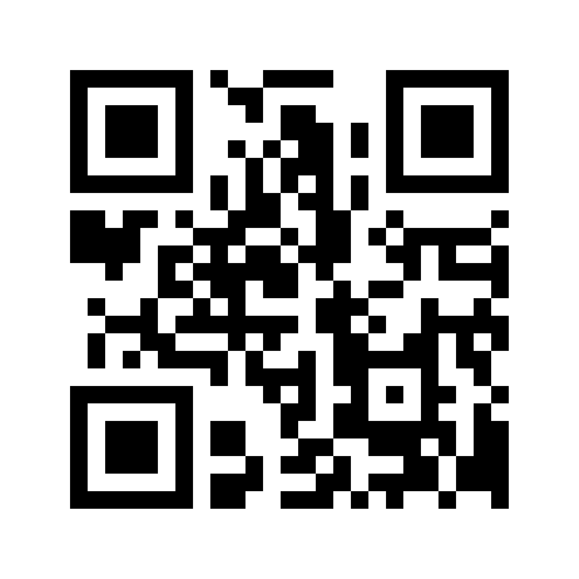

Figure 2.2: QR Code

There are four modes:

• Numeric mode

• Alphanumeric mode

• 8-bit byte mode

• Kanji and kana characters mode.

The combinations of these modes are also possible. QR code has in-built error correction based on Reed Solomon algorithms. Error correction level defined the readability percentage of damaged code. The QR code has four error correction levels 7%, 15%, 25% and 30% per symbol.

*1.1)QR CODING METHOD:* The QR encoding method works as follows:

1.1.1. QR code uses a smallest number of coding capability to store the QR code and error correction level, in consideration the total coding capability of data information.

1.1.2. Maximum number of coding characters in each mode is as follows.

• Numeric mode: 7089 characters

• Alphanumeric mode: 4296 characters

• 8-bit byte mode: 2953 characters

• Kanji and kana character mode: 1817 characters

1.1.3.To Create the QR Code and data encoding it uses the Reed Solomon code algorithm. RS Code parameters are shown in parentheses.

**3.1 OBJECTIVE**

**The proposed system shall solve the following problems:**

* Identifying person in different stages.
* Counting the number of persons according to their nationalities.
* Guiding person using their own languages (Identifying Language).
* Access Control.

**3.2 BLOCK DIAGRAM**

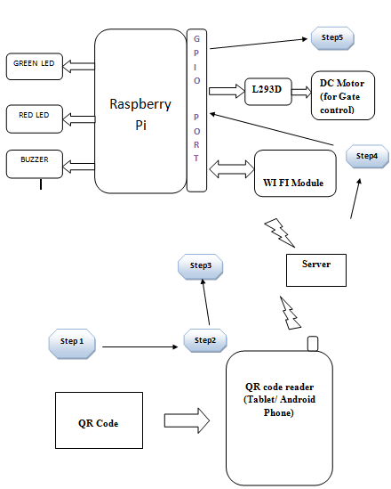

**3.2.1 DESCRIPTION:**

The propose system consist of raspberry pi module with QR code decoding features and QR code reader will be a camera that will connect to Raspberry pi’s USB port. Each person having their own QR code card in which the passport ID is saved. The OR code generated with the help of programming. Camera will scan the code and give it to raspberry pi that will decode the QR code and check the ID of person on web page that is designed in Raspberry pi. Web page is nothing but a data base where we will save the user ID which is a valid one. If person has a valid ID then GREEN led will glow and gate (motor on) will open. If person is unauthorized or ID is invalid the RED led will glow and Gate will not open, at the same time buzzer will beep.

For add a new user we can encode the QR code as well decode it. For encoding the QR code admin requires a server to connect with web page then admin can add or change the information on database or web page which is in raspberry pi.

For connecting with raspberry pi, wifi module is used. The web page designed in raspberry pi can access by other device like mobile or PC that should have network in range, for that we are using wifi. That can be access by admin.

**3.3 HARDWARE**

**3.3.1 Camera (QR code reader):**

**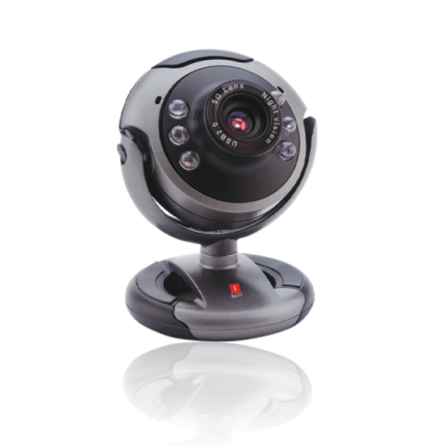**

Figure 3.2.1 iBall CHD 20.0 Webcam

**Key Features**

* HD 720p (1280 x 720) Widescreen resolution
* Clear and richer picture with 5G Wide angle lens
* 6 LEDs for night vision, with brightness controller.
* Built-in high sensitive USB microphone
* Snapshot button for still image capture.
* Multi-utility camera base (can be used on Desktop, Laptop & LCD)
* Auto face tracking & Digital zoom.
* Driverless – Just plug-n-play (However, to get best results use with provided drivers)
* High-speed USB 2.0 interface.
* Free tripod stand bundled.

**3.3.2 Raspberry pi:**

Raspberry Pi is a credit-card sized computer manufactured and designed in the United Kingdom by the Raspberry Pi foundation with the intention of teaching basic computer science to school students and every other person interested in computer hardware, programming and DIY-Do-it Yourself projects.

The Raspberry Pi is manufactured in three board configurations through licensed manufacturing deals with Newark element14 (Premier Farnell), RS Components and Egoman. These companies sell the Raspberry Pi online. Egoman produces a version for distribution solely in China and Taiwan, which can be distinguished from other Pis by their red coloring and lack of FCC/CE marks. The hardware is the same across all manufacturers.

The Raspberry Pi has a Broadcom BCM2835 system on a chip (SoC), which includes an ARM1176JZF-S 700 MHz processor, VideoCore IV GPU and was originally shipped with 256 megabytes of RAM, later upgraded (Model B & Model B+) to 512 MB. It does not include a built-in hard disk or solid-state drive, but it uses an SD card for booting and persistent storage, with the Model B+ using a MicroSD.

The Foundation provides Debian and Arch Linux ARM distributions for download. Tools are available for Python as the main programming language, with support for BBC BASIC (via the RISC OS image or the Brandy Basic clone for Linux), C, Java and Perl.



Figure3.2.2 Raspberry Pi

## A brief description of the components on the Pi.

1. Processor / SoC (System on Chip)

The Raspberry Pi has a Broadcom BCM2835 System on Chip module. It has a ARM1176JZF-S processor

The Broadcom SoC used in the Raspberry Pi is equivalent to a chip used in an old smartphone (Android or iPhone). While operating at 700 MHz by default, the Raspberry Pi provides a real world performance roughly equivalent to the 0.041 GFLOPS. On the CPU level the performance is similar to a 300 MHz Pentium II of 1997-1999, but the GPU, however, provides 1 Gpixel/s, 1.5 Gtexel/s or 24 GFLOPS of general purpose compute and the graphics capabilities of the Raspberry Pi are roughly equivalent to the level of performance of the Xbox of 2001. The Raspberry Pi chip operating at 700 MHz by default, will not become hot enough to need a heatsink or special cooling.



1. Power source

The Pi is a device which consumes 700mA or 3W or power. It is powered by a MicroUSB charger or the GPIO header. Any good smartphone charger will do the work of powering the Pi.

1. SD Card

The Raspberry Pi does not have any onboard storage available. The operating system is loaded on a SD card which is inserted on the SD card slot on the Raspberry Pi. The operating system can be loaded on the card using a card reader on any computer.

1. GPIO

GPIO – General Purpose Input Output

General-purpose input/output (GPIO) is a generic pin on an integrated circuit whose behaviour, including whether it is an input or output pin, can be controlled by the user at run time.

GPIO pins have no special purpose defined, and go unused by default. The idea is that sometimes the system designer building a full system that uses the chip might find it useful to have a handful of additional digital control lines, and having these available from the chip can save the hassle of having to arrange additional circuitry to provide them.

GPIO capabilities may include:

* GPIO pins can be configured to be input or output
* GPIO pins can be enabled/disabled
* Input values are readable (typically high=1, low=0)
* Output values are writable/readable
* Input values can often be used as IRQs (typically for wakeup events)

The production Raspberry Pi board has a 40-pin 2.54 mm (100 mil) expansion header, marked as P1, arranged in a 2x13 strip. They provide 8 GPIO pins plus access to I²C, SPI, UART), as well as +3.3 V, +5 V and GND supply lines. Pin one is the pin in the first column and on the bottom row.

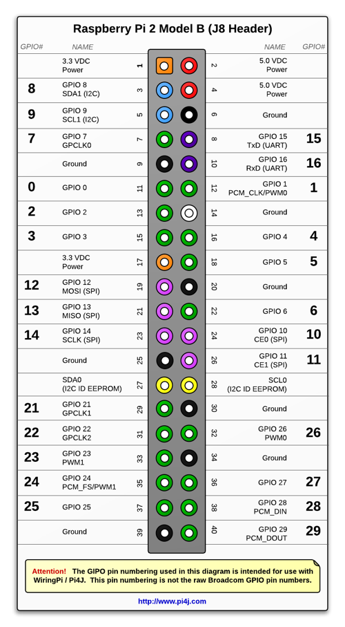

Figure : GPIO connector on RPi

1. DSI Connector

The Display Serial Interface (DSI) is a specification by the Mobile Industry Processor Interface (MIPI) Alliance aimed at reducing the cost of display controllers in a mobile device. It is commonly targeted at LCD and similar display technologies. It defines a serial bus and a communication protocol between the host (source of the image data) and the device (destination of the image data).

A DSI compatible LCD screen can be connected through the DSI connector, although it may require additional drivers to drive the display.

1. RCA Video

RCA Video outputs (PAL and NTSC) are available on all models of Raspberry Pi. Any television or screen with a RCA jack can be connected with the RPi.

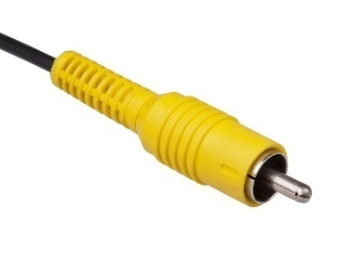

Figure : RCA Video Connector

1. Audio Jack

A standard 3.5 mm TRS connector is available on the RPi for stereo audio output. Any headphone or 3.5mm audio cable can be connected directly. Although this jack cannot be used for taking audio input, USB mics or USB sound cards can be used.

1. Status LEDs

There are 5 status LEDs on the RPi that show the status of various activities as follows:

“OK” - SDCard Access (via GPIO16) - labelled as "OK" on Model B Rev1.0 boards and "ACT" on Model B Rev2.0 and Model A boards

“POWER” - 3.3 V Power - labelled as "PWR" on all boards

“FDX” - Full Duplex (LAN) **(Model B)** - labelled as "FDX" on all boards

“LNK” - Link/Activity (LAN) **(Model B)** - labelled as "LNK" on all boards

“10M/100” - 10/100Mbit (LAN) **(Model B)** - labelled (incorrectly) as "10M" on Model B Rev1.0 boards and "100" on Model B Rev2.0 and Model A boards

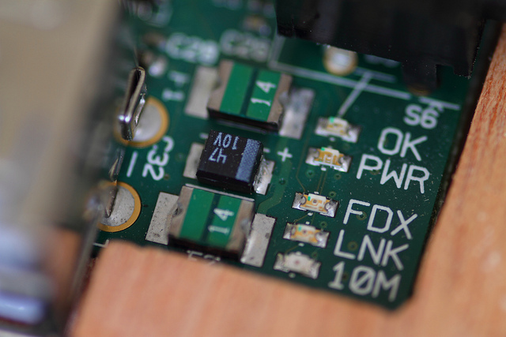

Figure : Status LEDs

1. USB 2.0 Port

USB 2.0 ports are the means to connect accessories such as mouse or keyboard to the Raspberry Pi. There is 1 port on Model A, 2 on Model B and 4 on Model B+. The number of ports can be increased by using an external powered USB hub which is available as a standard Pi accessory.

1. Ethernet

Ethernet port is available on Model B and B+. It can be connected to a network or internet using a standard LAN cable on the Ethernet port. The Ethernet ports are controlled by Microchip LAN9512 LAN controller chip.

1. CSI connector

CSI – Camera Serial Interface is a serial interface designed by MIPI (Mobile Industry Processor Interface) alliance aimed at interfacing digital cameras with a mobile processor.

The RPi foundation provides a camera specially made for the Pi which can be connected with the Pi using the CSI connector.

1. JTAG headers

JTAG is an acronym for ‘Joint Test Action Group', an organisation that started back in the mid 1980's to address test point access issues on PCB with surface mount devices. The organisation devised a method of access to device pins via a serial port that became known as the TAP (Test Access Port). In 1990 the method became a recognised international standard (IEEE Std 1149.1). Many thousands of devices now include this standardised port as a feature to allow test and design engineers to access pins.

1. HDMI

HDMI – High Definition Multimedia Interface

HDMI 1.3 a type A port is provided on the RPi to connect with HDMI screens.

**3.3.3 WIFI module:**

Wi-Fi is a popular wireless networking technology. Wi-Fi stands for “wireless fidelity”. The Wi-Fi was invented by NCR corporation/AT&T in Netherlands in 1991. By using this technology we can exchange the information between two or more devices. Wi-Fi has been developed for mobile computing devices, such has laptops, but it is now extensively using for mobile applications and consumer electronics like televisions, DVD players and digital cameras. There should be two possibilities in communicating with the Wi-Fi connection that may be through access point to the client connection or client to client connection. Wi-Fi is a one type of wireless technology. It is commonly called as wireless LAN (local area network). Wi-Fi allows local area networks to operate without cable and wiring. It is making popular choice for home and business networks. A computer’s wireless adaptor transfers the data into a radio signal and transfers the data into antenna for users.

[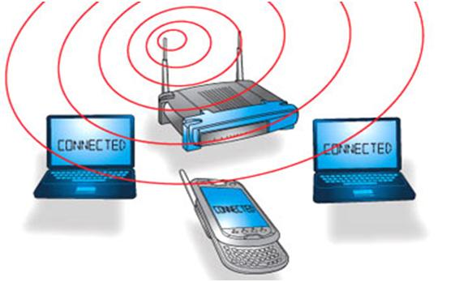](https://www.elprocus.com/wp-content/uploads/2013/09/WIFI-Technology.jpg)

Figure 3.2.3 Wi-Fi Module

**Tenda wifi module:**

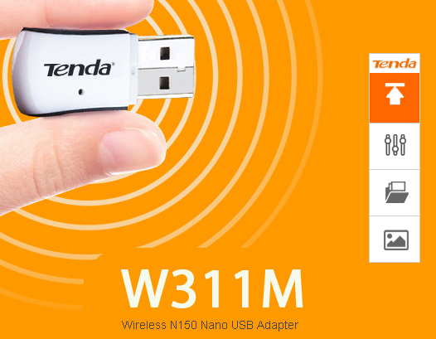

**What It Does:**

Compatible with 802.11g/b devices, W311M is a wireless high gain USB Adapter with wireless transmission rate 3 times faster than 802.11g devices. It connects your desktop or notebook computer with an available USB port to your wireless network for Internet access and file sharing. Desktop users can easily add wireless connectivity without having to open the PC case. It is best for lag-free online gaming, Internet calls or even HD video streaming wirelessly.

**Main feature:**

* Wireless N standard, speeds of up to 150Mbps.
* 3x greater wireless range than wireless G products.
* Secure your network with 64/128-bit WEP, WPA and WPA2.
* Supports soft AP to extend a wireless network.

**Enhanced Wireless Reception**

Compliant with wireless-N standard, this adapter is able to provide 3 times greater wireless range than conventional wireless-G adapter.

**Secured Connection**

WiFi Protected Setup (WPS) helps you to secure your wireless network just at a push of the WPS button without going through a complicated process of security setup. The adapter also provides 64/128-bit WEP, WPA and WPA2 encryptions for industrial-strength level of protection.

**Compatibility Assured**

The adapter is fully compatible with all major operation systems, including the latest Windows 7, MAC, and linux.

**Specification**

* Standard&ProtocolIEEE 802.11b/g/n
* InterfaceUSB 2.0
* Antenna2dBi fixed antenna\* 1 (internal PCB);Frequency: 2.4GHz
* ButtonWPS
* Dimension38.4mm×17.2mm×7.9mm
* LED1\* Link/Act
* Wireless SpeedUp to 150Mbps over 11n
* Frequency2.4GHZ
* Channel1~13
* Transmit Power17dBm (Max)

**3.3.4 LED (green & red):**

A light-emitting diode (LED) is an [electronic](http://en.wikipedia.org/wiki/Electronics) light source. LEDs are used as indicator lamps in many kinds of [electronics](http://en.wikipedia.org/wiki/Electronics) and increasingly for [lighting](http://en.wikipedia.org/wiki/Lighting). LEDs work by the effect of [electroluminescence](http://en.wikipedia.org/wiki/Electroluminescence), discovered by accident in 1907. The LED was introduced as a practical electronic component in 1962. All early devices emitted low-intensity red light, but modern LEDs are available across the [visible](http://en.wikipedia.org/wiki/Visible_spectrum), [ultraviolet](http://en.wikipedia.org/wiki/Ultraviolet) and [infrared](http://en.wikipedia.org/wiki/Infra_red) wavelengths, with very high brightness.

**3.3.5 Buzzer:**

The **piezo buzzer** produces sound based on reverse of the piezoelectric effect. The generation of pressure variation or strain by the application of electric potential across a piezoelectric material is the underlying principle. These buzzers can be used alert a user of an event corresponding to a switching action, counter signal or sensor input. They are also used in alarm circuits.

**3.3.6 IC L293d:**

L293D is used as a dc motor driver. The L293 is designed to provide bidirectional drive currents of up to 1 A at voltages from 4.5 V to 36 V. It is designed to drive inductive loads such as relays, solenoids, dc and bipolar stepping motors, as well as other high-current/high-voltage loads in positive-supply applications. One driver IC can run 2 DC motors.

**3.3.7 DC motor:**

Electrical motors are everywhere around us. Almost all the electro-mechanical movements we see around us are caused either by an A.C. or a **DC motor.** This DC or **direct current motor** works on the principal, when a current carrying conductor is placed in a magnetic field, it experiences a torque and has a tendency to move. We have used 12V ,10 to 100rpm operated dc motor.

**3.3.8 QR code:**

**What is it?**

QR codes are two-dimensional bar codes that can contain any alphanumeric text and often feature URLs that direct users to sites where they can learn about an object or place (a practice known as “mobile tagging”). Decoding software on tools such as camera phones interprets the codes, which represent considerably more information than a one-dimensional code of similar size. The codes are increasingly found in places such as product labels, billboards, and buildings, inviting passers-by to pull out their mobile phones and uncover the encoded information. Codes can provide tracking information for products in industry, routing data on a mailing label, or contact information on a business card. Small in size, the code pattern can be hidden or integrated into an esthetically attractive image in newspapers, magazines, or clothing.

**How does it work?**

Data can be translated into a QR code by any QR generator, many of which are available free online. Users simply enter the data to be translated, and the generator produces the code, which can then be displayed electronically or in printed format. Decoding the infor­mation can be done with any mobile camera phone that has a QR reader, which is freely available online for most devices. Once the software is loaded, a user points the cell phone camera toward the code and scans it. The software interprets the code, and the cell phone will either display the text or ask for permission to launch a browser to display the specified web page.

**Why is it significant?**

The idea of linking spaces to information is not new, but QR codes combine simple creation with easy access to QR code readers. As a result, QR codes might kick-start widespread thinking and innovation around information connected to locations and objects. In museums, for example, QR codes might appear on plaques beside art displays, directing patrons to information about the art­work and the artist. QR codes posted on a building might offer visitors the history of the building itself or the corner on which it stands, and they might give the architect’s name or discuss the events happening in the city when the building was built. At bo­tanical gardens, codes could direct users to information about the medicinal uses or food value of botanical specimens on display or offer data about the climate or soil requirements necessary for certain plants to thrive. Because QR codes are so inexpensive, they might even be printed as stickers and temporarily added to campus signs for a class activity.

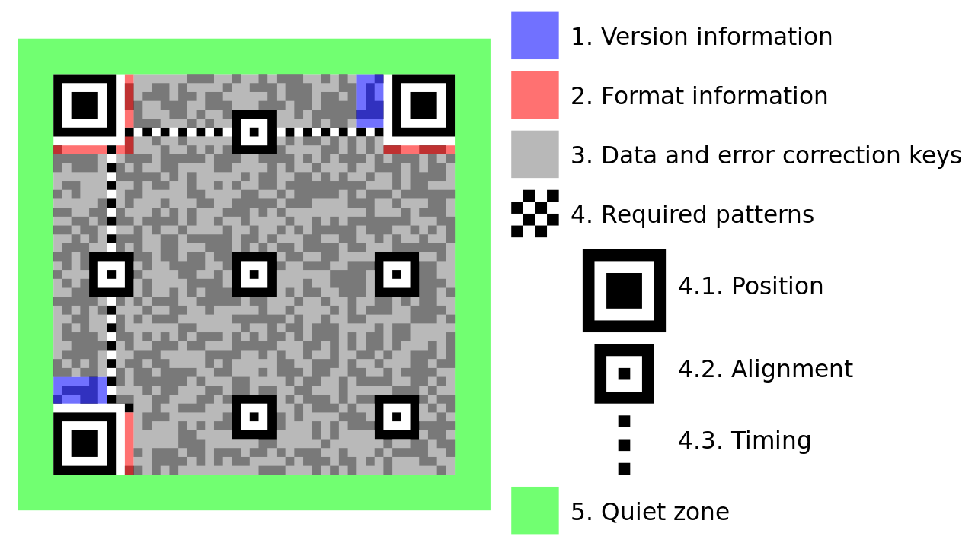

Figure 3.2.4 QR Code

### Storage

The amount of data that can be stored in the QR code symbol depends on the datatype (*mode*, or input character set), version (1,….40, indicating the overall dimensions of the symbol), and [error correction](https://en.wikipedia.org/wiki/QR_code#Error_correction) level. The maximum storage capacities occur for 40-L symbols (version 40, error correction level L).

|  |  |  |  |
| --- | --- | --- | --- |
|  | | | |
| **Input mode** | **max. characters** | **bits/char** | **possible characters, default encoding** |
| **Numeric only** | 7,089 | 3⅓ | 0, 1, 2, 3, 4, 5, 6, 7, 8, 9 |
| [**Alphanumeric**](https://en.wikipedia.org/wiki/Alphanumeric) | 4,296 | 5½ | 0–9, A–Z (upper-case only), space, $, %, \*, +, -, ., /, : |

**3.4 SOFTWARE**

**3.4.1 Eclipse**

**What is Eclipse?**

Eclipse is a platform that has been designed from the ground up for building integrated web and application development tooling. By design, the platform does not provide a great deal of end user functionality by itself. The value of the platform is what it encourages: rapid development of integrated features based on a plug-in model.

Eclipse provides a common user interface (UI) model for working with tools.  It is designed to run on multiple operating systems while providing robust integration with each underlying OS.  Plug-ins can program to the Eclipse portable APIs and run unchanged on any of the supported operating systems.

At the core of Eclipse is an architecture for dynamic discovery, loading, and running of plug-ins. The platform handles the logistics of finding and running the right code. The platform UI provides a standard user navigation model.  Each plug-in can then focus on doing a small number of tasks well for example-defining, testing, animating, publishing, compiling, debugging, diagramming etc.

**Open architecture**

The Eclipse platform defines an open architecture so that each plug-in development team can focus on their area of expertise. Let the repository experts build the back ends and the usability experts build the end user tools. If the platform is designed well, significant new features and levels of integration can be added without impact to other tools.

The Eclipse platform uses the model of a common workbench to integrate the tools from the end user's point of view. Tools that you develop can plug into the workbench using well defined hooks called extension points.

The platform itself is built in layers of plug-ins, each one defining extensions to the extension points of lower-level plug-ins, and in turn defining their own extension points for further customization. This extension model allows plug-in developers to add a variety of functionality to the basic tooling platform. The artifacts for each tool, such as files and other data, are coordinated by a common platform resource model.

The platform gives the users a common way to work with the tools, and provides integrated management o f the resources they create with plug-ins.

Plug-in developers also gain from this architecture.  The platform manages the complexity of different runtime environments, such as different operating systems or workgroup server environments.  Plug-in developers can focus on their specific task instead of worrying about these integration issues.

**Architecture**

Eclipse uses plug-ins to provide all the functionality within and on top of the runtime system. Its runtime system is based on [Equinox](https://en.wikipedia.org/wiki/Equinox_%28OSGi%29), an implementation of the [OSGi](https://en.wikipedia.org/wiki/OSGi) core framework specification. In addition to allowing the Eclipse Platform to be extended using other [programming languages](https://en.wikipedia.org/wiki/Programming_language), such as C and Python, the plug-in framework allows the Eclipse Platform to work with typesetting languages like LaTeX and networking applications such as telnet and database management systems. The plug-in architecture supports writing any desired extension to the environment, such as for configuration management. Java and CVS support is provided in the Eclipse SDK, with support for other version control systems provided by third-party plug-ins.

With the exception of a small run-time kernel, everything in Eclipse is a plug-in. This means that every plug-in developed integrates with Eclipse in exactly the same way as other plug-ins; in this respect, all features are "created equal". Eclipse provides plug-ins for a wide variety of features, some of which are through third parties using both free and commercial models. Examples of plug-ins include for UML, for Sequence and other UML diagrams, a plug-in for DB Explorer, and many others.

The Eclipse SDK includes the Eclipse Java development tools (JDT), offering an IDE with a built-in incremental Java compiler and a full model of the Java source files. This allows for advanced refactoring techniques and code analysis. The IDE also makes use of a workspace, in this case a set of metadata over a flat file space allowing external file modifications as long as the corresponding workspace "resource" is refreshed afterwards.

Eclipse implements the graphical control elements of the Java toolkit called SWT, whereas most Java applications use the Java standard Abstract Window Tool kit (AWT) or Swing. Eclipse's user interface also uses an intermediate graphical user interface layer called JFace, which simplifies the construction of applications based on SWT. Eclipse was made to run on Wayland during a GSoC-Project in 2014.

Language packs being developed by the "Babel project" provide translations into over a dozen natural languages.

**3.4.2 Java**

**What is Java?**

**Java** is a general-purpose computer programming language that is concurrent, class-based, object-oriented, and specifically designed to have as few implementation dependencies as possible. It is intended to let application developers "write once, run anywhere" (WORA), meaning that compiled Java code can run on all platforms that support Java without the need for recompilation. Java applications are typically compiled to byte code that can run on any Java virtual machine (JVM) regardless of computer architecture. As of 2016, Java is one of the most popular programming languages in use, particularly for client-server web applications, with a reported 9 million developers. Java was originally developed by James Gosling at Sun Microsystems (which has since been acquired by Oracle Corporation) and released in 1995 as a core component of Sun Microsystems' Java platform. The language derives much of its syntax from C and C++, but it has fewer low-level facilities than either of them.

**Why Java?**

* First of all java is a open source programming language created by [Sun](http://en.wikipedia.org/wiki/Sun_Microsystems" \t "_blank)Microsoft overtaken by oracle .Its source code is available for free inside every JDK ( Java Development Kit)
* Java is a platform Independent: – Platform independent means java can run on any computer irrespective to the hardware and software dependency. Means Java does not depend on hardware means what type of processor, RAM etc. Java will run on a machine which will satisfy its basic needs.
* Java Is a Secure Language: The Byte Code Concept separates java from all other language. As we know Byte Code is set of symbols created by sun Microsoft which are generated after the compilation of Program. This byte code is actually encoded source code that human cannot understand and that Byte code is converted to machine code by Java Runtime Environment. This Byte code is executed by java runtime environment which consist of Byte code loader which loads the byte code into memory and then Byte code verifier which verifies the Byte code and look for any extra symbols and code which does not resembles to the standards and throws unexpected code way and makes java byte code error free and secure. Java is fast because of JIT compiler. Just In Time compiler stores the repeated code in its cache memory and in byte code where repeated code is used, instead of loading that code again from memory JIT use it from its cache memory and safe time and space and make execution fast. Below is the graphical representation of java program.
* “Compile Once and Run Forever” is the famous tag line of java and yes it is very true this all is possible because of Byte code as once byte code is generated you can use that byte code and can run that program in any operating system, every operating system’s java runtime environment will convert that Byte Code into machine code and will give you your require output and because of this Java Byte Code is named as Portable Code or P-code.
* Due to its Byte code is in Bytes, java program takes very less memory on hard disk and therefore java technology is Portable also.

The Above features cannot be found in any other language, because of the above features java is used almost everywhere and in every application no matter its mobile application or web. Till date there is no programming language more secure than java.

**Principles**

There were five primary goals in the creation of the Java language:[[15]](https://en.wikipedia.org/wiki/Java_%28programming_language%29" \l "cite_note-design_goals-15)

1. It must be "simple, object-oriented, and familiar".
2. It must be "robust and secure".
3. It must be "architecture-neutral and portable".
4. It must execute with "high performance".
5. It must be "interpreted, threaded, and dynamic".

**Versions**

As of 2015, only Java 8 is supported ("publicly"). Major release versions of Java, along with their release dates:

* JDK 1.0 (January 21, 1996)
* JDK 1.1 (February 19, 1997)
* J2SE 1.2 (December 8, 1998)
* J2SE 1.3 (May 8, 2000)
* J2SE 1.4 (February 6, 2002)
* J2SE 5.0 (September 30, 2004)
* Java SE 6 (December 11, 2006)
* Java SE 7 (July 28, 2011)
* Java SE 8 (March 18, 2014)

**Java Platform**

One design goal of Java is portability, which means that programs written for the Java platform must run similarly on any combination of hardware and operating system with adequate runtime support. This is achieved by compiling the Java language code to an intermediate representation called Java Byte code, instead of directly to architecture-specific machine code. Java byte code instructions are analogous to machine code, but they are intended to be executed by a virtual machine (VM) written specifically for the host hardware. [End users](https://en.wikipedia.org/wiki/End_user) commonly use a [Java Runtime Environment](https://en.wikipedia.org/wiki/Java_virtual_machine) (JRE) installed on their own machine for standalone Java applications, or in a web browser for Java applets.

Standard libraries provide a generic way to access host-specific features such as graphics, [threading](https://en.wikipedia.org/wiki/Thread_%28computing%29), and [networking](https://en.wikipedia.org/wiki/Computer_network).

The use of universal byte code makes porting simple. However, the overhead of interpreting byte code into machine instructions makes interpreted programs almost always run more slowly than native [executables](https://en.wikipedia.org/wiki/Executable). However, [just-in-time](https://en.wikipedia.org/wiki/Just-in-time_compilation) (JIT) compilers that compile byte codes to machine code during runtime were introduced from an early stage. Java itself is platform-independent, and is adapted to the particular platform it is to run on by a [Java virtual machine](https://en.wikipedia.org/wiki/Java_virtual_machine) for it, which translates the [Java byte code](https://en.wikipedia.org/wiki/Java_bytecode) into the platform's machine language.

**3.4.3 Android**

**Android** is a mobile operating system (OS) currently developed by Google, based on the [Linux kernel](https://en.wikipedia.org/wiki/Linux_kernel) and designed primarily for [touchscreen](https://en.wikipedia.org/wiki/Touchscreen) mobile devices such as [smartphones](https://en.wikipedia.org/wiki/Smartphone) and [tablets](https://en.wikipedia.org/wiki/Tablet_computer). Android's [user interface](https://en.wikipedia.org/wiki/User_interface) is mainly based on [direct manipulation](https://en.wikipedia.org/wiki/Direct_manipulation_interface), using touch gestures that loosely correspond to real-world actions, such as swiping, tapping and pinching, to manipulate on-screen objects, along with a [virtual keyboard](https://en.wikipedia.org/wiki/Virtual_keyboard) for text input. In addition to touchscreen devices, Google has further developed [Android TV](https://en.wikipedia.org/wiki/Android_TV) for televisions, [Android Auto](https://en.wikipedia.org/wiki/Android_Auto) for cars and [Android Wear](https://en.wikipedia.org/wiki/Android_Wear) for wrist watches, each with a specialized user interface. Variants of Android are also used on [notebooks](https://en.wikipedia.org/wiki/Laptop), [game consoles](https://en.wikipedia.org/wiki/Video_game_console), [digital cameras](https://en.wikipedia.org/wiki/Digital_camera), and other electronics.

Android has the largest [installed base](https://en.wikipedia.org/wiki/Installed_base) of all operating systems of any kind. Android has been the best selling OS on tablets since 2013, and on smartphones it is dominant by any metric.

Initially developed by Android, Inc., which Google bought in 2005, Android was unveiled in 2007, along with the founding of the [Open Handset Alliance](https://en.wikipedia.org/wiki/Open_Handset_Alliance) – a consortium of [hardware](https://en.wikipedia.org/wiki/Computer_hardware), [software](https://en.wikipedia.org/wiki/Software) and telecommunication companies devoted to advancing [open standards](https://en.wikipedia.org/wiki/Open_standard) for mobile devices. As of July 2013, the [Google Play](https://en.wikipedia.org/wiki/Google_Play) store has had over one million Android applications ("apps") published, and over 50 billion applications downloaded. An April–May 2013 survey of mobile application developers found that 71% of developers create applications for Android, and a 2015 survey found that 40% of full-time professional developers see Android as their priority target platform, which is comparable to [Apple](https://en.wikipedia.org/wiki/Apple_Inc.)'s [iOS](https://en.wikipedia.org/wiki/IOS) on 37% with both platforms far above others. At [Google I/O](https://en.wikipedia.org/wiki/Google_I/O) 2014, the company revealed that there were over one billion active monthly Android users, up from 538 million in June 2013.

Android's [source code](https://en.wikipedia.org/wiki/Source_code) is released by Google under [open source](https://en.wikipedia.org/wiki/Open_source) licenses, although most Android devices ultimately ship with a combination of open source and proprietary software, including proprietary software required for accessing Google services. Android is popular with technology companies that require a ready-made, low-cost and customizable operating system for [high-tech](https://en.wikipedia.org/wiki/High-tech) devices. Its open nature has encouraged a large community of developers and enthusiasts to use the open-source code as a foundation for community-driven projects, which add new features for advanced users or bring Android to devices originally shipped with other operating systems. At the same time, as Android has no centralised update system most Android devices fail to receive security updates: research in 2015 concluded that almost 90% of Android phones in use had known but unpatched security vulnerabilities due to lack of updates and support. The success of Android has made it a target for patent litigation as part of the so-called "[smartphone wars](https://en.wikipedia.org/wiki/Smartphone_wars" \o "Smartphone wars)" between technology companies.

**Features**

**Interface**

Android's default user interface is mainly based on [direct manipulation](https://en.wikipedia.org/wiki/Direct_manipulation_interface), using touch inputs that loosely correspond to real-world actions, like swiping, tapping, pinching, and reverse pinching to manipulate on-screen objects, along with a [virtual keyboard](https://en.wikipedia.org/wiki/Virtual_keyboard). [Game controllers](https://en.wikipedia.org/wiki/Game_controller) and full-size physical [keyboards](https://en.wikipedia.org/wiki/Computer_keyboard) are supported via [Bluetooth](https://en.wikipedia.org/wiki/Bluetooth) or [USB](https://en.wikipedia.org/wiki/USB). The response to user input is designed to be immediate and provides a fluid touch interface, often using the vibration capabilities of the device to provide [haptic feedback](https://en.wikipedia.org/wiki/Haptic_technology) to the user. Internal hardware, such as [accelerometers](https://en.wikipedia.org/wiki/Accelerometer), [gyroscopes](https://en.wikipedia.org/wiki/Gyroscope) and [proximity sensors](https://en.wikipedia.org/wiki/Proximity_sensor)[[54]](https://en.wikipedia.org/wiki/Android_%28operating_system%29#cite_note-56) are used by some applications to respond to additional user actions, for example adjusting the screen from portrait to landscape depending on how the device is oriented, or allowing the user to steer a vehicle in a racing game by rotating the device, simulating control of a [steering wheel](https://en.wikipedia.org/wiki/Steering_wheel).

Android devices boot to the homescreen, the primary navigation and information "hub" on Android devices that is analogous to the [desktop](https://en.wikipedia.org/wiki/Desktop_metaphor) found on personal computers. (Android also runs on regular personal computers, as described [below](https://en.wikipedia.org/wiki/Android_%28operating_system%29#DESKTOP)). Android homescreens are typically made up of app icons and [widgets](https://en.wikipedia.org/wiki/Software_widget); app icons launch the associated app, whereas widgets display live, auto-updating content, such as the weather forecast, the user's email inbox, or a [news ticker](https://en.wikipedia.org/wiki/News_ticker) directly on the homescreen. A homescreen may be made up of several pages, between which the user can swipe back and forth, though Android's homescreen interface is heavily customisable, allowing users to adjust the look and feel of the devices to their tastes. Third-party apps available on [Google Play](https://en.wikipedia.org/wiki/Google_Play) and other app stores can extensively re-[theme](https://en.wikipedia.org/wiki/Theme_%28computing%29) the homescreen, and even mimic the look of other operating systems, such as [Windows Phone](https://en.wikipedia.org/wiki/Windows_Phone).

**Applications**

Applications ("[apps](https://en.wikipedia.org/wiki/Mobile_app)"), which extend the functionality of devices, are written using the [Android software development](https://en.wikipedia.org/wiki/Android_software_development) kit (SDK) and, often, the [Java](https://en.wikipedia.org/wiki/Java_%28programming_language%29) programming language that has complete access to the Android APIs. Java may be combined with [C](https://en.wikipedia.org/wiki/C_%28programming_language%29)/[C++](https://en.wikipedia.org/wiki/C%2B%2B), together with a choice of non-default runtimes that allow better C++ support; the [Go](https://en.wikipedia.org/wiki/Go_%28programming_language%29) programming language is also supported since its version 1.4, which can also be used exclusively although with a restricted set of Android APIs. The SDK includes a comprehensive set of development tools including a [debugger](https://en.wikipedia.org/wiki/Debugger), [software libraries](https://en.wikipedia.org/wiki/Software_library), a handset [emulator](https://en.wikipedia.org/wiki/Emulator) based on [QEMU](https://en.wikipedia.org/wiki/QEMU), documentation, sample code, and tutorials. Initially, Google's supported [integrated development environment](https://en.wikipedia.org/wiki/Integrated_development_environment) (IDE) was [Eclipse](https://en.wikipedia.org/wiki/Eclipse_%28software%29) using the Android Development Tools (ADT) plugin.

Android has a growing selection of third-party applications, which can be acquired by users by downloading and installing the application's [APK](https://en.wikipedia.org/wiki/APK_%28file_format%29) (Android application package) file, or by downloading them using an [application store](https://en.wikipedia.org/wiki/Application_store) program that allows users to [install, update, and remove applications](https://en.wikipedia.org/wiki/Package_manager) from their devices. [Google Play Store](https://en.wikipedia.org/wiki/Google_Play_Store) is the primary application store installed on Android devices that comply with Google's compatibility requirements and license the Google Mobile Services software. Google Play Store allows users to browse, download and update applications published by Google and third-party developers; as of July 2013, there are more than one million applications available for Android in Play Store. As of July 2013, 50 billion applications have been installed. Some carriers offer direct carrier billing for Google Play application purchases, where the cost of the application is added to the user's monthly bill.

Due to the open nature of Android, a number of third-party application marketplaces also exist for Android, either to provide a substitute for devices that are not allowed to ship with Google Play Store, provide applications that cannot be offered on Google Play Store due to policy violations, or for other reasons.

**Memory management**

Since Android devices are usually battery-powered, Android is designed to manage processes to keep power consumption at a minimum. When an application is not in use the system [suspends its operation](https://en.wikipedia.org/wiki/Process_state) so that, while available for immediate use rather than closed, it does not use battery power or CPU resources.

Android manages the applications stored in memory automatically: when memory is low, the system will begin invisibly and automatically closing inactive processes, starting with those that have been inactive for longest. Lifehacker reported in 2011 that third-party task killers were doing more harm than good.

**Security and privacy**

Android applications run in a [sandbox](https://en.wikipedia.org/wiki/Sandbox_%28computer_security%29), an isolated area of the system that does not have access to the rest of the system's resources, unless access permissions are explicitly granted by the user when the application is installed. Before installing an application, [Play Store](https://en.wikipedia.org/wiki/Google_Play) displays all required permissions: a game may need to enable vibration or save data to an [SD card](https://en.wikipedia.org/wiki/SD_card), for example, but should not need to read SMS messages or access the phonebook. After reviewing these permissions, the user can choose to accept or refuse them, installing the application only if they accept. The sandboxing and permissions system lessens the impact of vulnerabilities and bugs in applications, but developer confusion and limited documentation has resulted in applications routinely requesting unnecessary permissions, reducing its effectiveness. Google has now pushed an update to Android Verify Apps feature, which will now run in background to detect malicious processes and crack them down.

In Android 6.0 *Marshmallow*, the permissions system was changed to allow the user to control an application's permissions individually, to block applications if desired from having access to the device's contacts, calendar, phone, sensors, SMS, location, microphone and camera. Full permission control is only possible with [root](https://en.wikipedia.org/wiki/Android_rooting) access to the device.

**3.4.5 Web Server**

Client (any browser) server (raspberry pi)

Display a web page

* Accept the request
* Processing
* Send Response

HTTP Request

HTTP Response

* A web server is a piece of software that enables a website to be viewed using HTTP. HTTP (HyperText Transfer Protocol) is the key protocol for the transfer of data on the web.
* Every Web site sits on a computer known as a Web server. This server is always connected to the internet. Every Web server that is connected to the Internet is given a unique address made up of a series of four numbers between 0 and 255 separated by periods. for example, 68.178.157.132 or 68.122.35.127.
* When you register a Web address, also known as a domain name, such as tekinnovative.com you have to specify the IP address of the Web server that will host the site. You can load up with Dedicated Servers that can support your web-based operations.
* Here in our projects, our android phone will act as a server. Client (i.e any browser) can send request to the server (i.e android phone) using IP address and port number (Ip address : port number/Name of html page) . Our website is not registered so we don’t have domain name. That’s why we need to send request to server using Ip address & port number. For client-server communication both client(browser machine) and server(android phone) needs to be connected to the same network.
* Through HTML code we are designing web pages, using collection of web pages we create website and we are hosting that website on a server called as Webserver.

**3.4.6 HTML**

**Hyper Text Markup Language**, commonly abbreviated as **HTML**, is the standard [markup language](https://en.wikipedia.org/wiki/Markup_language) used to create [web pages](https://en.wikipedia.org/wiki/Web_page). Along with [CSS](https://en.wikipedia.org/wiki/Cascading_Style_Sheets), and [JavaScript](https://en.wikipedia.org/wiki/JavaScript), HTML is a cornerstone technology used to create web pages, as well as to create user interfaces for mobile and [web applications](https://en.wikipedia.org/wiki/Web_applications). [Web browsers](https://en.wikipedia.org/wiki/Web_browser) can read HTML files and render them into visible or audible web pages. HTML describes the structure of a [website](https://en.wikipedia.org/wiki/Website) [semantically](https://en.wikipedia.org/wiki/Semantic) and, before the advent of Cascading Style Sheets (CSS), included cues for the presentation or appearance of the document (web page), making it a markup language, rather than a [programming language](https://en.wikipedia.org/wiki/Programming_language).

[HTML elements](https://en.wikipedia.org/wiki/HTML_element) form the building blocks of HTML pages. HTML allows [images](https://en.wikipedia.org/wiki/Img_%28HTML_element%29) and other objects to be embedded and it can be used to create [interactive forms](https://en.wikipedia.org/wiki/Fieldset). It provides a means to create [structured documents](https://en.wikipedia.org/wiki/Structured_document) by denoting structural [semantics](https://en.wikipedia.org/wiki/Semantics) for text such as headings, paragraphs, lists, [links](https://en.wikipedia.org/wiki/Hyperlink), quotes and other items. HTML elements are delineated by *tags*, written using [angle brackets](https://en.wikipedia.org/wiki/Bracket#Angle_brackets). Tags such as <img /> and <input /> introduce content into the page directly. Others such as <p>...</p> surround and provide information about document text and may include other tags as sub-elements. Browsers do not display the HTML tags, but use them to interpret the content of the page.

HTML can embed [scripts](https://en.wikipedia.org/wiki/Scripting_language) written in languages such as [JavaScript](https://en.wikipedia.org/wiki/JavaScript) which affect the behavior of HTML web pages. HTML markup can also refer the browser to [Cascading Style Sheets](https://en.wikipedia.org/wiki/Cascading_Style_Sheets) (CSS) to define the look and layout of text and other material. The [World Wide Web Consortium](https://en.wikipedia.org/wiki/World_Wide_Web_Consortium) (W3C), maintainer of both the HTML and the CSS standards, has encouraged the use of CSS over explicit presentational HTML since 1997.

**3.4.3 Eagle**

Easily applicable graphical layout editor. The design of our printed circuit board has been done using eagle. Eagle software is a complete EDA (electronic design automation) system for pc compatible computer and windows 95/98/nt/2k/xp operating system. It includes schematic and PCB (printed circuit board) modules.

**EAGLE Modules**

A number of EAGLE editions are offered. You can add an Auto router Module and/or a Schematic Editor to the Layout Editor. A standalone Schematic Editor can be used for drawing wiring diagrams. In this case you won't need the Layout Editor. The user interface is identical for all parts of the program.

**The Layout Editor**

The Layout Editor, which allows you to design Printed Circuit Boards (PCBs), comes with the Library Editor, the Computer Aided Manufacturing (CAM) Processor, and the Text Editor. With the Library Editor you can already design Packages (footprints), Symbols and Devices (for a schematic). The CAM Processor is the program which generates the output data for the production of the PCB (e.g. Gerber or drill files). It is also possible to use User Language programs and Script files.

**Schematic Editor**

The Schematic Editor without Layout Editor is applicable for drawing electrical wiring diagrams (connection scheme, contact plans...). The Schematic Editor comes, as well as the Layout Editor, with the full Library Editor for designing Symbols for the Schematic and Packages for the Layout, with the CAM Processor, and the Text Editor. You can also use User Language programs and Script files. If you want to draw Schematic diagrams for electronic systems you should have Schematic and Layout Editor. You can generate the associated circuit board at any time with a mouse click. EAGLE then changes to the Layout Editor, where the packages are placed next to an empty board connects edviaai wires (rubber bands). From here you can go on designing with the Layout Editor as usual. Schematic and layout are automatically kept consistent by EAGLE (Forward &Back Annotation). Schematic diagrams can consist of maximum of 999 sheets in the Professional Edition (99 sheets in the General

* maximum drawing area 64 x 64 inches
* resolution 1/10,000 mm (0.1 microns)
* up to 255 drawing laye

**3.4.4 WinSCP**

**WinSCP** (***Win****dows* ***S****ecure* ***C****o****p****y*) is a free and open-source SFTP, FTP, WebDAV and SCP client for Microsoft Windows. Its main function is secure file transfer between a local and a remote computer. Beyond this, WinSCP offers basic file manager and file synchronization functionality. For secure transfers, it uses Secure Shell (SSH) and supports the SCP protocol in addition to SFTP.

Development of WinSCP started around March 2000 and continues. Originally it was hosted by the University of Economics in Prague, where its author worked at the time. Since July 16, 2003, it is licensed under the GNU GPL and hosted on SourceForge.net**.**

WinSCP is based on the implementation of the SSH protocol from PuTTY and FTP protocol from FileZilla. It is also available as a plugin for Altap Salamander file manager, and there exists a third-party plugin for the FAR file manager.

**Features**

* Graphical user interface
* [Translated into many languages](https://winscp.net/eng/docs/languages)
* Integration with Windows (drag & drop, [URL](https://winscp.net/eng/docs/integration_url), shortcut icons, [jump list](https://winscp.net/eng/docs/ui_jump_list))
* All common [operations with files](https://winscp.net/eng/docs/task_index)
* Support for [SFTP and SCP protocols](https://winscp.net/eng/docs/protocols) over SSH and [FTP](https://winscp.net/eng/docs/ftp) and [WebDAV](https://winscp.net/eng/docs/webdav) protocols
* Batch file [scripting and command-line interface](https://winscp.net/eng/docs/scripting) and [.NET assembly](https://winscp.net/eng/docs/library) for advanced programming tasks
* [Directory synchronization](https://winscp.net/eng/docs/task_synchronize) in several semi or fully automatic ways
* [Integrated text editor](https://winscp.net/eng/docs/ui_editor)
* [Shares site settings with PuTTY](https://winscp.net/eng/docs/integration_putty)
* Support for password, keyboard-interactive, public key and Kerberos (GSS) [authentication](https://winscp.net/eng/docs/ui_login_authentication)
* Integrates with [Pageant](https://winscp.net/eng/docs/ui_pageant) (PuTTY authentication agent) for full support of [public key authentication](https://winscp.net/eng/docs/public_key) with SSH
* [Explorer](https://winscp.net/eng/docs/ui_explorer) and [Commander](https://winscp.net/eng/docs/ui_commander) [interfaces](https://winscp.net/eng/docs/interfaces)
* Optionally protects [stored site information](https://winscp.net/eng/docs/session_configuration#site) with [master password](https://winscp.net/eng/docs/master_password)
* Optionally supports portable operation using a [configuration file in place of registry entries](https://winscp.net/eng/docs/config), suitable for operation from removable media.

**3.4.5 PuTTY**

**PuTTY** is a free and open-source terminal emulator, serial console and network file transfer application. It supports several network protocols, including SCP, SSH, Telnet, rlogin, and raw socket connection. It can also connect to a serial port. The name "PuTTY" has no definitive meaning.

PuTTY was originally written for Microsoft Windows, but it has been ported to various other operating systems. Official ports are available for some Unix-like platforms, with work-in-progress ports to Classic Mac OS and Mac OS X, and unofficial ports have been contributed to platforms such as Symbian, Windows Mobile and Windows Phone.

PuTTY was written and is maintained primarily by Simon Tatham and is currently beta software.

**Features**

PuTTY supports many variations on the secure remote terminal, and provides user control over the SSH encryption key and protocol version, alternate ciphers such as 3DES, [Arcfour](https://en.wikipedia.org/wiki/RC4), [Blowfish](https://en.wikipedia.org/wiki/Blowfish_%28cipher%29), [DES](https://en.wikipedia.org/wiki/Data_Encryption_Standard), and [Public-key](https://en.wikipedia.org/wiki/Public-key) authentication. It also can emulate control sequences from [xterm](https://en.wikipedia.org/wiki/Xterm), [VT102](https://en.wikipedia.org/wiki/VT102) or [ECMA-48](https://en.wikipedia.org/wiki/ECMA-48) [terminal emulation](https://en.wikipedia.org/wiki/Terminal_emulator), and allows local, remote, or dynamic [port forwarding](https://en.wikipedia.org/wiki/Port_forwarding) with SSH (including [X11](https://en.wikipedia.org/wiki/X11) forwarding). The network communication layer supports [IPv6](https://en.wikipedia.org/wiki/IPv6), and the SSH protocol supports the zlib@openssh.com delayed compression scheme. It can also be used with local serial port connections.

PuTTY comes bundled with command-line [SCP](https://en.wikipedia.org/wiki/Secure_copy) and [SFTP](https://en.wikipedia.org/wiki/SSH_file_transfer_protocol) clients, called "pscp" and "psftp" respectively.

**Components**

PuTTY consists of several components:

* PuTTY: the [Telnet](https://en.wikipedia.org/wiki/Telnet), [rlogin](https://en.wikipedia.org/wiki/Rlogin), and [SSH](https://en.wikipedia.org/wiki/Secure_Shell) client itself, which can also connect to a [serial port](https://en.wikipedia.org/wiki/Serial_port)
* PSCP: an [SCP](https://en.wikipedia.org/wiki/Secure_copy) client, i.e. command-line secure file copy
* PSFTP: an [SFTP](https://en.wikipedia.org/wiki/SSH_File_Transfer_Protocol) client, i.e. general file transfer sessions much like [FTP](https://en.wikipedia.org/wiki/File_Transfer_Protocol)
* PuTTYtel: a Telnet-only client
* Plink: a command-line interface to the PuTTY back ends
* Pageant: an SSH authentication agent for PuTTY, PSCP and Plink
* PuTTYgen: an [RSA](https://en.wikipedia.org/wiki/RSA_%28algorithm%29) and [DSA](https://en.wikipedia.org/wiki/Digital_Signature_Algorithm) key generation utility
* pterm: a standalone terminal emulator

**3.4.6 DATABASE, SQL AND MYSQL**

**Database:**

Essentially, where computers are concerned, a database is a just collection of data. Specialised (or "specialized" in [US English](http://www.thesitewizard.com/general/beware-of-english-variants.shtml)) database software, like MySQL, are just programs that lets you store and retrieve that data as efficiently as possible.

A little analogy may help make it clearer why we use specialised database software. Think about the documents stored on your computer. If you were to save all your documents using a (brain-dead) file naming scheme like "1.doc", "2.doc", "3.doc", ... "9,999,999.doc" (etc), you will eventually face a problem of finding the right file if you're looking for a specific document. For example, if you're looking for a business proposal you made some time ago to XYZ Company, which file should you open? One way is to sequentially check every single file, starting from "1.doc", till you get the right data. But this is obviously a highly inefficient method of getting the right file. And it's primarily the result of an inefficient method of storing your data (ie, saving your files) in the first place.

Now, this is of course a ridiculous example. I mean, no one I know saves files with names like these, and even if so, there are [many search software](http://www.thefreecountry.com/programming/searchandreplace.shtml) that can help you locate the correct file without your having to manually open every single one in sequence. But it serves to make the point that once you have a lot of data, if you don't have a good system of organising it, finding the correct piece of data is a very time consuming operation. And it becomes more time consuming as the amount of data grows.

A database program is a type of computer software that is designed to handle lots of data, but to store them in such a way that finding (and thus retrieving) any snippet of data is more efficient than it would have been if you simply dumped them willy nilly all over the place. With such database software, if you (say) keep a list of customers and their shipping addresses, entering and retrieving information about your one millionth customer will not take much longer (if at all) than entering and retrieving information about your 1st customer.

**SQL:**

Many computer programs, including web-based programs like [blogs](http://www.thefreecountry.com/php/free-blog-scripts.shtml), [photo galleries](http://www.thefreecountry.com/php/photo-galleries.shtml) and [content management systems](http://www.thesitewizard.com/gettingstarted/difference-cms-site-builder.shtml) need to store and retrieve data. For example, blog software need to store the posts (ie, articles) you write, and retrieve them when a visitor goes to your site. Similarly, photo galleries store information about their pictures (for example, for sites that allow users to rate the photos, the numerical rating for each picture is stored in a database). Instead of reinventing the wheel and implementing their own system of storing and retrieving data, these software simply use the specialised database programs I mentioned earlier.

To make it easy for other programs to access data through them, many database software support a computer language called "SQL" (often pronounced as "sequel"). SQL was specially designed for such a purpose. Programs that want the database software to handle the low-level work of managing data simply use that language to send it instructions.

**MySQL:**

MySQL is the world's most popular open source database. With its proven performance, reliability and ease-of-use, MySQL has become the leading database choice for web-based applications, used by high profile web properties including Facebook, Twitter, YouTube, Yahoo! and many more.

Oracle drives MySQL innovation, delivering new capabilities to power next generation web, cloud, mobile and embedded applications.

MySQL is a popular choice of database for use in web applications, and is a central component of the widely used [LAMP](https://en.wikipedia.org/wiki/LAMP_%28software_bundle%29) open-source web application software stack (and other "[AMP](https://en.wikipedia.org/wiki/List_of_AMP_packages)" stacks). LAMP is an acronym for "[Linux](https://en.wikipedia.org/wiki/Linux), [Apache](https://en.wikipedia.org/wiki/Apache_HTTP_Server), MySQL, [Perl](https://en.wikipedia.org/wiki/Perl)/[PHP](https://en.wikipedia.org/wiki/PHP)/[Python](https://en.wikipedia.org/wiki/Python_%28programming_language%29)". [Free-software](https://en.wikipedia.org/wiki/Free_software) open-source projects that require a full-featured database management system often use MySQL. Applications that use the MySQL database include: [TYPO3](https://en.wikipedia.org/wiki/TYPO3), [MODx](https://en.wikipedia.org/wiki/MODx), [Joomla](https://en.wikipedia.org/wiki/Joomla), [WordPress](https://en.wikipedia.org/wiki/WordPress), [phpBB](https://en.wikipedia.org/wiki/PhpBB), [MyBB](https://en.wikipedia.org/wiki/MyBB), [Drupal](https://en.wikipedia.org/wiki/Drupal) and other software. MySQL is also used in many high-profile, large-scale [websites](https://en.wikipedia.org/wiki/Website), including [Google](https://en.wikipedia.org/wiki/Google) (though not for searches), [Facebook](https://en.wikipedia.org/wiki/Facebook), [Twitter](https://en.wikipedia.org/wiki/Twitter), [Flickr](https://en.wikipedia.org/wiki/Flickr) and [YouTube](https://en.wikipedia.org/wiki/YouTube).

**Features:**

MySQL is offered under two different editions: the open source MySQL Community Server and the proprietary [Enterprise Server](https://en.wikipedia.org/wiki/MySQL_Enterprise). MySQL Enterprise Server is differentiated by a series of proprietary extensions which install as server plugins, but otherwise shares the version numbering system and is built from the same code base.

Major features as available in MySQL 5.6:

* A broad subset of [ANSI SQL 99](https://en.wikipedia.org/wiki/SQL:1999), as well as extensions
* Cross-platform support
* [Stored procedures](https://en.wikipedia.org/wiki/Stored_procedure), using a procedural language that closely adheres to [SQL/PSM](https://en.wikipedia.org/wiki/SQL/PSM)
* [Triggers](https://en.wikipedia.org/wiki/Database_trigger)
* [Cursors](https://en.wikipedia.org/wiki/Cursor_%28databases%29)
* Updatable [views](https://en.wikipedia.org/wiki/View_%28SQL%29)
* [Online DDL](https://en.wikipedia.org/wiki/Data_Definition_Language) when using the InnoDB Storage Engine.
* [Information schema](https://en.wikipedia.org/wiki/Information_schema)
* Performance Schema that collects and aggregates statistics about server execution and query performance for monitoring purposes.
* A set of SQL Mode options to control runtime behavior, including a strict mode to better adhere to SQL standards.
* [X/Open XA](https://en.wikipedia.org/wiki/X/Open_XA) [distributed transaction processing](https://en.wikipedia.org/wiki/Distributed_transaction_processing) (DTP) support; [two phase commit](https://en.wikipedia.org/wiki/Two-phase-commit_protocol) as part of this, using the default [InnoDB](https://en.wikipedia.org/wiki/InnoDB) storage engine

The developers release minor updates of the MySQL Server approximately every two months. The sources can be obtained from MySQL's website or from MySQL's [GitHub](https://en.wikipedia.org/wiki/Git_%28software%29) repository, both under the GPL license.

**4.1 INTRODUCTION**

A PCB is used to mechanically support and electrically connect electronic components using conductive pathways, tracks or etched from copper sheets. It is also referred to as printed wiring board (PWB). A PCB populated with electronic components is a printed circuit assembly (PCA), also known as a printed circuit board assembly (PCBA).PCBs is inexpensive, and can be highly reliable. They require much more layout effort and higher initial cost than either wire-wrapped or point-to-point constructed circuits, but are much cheaper and faster for high-volume production. One of the most discouraging things about making a hardware project is building PCB. Due to the improvements in printing technologies it is now relatively easy to make inexpensive high quality PCB's at home.

PCB stands for Printed Circuit Board. It is of two types:

* General purpose: It is already drilled and etched.
* Special purpose: It requires step by step process of making layout then etching and then drilling.

**4.2 PRINTED CIRCUIT BOARD (PCB)**

A printed circuit board (PCB) mechanically supports and electrically connects electronic components using conductive tracks, pads and other features etched from copper sheets laminated onto a non-conductive substrate. PCBs can be single sided (one copper layer), double sided (two copper layers) or multi-layer.

**1) Single Sided**

The most basic PCBs have the components mounted on one side of the board and the conductor pattern on the other side .Because there is only a conductor pattern on one side, this type of PCB is called 'single-sided’ or ‘single–layer’. This type of circuit board is suitable for simple circuits only. Because there is only one side, no wires can cross and they have to be routed around each other.

**2) Double Sided**

Double-sided or double-layer printed circuit boards (PCB)s are better suited to complex circuits as they have twice the area for the conductor pattern compared to single-sided PCBs. Double-sided PCBs have a conductor pattern on both sides of the board. Having two separate conductor patterns requires an electrical connection between them.

Such electrical 'bridges' are called 'vias '. A via is simply a hole in the PCB that is filled or plated with metal and touches the conductor pattern on both sides.

**3) Multi-Layer**

Multilayer PCBs have one or more conductor pattern inside the board, to increase the area available for the wiring. This is achieved by gluing (laminating) several double-sided circuit boards together with insulating layers in between.

The number of layers is referred to as the number of separate conductor patterns – usually even and including the two outer layers. Most boards have between 4 and 8 layers, but PCBs with almost 100 layers can be made.

**Raw Material:-**

The substrate most commonly used in printed circuit boards is a glass fiber reinforced(fiberglass) [epoxy](http://www.madehow.com/knowledge/Epoxy.html) resin with a copper foil bonded on to one or both sides. PCBs made from paper reinforced phenolic resin with a bonded copper foil are less expensive and are often used in household electrical devices. The printed circuits are made of copper, which is either plated or etched away on the surface of the substrate to leave the pattern desired. The copper circuits are coated with a layer of tin-lead to prevent oxidation.

4.3 PCB CONSTRUCTION

The different processes that take place in the fabrication of a PCB are as follows:

1. Layout designing
2. Transfer of pattern on copper board.
3. Drying
4. Etching
5. Tinning
6. Drilling
7. Soldering
8. Surface cleaning
9. Final inspection of PCB

**4.3.1 LAYOUT DESIGNING**

First of all layout design of the circuit switch is to be traced on the PCB, is prepared. The layout of a PCB has to incorporate all the information on the board one can go to the art work preparation. The detailed circuit diagram is very important for the layout designer but he must also familiar with the design concept & with the philosophy behind the equipment. In this process the layout designer, traces the circuit on a graph paper. By this process he marks wherethe holes should be. Thus the circuit, which is to be traced on the PB, is firstly traced on the graph paper or its layout is designed. In layout designing the distance between the copper tracks & length, size etc. of components are also taken into consideration.

**4.3.2 TRANSFER OF PATTERN**

After designing the art work on the graph paper, we transferred it onto the trace paper. The conductor pattern is then transferred n to the copper clad lamination with the help of carbon paper. By this the pattern gets transferred on the copper clad lamination.

**4.3.3 ETCHING**

Etching is done to remove all the unwanted copper which is present on the portion other than the pattern on the PCB. For this the PCB is kept dipped in the solution (Fe.Cl2) & two or three drops of HCL. The chemicals react with copper & dissolve it. After some hours of time we get the PCB left with only copper tracks on it.

**4.3.4 TINNING**

The board is tinned using a soldering iron and a small piece of tinned solderwick. Tinning isn't absolutely necessary but it improves the appearance of the board, and prevents the copper from oxidizing before it's time to solder the parts to the board.

**4.3.5 DRILLING**

Drilling of component mounting holes into PCB is the most important mechanical matching operation in PCB production process. Holes are made by drilling where ever a superior hole finish in is required. Therefore, drilling is applied by all the professional grade PCB manufacturers & generally in all smaller PCB production plants & laboratories.

**4.3.6 SURFACE CLEANING**

After drilling the surface is cleaned so that the scraps may be removed which are settled on the board during drilling.

# 4.3.7 SOLDERING

# Soldering is the process of joining two metallic conductors, the joint where the two metallic conductors are to be joined or fused is heated with a device called soldering iron and then an alloy of tin and lead called solder is applied which melts and cover the joint. The solder coolsand solidifies quickly to ensure a good and durable connection between the joined metals. Covering the joint with solder prevents oxidation.

**4.3.8 FINAL INSPECTION OF PCB**

After complete fabrication, PCB is inspected for any defect such as short circuit or open circuit. If no defect found, then the PCB will be directly considered for operation.

**4.4 EQUIPMENTS REQUIRED:**

The various tools and equipments required for construction of a PCB are given below:

1.Solder kit consist of:

* 1. Soldering iron.
  2. Soldering wire.
  3. Flux

2.Tweezer

3.Cutter

4.Multi-meter (Measuring instrument).

**4.5 PRECAUTIONS FOR PRACTICAL:**

1. The quantity of soldering of component on PCB should be good quantity.
2. The component fitted on the PCB should loosely fit.
3. Use ferric chloride safely.
4. Add ferric chloride to the water, not water to the ferric chloride.

**4.6 PCB LAYOUT AND ART WORK**

**4.6.1 PCB layout**

Layout basically means placing or arranging things in a specific order on the PCB. Layout means placing of components in an order. This placement is made such that the interconnection lengths are optimal .At the same time, it also aims at providing accessibility to the components for insertion testing and repair. The PCB layout is the starting point for the final artwork preparation layout design should reflect the concept of final equipment. There are several factors, which we must keep in mind for placing the layout.

**Schematic Diagram:**

The schematic diagram forms main input document for preparation of the layout For this purpose the software for PCB design, ORCAD was used.

**Electrical and thermal requirement:**

The PCB designer must be aware of the circuit performance in critical aspects of the same concerning electrical conditions and the environment to be used in.

**Mechanical requirement:**

The designer should have the information about physical size of the board, type of installation of board (vertical/horizontal). The method of cooling adopted, front panel operated components etc.

**Component placing requirement**:

All components are too placed first in a configuration that demands only the minimum length for critical conductors. These key components are placed first and the others are grouped around like satellites**.**

**Components mounting requirements**:

All components must be placed parallel to one another as far as possible .i.e. in the same direction and orientation mechanical over stressing of solder should be avoided.

**Layout Methodology:**

For proper layout design minimal, steps to be followed are;

1. Get the final circuit diagram and component list.

2. Choose the board types, single sided / double sided / multilayered.

3. Identify the appropriate scale for layout.

4. Select suitable grid pattern.

5. Choose the correct board size keeping in view the constraints.

6. Select appropriate layout technique, manual / automated.

7. Document in the form of the layout scale.

Fig4.1 PCB layout of system

**4.6.2 PCB ART WORK**

Art work is accurately scaled configuration of the printed circuit from which the master pattern is made photographically.

**ART WORK RULES:**

Rules followed while selecting artwork symbol takes

1. Minimum spacing between parallel conductors should be 0.4 mm in 1:1 scale.

2. The area of non-PTH solder pad should not be less than 5sq.mm.

3. The width of current carrying conductors should be determined for max. temp. rise of 20ºC.

**GENERAL ART WORK RULES:**

When there is higher conductor density assumes the conductors parallel to any one of the edge of the board When conductors have to be placed in other direction preference should be given to the 45º direction or to the 30º /60º direction. Whenever there is sufficient space available the conductors can be run in any direction so as to achieve sorted possible interconnection.

**PCB ARTWORK:**

Following are the PCB artwork rules:

1. Crystal should be placed near to IC.
2. Power supply track width should be 1mm
3. Signal track width should be 0.4mm
4. Difference between A GND & D GND :

There is generally a single point connection between the DIGITAL and ANALOG grounds.This single point keeps the ground potentials of those different ground planes same but keeps the transfer of digital noise to analogue side minimum grounds are invariably noisier than analog grounds because of the switching noise generated in digital chips when they change state. For large current transients, PCB trace inductances causes voltage drops between various ground points on the board (aka "ground bounce"). Ground bounce translates into varying voltage level bounce on signal lines. . For digital lines this isn't a problem unless you cross a logic threshold. For analog it's just plain noise to be added to your signals

**4.7 SHIELDING**

Electromagnetic shielding is the practice of reducing the electromagnetic field in a space by blocking the field with barriers made of conductive or magnetic materials. The objective of electromagnetic, electric and magnetic shielding is to provide a significant reduction or elimination of incident fields that can affect sensitive circuits as well as to prevent the emission of components of the system from radiating outside the boundaries limited by the shield. The basic approach is to interpose between the field source and the circuit a barrier of conducting or magnetic material.

**4.8 SOLDERING**

**4.8.1 SOLDERING GUN SELECTION:**

A soldering iron is a hand tool used in soldering. There are many soldering irons available on the market. They come in a variety of sizes and shapes. Which soldering iron to choose for yourself depends on the soldering projects you are planning to do, as well as how often you are planning on using it. This instructable will cover choosing a soldering iron that will be used for projects in electronics for soldering and de-soldering work on the circuit boards. Select an inexpensive pencil-style iron with a thin, conical tip for occasional repairs to electronics. A 35 watt iron will generate enough heat to melt the solder, without unnecessary risk to delicate components nearby

1. Use a soldering iron in good condition. Inspect the tip to make sure that it is not past good operation. If it looks in bad condition it will not help you solder a good joint. The shape of the tip may vary from one soldering iron to the next but generally they should look clean and not burnt.
2. **.** The heated soldering iron should then be placed in contact with the track and the component and allowed to heat them up. Once they are heated the solder can be applied. The solder should flow through and around the component and the track
3. Bend leads correctly if required

 Having completed soldering the circuit the extended legs on the components need to be trimmed using wire clippers.

**5.1GENERAL ALGORITHM**

1. Start
2. Initialize the camera of the android phone.
3. Read the input of the camera as QR code image.
4. Apply decoding algorithm of the QR code and send the decoded id from the qr code to the raspberry pi via wifi.
5. Server is running on the raspberry pi.
6. Server will receive the QR code of the person via wifi check in the database and will show his/her photo id.
7. When authorized person present in the room see that information is correct or not.
8. If the information is correct, person will press the switch input and gate get open.
9. If information is wrong , buzzer will get activated.

**5.2 GENERAL FLOWHART**

**5.3 Setting up Raspberry Pi**

## The NOOBS installer

The Raspberry Pi package only comes with the main board and nothing else. It does not come shipped with an operating system. Operating systems are loaded on a SD card from a computer and then the SD card is inserted in the Pi which becomes the primary boot device.

Installing operating system can be easy for some enthusiasts, but for some beginners working with image files of operating systems can be difficult. So the Raspberry Pi foundation made a software called NOOBS – New Out Of Box Software which eases the process of installing an operating system on the Pi.

The NOOBS installer can be downloaded from the official website. A user only needs to connect a SD card with the computer and just run the setup file to install NOOBS on the SD card. Next, insert the card on the Raspberry Pi. On booting the first time, the NOOBS interface is loaded and the user can select from a list of operating systems to install. It is much convenient to install the operating system this way. Also once the operating system is installed on the card with the NOOBS installer, every time the Pi boots, a recovery mode provided by the NOOBS can be accessed by holding the shift key during boot. It also allows editing of the config.txt file for the operating system

**To set up raspberry Pi follow the steps given below:**

* Insert SD/micro-SD card into the slot at the back of Raspberry Pi. This should always be the first step (recommended). Never ever remove it from the Raspberry Pi as long as it is powered up!
* Connect one end of the HDMI cable to Raspberry Pi, the other end to monitor/TV.
* Connect one end of the Ethernet cable to Raspberry Pi, the other end to modem/router/PC.
* Connect the keyboard and mouse to the USB ports directly.
* Connect any other peripheral you wish to connect (could be any other USB device, camera module, audio device, or any other circuit/device connected to the GPIO pins).
* Connect the micro-USB power supply. This is the last step and the Raspberry Pi starts booting up!

**A connected Raspberry Pi looks something like this–**

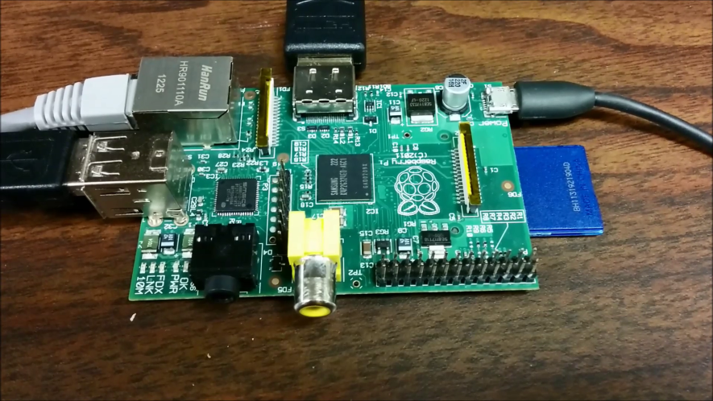

# First Boot

The first boot of Raspberry Pi takes some time since it initializes and configures some things. If it is Raspbian, it also displays you the raspi-config software configuration menu, something like this–

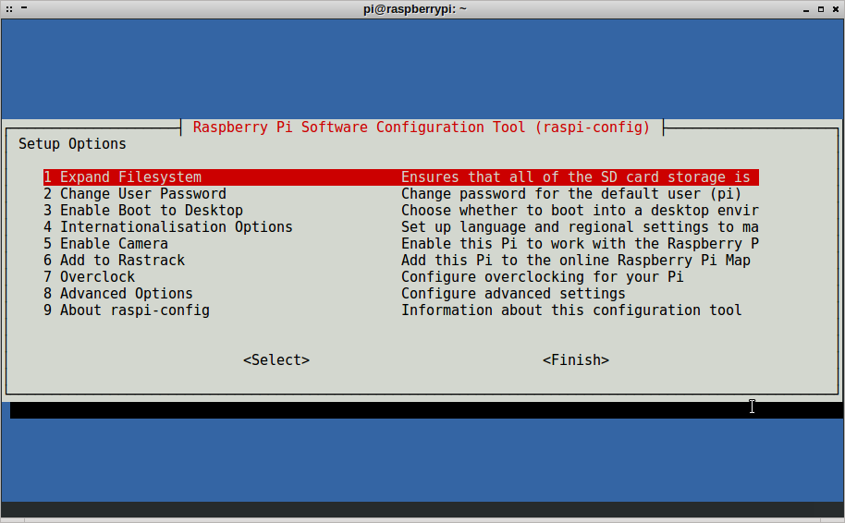

We can set some parameters if you want.

To expand the file system to fill up the entire space in your SD card and enable SSH. The SD image written by the Win32 Disk Imager is only for 3 GB.

If an SD card of capacity 8 GB, then we would like to expand the file system to utilize the entire space.

It would be asked to reboot your Raspberry Pi after this. The reboot would take some time as well since it needs to resize the root file system.

Once the reboot is successful, the Raspberry Pi asking for you to login

If you don’t already know, your login id is pi and password is raspberry.

In Linux terminal, when you type in the password, it usually doesn’t show up on screen.

This could be baffling if you aren’t familiar with Linux. Don’t worry, just go ahead and type in the password. It will accept it!

when you can see the following, it means that you have successfully logged into your Raspberry Pi! Woohoo! Congrats!

|  |
| --- |
| Raspbian GNU/Linux 7 raspberrypi tty1    raspberrypi login: pi  Password:    ... some messages ...    pi@raspberrypi ~ $ |

### Starting your Desktop Environment

The Raspbian comes in with LXDE (Lightweight X Desktop Environment) as its default desktop environment.

To start that, simply type in startx in the console in front of you.

|  |
| --- |
| startx |

This should start the visual GUI desktop for you, and you should see something like this–

[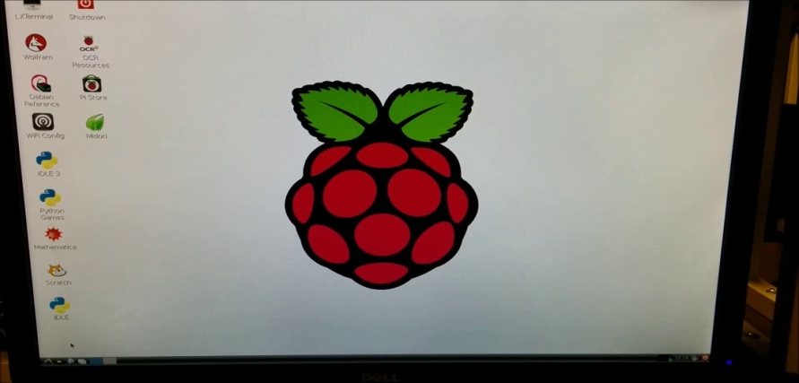](http://maxembedded.com/wp-content/uploads/2014/07/LXDE-Desktop-Raspberry-Pi.png)

LXDE Desktop Raspberry Pi

Beautiful! Isn’t it! And cute too! Go ahead, play around with it!

If you have your Ethernet cable connected, then you can browse internet using the Midori browser.

### Opening Raspberry Pi Software Configuration Tool (raspi-config)

You can open the RPi Software Configuration Tool from the terminal as well. Go to LXTerminal and type in the following–

|  |
| --- |
| sudo raspi-config |

This will reopen the same configuration tool that you encountered during your first boot.

### Shutting Down your Raspberry Pi

One last thing that you should know is how to turn off your RPi. Definitely disconnecting the power supply directly is not the way to go. If you haven’t noticed already, there’s a Shutdown icon on the desktop. Double click it and it asks for your confirmation.

You can Log Out from the desktop environment by clicking on the little red power button on the bottom left of the LXDE’s screen. But this DOES NOT shut down your RPi. It merely closes the desktop environment, that’s it.

Alternatively, you can also shut down using the terminal. Go to LXTerminal (or the console if you don’t have LXDE running), and just type–

|  |
| --- |
| sudo halt |

And if you wish to restart your RPi, type–

|  |
| --- |
| sudo reboot |

**3.3HARDWARE REQUIREMENTS**

* Camera (QR code reader)
* Raspberry pi
* WIFI module
* LED (green & red)
* Buzzer
* IC L293d
* DC motor

**3.4 SOFTWARE REQUIREMENTS**

* Linux OS
* Platform :Java
* Eclipse

**3.5 ADVANTAGES**

* Reduces human affords for checking every person
* Fast process
* Provide Security from any danger

**3.6 APPLICATION**

* In hotels, Restaurants
* At Airport Security Gate

**3.7 CONCLUSION**

The proposed method will be used to demonstrate on a sample passport to verify the passport text details. Therefore we choose a QR code based password identification which reduces the human work and efforts. Only admin is able to use the database related problems and changes. Only valid person can enter after verification, and it needs very less time and efforts. Security level is increased in this system as QR code having with each person as a valid ID.

**REFERENCES:**

* <https://www.raspberrypi.org/>
* “Data Encryption Using Hybrid Authentication System: A Review” INTERNATIONAL JOURNAL OF ADVANCED ELECTRONICS & COMMUNICATION SYSTEMS, Approved by CSIR-NISCAIR ISSN NO: 2277-7318
* “[2] Integration of 2 D Secure Barcode in Identity Cards :A New Approach” International Journal Of Engineering And Computer Science ISSN:2319-7242 Volume 2 Issue 4 April, 2013 Page No. 1225-1233.
* International journal of advanced electronics & communication systems approved by csir-niscairissn no: 2277-7318 proceedings of international conference on modeling and simulation in engineering & technology (icmset-2014) 15th - 16th february, 2014
* Wikipedia", <http://en.wikipedia.org/wiki/QR_code>
* “Data Encryption using hybrid authenticationsystem: a review”Iinternational journal of advanced electronics & communication systems, approved by csir-niscairissn no: 2277-7318.