

MINI PROJECT REPORT

ON

A scalable database system that integrates telemedicine services with e-commerce operations

Submitted By

UIT No: Nakshatra Satpute(2024951)

UIT No: Mahi Sheth(2024954)

UIT No:Sayali Shirode(2024956)

UIT No: Tanvi Dhudagundi(2024962)

DEPARTMENT OF INFORMATION TECHNOLOGY
MKSSS's CUMMINS COLLEGE OF ENGINEERING FOR WOMEN, PUNE
SAVITRIBAI PHULE PUNE UNIVERSITY
2025 – 2026


DEPARTMENT OF INFORMATION TECHNOLOGY

Certificate

This is to certify that,

UIT No: Nakshatra Satpute(2024951)
UIT No: Mahi Sheth(2024954)
UIT No:Sayali Shirode(2024956)
UIT No: Tanvi Dhudagundi(2024962)

have successfully completed the Mini Project entitled “___________________________________”, under my guidance in partial fulfillment of the requirement for the Database Management Laboratory second year in Department of Information Technology of Savitribai Phule Pune University during the Academic Year 2025 – 2026

Date :
Place : Pune

Dr. Anagha Kulkarni
Name of subject Teacher (Head, Dept. of Information Technology)

Dr. Madhuri Khambete
Principal

ACKNOWLEDGMENT

We have taken efforts in this project. However, it would not have been possible without the kind support and valuable inputs from our teachers and guides. I would like to extend my sincere thanks to all of them.

I am highly indebted to Dr Milind Kolambe for their guidance and constant supervision as well as for providing necessary information regarding the project and also for their support in completing the project.

ABSTRACT

The Telemedicine and Doctor Consultation Platform is a web-based healthcare application developed to provide remote medical consultation services. In today’s fast-paced world, accessing healthcare services quickly and efficiently is a major challenge, especially for people living in rural or remote areas. This system addresses that issue by enabling patients to consult doctors online without visiting hospitals physically.
The platform allows patients to register, log in, search for doctors based on specialisation, and book appointments. Doctors can manage their schedules, view patient details, and provide consultation through the system. The application maintains a secure database for storing patient and doctor information.
This system improves accessibility, reduces waiting time, and enhances healthcare delivery. It also promotes digital transformation in the healthcare sector by making medical consultation more convenient, efficient, and accessible anytime and anywhere.

CONTENTS

Chapter Name Page Number
- Introduction
- Scope
- Functional Requirements of the system
3.1 Possible users of the system with privileges
4. Technologies Used
4.1 Back end
4.2 Database
4.3 Front end
5. E R Diagram
6. Normalization of tables
7. Data Dictionary
8. Business Logic Implemented
9. Testing Documents
10. Screenshots
Conclusion
References

LIST OF FIGURES

Sr. No. Fig.No. Fig.Title Page No.
- 10.1 Homepage
- 10.2 Login
- 10.3 Welcome page of doctor
- 10.4 Doctor page
- 10.5 Assigning of doctor to recipient
- 10.6 Assign view page

LIST OF TABLES

Sr. No. Fig. No. Fig. Title Page No.
- 6.1 Normalization of tables 12
- 7.1 Doctor 13
7.2 Doctor Avaliability 13
7.3 Patient 13
7.4 Consultation 13
7.5 Prescription 13
7.6 Prescription Item 14
7.7 Subscription 14
7.8 Product 15
7.9 Cart 15
7.10 Cart Item 15
7.11 Order 16
7.12 Order Item 16
7.13 Shipment 16
7.14 Shipment Item 16
3. 9.1 Testing documents 16

1.Introduction
Telemedicine is the use of information and communication technologies to provide healthcare services remotely. With the increasing demand for digital solutions, telemedicine has become an essential part of modern healthcare systems.
The Telemedicine and Doctor Consultation Platform is designed to connect patients and doctors through an online interface. It eliminates geographical barriers and provides instant access to medical services. Patients no longer need to travel long distances or wait in queues, as consultations can be done from the comfort of their homes.
The system includes features such as patient registration, doctor listing, appointment booking, and consultation management. Doctors can efficiently manage appointments and provide timely medical advice.
Users of the system include:
- Patients seeking medical consultation
- Doctors providing healthcare services
- Admin for system management

2. SCOPE

The scope of the Telemedicine and Doctor Consultation Platform involves developing a web-based system that enables seamless communication between patients and doctors through an online interface. The system is designed to provide essential healthcare services such as patient registration, doctor profile management, appointment booking, and digital consultation. It allows patients to access medical advice without the need for physical hospital visits, thereby reducing travel time and costs. The platform also enables doctors to efficiently manage their schedules and patient interactions.
This system is particularly beneficial for individuals residing in remote or rural areas where access to healthcare facilities is limited. It helps in reducing overcrowding in hospitals and provides timely medical assistance. Additionally, the system ensures secure storage and easy retrieval of patient and doctor data, making the overall process more efficient and organized.
However, the system has certain limitations. It cannot fully replace physical examinations required for accurate diagnosis in some cases, and it depends heavily on internet connectivity for proper functioning. Despite these limitations, the platform serves as a valuable solution for basic consultations and significantly contributes to improving accessibility and convenience in healthcare services.

3.FUNCTIONAL REQUIREMENTS OF THE SYSTEM

The Telemedicine and Doctor Consultation Platform is designed to perform various essential functions to ensure smooth operation. The system provides secure login and registration features for both patients and doctors, ensuring proper authentication. It allows doctors to manage their profiles, including specialization and availability, while patients can search for doctors and book appointments according to their needs. The system also enables users to update their personal information and view appointment history. Doctors can access patient details, manage appointment requests, and provide consultation through the platform. The appointment system supports booking, cancellation, and rescheduling, ensuring flexibility for users. All data is stored securely in the database, allowing efficient retrieval and management of information.

3.1 POSSIBLE USERS OF THE SYSTEM WITH PREVILEGES:

The three main groups of the Telemedicine and doctor consultation system users are the admin,patient and the doctors.

3.1.1 ADMINISTRATOR:
The administrator manages the overall system. The admin is responsible for maintaining records of users, monitoring system activities, and ensuring smooth functioning of the platform. The administrator ensures that the system runs efficiently without errors.

3.1.2 PATIENT:
A patient is a user who seeks medical consultation through the system. Patients can register themselves, log in, and search for doctors based on specialization. They can book appointments and view their consultation details. The system is designed in such a way that it is easy to use, requiring minimal technical knowledge from the patient.

3.1.3 DOCTOR:
A doctor is responsible for providing medical consultation to patients. Doctors can log into the system, view appointment requests, access patient details, and provide consultation. They can also manage their schedules and respond to appointment requests accordingly.

4. TECHNOLOGIES USED

4.1. Back-End Technology:

The backend of the system is responsible for handling server-side operations, data processing, and communication with the database. Technologies such as Node.js or PHP are used to develop the backend, ensuring efficient handling of user requests and system operations.

4.2. Database:

MySQL: MySQL is a freely available open source Relational Database Management System (RDBMS) that uses Structured Query Language (SQL). SQL is the most popular language for adding, accessing and managing content in a database. It is most noted for its quick processing, proven reliability, ease and flexibility of use. MySQL is the most popular database system used with PHP.

4.3 Front-End

i. HTML: Hypertext Markup Language (HTML) is the standard markup language for creating web pages and web applications .In the project, a responsive web design has been developed using HTML .HTML is used to structure the look and layout of a webpage.

ii. CSS: CSS stands for Cascading Style Sheets. It is a style sheet language used to describe the design elements of the websites such as the layout, color, font size, etc. It can allow multiple pages to share the same formatting. CSS has been used for describing the presentation of a document written in a markup language.CSS is used to define styles for web pages, including the design, layout and variations in display for different devices and screen sizes.

iii. JavaScript: JavaScript is a full-fledged dynamic programming language that, when applied to an HTML document, can provide dynamic interactivity on websites. JavaScript is the programming language of HTML and the Web .In the project, HTML form validations have been done using JavaScript. JavaScript provides the facility to validate the form on the client side so that processing will be faster as compared to server side validations. Through JavaScript, we can validate name, password, email, mobile number etc.The project is hosted on GitHub, which helps in version control and project management.

5. ER DIAGRAM

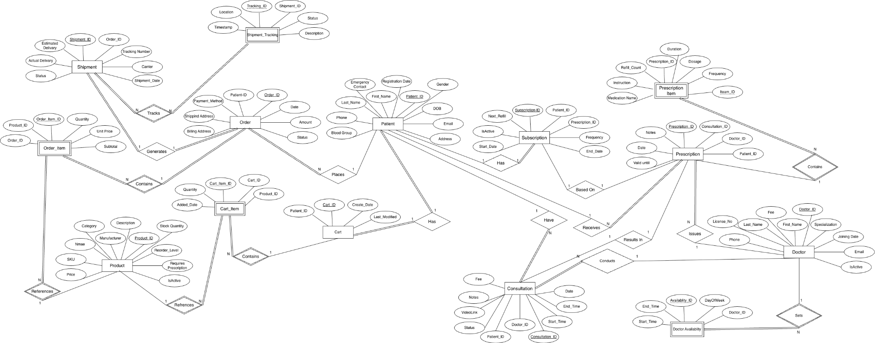

6. NORMALIZATION OF TABLES

Table 6.1: Normalization Table

TABLE NAME | NORMAL FORM
Patient | 2 NF
Doctor | 2 NF
Consultation | 3 NF
Prescription | 3 NF
Prescription_Item | 3 NF
Subscription | 2 NF
Cart | 2 NF
Cart_Item | 3 NF
Product | 2 NF
Order | 2 NF
Order_Item | 3 NF
Shipment | 2 NF
Shipment_Tracking | 3 NF
Doctor_Availability | 3 NF

7.DATA DICTIONARY

Table 7.1: Patient

Column Name | Optional | Format | Length | Description
Patient_ID | No | INT | 11 | Primary Key
First_Name | No | VARCHAR | 50 | Patient first name
Last_Name | No | VARCHAR | 50 | Patient last name
DOB | No | DATE | - | Date of birth
Gender | No | VARCHAR | 10 | Gender
Email | No | VARCHAR | 100 | Email address
Phone | No | BIGINT | 10 | Contact number
Address | No | VARCHAR | 255 | Address
Blood_Group | Yes | VARCHAR | 10 | Blood group

Table 7.2:Doctor

Column Name | Optional | Format | Length | Description
Doctor_ID | No | INT | 11 | Primary Key
First_Name | No | VARCHAR | 50 | First name
Last_Name | No | VARCHAR | 50 | Last name
Specialization | No | VARCHAR | 100 | Doctor field
Email | No | VARCHAR | 100 | Email
Phone | No | BIGINT | 10 | Contact
License_No | No | VARCHAR | 50 | License number
Joining_Date | No | DATE | - | Joining date
IsActive | No | BOOLEAN | - | Status

₹

Table 7.3:Consultation

Column Name | Optional | Format | Length | Description
Consultation_ID | No | INT | 11 | Primary Key
Patient_ID | No | INT | 11 | Foreign Key
Doctor_ID | No | INT | 11 | Foreign Key
Date | No | DATE | - | Consultation date
Start_Time | No | TIME | - | Start time
End_Time | No | TIME | - | End time
Notes | Yes | TEXT | - | Remarks
Fee | Yes | FLOAT | - | Consultation fee
Status | No | VARCHAR | 20 | Status

Table 7.4:Prescription

Column Name | Optional | Format | Length | Description
Prescription_ID | No | INT | 11 | Primary Key
Consultation_ID | No | INT | 11 | Foreign Key
Patient_ID | No | INT | 11 | Foreign Key
Doctor_ID | No | INT | 11 | Foreign Key
Date | No | DATE | - | Prescription date
Notes | Yes | TEXT | - | Notes
Valid_Until | Yes | DATE | - | Expiry

Table 7.5 :Prescription item

Column Name | Optional | Format | Length | Description
Item_ID | No | INT | 11 | Primary Key
Prescription_ID | No | INT | 11 | Foreign Key
Medication_Name | No | VARCHAR | 100 | Medicine name
Dosage | No | VARCHAR | 50 | Dosage
Frequency | No | VARCHAR | 50 | Frequency
Duration | No | VARCHAR | 50 | Duration
Instruction | Yes | TEXT | - | Instructions

Table 7.6: Subscription

Column Name | Optional | Format | Length | Description
Subscription_ID | No | INT | 11 | Primary Key
Patient_ID | No | INT | 11 | Foreign Key
Start_Date | No | DATE | - | Start date
End_Date | Yes | DATE | - | End date
IsActive | No | BOOLEAN | - | Status
Next_Refill | Yes | DATE | - | Next refill

Table 7.7:Product

Column Name | Optional | Format | Length | Description
Product_ID | No | INT | 11 | Primary Key
Name | No | VARCHAR | 100 | Product name
Category | No | VARCHAR | 50 | Category
Price | No | FLOAT | - | Price
Stock_Quantity | No | INT | 11 | Stock
Manufacturer | Yes | VARCHAR | 100 | Manufacturer
IsActive | No | BOOLEAN | - | Status

Table 7.8:Order

Column Name | Optional | Format | Length | Description
Order_ID | No | INT | 11 | Primary Key
Patient_ID | No | INT | 11 | Foreign Key
Date | No | DATE | - | Order date
Amount | No | FLOAT | - | Total amount
Status | No | VARCHAR | 20 | Order status
Payment_Method | No | VARCHAR | 50 | Payment

Table 7.9:Order

Column Name | Optional | Format | Length | Description
Order_Item_ID | No | INT | 11 | Primary Key
Order_ID | No | INT | 11 | Foreign Key
Product_ID | No | INT | 11 | Foreign Key
Quantity | No | INT | 11 | Quantity
Unit_Price | No | FLOAT | - | Price
Subtotal | No | FLOAT | - | Subtotal

Table 7.10:Shipment

Column Name | Optional | Format | Length | Description
Shipment_ID | No | INT | 11 | Primary Key
Order_ID | No | INT | 11 | Foreign Key
Tracking_Number | Yes | VARCHAR | 100 | Tracking
Carrier | Yes | VARCHAR | 50 | Carrier
Status | No | VARCHAR | 20 | Status

Table 7.11:Shipment Tracking

Column Name | Optional | Format | Length | Description
Tracking_ID | No | INT | 11 | Primary Key
Shipment_ID | No | INT | 11 | Foreign Key
Location | No | VARCHAR | 100 | Location
Timestamp | No | DATETIME | - | Time
Status | No | VARCHAR | 50 | Status

Table 7.12:Doctor Availability

Column Name | Optional | Format | Length | Description
Availability_ID | No | INT | 11 | Primary Key
Doctor_ID | No | INT | 11 | Foreign Key
DayOfWeek | No | VARCHAR | 20 | Day
Start_Time | No | TIME | - | Start
End_Time | No | TIME | - | End

8. BUSINESS LOGIC IMPLEMENTED

The system follows a well-defined and structured workflow to perform all its operations efficiently. Initially, users such as patients and doctors are required to register themselves into the system by providing necessary details, after which they can log in securely using their credentials. Once logged in, patients can search for doctors based on various criteria such as specialization, availability, and experience. After selecting a suitable doctor, patients can book an appointment by choosing a preferred date and time slot.
The appointment request is then sent to the respective doctor, who has the authority to either accept or reject the request based on their availability and schedule. If the doctor accepts the request, the appointment is confirmed and both the patient and doctor can proceed with the consultation process. During the consultation, the doctor can review patient details, understand symptoms, and provide appropriate medical advice, diagnosis, or prescription through the platform.
All the information related to users, appointments, and consultations is stored securely in the database for future reference and record management. The system incorporates proper validation mechanisms to ensure that all input data is accurate and complete, along with authentication processes to maintain data security and user privacy. The smooth coordination between different modules of the system ensures efficient handling of operations, reduces errors, and enhances overall reliability and performance of the platform.

9.DATA TESTING DOCUMENTS

Following are some of the validations done at the front end:

Sr. No. | Field Name | Validation
1 | Username (Patient/Doctor) | Accepts valid email format and must be unique
2 | Password | Minimum 6–8 characters, stored in encrypted format
3 | Confirm Password | Must match with password
4 | Email ID | Must follow valid email format
5 | Mobile Number | Must be exactly 10 digits
6 | Patient Registration Form | All required fields must be filled
7 | Doctor Registration Form | Requires valid specialization and details
8 | Login Authentication | Only valid credentials allowed
9 | Appointment Booking | Doctor, date, and time must be selected
10 | Appointment Date | Should not allow past dates
11 | Duplicate Appointment | Prevent same slot booking
12 | Consultation Form | Diagnosis/prescription required
13 | Search Doctor | Should return valid results
14 | Database Connectivity | Must connect successfully
15 | Session Management | Proper login/logout handling
16 | Form Submission | All validations must pass
17 | Data Storage | Data stored and retrieved correctly
18 | UI Responsiveness | Works on all screen sizes
19 | Error Handling | Displays proper error messages

10.SCREENSHOTS

Figure 10.1: Welcome page

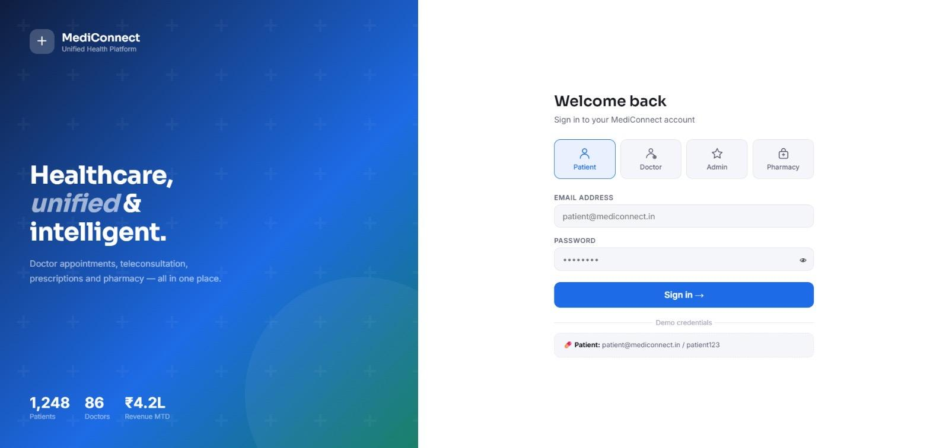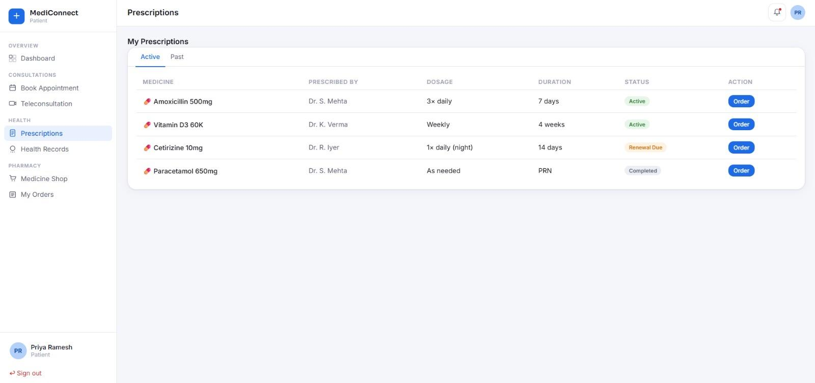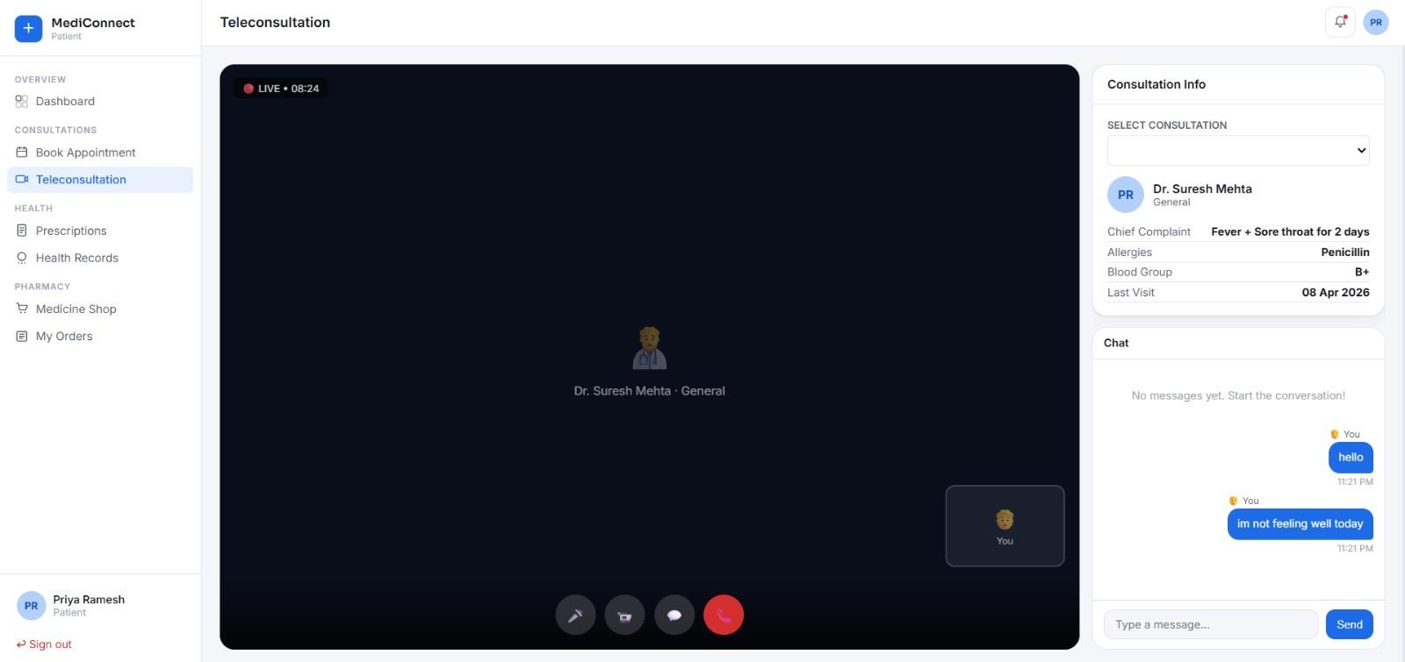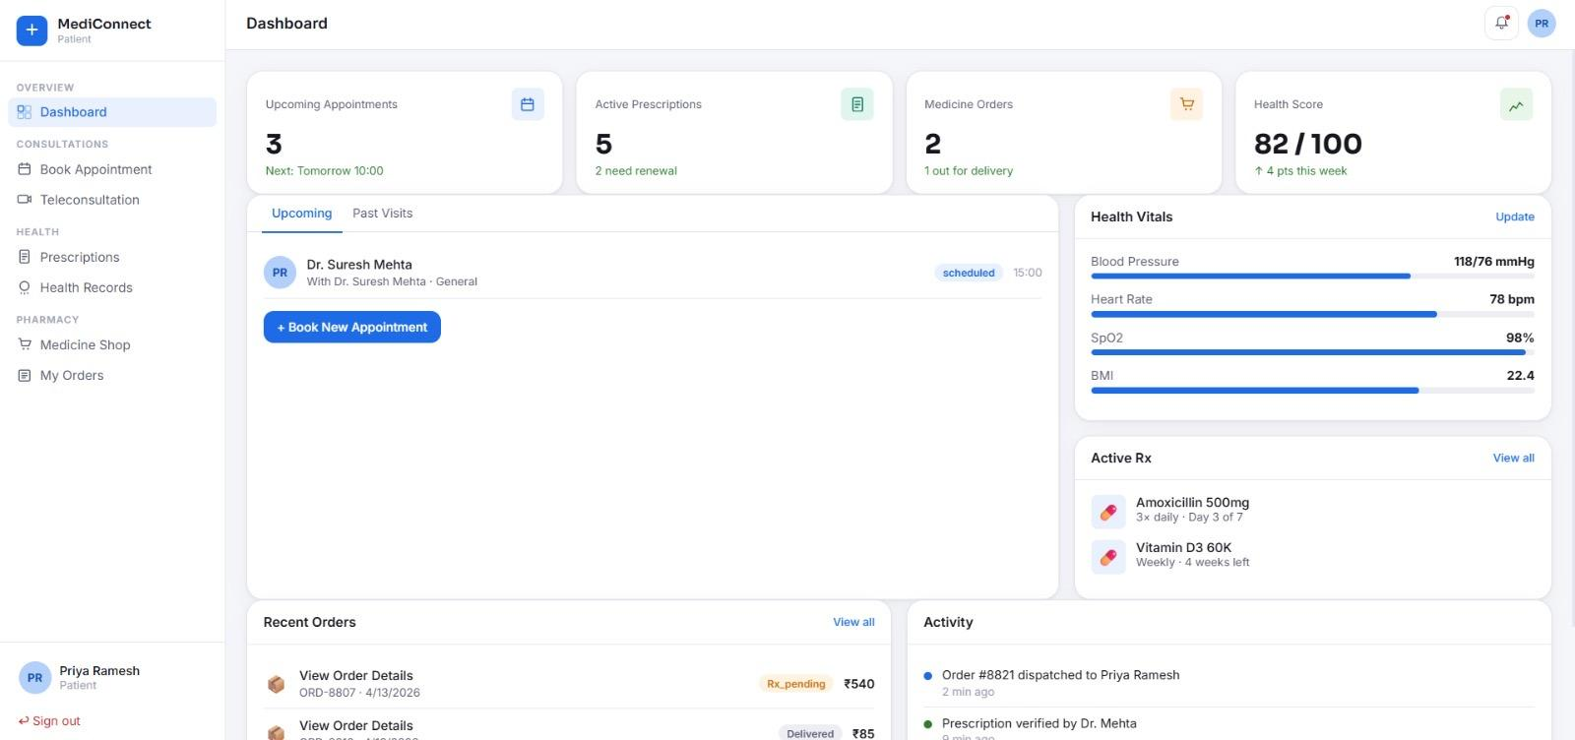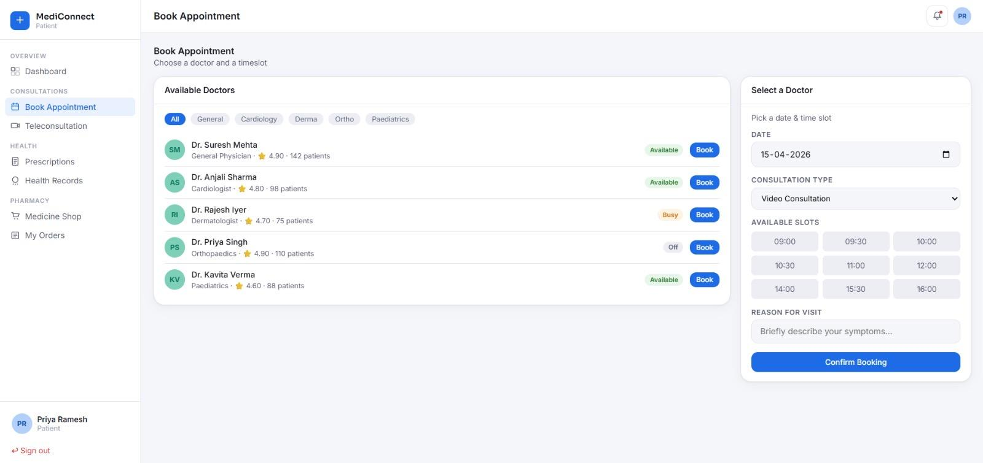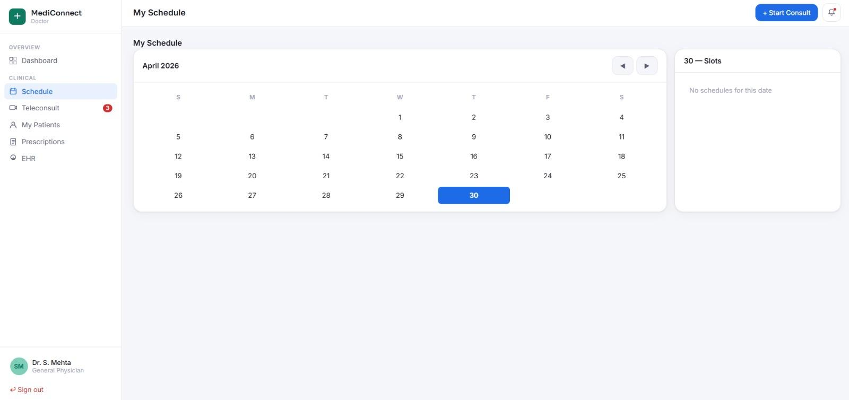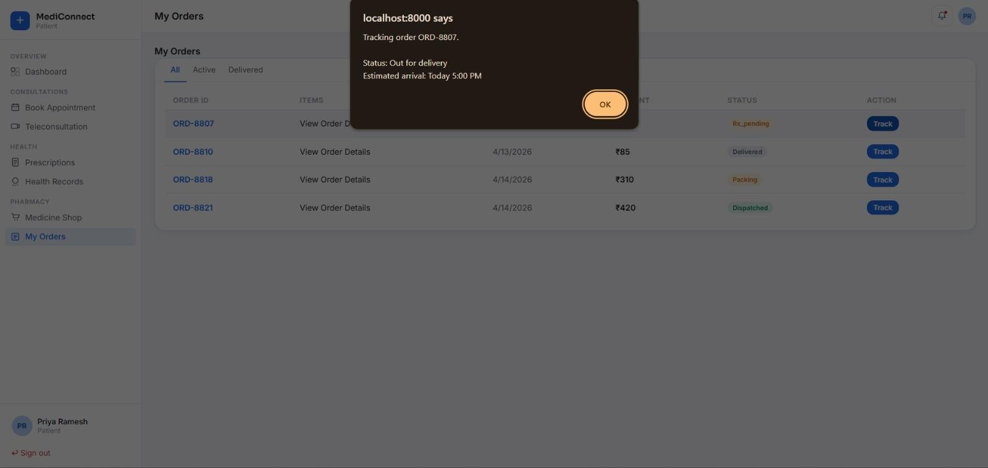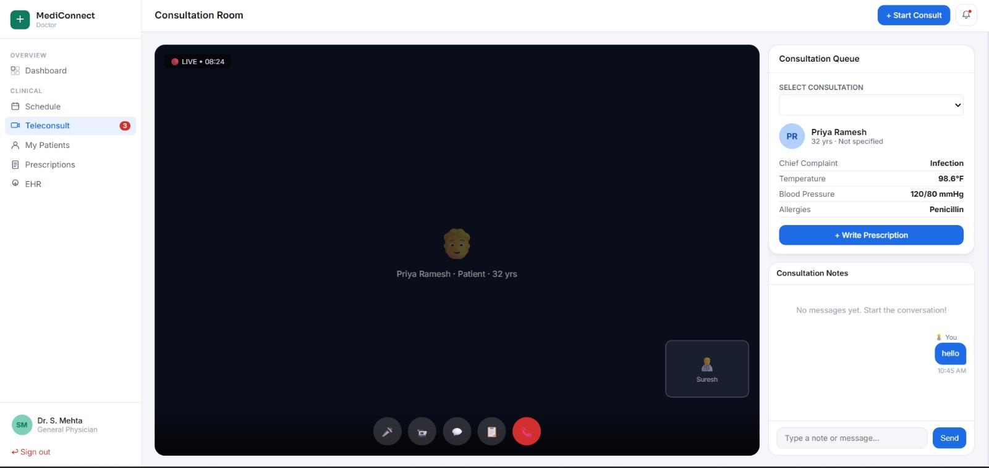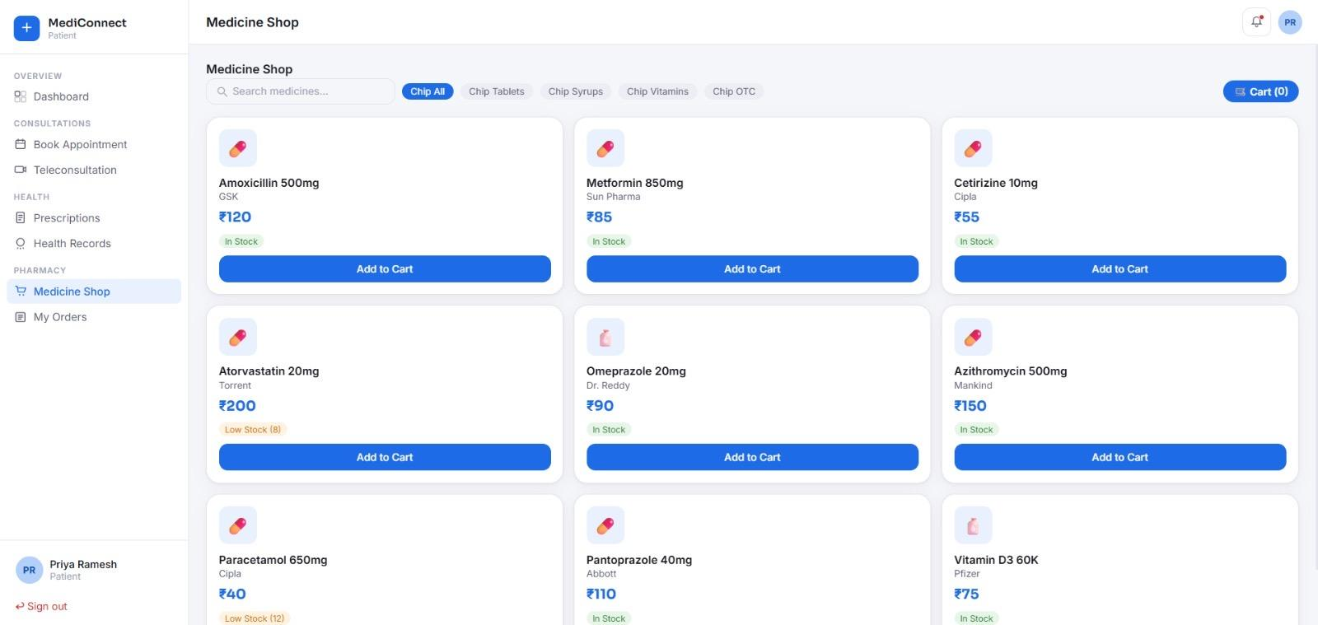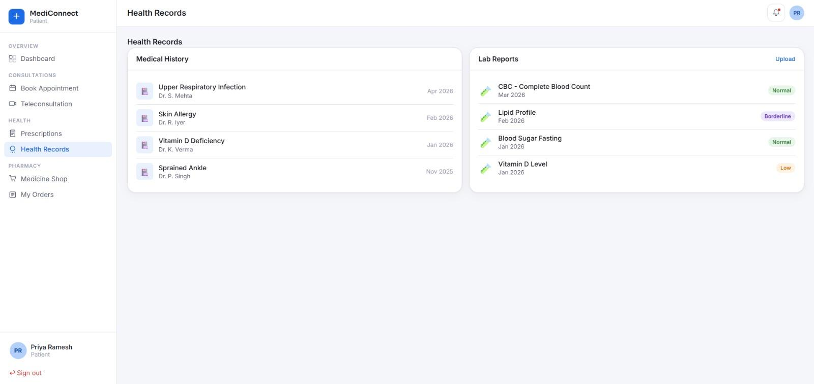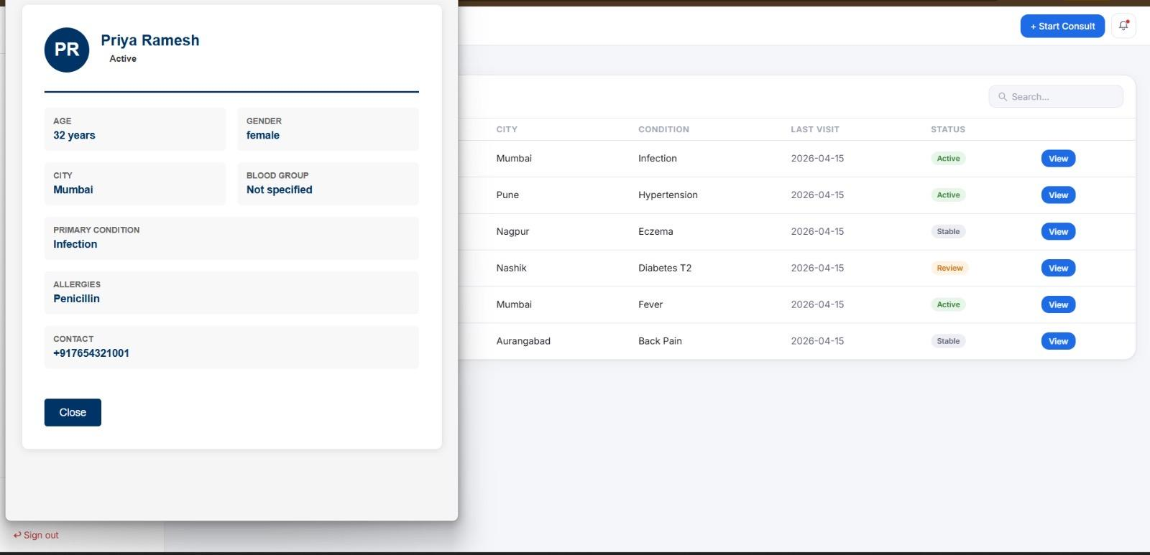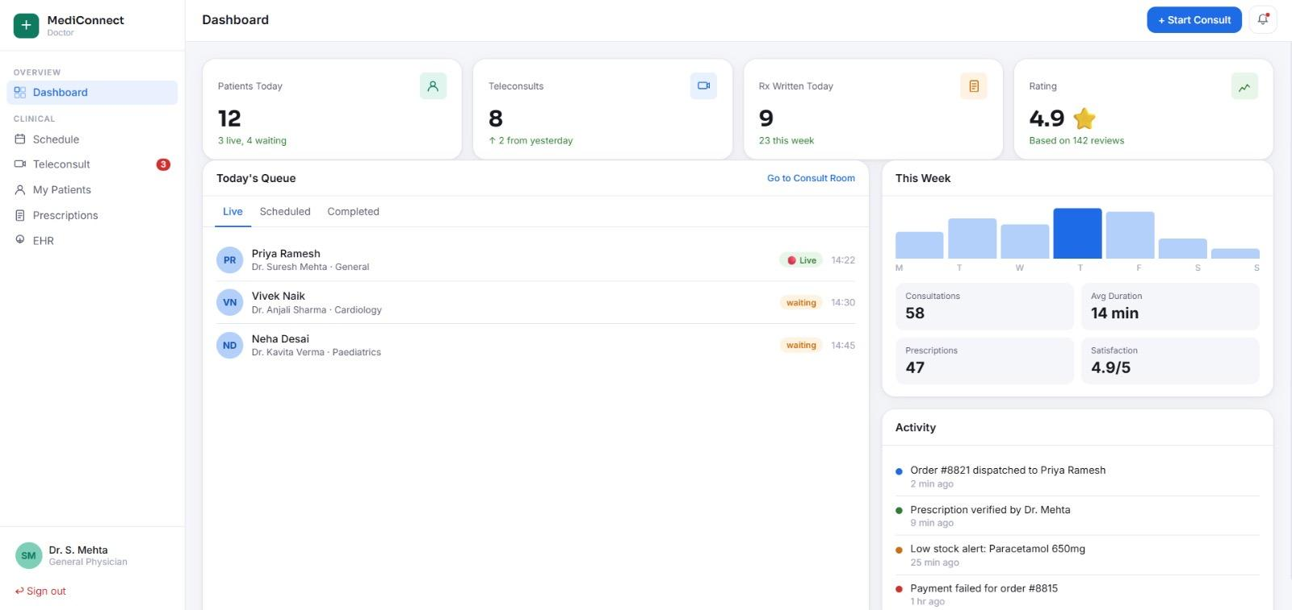

11.CONCLUSION

The Telemedicine and Doctor Consultation Platform provides an efficient solution for delivering healthcare services remotely. It improves accessibility, reduces time and cost, and simplifies the process of medical consultation. The system demonstrates the effective use of technology in healthcare and helps bridge the gap between patients and doctors. Although it has certain limitations, it remains a valuable tool for basic medical consultation and can be further enhanced with advanced features in the future.

REFERENCES

1..MySQL Documentation
2.Web Development Tutorials

