**Q. A_1**

;; Function main (main, funcdef_no=0, decl_uid=1908, cgraph_uid=1, symbol_order=1)

;; 1 loops found

;;

;; Loop 0

;; header 0, latch 1

;; depth 0, outer -1

;; nodes: 0 1 2

;; 2 succs { 1 }

main ()

{

int q;

int p;

int c;

int b;

int a;

<bb 2> :

p = 6;

a = 10;

b = 20;

_1 = a * b;

c = _1 + 25;

p = 6;

q = Z;

return;

}

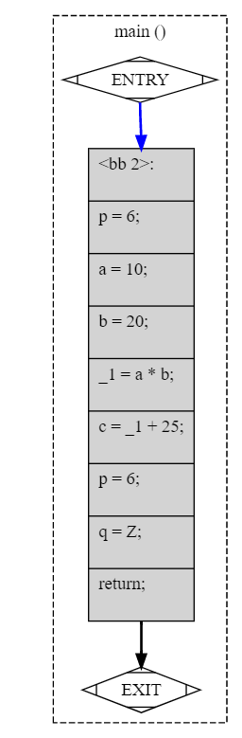

**Q. A-2**

;; Function f (f, funcdef_no=0, decl_uid=1908, cgraph_uid=1, symbol_order=1)

;; 1 loops found

;;

;; Loop 0

;; header 0, latch 1

;; depth 0, outer -1

;; nodes: 0 1 2 3 4 5 6

;; 2 succs { 3 4 }

;; 3 succs { 6 }

;; 4 succs { 5 6 }

;; 5 succs { 6 }

;; 6 succs { 1 }

f ()

{

int c;

int b;

int a;

<bb 2> :

a = Z;

if (a <= 9)

goto <bb 3>; [INV]

else

goto <bb 4>; [INV]

<bb 3> :

b = 5;

c = 17;

goto <bb 6>; [INV]

<bb 4> :

b = 6;

c = 20;

if (a == 0)

goto <bb 5>; [INV]

else

goto <bb 6>; [INV]

<bb 5> :

c = 0;

<bb 6> :

_1 = b * 10;

_2 = c + _1;

Z = _2;

return;

}

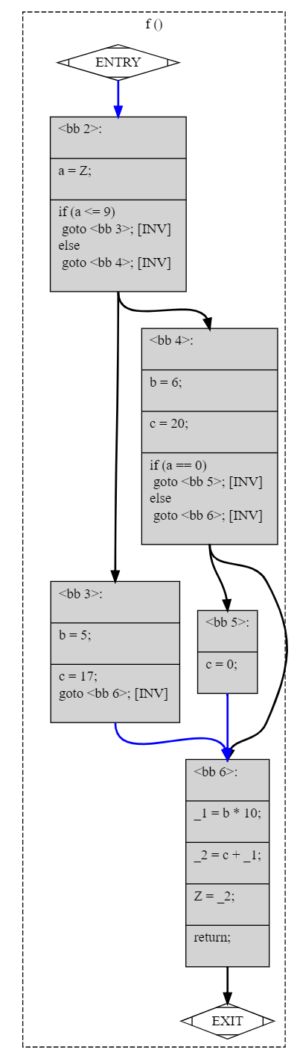

**Q. A-3**

;; Function main (main, funcdef_no=0, decl_uid=1907, cgraph_uid=1, symbol_order=0)

;; 4 loops found

;;

;; Loop 0

;; header 0, latch 1

;; depth 0, outer -1

;; nodes: 0 1 2 3 4 5 6 7 8 9 10 11 12

;;

;; Loop 2

;; header 10, latch 9

;; depth 1, outer 0

;; nodes: 10 9 8 6 7

;;

;; Loop 3

;; header 8, latch 7

;; depth 2, outer 2

;; nodes: 8 7

;;

;; Loop 1

;; header 4, latch 3

;; depth 1, outer 0

;; nodes: 4 3

;; 2 succs { 4 }

;; 3 succs { 4 }

;; 4 succs { 3 5 }

;; 5 succs { 10 }

;; 6 succs { 8 }

;; 7 succs { 8 }

;; 8 succs { 7 9 }

;; 9 succs { 10 }

;; 10 succs { 6 11 }

;; 11 succs { 12 }

;; 12 succs { 1 }

main ()

{

int j;

int i;

int sum;

int D.1922;

<bb 2> :

sum = 0;

goto <bb 4>; [INV]

<bb 3> :

sum = sum * 2;

<bb 4> :

if (sum <= 99)

goto <bb 3>; [INV]

else

goto <bb 5>; [INV]

<bb 5> :

i = 0;

goto <bb 10>; [INV]

<bb 6> :

j = 0;

goto <bb 8>; [INV]

<bb 7> :

_1 = i * j;

sum = sum + _1;

j = j + 1;

<bb 8> :

if (j <= 49)

goto <bb 7>; [INV]

else

goto <bb 9>; [INV]

<bb 9> :

i = i + 1;

<bb 10> :

if (i <= 24)

goto <bb 6>; [INV]

else

goto <bb 11>; [INV]

<bb 11> :

D.1922 = 0;

<bb 12> :

<L9>:

return D.1922;

}

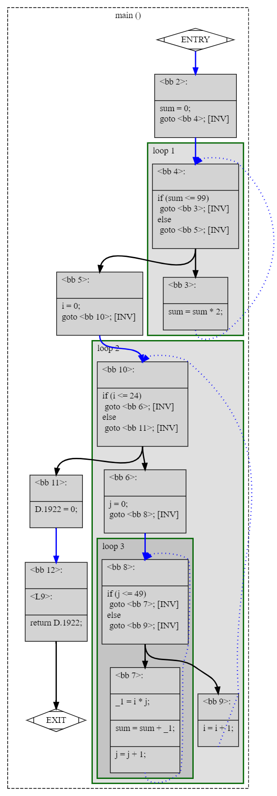

**Q. A-4**

;; Function main (main, funcdef_no=0, decl_uid=1907, cgraph_uid=1, symbol_order=0)

;; 2 loops found

;;

;; Loop 0

;; header 0, latch 1

;; depth 0, outer -1

;; nodes: 0 1 2 3 4 5 6

;;

;; Loop 1

;; header 4, latch 3

;; depth 1, outer 0

;; nodes: 4 3

;; 2 succs { 4 }

;; 3 succs { 4 }

;; 4 succs { 3 5 }

;; 5 succs { 6 }

;; 6 succs { 1 }

main ()

{

int * p;

int i;

int b[3];

int a[3];

int D.1917;

<bb 2> :

b[0] = 1;

b[1] = 2;

b[2] = 3;

i = 0;

goto <bb 4>; [INV]

<bb 3> :

_1 = b[i];

a[i] = _1;

i = i + 1;

<bb 4> :

if (i <= 2)

goto <bb 3>; [INV]

else

goto <bb 5>; [INV]

<bb 5> :

p = &a;

_2 = p + 8;

*_2 = 5;

a = {CLOBBER};

b = {CLOBBER};

D.1917 = 0;

<bb 6> :

<L3>:

return D.1917;

}

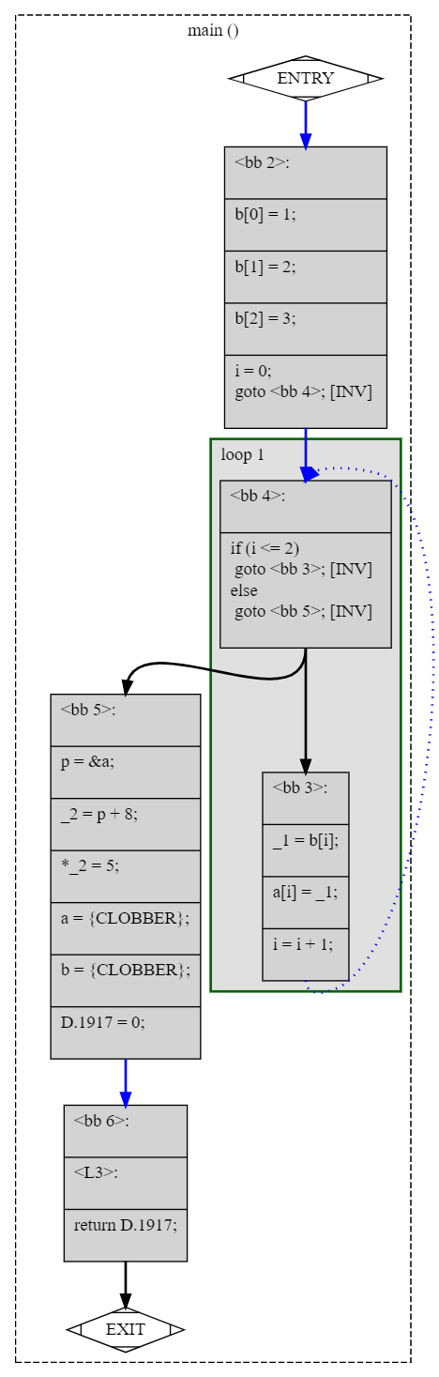

**Q. A-5**

;; Function main (main, funcdef_no=0, decl_uid=1907, cgraph_uid=1, symbol_order=0)

;; 1 loops found

;;

;; Loop 0

;; header 0, latch 1

;; depth 0, outer -1

;; nodes: 0 1 2 3 4 5 6

;; 2 succs { 3 4 }

;; 3 succs { 5 }

;; 4 succs { 5 }

;; 5 succs { 6 }

;; 6 succs { 1 }

main ()

{

int d;

int c;

int b;

int a;

int D.1917;

<bb 2> :

d = 10;

if (c > d)

goto <bb 3>; [INV]

else

goto <bb 4>; [INV]

<bb 3> :

a = 3;

b = 2;

goto <bb 5>; [INV]

<bb 4> :

a = 2;

b = 3;

<bb 5> :

c = a + b;

D.1917 = 0;

<bb 6> :

<L3>:

return D.1917;

}

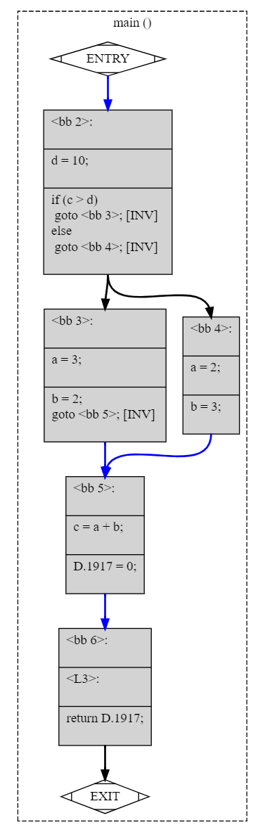

**Q. B-1**

;; Function AddTwo (AddTwo, funcdef_no=0, decl_uid=1908, cgraph_uid=1, symbol_order=0)

;; 1 loops found

;;

;; Loop 0

;; header 0, latch 1

;; depth 0, outer -1

;; nodes: 0 1 2 3

;; 2 succs { 3 }

;; 3 succs { 1 }

AddTwo (int a)

{

int D.1914;

<bb 2> :

a = a + 2;

D.1914 = a;

<bb 3> :

<L0>:

return D.1914;

}

;; Function main (main, funcdef_no=1, decl_uid=1910, cgraph_uid=2, symbol_order=1)

Removing basic block 3

;; 1 loops found

;;

;; Loop 0

;; header 0, latch 1

;; depth 0, outer -1

;; nodes: 0 1 2 3

;; 2 succs { 3 }

;; 3 succs { 1 }

main ()

{

int x;

int D.1916;

<bb 2> :

x = 3;

x = AddTwo (x);

D.1916 = x;

<bb 3> :

<L0>:

return D.1916;

}

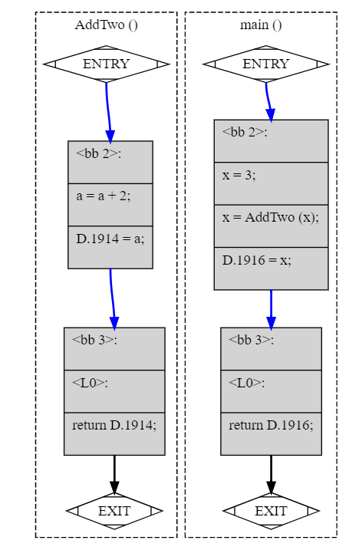

**Q. B-2**

;; Function main (main, funcdef_no=0, decl_uid=1908, cgraph_uid=1, symbol_order=1)

Removing basic block 6

;; 2 loops found

;;

;; Loop 0

;; header 0, latch 1

;; depth 0, outer -1

;; nodes: 0 1 2 3 4 5 6

;;

;; Loop 1

;; header 4, latch 3

;; depth 1, outer 0

;; nodes: 4 3

;; 2 succs { 4 }

;; 3 succs { 4 }

;; 4 succs { 3 5 }

;; 5 succs { 6 }

;; 6 succs { 1 }

main ()

{

int a;

int i;

int D.1916;

<bb 2> :

a = 10;

i = 0;

goto <bb 4>; [INV]

<bb 3> :

N.0_1 = N;

a = a + N.0_1;

i = i + 1;

<bb 4> :

if (i <= 3)

goto <bb 3>; [INV]

else

goto <bb 5>; [INV]

<bb 5> :

D.1916 = a;

<bb 6> :

<L3>:

return D.1916;

}

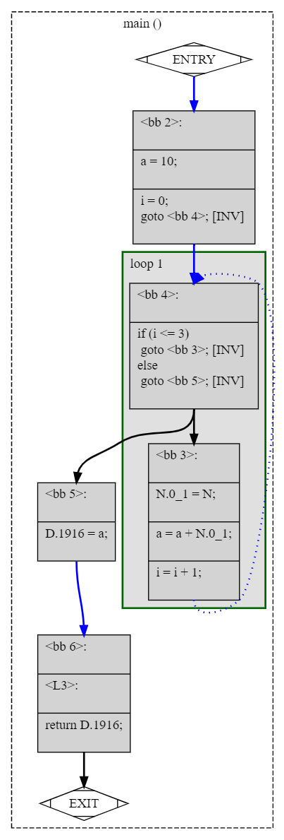

**Q. B-3**

;; Function main (main, funcdef_no=12, decl_uid=3089, cgraph_uid=13, symbol_order=12)

;; 2 loops found

;;

;; Loop 0

;; header 0, latch 1

;; depth 0, outer -1

;; nodes: 0 1 2 3 4 5 6 7 8 9

;;

;; Loop 1

;; header 7, latch 6

;; depth 1, outer 0

;; nodes: 7 6 4 5 3

;; 2 succs { 7 }

;; 3 succs { 4 5 }

;; 4 succs { 6 }

;; 5 succs { 6 }

;; 6 succs { 7 }

;; 7 succs { 3 8 }

;; 8 succs { 9 }

;; 9 succs { 1 }

main ()

{

int b;

int a;

int D.3100;

<bb 2> :

a = 4;

goto <bb 7>; [INV]

<bb 3> :

if (a <= 3)

goto <bb 4>; [INV]

else

goto <bb 5>; [INV]

<bb 4> :

b = b + 2;

goto <bb 6>; [INV]

<bb 5> :

b = b * 2;

<bb 6> :

a = a + 1;

<bb 7> :

if (a <= 99)

goto <bb 3>; [INV]

else

goto <bb 8>; [INV]

<bb 8> :

printf ("%d%d", a, b);

D.3100 = 0;

<bb 9> :

<L6>:

return D.3100;

} 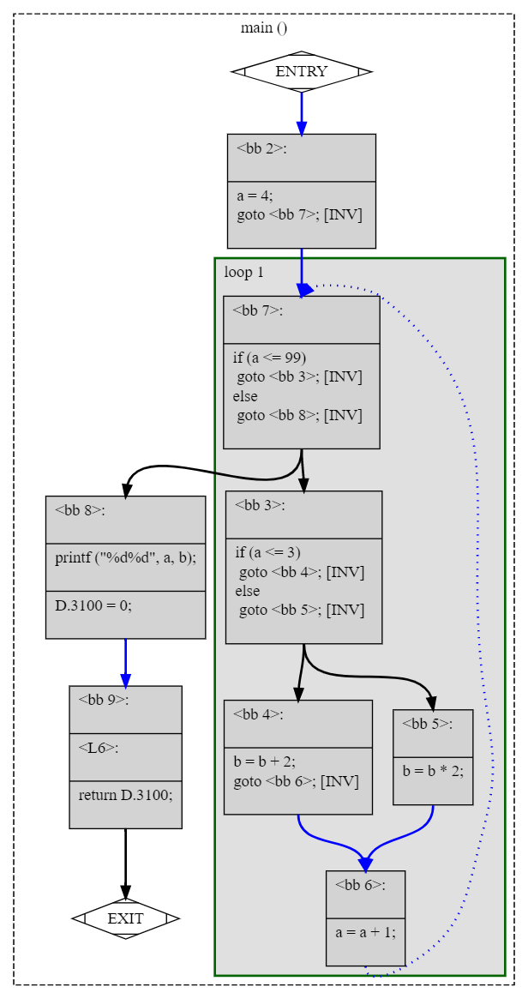

**Q. B-4**

;; Function main (main, funcdef_no=0, decl_uid=1907, cgraph_uid=1, symbol_order=0)

Removing basic block 3

;; 1 loops found

;;

;; Loop 0

;; header 0, latch 1

;; depth 0, outer -1

;; nodes: 0 1 2 3

;; 2 succs { 3 }

;; 3 succs { 1 }

main ()

{

int c;

int b;

int a;

int D.1913;

<bb 2> :

_1 = a + c;

_2 = b + _1;

_3 = c + a;

b = _2 * _3;

D.1913 = b;

<bb 3> :

<L0>:

return D.1913;

}

