**Environment Setup:**

First and foremost, SDN has its wide applications in the data centers. So, I have designed a simple data center like fat-tree topology using the mininet emulator. The designed topology is as shown in the figure below.

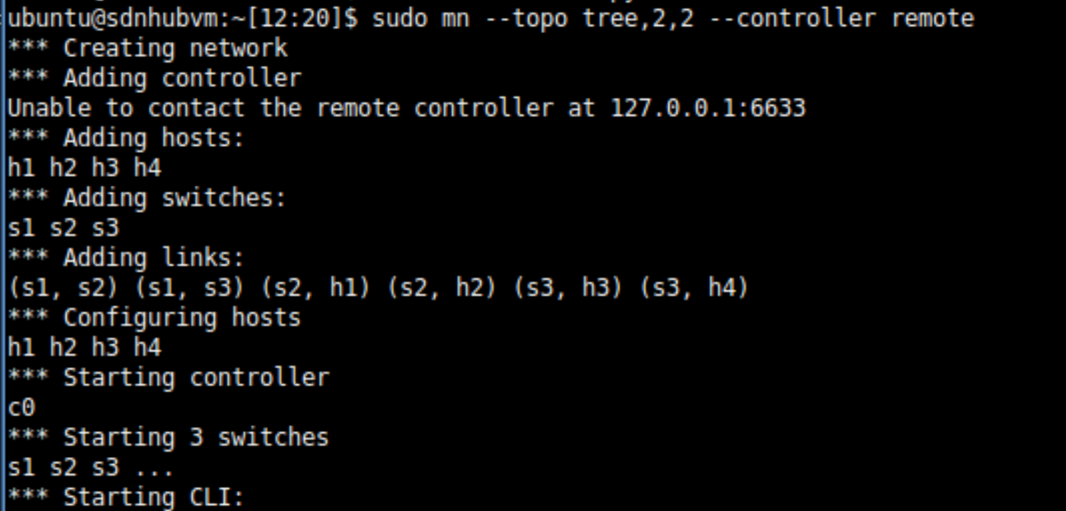

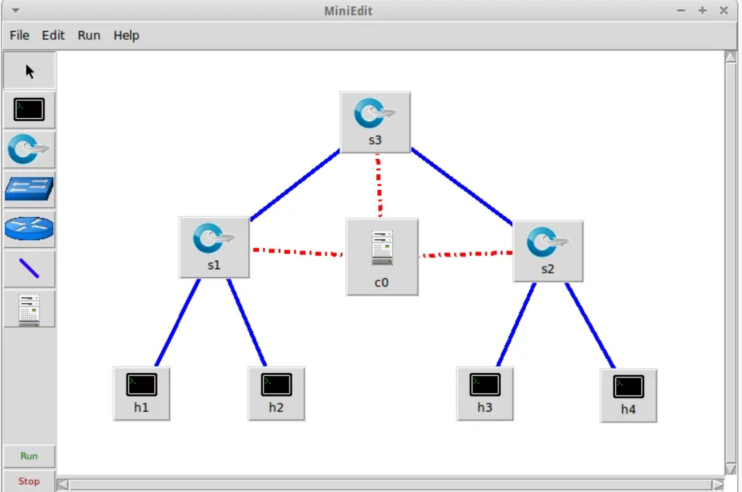

As seen in the figure above, we have a control plane, three switches and four hosts. We will be using this topology to perform several types of DoS attacks. But before that, we need to start the SDN controller. The choice of controller I made is a POX controller as it is light weight, flexible and supports python programming.

After starting the POX controller, we can see the log that shows the controller starts and connects to the switches previously set up by the Mininet network simulator:

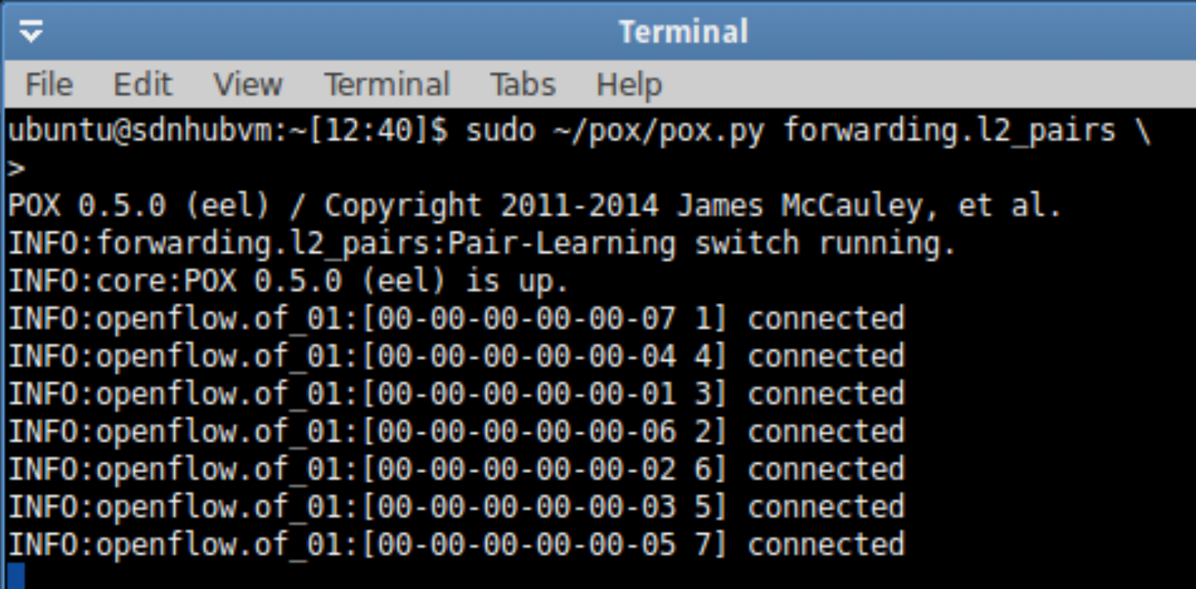

The successful reachability of the network can now be tested inside the mininet:

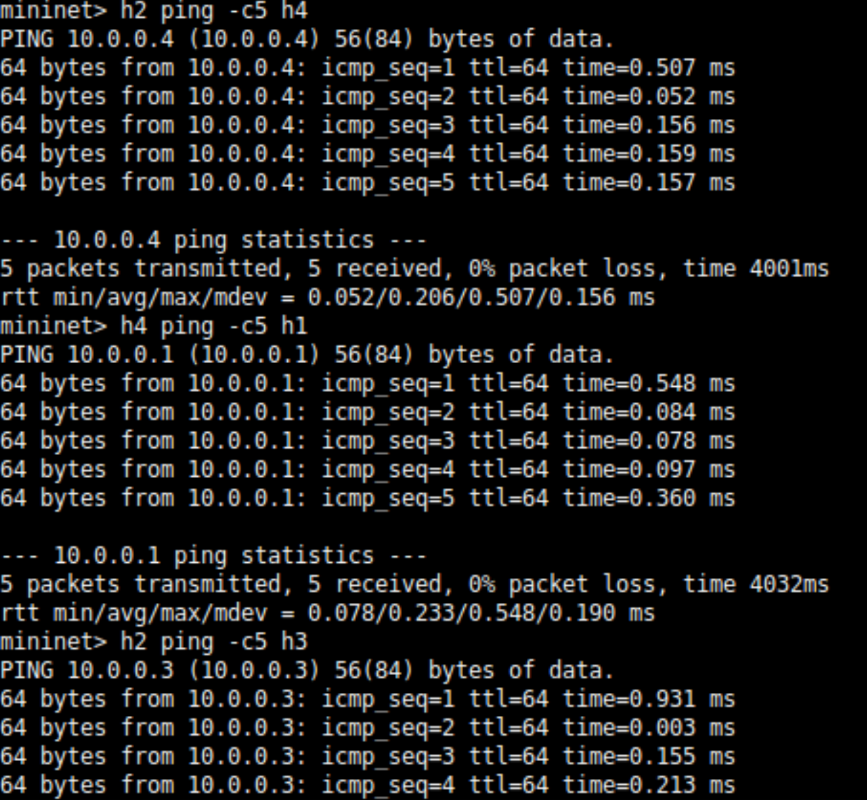

We can also use the ping all command to test the ping reachability inside the network:

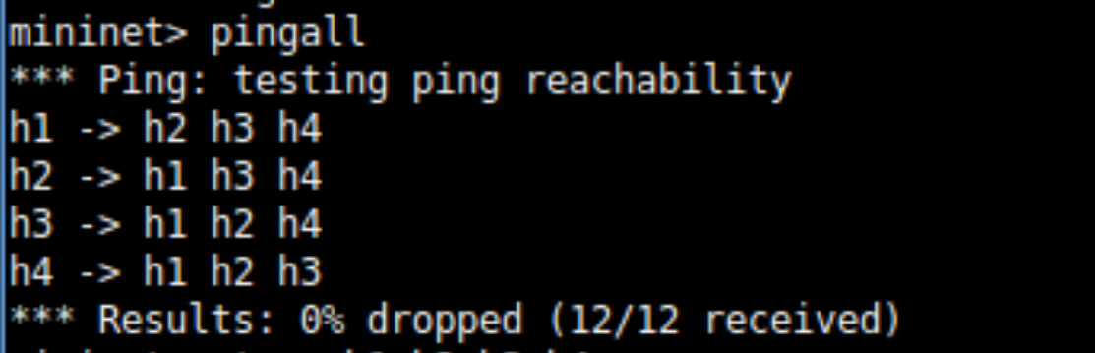

The IP addresses of the host machines are:

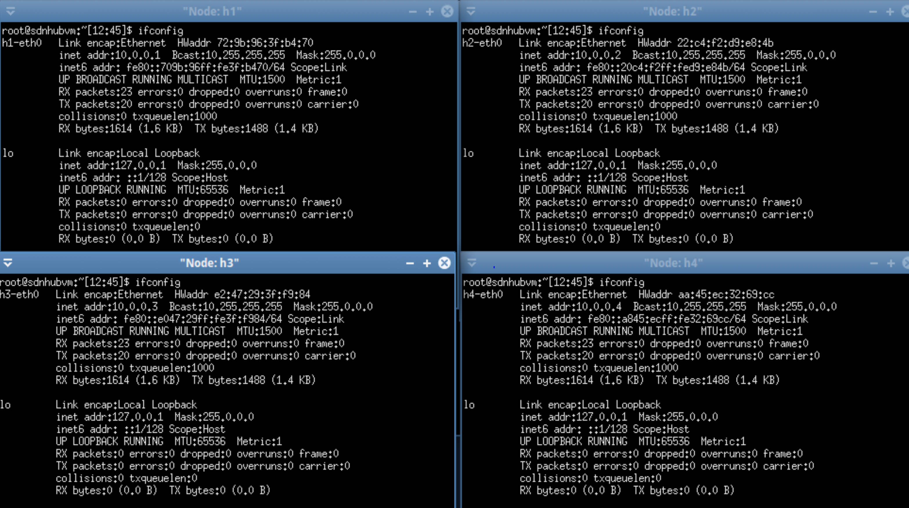

Host 1, 2, 3, 4 have the IP addresses 10.0.0.1, 10.0.0.2, 10.0.0.3, 10.0.0.4 respectively. These end systems can be used as targets for DoS attacks. Hence, I will be focusing on using the tool hping3 to perform ten different types of attacks in DoS category and also provide with the analysis part by using Wireshark.