**Final Year B. Tech., Sem VII 2022-23**

**High Performance Computing Lab**

**PRN: 2020BTECS00206**

**Full Name: SAYALI YOGESH DESAI**

**Batch: B4**

**Assignment No. 11**

**Q1. Execute the all-to-all broadcast operation (Program C) with varying message sizes.**

**Plot the performance of the operation with varying message sizes from 1K to 10K (with constant number of processes, 8). Explain the performance observed.**

**Code:**

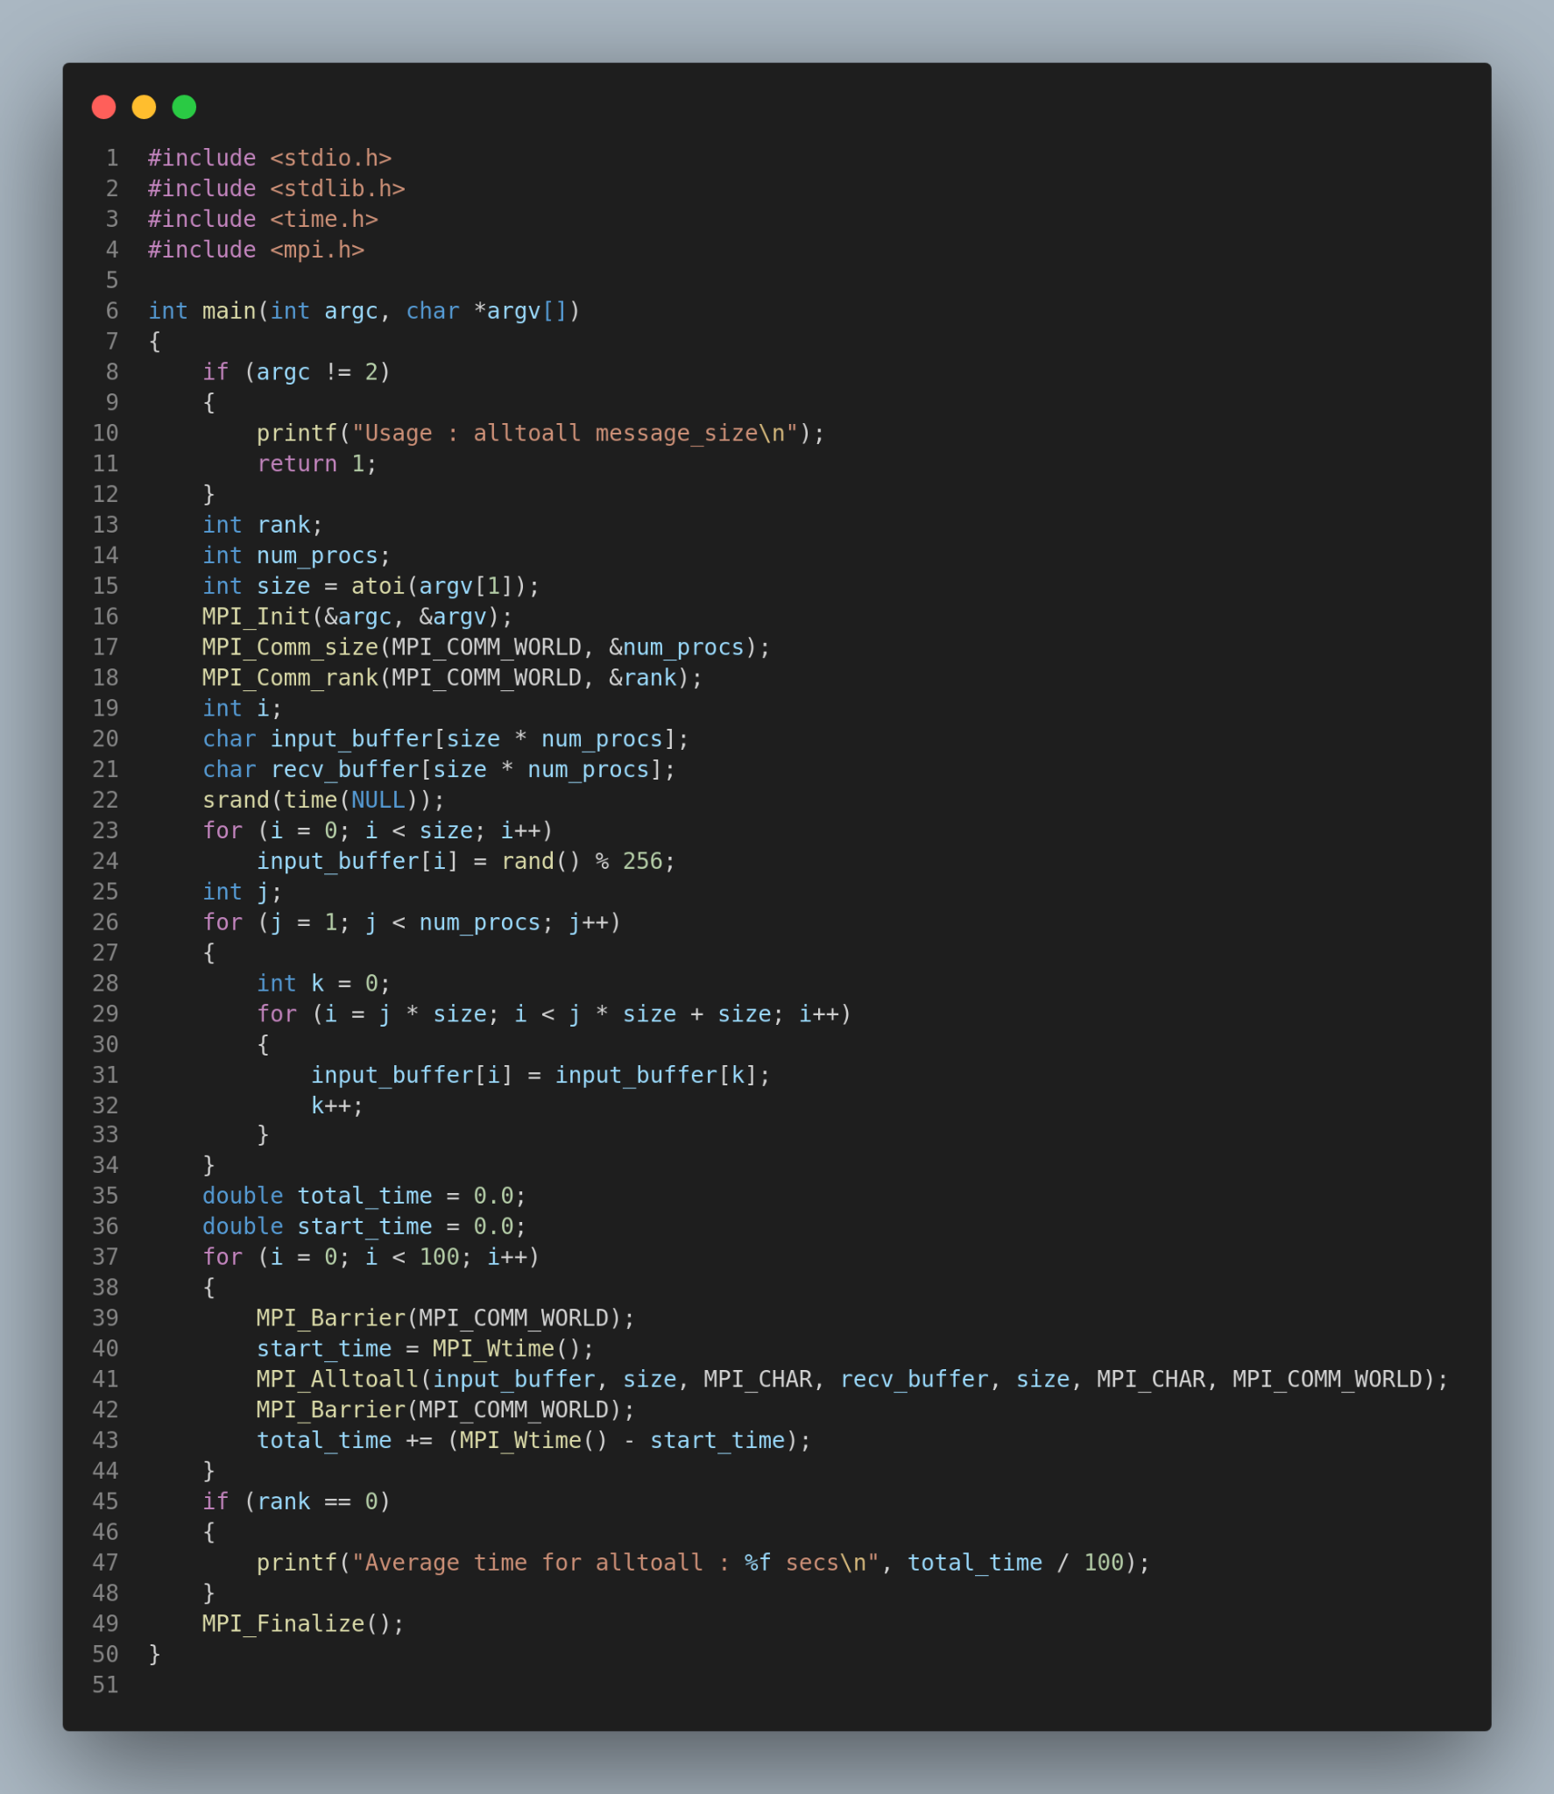

**Output:**

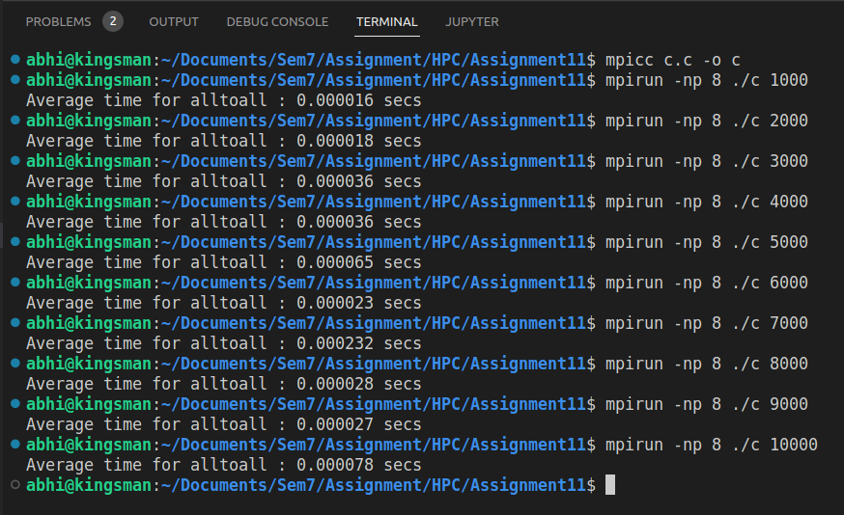

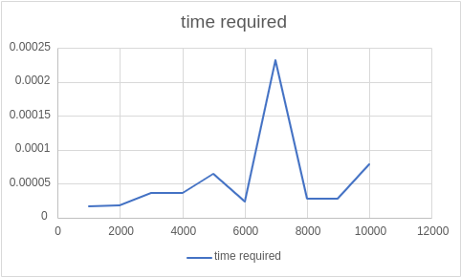

**Q2. Execute the all-reduce operation (Program D) with varying number of processes (1**

**to 16) and fixed message size of 10K words. Plot the performance of the operation with varying number of processes (with constant message size). Explain the performance observed.**

**Code:**

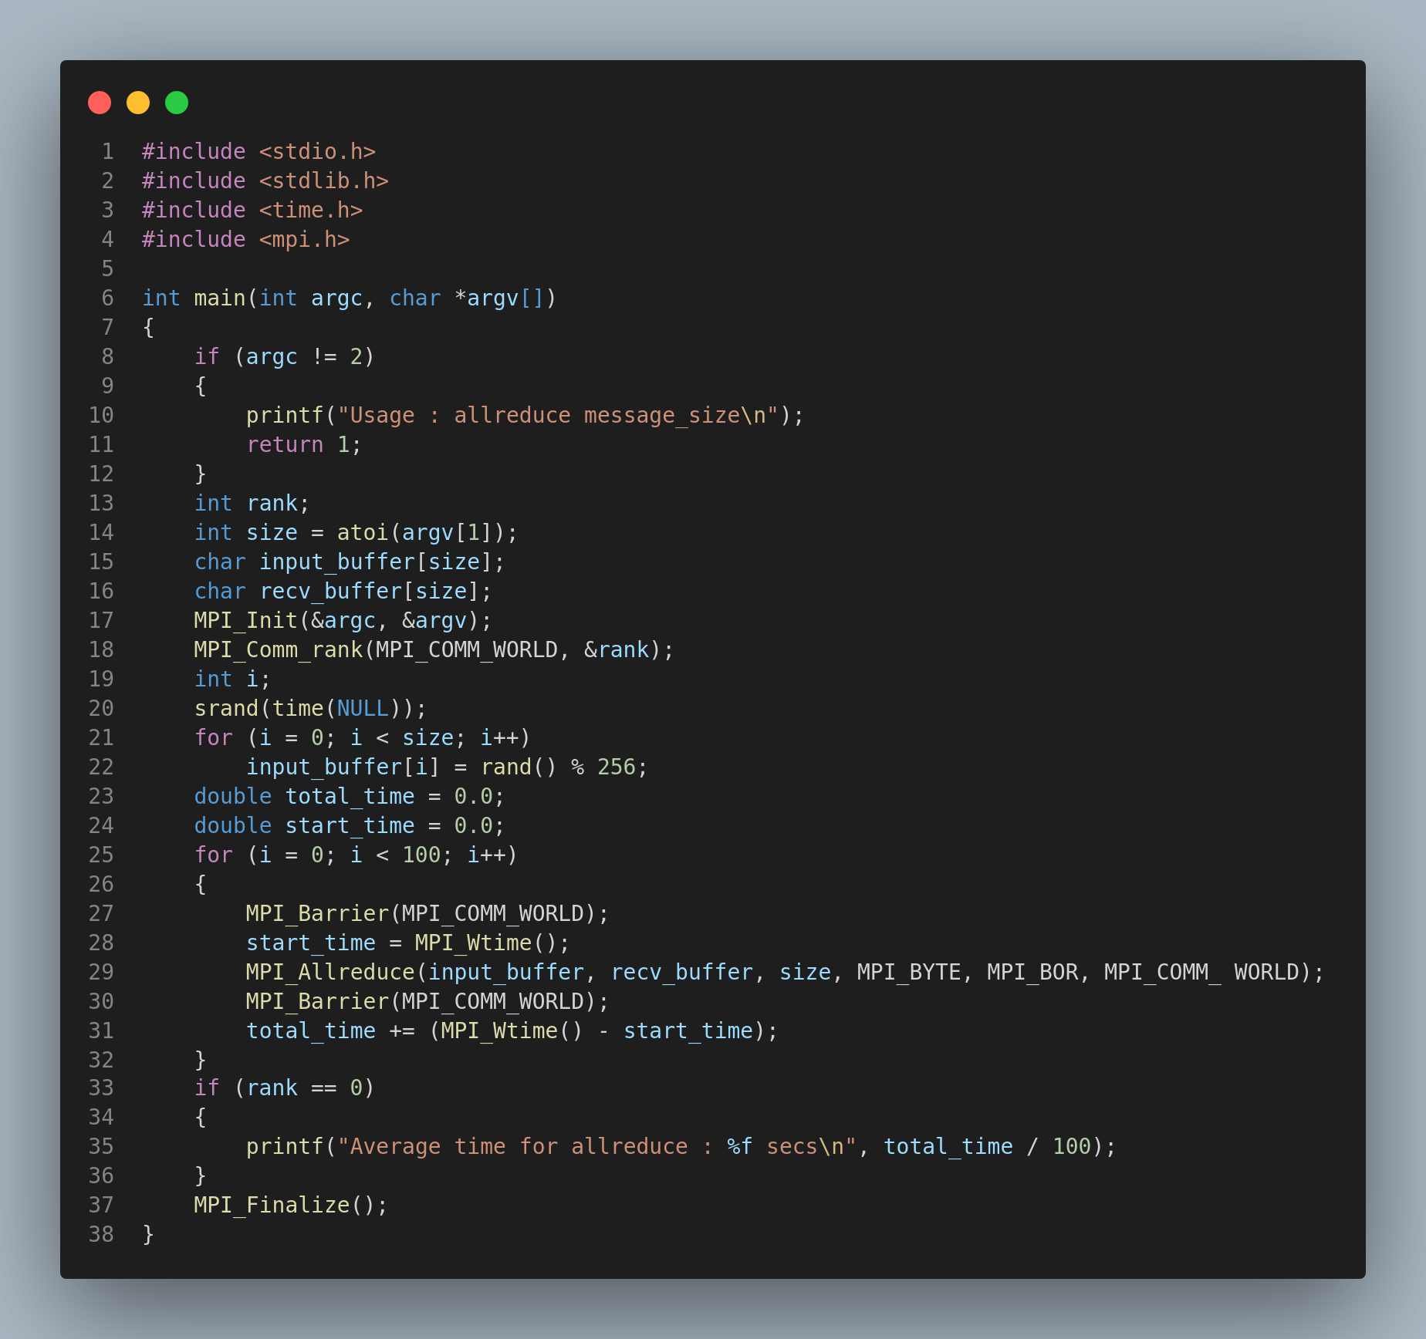

**Output:**

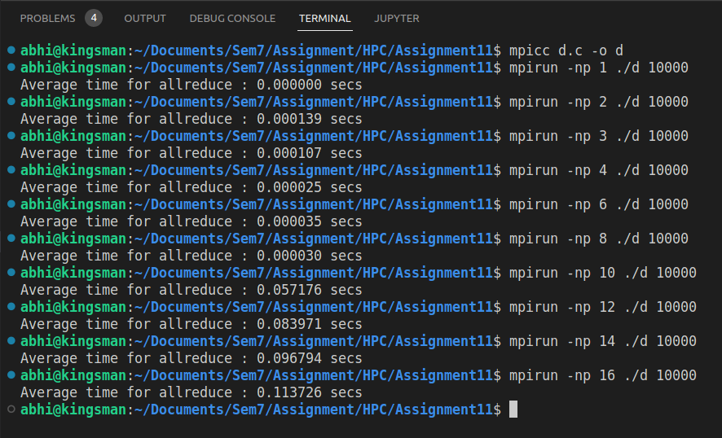

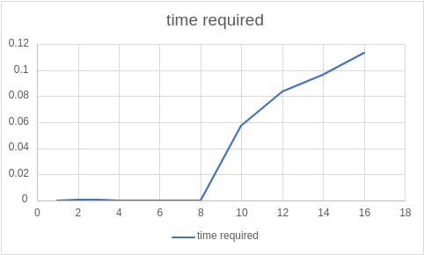

**Github Link:** [**https://github.com/SayaliDesai4/HPC-Practicals**](https://github.com/SayaliDesai4/HPC-Practicals)