**Final Year B. Tech., Sem VII 2022-23**

**High Performance Computing Lab**

**PRN: 2020BTECS00206**

**Full Name: SAYALI YOGESH DESAI**

**Batch: B4**

**Assignment No. 4**

**Que 1. Analyse and implement a Parallel code for below programs using OpenMP considering synchronization requirements.**

**(Demonstrate the use of different clauses and constructs wherever applicable).**

//Fibonacci Series using Dynamic Programming

#include<stdio.h>

int fib(int n)

{

/* Declare an array to store Fibonacci numbers. */

int f[n+2]; // 1 extra to handle case, n = 0

int i;

/* 0th and 1st number of the series are 0 and 1*/

f[0] = 0;

f[1] = 1;

for (i = 2; i <= n; i++)

{

/* Add the previous 2 numbers in the series and store it */

f[i] = f[i-1] + f[i-2];

}

return f[n];

}

int main ()

{

int n = 9; printf("%d", fib(n)); getchar();

return 0;

}

**PARALLEL CODE:**

#include <stdio.h>

#include <stdlib.h>

#include <omp.h>

int fib(int n)

{

int i, j;

if (n<2)

return n;

else

{

#pragma omp task shared(i)

i=fib(n-1);

#pragma omp task shared(j)

j=fib(n-2);

#pragma omp taskwait

return i+j;

}

}

int main(int argc, char **argv)

{

int n, result;

char *a = argv[1];

n = atoi(a);

#pragma omp parallel

{

#pragma omp single

result = fib(n);

}

printf("Result is %d\n", result);

}

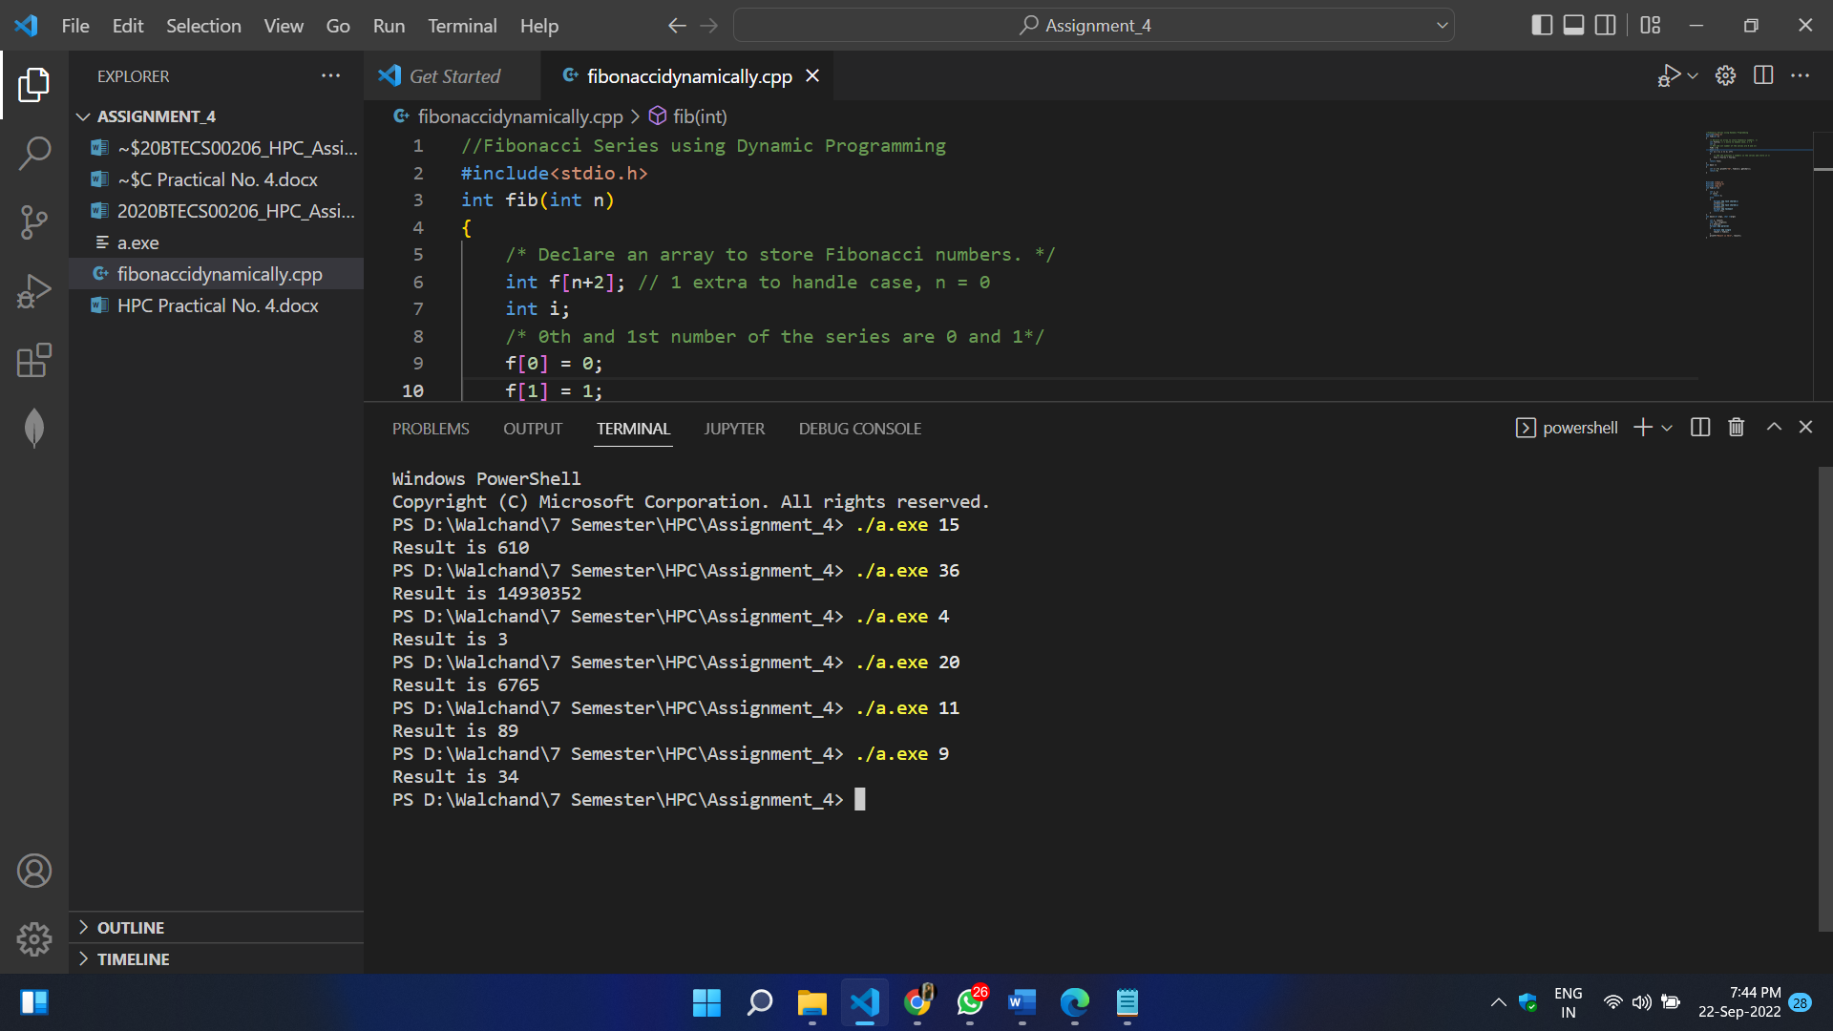

**Que 2. Analyse and implement a Parallel code for below programs using OpenMP considering synchronization requirements. (Demonstrate the use of different clauses and constructs wherever applicable).**

**Producer Consumer Problem:**

// C program for the above approach

#include <stdio.h>

#include <stdlib.h>

// Initialize a mutex to 1

int mutex = 1;

// Number of full slots as 0a

int full = 0;

// Number of empty slots as size of buffer

int empty = 10, x = 0;

// Function to produce an item and add it to the buffer

void producer()

{

// Decrease mutex value by 1

--mutex;

// Increase the number of full slots by 1

++full;

// Decrease the number of empty slots by 1

--empty;

// Item produced

x++;

printf("\nProducer produces item %d", x);

// Increase mutex value by 1

++mutex;

}

// Function to consume an item and remove it from buffer

void consumer()

{

// Decrease mutex value by 1

--mutex;

// Decrease the number of full slots by 1

--full;

// Increase the number of empty slots by 1

++empty;

printf("\nConsumer consumes item %d", x);

x--;

// Increase mutex value by 1

++mutex;

}

// Driver Code

int main()

{

int n, i;

printf("\n1. Press 1 for Producer \n2. Press 2 for Consumer \n3. Press 3 for Exit");

// Using '#pragma omp parallel for' can give wrong value due to synchronization issues.

// 'critical' specifies that code is executed by only one thread at a time

// i.e., only one thread enters the critical section at a given time

#pragma omp critical

for (i = 1; i > 0; i++)

{

printf("\nEnter your choice:");

scanf("%d", &n);

// Switch Cases

switch (n)

{

case 1:

// If mutex is 1 and empty is non-zero, then it is possible to produce

if ((mutex == 1) && (empty != 0))

{

producer();

}

// Otherwise, print buffer is full

else

{

printf("Buffer is full!");

}

break;

case 2:

// If mutex is 1 and full is non-zero, then it is possible to consume

if ((mutex == 1) && (full != 0))

{

consumer();

}

// Otherwise, print Buffer is empty

else

{

printf("Buffer is empty!");

}

break;

// Exit Condition

case 3:

exit(0);

break;

}

}

}

