**Final Year B. Tech., Sem VII 2022-23**

**High Performance Computing Lab**

**PRN: 2020BTECS00206**

**Full Name: SAYALI YOGESH DESAI**

**Batch: B4**

**Assignment No. 5**

Complete the installation of MPI on the platform chosen by you.

**Installation of MPI:**

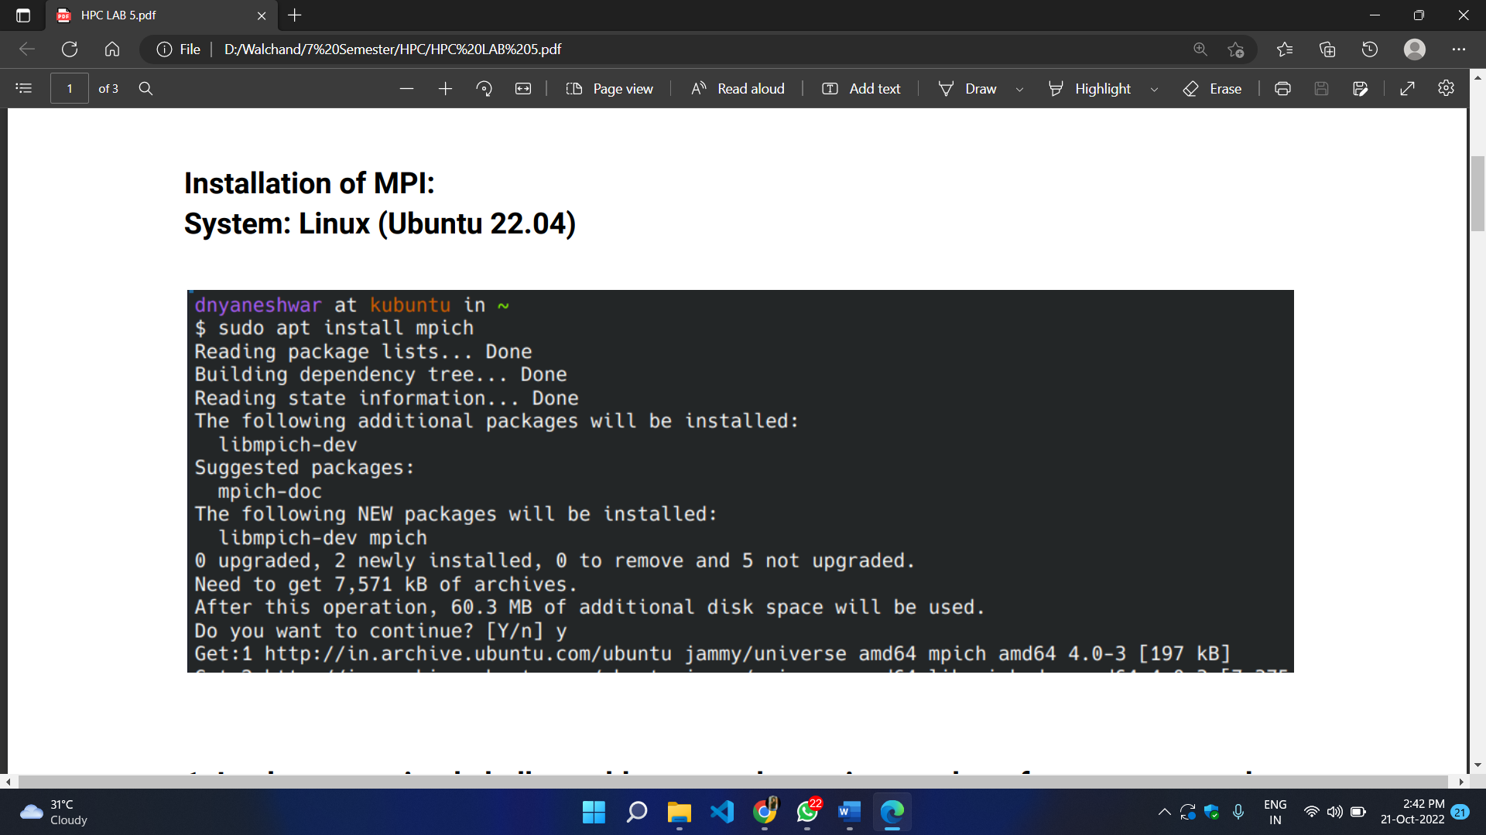

**Q1. Implement a simple hello world program by setting number of processes equal to 10.**

#include <mpi.h>

#include <stdio.h>

int main( int argc, char *argv[] )

{

MPI_Init( &argc, &argv );

printf("Hello, world!\n");

return 0;

}

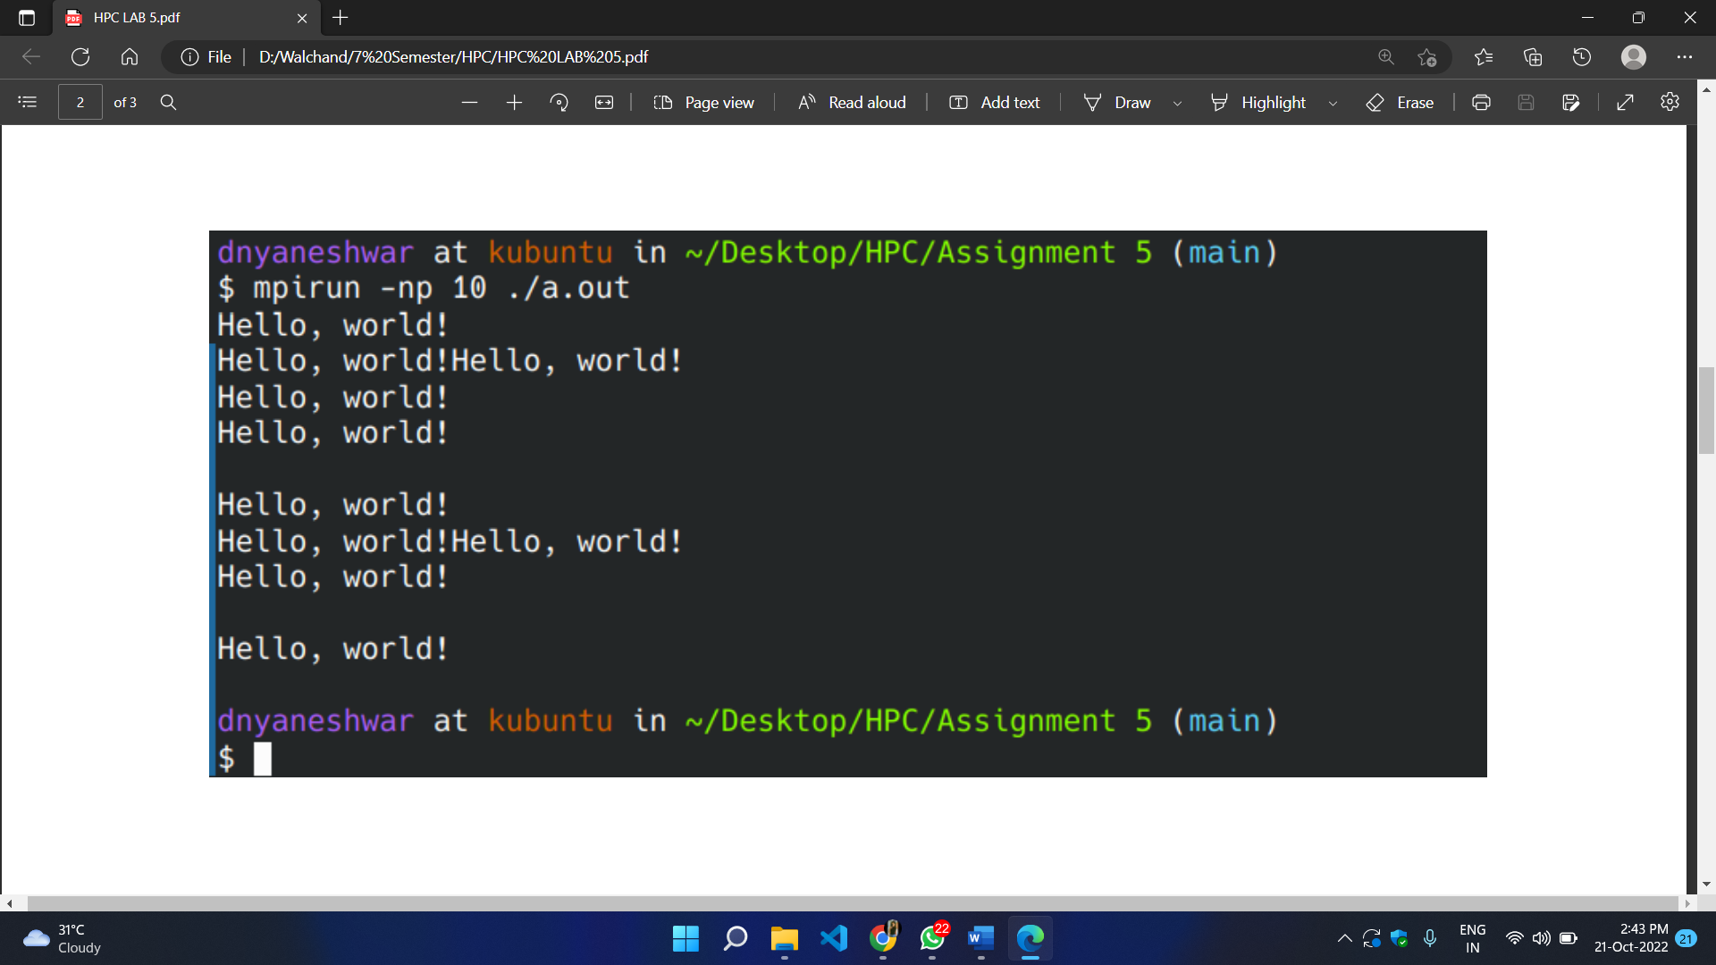

**Q2. Implement a program to display rank and communicator group of five processes.**

#include <mpi.h>

#include <stdio.h>

int main( int argc, char *argv[] )

{

MPI_Init( &argc, &argv );

int rank;

MPI_Group group;

MPI_Comm_group(MPI_COMM_WORLD, &group);

MPI_Comm_rank(MPI_COMM_WORLD, &rank);

printf("Rank: %d, Group: %d \n", rank, group);

MPI_Finalize();

return 0;

}

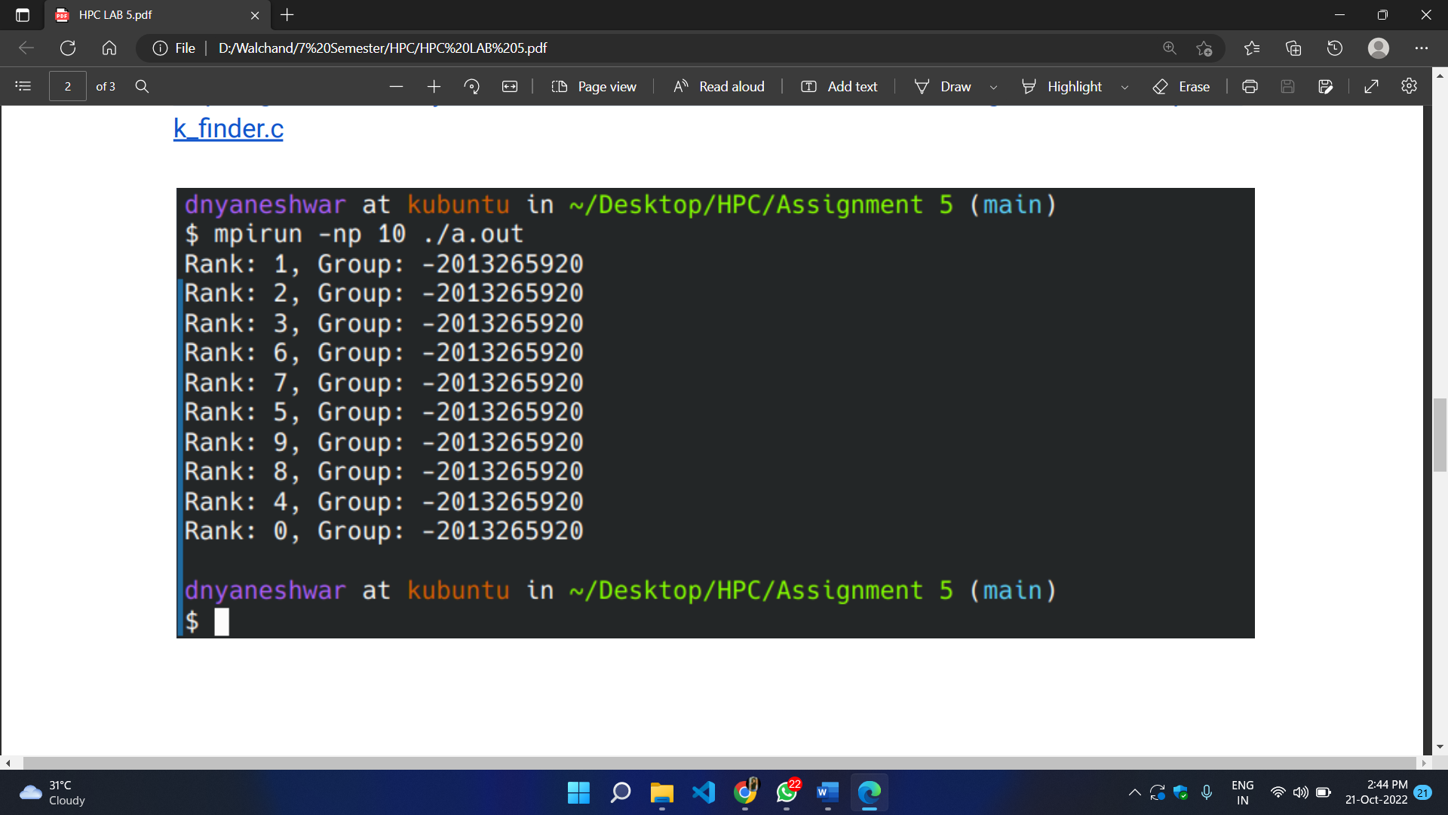

**Github Link:** [**https://github.com/SayaliDesai4/HPC-Practicals**](https://github.com/SayaliDesai4/HPC-Practicals)