**Final Year B. Tech., Sem VII 2022-23**

**High Performance Computing Lab**

**PRN: 2020BTECS00206**

**Full Name: SAYALI YOGESH DESAI**

**Batch: B4**

**Assignment No. 8**

1. **Study and implement 2D Convolution using MPI. Use different number of processes and analyze the performance.**

#include <assert.h>

#include <math.h>

#include <string.h>

#include <stdio.h>

#include <stdlib.h>

#include <mpi.h>

typedef struct

{

float r;

float i;

} complex;

static complex ctmp;

#define C_SWAP(a, b) \

{ \

ctmp = (a); \

(a) = (b); \

(b) = ctmp; \

}

#define N 512

void c_fft1d(complex *r, int n, int isign)

{

int m, i, i1, j, k, i2, l, l1, l2;

float c1, c2, z;

complex t, u;

if (isign == 0)

return;

/* Do the bit reversal */

i2 = n >> 1;

j = 0;

for (i = 0; i < n - 1; i++)

{

if (i < j)

C_SWAP(r[i], r[j]);

k = i2;

while (k <= j)

{

j -= k;

k >>= 1;

}

j += k;

}

/* m = (int) log2((double)n); */

for (i = n, m = 0; i > 1; m++, i /= 2)

;

/* Compute the FFT */

c1 = -1.0;

c2 = 0.0;

l2 = 1;

for (l = 0; l < m; l++)

{

l1 = l2;

l2 <<= 1;

u.r = 1.0;

u.i = 0.0;

for (j = 0; j < l1; j++)

{

for (i = j; i < n; i += l2)

{

i1 = i + l1;

/* t = u * r[i1] */

t.r = u.r * r[i1].r - u.i * r[i1].i;

t.i = u.r * r[i1].i + u.i * r[i1].r;

/* r[i1] = r[i] - t */

r[i1].r = r[i].r - t.r;

r[i1].i = r[i].i - t.i;

/* r[i] = r[i] + t */

r[i].r += t.r;

r[i].i += t.i;

}

z = u.r * c1 - u.i * c2;

u.i = u.r * c2 + u.i * c1;

u.r = z;

}

c2 = sqrt((1.0 - c1) / 2.0);

if (isign == -1) /* FWD FFT */

c2 = -c2;

c1 = sqrt((1.0 + c1) / 2.0);

}

/* Scaling for inverse transform */

if (isign == 1)

{ /* IFFT*/

for (i = 0; i < n; i++)

{

r[i].r /= n;

r[i].i /= n;

}

}

}

void getData(char fileName[15], complex **data)

{

FILE *fp = fopen(fileName, "r");

int i, j, result;

for (i = 0; i < N; i++)

{

for (j = 0; j < N; j++)

{

result = fscanf(fp, "%g", &data[i][j].r);

data[i][j].i = 0.00;

}

}

fclose(fp);

}

void transpose(complex **data, complex **transp)

{

int i, j;

for (i = 0; i < N; i++)

for (j = 0; j < N; j++)

transp[j][i] = data[i][j];

}

void mmpoint(complex **data1, complex **data2, complex **data3)

{

int i, j;

float real, imag;

for (i = 0; i < N; i++)

{

for (j = 0; j < N; j++)

{

data3[i][j].r = (data1[i][j].r * data2[i][j].r) - (data1[i][j].i * data2[i][j].i);

data3[i][j].i = (data1[i][j].r * data2[i][j].i) + (data1[i][j].i * data2[i][j].r);

}

}

}

void printfile(char fileName[15], complex **data)

{

FILE *fp = fopen(fileName, "w");

int i, j;

for (i = 0; i < N; i++)

{

for (j = 0; j < N; j++)

{

fprintf(fp, " %.7e", data[i][j].r);

}

fprintf(fp, "\n");

}

fclose(fp);

}

int main(int argc, char **argv)

{

int my_rank, p, source = 0, dest, x;

complex **data1, **data2, **data3, **data4;

data1 = malloc(N * sizeof(complex *));

data2 = malloc(N * sizeof(complex *));

data3 = malloc(N * sizeof(complex *));

data4 = malloc(N * sizeof(complex *));

for (x = 0; x < N; x++)

{

data1[x] = malloc(N * sizeof(complex *));

data2[x] = malloc(N * sizeof(complex *));

data3[x] = malloc(N * sizeof(complex *));

data4[x] = malloc(N * sizeof(complex *));

}

complex *vec;

char fileName1[15] = "sample/in1";

char fileName2[15] = "sample/in2";

char fileName3[15] = "mpi_out_test";

MPI_Status status;

MPI_Init(&argc, &argv);

MPI_Comm_rank(MPI_COMM_WORLD, &my_rank);

MPI_Comm_size(MPI_COMM_WORLD, &p);

/* Setup description of the 4 MPI_FLOAT fields x, y, z, velocity */

MPI_Datatype mystruct;

int blocklens[2] = {1, 1};

MPI_Aint indices[2] = {0, sizeof(float)};

MPI_Datatype old_types[2] = {MPI_FLOAT, MPI_FLOAT};

/* Make relative */

MPI_Type_struct(2, blocklens, indices, old_types, &mystruct);

MPI_Type_commit(&mystruct);

int i, j;

double startTime, stopTime;

// Starting and send rows of data1, data2

int offset;

int tag = 345;

int rows = N / p;

int lb = my_rank * rows;

int hb = lb + rows;

printf("%d have lb = %d and hb = %d\n", my_rank, lb, hb);

// Starting and send rows of data1, data2

if (my_rank == 0)

{

getData(fileName1, data1);

getData(fileName2, data2);

/* Start Clock */

printf("\nStarting clock.\n");

startTime = MPI_Wtime();

for (i = 1; i < p; i++)

{

offset = i * rows;

for (j = offset; j < (offset + rows); j++)

{

MPI_Send(&data1[j][0], N, mystruct, i, tag, MPI_COMM_WORLD);

MPI_Send(&data2[j][0], N, mystruct, i, tag, MPI_COMM_WORLD);

}

}

}

else

{

for (j = lb; j < hb; j++)

{

MPI_Recv(data1[j], N, mystruct, 0, tag, MPI_COMM_WORLD, &status);

MPI_Recv(data2[j], N, mystruct, 0, tag, MPI_COMM_WORLD, &status);

}

}

// Doing fft1d forward for data1 and data2 rows

vec = (complex *)malloc(N * sizeof(complex));

for (i = lb; i < hb; i++)

{

for (j = 0; j < N; j++)

{

vec[j] = data1[i][j];

}

c_fft1d(vec, N, -1);

for (j = 0; j < N; j++)

{

data1[i][j] = vec[j];

}

}

free(vec);

vec = (complex *)malloc(N * sizeof(complex));

for (i = lb; i < hb; i++)

{

for (j = 0; j < N; j++)

{

vec[j] = data2[i][j];

}

c_fft1d(vec, N, -1);

for (j = 0; j < N; j++)

{

data2[i][j] = vec[j];

}

}

free(vec);

// Receving rows of data1, data2

if (my_rank == 0)

{

for (i = 1; i < p; i++)

{

offset = i * rows;

for (j = offset; j < (offset + rows); j++)

{

MPI_Recv(data1[j], N, mystruct, i, tag, MPI_COMM_WORLD, &status);

MPI_Recv(data2[j], N, mystruct, i, tag, MPI_COMM_WORLD, &status);

}

}

}

else

{

for (j = lb; j < hb; j++)

{

MPI_Send(&data1[j][0], N, mystruct, 0, tag, MPI_COMM_WORLD);

MPI_Send(&data2[j][0], N, mystruct, 0, tag, MPI_COMM_WORLD);

}

}

// Starting and send columns of data1, data2

if (my_rank == 0)

{

transpose(data1, data3);

transpose(data2, data4);

for (i = 1; i < p; i++)

{

offset = i * rows;

for (j = offset; j < (offset + rows); j++)

{

MPI_Send(&data3[j][0], N, mystruct, i, tag, MPI_COMM_WORLD);

MPI_Send(&data4[j][0], N, mystruct, i, tag, MPI_COMM_WORLD);

}

}

}

else

{

for (j = lb; j < hb; j++)

{

MPI_Recv(data3[j], N, mystruct, 0, tag, MPI_COMM_WORLD, &status);

MPI_Recv(data4[j], N, mystruct, 0, tag, MPI_COMM_WORLD, &status);

}

}

// Doing fft1d forward for data1 and data2 columns

vec = (complex *)malloc(N * sizeof(complex));

for (i = lb; i < hb; i++)

{

for (j = 0; j < N; j++)

{

vec[j] = data3[i][j];

}

c_fft1d(vec, N, -1);

for (j = 0; j < N; j++)

{

data3[i][j] = vec[j];

}

}

free(vec);

vec = (complex *)malloc(N * sizeof(complex));

for (i = lb; i < hb; i++)

{

for (j = 0; j < N; j++)

{

vec[j] = data4[i][j];

}

c_fft1d(vec, N, -1);

for (j = 0; j < N; j++)

{

data4[i][j] = vec[j];

}

}

free(vec);

// Receving columns of data1, data2

if (my_rank == 0)

{

for (i = 1; i < p; i++)

{

offset = i * rows;

for (j = offset; j < (offset + rows); j++)

{

MPI_Recv(data3[j], N, mystruct, i, tag, MPI_COMM_WORLD, &status);

MPI_Recv(data4[j], N, mystruct, i, tag, MPI_COMM_WORLD, &status);

}

}

}

else

{

for (j = lb; j < hb; j++)

{

MPI_Send(&data3[j][0], N, mystruct, 0, tag, MPI_COMM_WORLD);

MPI_Send(&data4[j][0], N, mystruct, 0, tag, MPI_COMM_WORLD);

}

}

if (my_rank == 0)

{

transpose(data3, data1);

transpose(data4, data2);

mmpoint(data1, data2, data3);

}

// Starting and send rows of data1, data2

if (my_rank == 0)

{

for (i = 1; i < p; i++)

{

offset = i * rows;

for (j = offset; j < (offset + rows); j++)

{

MPI_Send(&data3[j][0], N, mystruct, i, tag, MPI_COMM_WORLD);

}

}

}

else

{

for (j = lb; j < hb; j++)

{

MPI_Recv(data3[j], N, mystruct, 0, tag, MPI_COMM_WORLD, &status);

}

}

// Doing fft1d forward for data1 and data2 rows

vec = (complex *)malloc(N * sizeof(complex));

for (i = lb; i < hb; i++)

{

for (j = 0; j < N; j++)

{

vec[j] = data3[i][j];

}

c_fft1d(vec, N, 1);

for (j = 0; j < N; j++)

{

data3[i][j] = vec[j];

}

}

free(vec);

// Receving rows of data1, data2

if (my_rank == 0)

{

for (i = 1; i < p; i++)

{

offset = i * rows;

for (j = offset; j < (offset + rows); j++)

{

MPI_Recv(data3[j], N, mystruct, i, tag, MPI_COMM_WORLD, &status);

}

}

}

else

{

for (j = lb; j < hb; j++)

{

MPI_Send(&data3[j][0], N, mystruct, 0, tag, MPI_COMM_WORLD);

}

}

// Starting and send columns of data1, data2

if (my_rank == 0)

{

transpose(data3, data4);

for (i = 1; i < p; i++)

{

offset = i * rows;

for (j = offset; j < (offset + rows); j++)

{

MPI_Send(&data4[j][0], N, mystruct, i, tag, MPI_COMM_WORLD);

}

}

}

else

{

for (j = lb; j < hb; j++)

{

MPI_Recv(data4[j], N, mystruct, 0, tag, MPI_COMM_WORLD, &status);

}

}

// Doing fft1d forward for data1 and data2 columns

vec = (complex *)malloc(N * sizeof(complex));

for (i = lb; i < hb; i++)

{

for (j = 0; j < N; j++)

{

vec[j] = data4[i][j];

}

c_fft1d(vec, N, 1);

for (j = 0; j < N; j++)

{

data4[i][j] = vec[j];

}

}

free(vec);

// Receiving columns of data1, data2

if (my_rank == 0)

{

for (i = 1; i < p; i++)

{

offset = i * rows;

for (j = offset; j < (offset + rows); j++)

{

MPI_Recv(data4[j], N, mystruct, i, tag, MPI_COMM_WORLD, &status);

}

}

}

else

{

for (j = lb; j < hb; j++)

{

MPI_Send(&data4[j][0], N, mystruct, 0, tag, MPI_COMM_WORLD);

}

}

if (my_rank == 0)

{

transpose(data4, data3);

/* Stop Clock */

stopTime = MPI_Wtime();

printf("\nElapsed time = %lf s.\n", (stopTime - startTime));

printf("--------------------------------------------\n");

}

MPI_Finalize();

if (my_rank == 0)

{

printfile(fileName3, data3);

}

free(data1);

free(data2);

free(data3);

free(data4);

return 0;

}

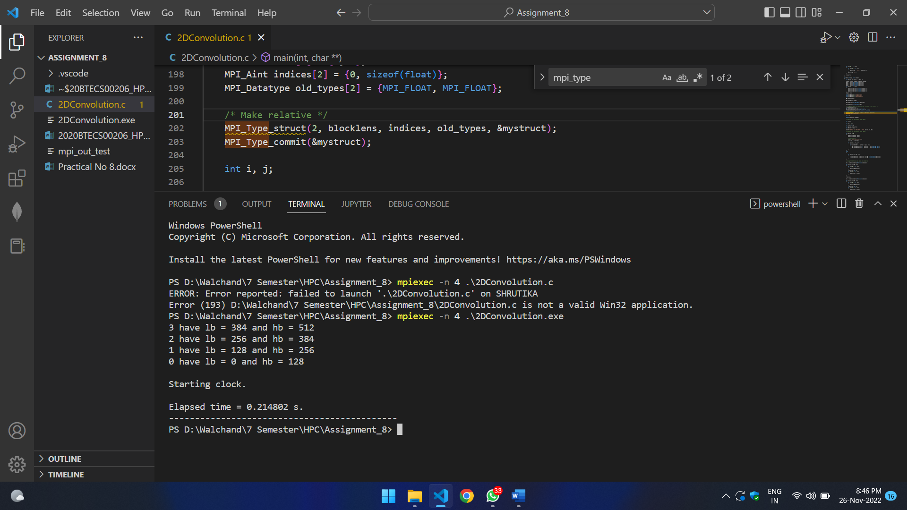

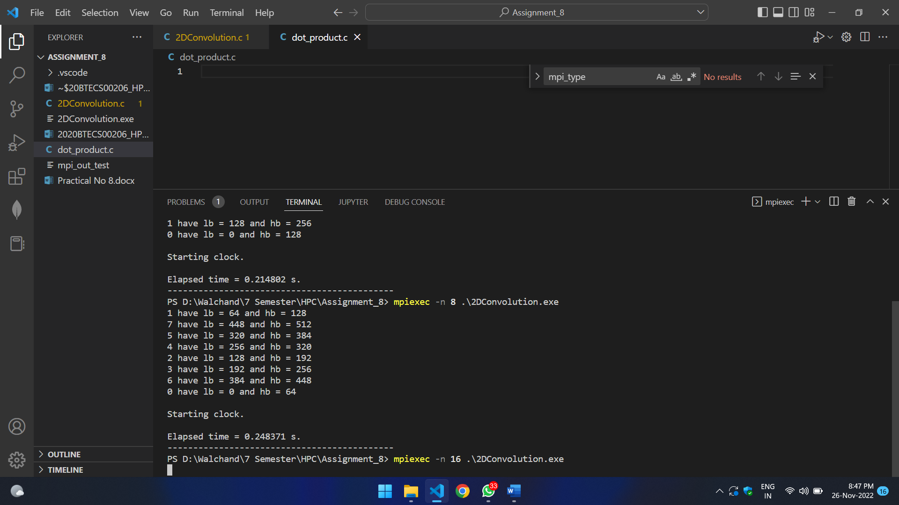

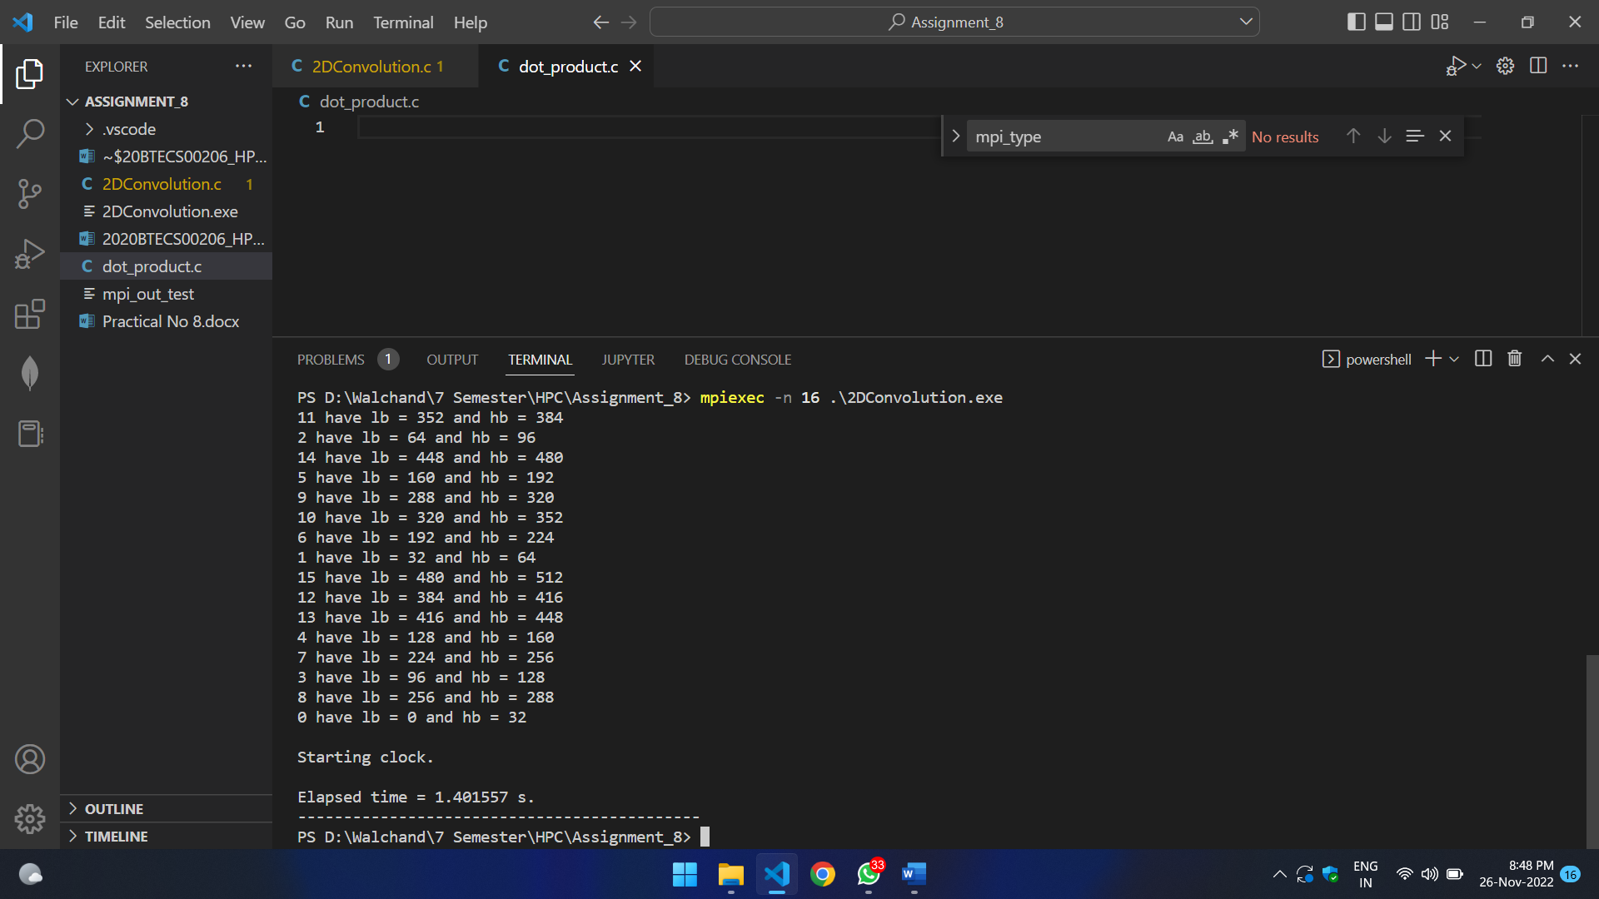

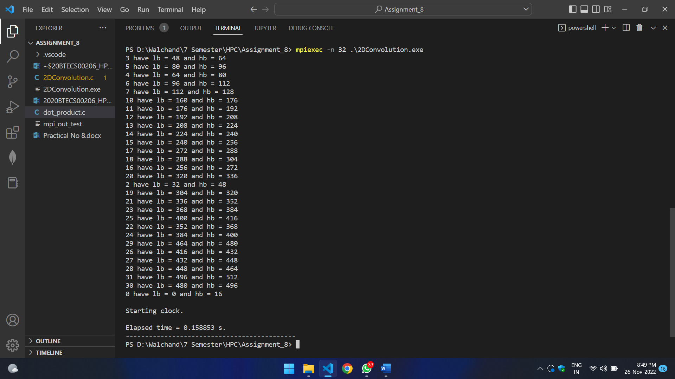

1. **Implement dot product using MPI. Use different number of processes and analyze the performance.**

#include <stdio.h>

#include <mpi.h>

#include <unistd.h>

#include <math.h>

#include <time.h>

#include <stdlib.h>

#define NELMS 100000

#define MASTER 0

#define MAXPROCS 16

int dot_product();

void init_lst();

void print_lst();

int main() {

int i,n,vector_x[NELMS],vector_y[NELMS];

int prod,sidx,eidx,size;

int pid,nprocs, rank;

double stime,etime;

MPI_Status status;

MPI_Comm world;

n = 100000;

if (n > NELMS) { printf("n=%d > N=%d\n",n,NELMS); exit(1); }

MPI_Init(NULL, NULL);

world = MPI_COMM_WORLD;

MPI_Comm_size(MPI_COMM_WORLD, &nprocs);

MPI_Comm_rank(MPI_COMM_WORLD, &pid);

int portion = n / nprocs;

sidx = pid * portion;

eidx = sidx + portion;

init_lst(vector_x, n);

init_lst(vector_y, n);

int tmp_prod[nprocs];

for (i = 0; i < nprocs; i++)

tmp_prod[i] = 0;

stime = MPI_Wtime();

if (pid == MASTER) {

prod = dot_product(sidx, eidx, vector_x, vector_y, n);

for (i = 1; i < nprocs; i++)

MPI_Recv(&tmp_prod[i-1], 1, MPI_INT, i, 123, MPI_COMM_WORLD, &status);

}

else {

prod = dot_product(sidx, eidx, vector_x, vector_y, n);

MPI_Send(&prod, 1, MPI_INT, MASTER, 123, MPI_COMM_WORLD);

}

if (pid == MASTER) {

for (i = 0; i < nprocs; i++)

prod += tmp_prod[i];

}

etime = MPI_Wtime();

if (pid == MASTER) {

//print_lst(vector_x,n);

//print_lst(vector_y,n);

printf("pid=%d: final prod=%d\n",pid,prod);

printf("pid=%d: elapsed=%f\n",pid,etime-stime);

}

MPI_Finalize();

}

int dot_product(int s,int e, int x[], int y[], int n){

int i,prod=0;

for (i = s; i < e; i++)

prod = prod + x[i] * y[i];

return prod;

}

void init_lst(int *l,int n){

int i;

for (i=0; i<n; i++) *l++ = i;

}

void print_lst(int l[],int n){

int i;

for (i=0; i<n; i++) {

printf("%d ", l[i]);

}

printf("\n");

}

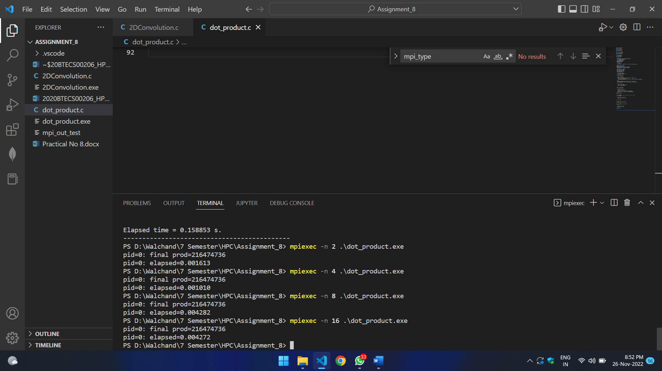

1. **Implement Prefix sum using MPI. Use different number of processes and analyze the performance.**

#include <stdio.h>

#include<stdlib.h>

#include <math.h>

#include "mpi.h"

int main(int argc, char* argv[]){

int my_rank; /* rank of process */

int p; /* number of processes */

MPI_Status status ; /* return status for receive */

int value;

/* start up MPI */

MPI_Init(&argc, &argv);

/* find out process rank */

MPI_Comm_rank(MPI_COMM_WORLD, &my_rank);

/* find out number of processes */

MPI_Comm_size(MPI_COMM_WORLD, &p);

int prefix_arr[p];

/* getting input and scatter values */

if(my_rank == 0){

int i;

for(i = 0; i < p; ++i){

prefix_arr[i] = i + 1;

}

}

double start = MPI_Wtime();

//all call scatter

MPI_Scatter(prefix_arr, 1, MPI_INT, &value, 1, MPI_INT, 0, MPI_COMM_WORLD);

/*

prefix sum:

repeat log n times

each time, if we are the chosen one, we receve a value from someone and add to ours

otherwise, we send to the chosen one

*/

int i;

int logn = log2(p);

for(i = 0; i <= logn; i++){

int lower_bound = pow(2,i);

int upper_bound = p - lower_bound;

if(upper_bound < lower_bound){

upper_bound = lower_bound;

}

if(my_rank < lower_bound){

int send = (int) (my_rank + pow(2,i));

if(send >= p)

continue;

printf("%d sending to %d\n", my_rank, (int) (my_rank+pow(2,i)));

MPI_Send(&value, 1, MPI_INT, (int) (my_rank+pow(2,i)), 0, MPI_COMM_WORLD);

}

else if(my_rank >= upper_bound){

int recv = (int) (my_rank - pow(2,i));

if(recv >= p)

continue;

int recv_value;

printf("%d receving..\n", my_rank);

MPI_Recv(&recv_value, 1, MPI_INT, (my_rank - pow(2,i)), 0, MPI_COMM_WORLD, &status);

value += recv_value;

}

else{

int send = (int) (my_rank + pow(2,i));

int recv = (int) (my_rank - pow(2,i));

if(send >= p || recv >= p)

continue;

printf("%d sending to %d\n", my_rank, (int) (my_rank+pow(2,i)));

MPI_Send(&value, 1, MPI_INT, (int) (my_rank+pow(2,i)), 0, MPI_COMM_WORLD);

printf("%d receving..\n", my_rank);

int recv_value;

MPI_Status status;

MPI_Recv(&recv_value, 1, MPI_INT, (my_rank - pow(2,i)), 0, MPI_COMM_WORLD, &status);

value += recv_value;

}

}

//after algorithm, each processor hols its own prefix sum

//we gather at rank

int gather[p];

MPI_Gather(&value, 1, MPI_INT, gather, 1, MPI_INT, 0, MPI_COMM_WORLD);

if(my_rank == 0){

double end = MPI_Wtime();

printf("Execution Time: %f\n", end - start);

}

/* shut down MPI */

MPI_Finalize();

return 0;

}

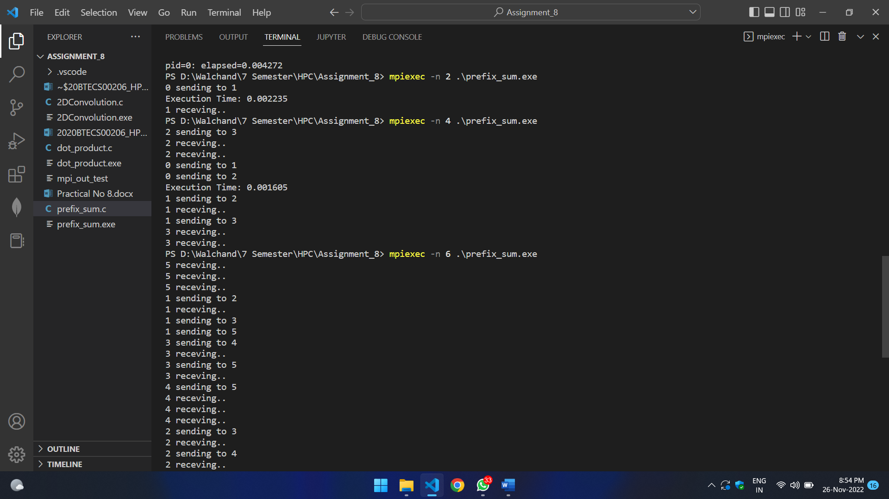



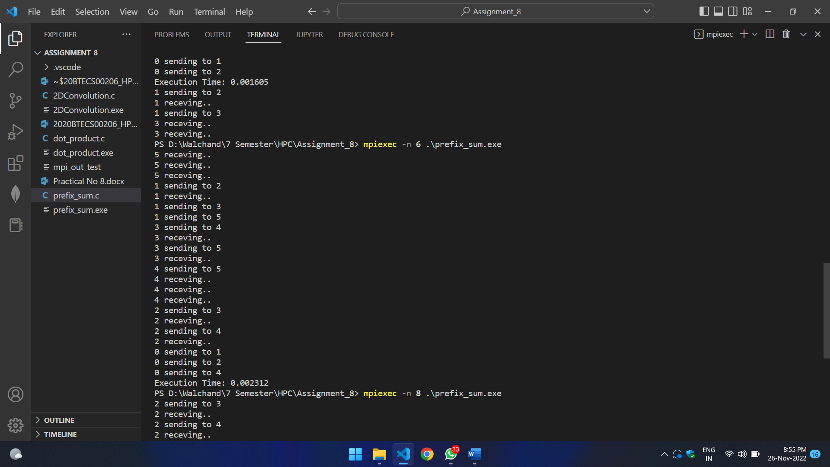

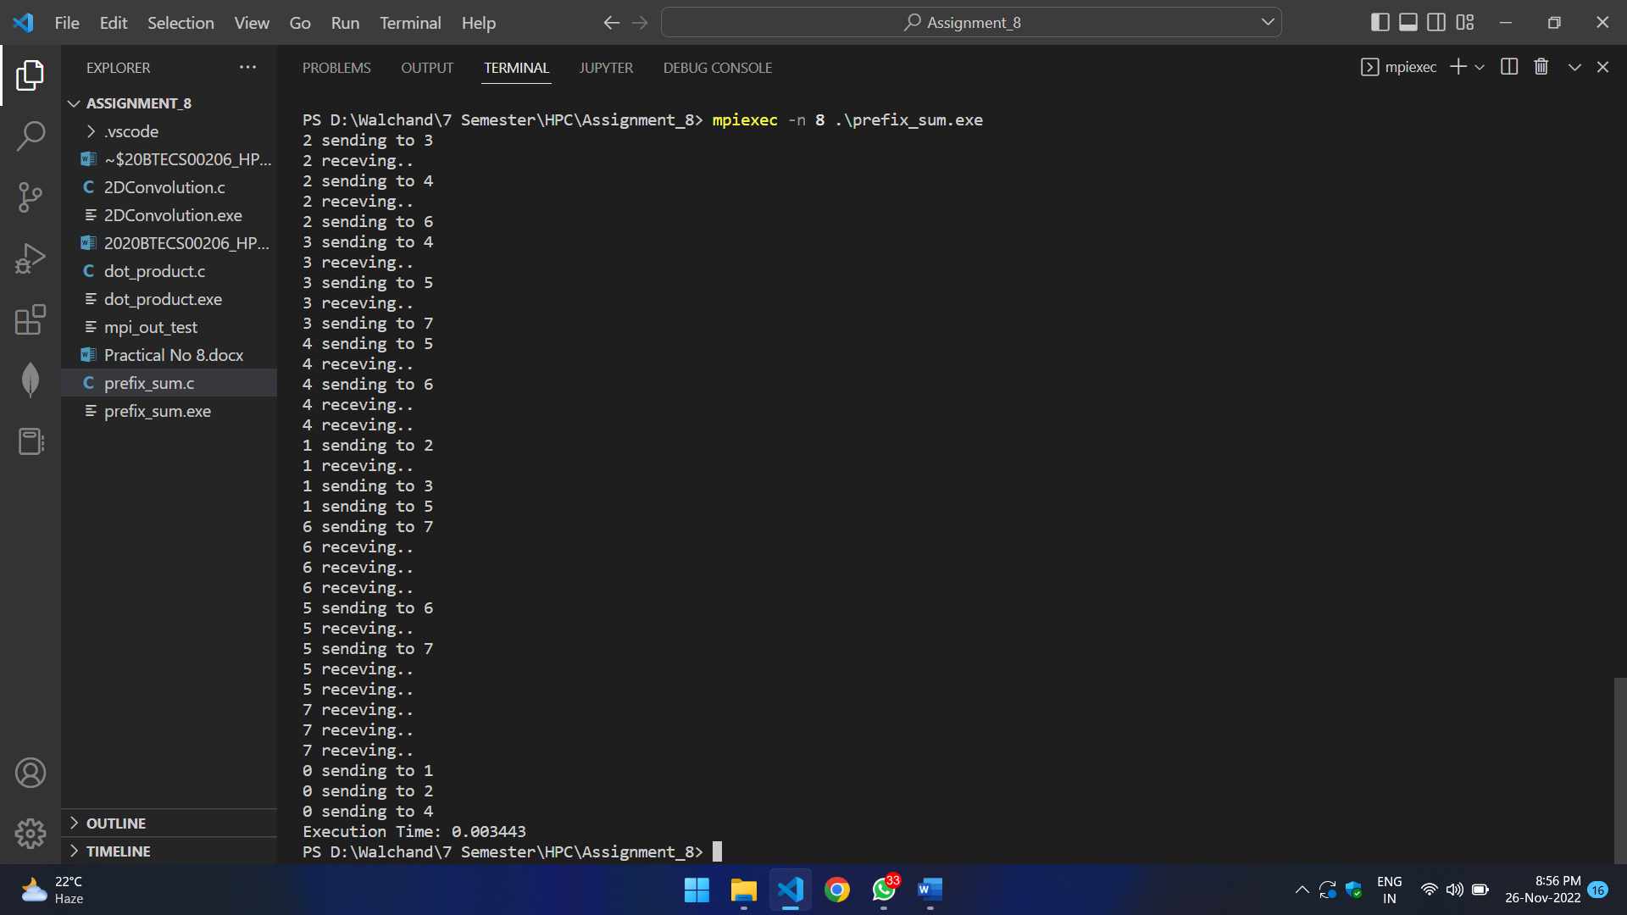

**Github Link:** [**https://github.com/SayaliDesai4/HPC-Practicals**](https://github.com/SayaliDesai4/HPC-Practicals)