

INSTITUTE FOR ADVANCED
COMPUTING AND
SOFTWARE DEVELOPMENT
AKURDI, PUNE

Documentation On

“SECOND HAND BOOK SELLING AND BUYING ONLINE PORTAL”
PG-DAC FEB 2020

Submitted By:
Group No: 48
Ashwini Surwase (1096)
Sayali Jangam(1144)

Prashant Karhale Mr.Kashinath Patil
Centre Coordinator Project Guide

Table of Contents

- Introduction……………………………………………………………………………………..1
Document Purpose………………………………………………………………………………2
Problem Statement………………………………………………………………………………..2
Product Scope…………………………………………………………………………………….2
Aim & Objectives………………………………………………………………………………...2

- Overall Description……………………………………………………………………………3
Product Perspective……………………………………………………………………………..3
Benefits of Second Hand Book Online Portal…………………………………………………..3
User andcharacteristics…………………………………………………………………………3
Operating Environment…………………………………………………………………………3
Design and Implementation Constraints…………………………………………………………3

- Requirements Specification……………………………………………………………………..4

External Interface Requirements…………………………………………………………………………………….4
Non-Functional Requirements……………………………………………………………………………………..5

- System Diagram………………………………………………………………………………….

Activity Diagram…………………………………………………………………………………
Data Flow Diagram………………………………………………………………………………
Class Diagram……………………………………………………………………………………
ER Diagram………………………………………………………………………………………

- Table Structure
- Conclusion
- References

1.List of Figures
1.Use Case Diagram
2.ER Diagram

2.Introduction

Now a day’s second hand book market is mostly handled by small vendors only and students don’t have many options regarding second hands books buying or selling. Second hands book store is a platform for students to share their books with their juniors here they can upload set of books that they have and found buyer through this project both buyers and sellers will get benefit because they need not to deal with third party that is vendors. In this project we are designing web page , on this web page we are providing option through which user can sign up and he will get username and password. The book set uploded by seller will be visible to all.

Aim & Objective

Specific goals are:-
To produce a web based system that allow the admin to add customers and provide functionalities to its role.
The major goal of e-second book shop is that in future people,especially students should have an easy way to buy and sell secondhand books online.The users will be able to carry out these in a secured and managed environment.
The secondhand book -eBook shop shall be easy to navigate and user friendly and easy to find books in various categories.

Overall Description
Existing System Function:
There are many existing websites,on the web that provides services on secondhand books.My goal is to provide a bettter, faster and user friendly website with services that other might be lacking.

Benefits of SecondHand book buying and selling online portal:
- This online book portal is fully functional and flexible.
- It is easy to use.
- It saves a lot of time, money,labour.
- Eco-friendly: The monitoring of the online secondhand book system and the overall business becomes very easy and includes the least of paper work.
- The application acts as an office that is open 24/7.
- It increases the efficiency of the system at offering quality services to the customers.
- It provides custom features development and support with application.

Users and Characteristics:

Admin:
- Admin can login to the system.
- View the list of all Customers.
- Add new Customer.
- Delete Customer.
- Update Customer.
- Add Book.
- Update Book.
- Delete Book.

Customer:
- Customer can login to the system.
- View his/her details.
- View notices.
- Generate complaints.
- Update their personal credentials.

Operating Environment:
Server Side:

Processor: Intel® Xeon® processor 3500 series
HDD: Minimum 500GB Disk Space
RAM: Minimum 2GB
OS: Windows 8.1, Linux 6
Database: MySQL
Client Side (minimum requirement):
Processor: Intel Dual Core
HDD: Minimum 80GB Disk Space
RAM: Minimum 1GB
OS: Windows 7, Linux

Design and Implementation Constraints:
Specific Requirement
External Interface Requirements:
User Interfaces:
- All the users will see the same when they enter in this website. This page asks the users a username and a password.
- After being authenticated by correct username and password, user will be redirect to their corresponding profile where they can do various activities.
- The user interface will be simple and consistence,using terminology commonly understood by intended users of the system. The system will have simple interface, consistence with standered interface, to eliminate need for user training of infrequent users.

Hardware Interfaces:
- No extra hardware interfaces are needed.
- The system will use the standered hardware and data communication resources.
- This includes but not limited to,general network connection at the server/hosting site,network server and network management tools.

OS: Windows 7

Browser:
The system is a web-based application; clients need a modern web browser such as Mozilla Firebox,Internet Explorer,Opera, and Chrome. The computer must have an Internet connection in order to be able to access the system.

Communication Interfaces:
- This system uses communication resources which includes but not limited to,
HTTP protocol for communication with the web browser and web server and TCP/IP
Network protocol with HTTP protocol.
- This application will communicate with the database that holds all the booking information. Users can contact with server side through HTTP protocol by means of a function that is called HTTP service. This function allows the application to use the data retrieved by server to fulfil the request fired by the user.

Use case Diagram:

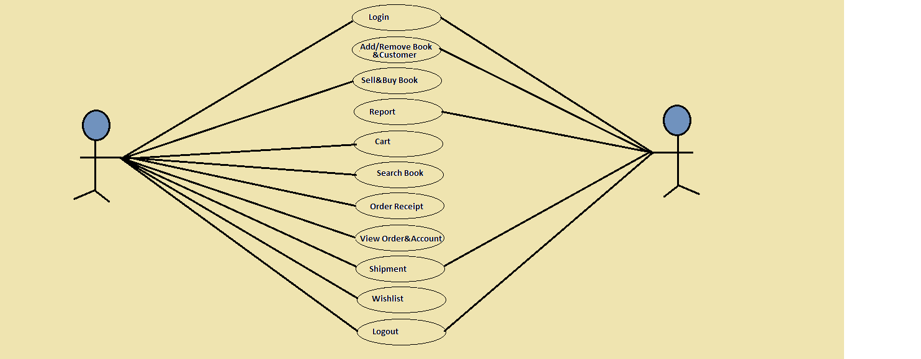
Figure 1:user case Diagram

ER Diagram:

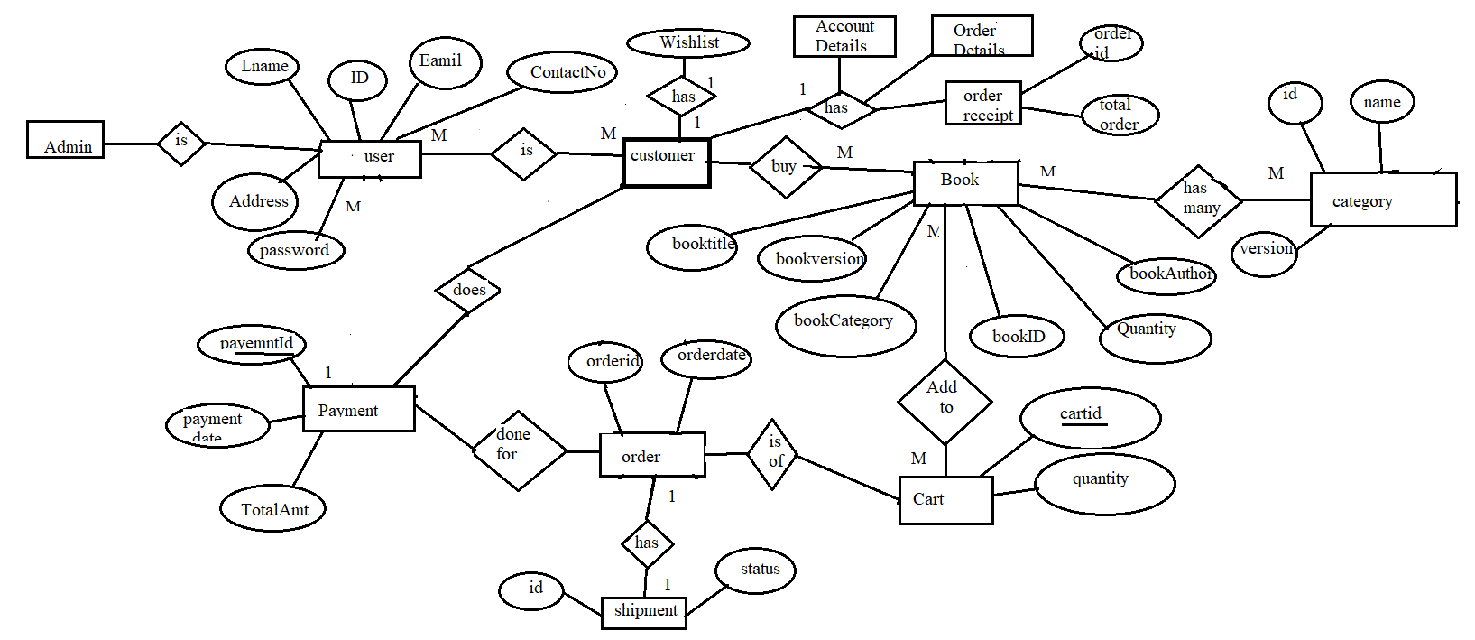

Figure 2:ER Diagram

Table Structure:

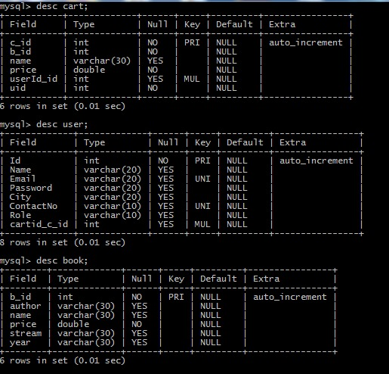

Conclusion:
Hence we developed an online book portal , through which student can exchange,buy,sell their books. An interactive user friendly and focused website in the form of online shop can generate good business .

Future Scope:

The software is flexible enough to be modified and implemented as per future requirements. We have tried our best to present this free and user friendly website to all customers. This project can be enhanced further by adding meassage alerts for various activities can be added to the system so that user do not miss the updates.

References:
[1] Vamsi Krishna, “Online Book Store”, Mummaneni Kansas State University Manhattan.
[2] Vishal Ambhore, “SECOND HAND BOOK STORE”, International Journal of Advanced Technology & Engineering Research (IJATER), ISSN No: 2250-3536 Volume 8, Issue 3, May 2018.
[3] Talla Ngala Yiga, Design and Implementation of a Secondhand E-bookshop

