**Sayan Banerjee**

EE890: mini-project 5 report

# **SVM: Liner Kernel**

clear all;

load('SVM_data.mat','x','y') ;

[m, n] = size(x);

figure()

plot(x(1:m/2,1),x(1:m/2,2),'+');

hold on

plot(x((m/2)+1:m,1),x((m/2)+1:m,2),'rO');

pbaspect([1 1 1])

target=y;

X_T=x;

X=x';

Q=((y*y').*(X_T*X));

one=-1.*(ones(40,1));

AD=[y';(-1).*y';eye(40,40)];

zero=zeros(42,1);

[alpha,fval] = quadprog(Q,one,-AD,zero,[],[]);

for i=1:40

if alpha(i,1)<0.00001

alpha(i,1)=0.0;

end

end

W=double(zeros(1,2));

for i= 1:40

W=W+(y(i,1)*alpha(i,1))*x(i,:);

end

b=y(3,1)-W*x(3,:)';

plot(x(3,1),x(3,2), '-.k*');

plot(x(26,1),x(26,2), '-.k*');

plot(x(27,1),x(27,2), '-.k*');

x = linspace(-4,4);

w1=W(1,1);

w2=W(1,2);

y=(-b-w1*x)/w2;

line(x,y)

y=(1-b-w1*x)/w2;

line(x,y,'Color','red','LineStyle','--')

y=(-1-b-w1*x)/w2;

line(x,y,'Color','red','LineStyle','--')

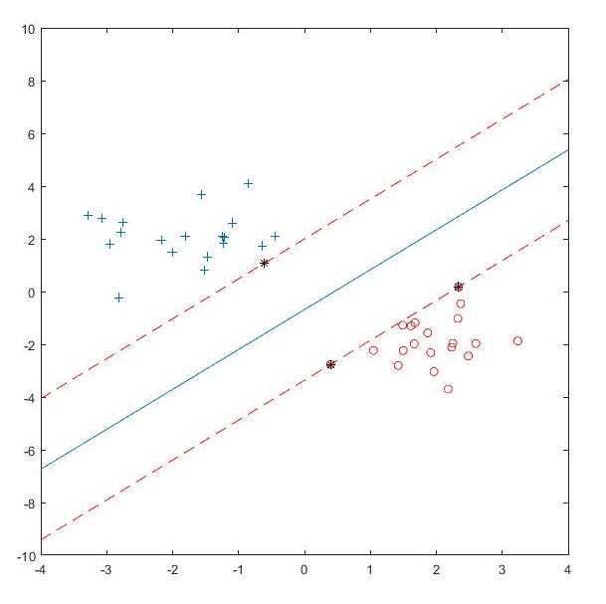

# **SVM Kernel Trick (Polynomial Degree 3)**

**Kernel: K=** (1+XT*X)3

clear all ;

load('SVM_data_nonlinear.mat','x','y') ;

[m, n] = size(x);

figure()

plot(x(1:m/2,1),x(1:m/2,2),'+');

hold on

plot(x((m/2)+1:m,1),x((m/2)+1:m,2),'rO');

pbaspect([1 1 1])

X_T=x;

X=x';

K=(X_T*X);

K=1+K;

K=K.^3;

Q=((y*y').*K);

one=-1.*(ones(60,1));

AD=[y';(-1).*y';eye(60,60)];

zero=zeros(62,1);

[alpha,fval] = quadprog(Q,one,-AD,zero,[],[]);

for i=1:60

if alpha(i,1)<0.00001

alpha(i,1)=0.0;

end

end

for i=1:60

if alpha(i,1)~=0

plot(x(i,1),x(i,2), '-.k*');

end

end

SV=X(:,6);

bias=0.0;

for i=1:60

if alpha(i,1)~=0

K_b=(X_T(i,:)*SV);

K_b=1+K_b;

K_b=K_b^3;

bias=bias+(alpha(i,1)*y(i,1)*K_b);

end

end

length=1;

boundary=zeros(100,2);

while length<101

random_x1=(3-(-5)).*rand(1,1)+(-5);

random_x2=(2-(-3)).*rand(1,1)+(-3);

p=[random_x1;random_x2];

g=0.0;

for i=1:60

if alpha(i,1)~=0

K_p=(X_T(i,:)*p);

K_p=1+K_p;

K_p=K_p.^3;

g=g+(alpha(i,1)*y(i,1)*K_p);

end

end

g=g+bias;

if abs(g)<0.00001

boundary(length,1)=random_x1;

boundary(length,2)=random_x2;

length=length+1;

end

end

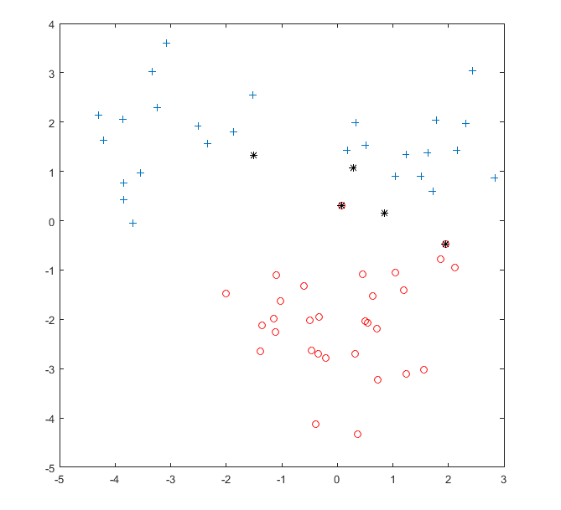

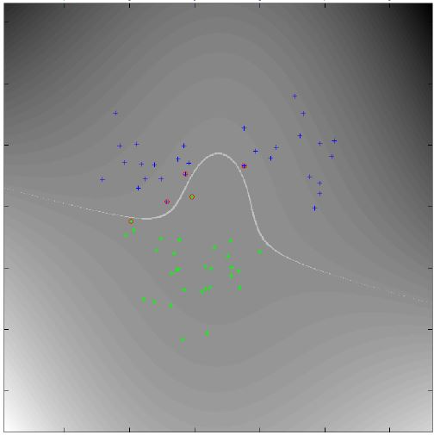

# **SVM Kernel Trick (Polynomial Degree 3)**

**Kernel: K=** Φ(X)T* Φ(X)

Φ(X)= 1, x1, x2, x2, x1x2, x22, x13, x12x2, x1x22, x23

clear all ;

clc;

clear;

load('SVM_data_nonlinear.mat','x','y') ;

[m, n] = size(x);

figure()

plot(x(1:m/2,1),x(1:m/2,2),'+');

hold on

plot(x((m/2)+1:m,1),x((m/2)+1:m,2),'rO');

pbaspect([1 1 1])

K_X=zeros(m,10);

for i=1:m

K_X(i,1)= 1;

K_X(i,2)= x(i,1);

K_X(i,3)= x(i,2);

K_X(i,4)= x(i,1)^2;

K_X(i,5)= x(i,1)*x(i,2);

K_X(i,6)= x(i,2)^2;

K_X(i,7)= x(i,1)^3;

K_X(i,8)= x(i,1)^2*x(i,2);

K_X(i,9)= x(i,1)*x(i,2)^2;

K_X(i,10)= x(i,2)^3;

end

X_T=K_X;

X=K_X';

Q=((y*y').*(X_T*X));

one=-1.*(ones(60,1));

AD=[y';(-1).*y';eye(60,60)];

zero=zeros(62,1);

[alpha,fval] = quadprog(Q,one,-AD,zero,[],[]);

for i=1:60

if alpha(i,1)<0.00001

alpha(i,1)=0.0;

end

end

for i=1:60

if alpha(i,1)~=0

plot(x(i,1),x(i,2), '-.k*');

end

end

W=double(zeros(1,10));

for i= 1:60

W=W+(y(i,1)*alpha(i,1))*K_X(i,:);

end

bias=y(6,1)-W*K_X(6,:)';

w1=W(1);

w2=W(2);

w3=W(3);

w4=W(4);

w5=W(5);

w6=W(6);

w7=W(7);

w8=W(8);

w9=W(9);

w10=W(10);

min=-5;

max=3;

random=(max-min).*rand(1000,1)+min;

random_y=zeros(1000,1);

syms y

for i=1:1000

eqn=w1+w2*random(i)+w3*y+w4*random(i)^2+w5*random(i)*y+w6*y^2+w7*random(i)^3+w8*random(i)^2*y+w9*random(i)*y^2+w10*y^3+bias==0;

soly=solve(eqn,y);

soly=double(soly);

[m,n]=size(soly);

for j=1:m

p=real(soly(j,n));

%q=soly(j,n).real;

if p>=-5 && p<=4

random_y(i,1)=p;

end

break;

end

end

for i=1:1000

plot(random(i,1),random_y(i,1), '+');

end

