EXPLORATORY DATA ANALYSIS REPORT
Investment Trends in India:
Foreign Direct Investment and Gross Capital Formation, 2014–2025

Prepared by
Sayan Kumar Modak
Data source: World Bank, World Development Indicators (India)

1. Executive Summary
This report presents an exploratory data analysis (EDA) of two related investment indicators for India — Foreign Direct Investment (FDI), net inflows (% of GDP) and Gross Capital Formation (GCF, % of GDP) — over the period 2014–2025. Both indicators are drawn from the World Bank's World Development Indicators dataset. The analysis examines each series individually, identifies major turning points, and then evaluates the relationship between the two indicators using a scatter plot and a linear regression.
Gross Capital Formation followed a W-shaped pattern over the period: a decline from 2014 to 2016, a partial recovery through 2018–2019, a sharp fall in 2020 linked to the COVID-19 pandemic, and a sustained recovery from 2021 onward that carried the indicator to its highest level of the study period by 2025. FDI net inflows peaked in 2020 and have declined since, reaching their lowest points in 2023–2024 before a modest uptick in 2025. When plotted against each other, the two series show a moderate-to-strong negative correlation (r ≈ -0.76), meaning that, across this twelve-year window, higher FDI inflows as a share of GDP have tended to coincide with lower Gross Capital Formation, and vice versa — the opposite of what a simple demand-for-investment narrative would predict.

2. Introduction

2.1 Background
Investment is one of the principal drivers of economic growth. Gross Capital Formation (GCF) captures the addition of fixed assets in an economy — infrastructure, machinery, buildings, and equipment — that expand its future productive capacity. Foreign Direct Investment (FDI) reflects the extent to which overseas capital is flowing into (or, in the case of the outflow measure, out of) the domestic economy. Analysing how these two indicators evolved for India between 2014 and 2025, and how they relate to one another, offers a lens into the country's investment climate over a decade that included a structural credit slowdown, a pandemic shock, and a subsequent recovery.

2.2 Research Question
How has Gross Capital Formation (% of GDP) changed in India between 2014 and 2025, what major economic phases can be identified, and how does it relate to FDI net inflows (% of GDP) over the same period?

2.3 Guiding Questions
Rather than plotting the data without a clear objective, the analysis was structured around four guiding questions:
- Did investment increase or decline between 2014 and 2025?
- Were there significant turning points during the study period?
- Do these turning points correspond to well-documented economic events?
- How resilient was investment after periods of economic slowdown, and how does it relate to FDI inflows?

3. Data & Methodology

3.1 Data Source
The underlying dataset is the World Bank World Development Indicators export for India, containing 1,510 indicators reported from 1960 to 2025. The analysis focuses on the 2014–2025 window and, within it, on two indicators: Foreign direct investment, net inflows (% of GDP) and Gross capital formation (% of GDP).

3.2 Data Preparation
- Numerical values were displayed to two decimal places for readability; underlying precision was preserved for calculations.
- The dataset's structure and coverage were reviewed using summary and null-value checks before any indicator was selected.
- Across all indicators for the 2014–2025 window, roughly 37% of year-indicator cells were missing (6,714 of 18,120). Missing values were retained rather than imputed, since a gap typically reflects data that was not collected or reported for that year rather than an actual value of zero — imputing it risked distorting the underlying trend.
- Indicators were grouped into six thematic categories (GDP, Inflation, Trade, Employment, Investment, Human Capital Investment) by matching keywords in the indicator name, which narrowed the 1,510 indicators down to the subset relevant to investment analysis.
- Within the Investment category, each indicator's missing-year count was checked, and the two series with complete 2014–2025 coverage — FDI net inflows (% of GDP) and Gross Capital Formation (% of GDP) — were selected for detailed analysis.

3.3 Tools Used
Python (pandas, NumPy, Matplotlib, Seaborn) was used for data cleaning, aggregation, and visualisation within a Jupyter notebook.

4. Univariate Analysis — FDI Net Inflows (% of GDP)
FDI net inflows as a share of GDP were plotted year-on-year to identify the overall trend and turning points across the study period.
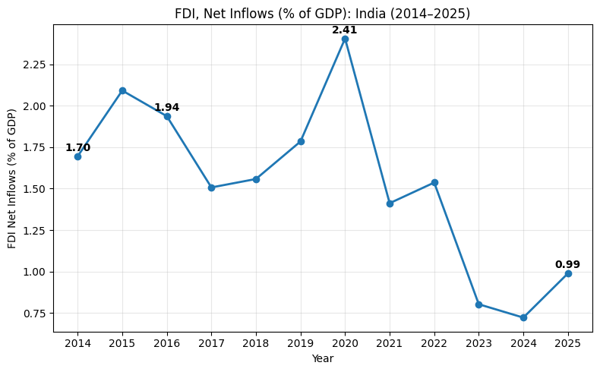
Figure 1. FDI Net Inflows (% of GDP): India, 2014–2025

4.1 Key Data Points
- 2014 (1.70%): starting level for the study period.
- 2015–2016 (2.09% and 1.94%): the two highest readings prior to 2020.
- 2017–2019: inflows eased before climbing again into 2019 (1.79%).
- 2020 (2.41%): the peak value of the entire series.
- 2021–2022: inflows fell back and then partially recovered (1.41% to 1.54%).
- 2023–2024 (0.80% and 0.72%): the two lowest readings of the study period.
- 2025 (0.99%): a modest recovery, though still well below the 2014–2022 range.

4.2 Observations
- Unlike Gross Capital Formation, FDI net inflows do not show a clean W-shape; the series peaks in the pandemic year (2020) rather than troughing in it, and then declines steadily through 2021–2024.
- The 2023–2025 period stands out as the weakest stretch of FDI inflows in the twelve-year window, even as Gross Capital Formation was reaching its highest levels over the same years (Section 5).

5. Univariate Analysis — Gross Capital Formation (% of GDP)
Gross Capital Formation as a share of GDP was plotted over the same period to trace the trajectory of domestic investment activity.
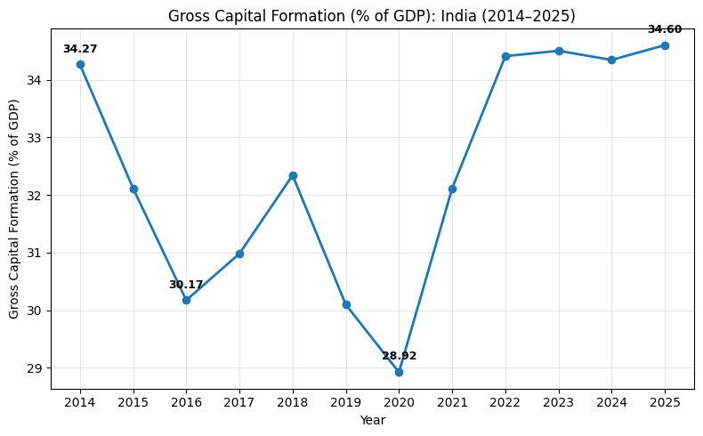
Figure 2. Gross Capital Formation (% of GDP): India, 2014–2025

5.1 Key Data Points
- 2014 (34.27%): highest investment level at the start of the period, serving as the baseline for comparison.
- 2016 (30.17%): first trough, reflecting a slowdown in capital formation and private investment.
- 2020 (28.92%): lowest value of the study period, driven by the COVID-19 disruption.
- 2025 (34.60%): latest available value; Gross Capital Formation recovered to, and slightly exceeded, its 2014 level.

5.2 Overall Pattern
Taken together, these data points describe a W-shaped recovery: a decline from 2014 to 2016, a partial rebound through 2017–2018, a second and sharper decline into 2020, and a sustained recovery from 2021 onward that carried the indicator to a new high by 2025. Between 2022 and 2025 specifically, the indicator stayed within a relatively narrow band of roughly 34–35% of GDP, suggesting the recovery had become steady rather than volatile.

5.3 Economic Phases
The trend can be broken into four broad phases, each associated with a distinct set of contributing factors.

Phase I — Investment Slowdown (2014–2016)
Trend | Gross Capital Formation declined steadily.
Key Drivers | • Twin Balance Sheet problem: companies that had borrowed heavily during 2003–2011 struggled to repay loans as growth slowed, while banks — burdened with rising non-performing assets — became reluctant to extend new credit.  • Excess industrial capacity, with many firms already operating below capacity due to weak domestic and global demand, reducing the incentive to invest in expansion.  • Policy and implementation challenges, including delays in project approvals, land acquisition, and environmental clearances, alongside stalled infrastructure projects.  • A shift in household savings away from productive financial assets and toward valuables such as gold, reducing the pool of savings available for productive investment.

Phase II — Gradual Recovery (2017–2019)
Trend | Investment gradually recovered after the earlier slowdown.
Key Drivers | • Resolution of stressed assets gradually improved investor confidence.  • Credit conditions slowly improved.  • Business activity began recovering after the earlier structural challenges.

Phase III — COVID-19 Shock (2020)
Trend | Gross Capital Formation experienced its sharpest decline in the study period.
Key Drivers | • Nationwide lockdowns  • Supply chain disruptions  • Sharp fall in business activity  • High uncertainty leading to delayed investment decisions

Phase IV — Post-COVID Recovery (2021–2025)
Trend | Investment recovered strongly and then remained relatively stable at a higher level.
Key Drivers | • Economic reopening  • Recovery in domestic demand  • Increased infrastructure investment  • Improved investor confidence

5.4 Why Gross Capital Formation?
Gross Capital Formation is one of the key indicators of investment activity in an economy: it captures spending on fixed assets — infrastructure, machinery, buildings, and equipment — that contribute to future economic growth. Since investment is one of the primary drivers of GDP, tracking Gross Capital Formation offers insight into how investment activity evolved over time and how it responded to major economic events.

6. Bivariate Analysis — FDI vs. Gross Capital Formation
Having examined each indicator separately, the two series were plotted against each other to assess whether FDI inflows and domestic Gross Capital Formation moved together over 2014–2025.

6.1 Scatter Plot
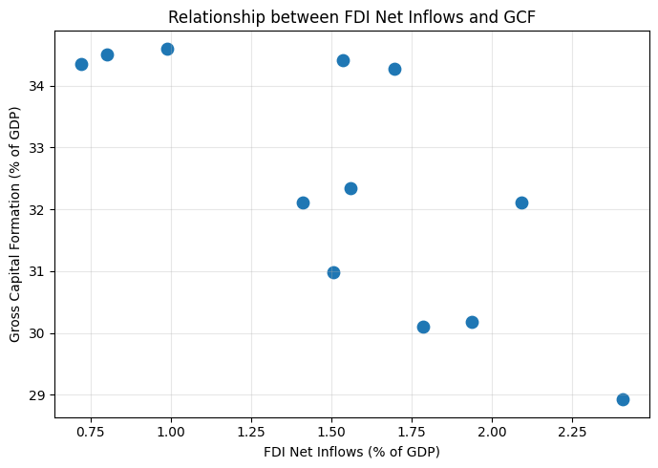
Figure 3. Relationship Between FDI Net Inflows and Gross Capital Formation, 2014–2025
The scatter plot groups the twelve years into two broad clusters: years with lower FDI (roughly 0.7–1.0% of GDP) cluster at higher Gross Capital Formation levels (32–35%), while years with higher FDI (roughly 1.8–2.4% of GDP) cluster at lower Gross Capital Formation levels (29–32%). This pattern runs counter to a simple expectation that stronger foreign investment inflows would coincide with stronger overall capital formation.
6.2 Regression Analysis
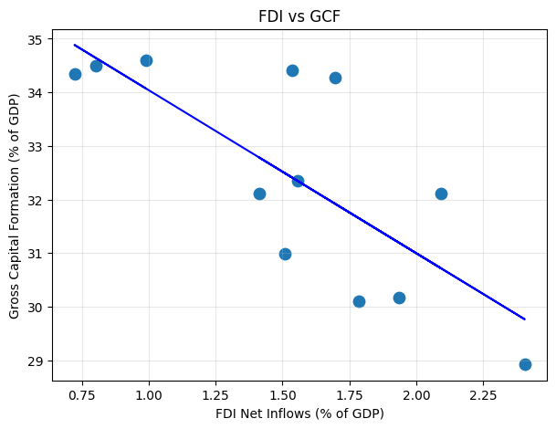
Figure 4. Regression Trend — Gross Capital Formation vs. FDI Net Inflows
A linear regression of Gross Capital Formation on FDI net inflows (% of GDP) was fitted to quantify the relationship shown above.
Statistic | Value
Pearson correlation coefficient (r) | -0.76
Coefficient of determination (R²) | 0.58
Regression equation | GCF = 37.08 − 3.04 × FDI
p-value | 0.004 (statistically significant at the 5% level)
n (years) | 12 (2014–2025)

6.3 Interpretation
- The correlation between the two series is moderate-to-strong and negative (r ≈ -0.76): over this period, years with higher FDI net inflows as a share of GDP tended to have lower Gross Capital Formation, and vice versa.
- The regression indicates that roughly 58% of the year-to-year variation in Gross Capital Formation over this window is associated with variation in FDI net inflows, with the remainder attributable to other factors.
- This is a correlation observed within a single 12-year time series for one country, not a causal claim — both indicators move in response to broader macroeconomic cycles (credit conditions, global capital flows, the pandemic), which can produce a negative relationship between them without one directly causing the other.
- A plausible reading is compositional: GCF is a much broader measure that includes domestic public and private investment, while FDI is one narrower channel within it — so a domestic investment boom (e.g., 2021–2025) can lift GCF even as FDI's own share of GDP shrinks, and periods of weak domestic activity can coincide with relatively larger FDI shares.

7. Key Findings & Conclusion
Summary of Findings
• Gross Capital Formation followed a W-shaped path over 2014–2025: decline (2014–2016), partial recovery (2017–2019), sharp COVID-19 shock (2020), and sustained recovery (2021–2025) to a new high.
• FDI net inflows peaked in the pandemic year (2020) and then declined steadily, reaching their lowest levels of the study period in 2023–2024 before a modest recovery in 2025.
• The two series are moderately-to-strongly negatively correlated (r ≈ -0.76, R² ≈ 0.58, p = 0.004) — the post-2021 domestic investment recovery occurred alongside a declining FDI share of GDP, not alongside it.
• The 2014–2016 slowdown in Gross Capital Formation is consistent with the Twin Balance Sheet problem, excess industrial capacity, and implementation delays; the 2021–2025 recovery is consistent with economic reopening and improved investor confidence.

Overall, the analysis answers the research question in two parts. First, Gross Capital Formation in India exhibited a clear W-shaped recovery between 2014 and 2025, with turning points that align with well-documented economic events — the Twin Balance Sheet problem, and the COVID-19 pandemic — followed by a durable post-2021 recovery. Second, FDI net inflows followed a materially different path over the same period, and the negative correlation between the two series suggests that India's recent investment recovery has been driven predominantly by domestic capital formation rather than by a parallel rise in foreign direct investment as a share of GDP.

8. Limitations & Scope for Further Analysis
- The analysis covers a single country (India) over twelve annual observations; a sample of this size limits the statistical power of the correlation and regression results.
- Correlation between FDI and Gross Capital Formation does not establish causation; both indicators are influenced by shared macroeconomic drivers not modelled here (credit cycles, global capital flows, exchange rates, policy changes).
- The explanations offered for each phase of Gross Capital Formation are grounded in well-documented economic events for the corresponding years, rather than derived directly from statistical testing within this dataset.
- Extending the analysis to other Investment-category indicators (e.g., FDI net outflows, Gross Capital Formation growth rates) or to a peer-country comparison would help validate whether the observed relationship is specific to India or holds more broadly.

9. Appendix

9.1 Indicator Categorisation
Indicators in the World Development Indicators dataset were grouped into six thematic categories using keyword matching on the indicator name, to narrow the full set of 1,510 indicators down to those relevant to this analysis:
- GDP — GDP, Gross domestic product
- Inflation — Inflation, Consumer price, GDP deflator
- Trade — Export, Import
- Employment — Employment, Unemployment, Labor force
- Investment — Foreign direct investment, Gross capital formation, Investment
- Human Capital Investment — Human Capital, Investment on human capital

9.2 Data Source
World Bank, World Development Indicators — India country export, indicators for 1960–2025 (analysis window: 2014–2025).

9.3 Code Walkthrough
The steps below reproduce the core logic used in the underlying Jupyter notebook, in the order it was carried out — from loading the raw World Bank export through to generating the annotated Gross Capital Formation chart in Figure 2. Output-only cells (e.g., .info(), .shape(), .head()) are omitted; only the code that shaped the dataset or produced a result used in this report is shown.

Step 1 — Setup and Data Loading
import pandas as pd
import numpy as np
import matplotlib.pyplot as plt
import seaborn as sns

df = pd.read_excel(
'WorldBank_IND_Dataset.xls',
sheet_name='Data', skiprows=3
)
pd.set_option("display.float_format", "{:.2f}".format)
The World Bank export has three metadata rows above the header, hence skiprows=3. The float-format option only changes how numbers are displayed — the underlying precision used for analysis is unaffected.

Step 2 — Missing Value Assessment
year_cols = df.loc[:, '2014':'2025'].columns
missing_values = df[year_cols].isna().sum()
missing_percentage = missing_values / len(df[year_cols]) * 100

pd.DataFrame({
'missing_values': missing_values,
'missing_percentage': missing_percentage
})
This quantified how much of the 2014–2025 window was missing per year across all 1,510 indicators, and informed the decision (Section 3.2) to retain rather than impute missing values.

Step 3 — Indicator Categorisation
categories = {
"GDP": ["GDP", "Gross domestic product"],
"Inflation": ["Inflation", "Consumer price",
"GDP deflator"],
"Trade": ["Export", "Import"],
"Employment": ["Employment", "Unemployment",
"Labor force"],
"Investment": ["Foreign direct investment",
"Gross capital formation", "Investment"],
"Human Capital Investment": ["Human Capital",
"Investment on human capital"]
}

indicator_groups = {}
for category, keywords in categories.items():
pattern = r'|'.join(keywords)
indicator_groups[category] = main_df[
main_df["Indicator Name"].str.contains(
pattern, case=False, na=False)
]
Each of the six categories is defined by a small set of keywords; str.contains() with a regex OR pattern groups every matching indicator name into the corresponding bucket, which is how the 1,510 indicators were narrowed down to the Investment subset used in this analysis.
Step 4 — Selecting Indicators with Full Coverage
investment = indicator_groups["Investment"].copy()
investment["Missing Years"] = investment.loc[
:, "2014":"2025"].isna().sum(axis=1)

# investment sorted and reviewed by Missing Years, then:
investment.drop(columns="Missing Years", inplace=True)

gcf_gdp = investment[
investment["Indicator Name"]
== "Gross capital formation (% of GDP)"
]
Adding a per-row missing-year count made it possible to compare coverage across all Investment-category indicators and confirm that FDI net inflows (% of GDP) and Gross Capital Formation (% of GDP) were the two series with complete 2014–2025 coverage, before isolating the GCF row for plotting.

Step 5 — Annotated Trend Visualisation (Figure 2)
x = [int(year) for year in year_cols]
y = gcf_gdp.loc[:, year_cols].iloc[0].astype(float)

plt.figure(figsize=(8, 5))
plt.plot(x, y, marker="o", linewidth=2)

key_years = [2014, 2016, 2020, 2025]
for year in key_years:
idx = x.index(year)
plt.annotate(f"{y.iloc[idx]:.2f}", (x[idx], y.iloc[idx]),
textcoords="offset points", xytext=(0, 10),
ha="center", fontsize=9, fontweight="bold")

plt.title("Gross Capital Formation (% of GDP): India (2014–2025)")
plt.xlabel("Year"); plt.ylabel("Gross Capital Formation (% of GDP)")
plt.xticks(x); plt.grid(alpha=0.3)
plt.tight_layout(); plt.show()
This is the exact logic behind Figure 2: the key turning points (2014, 2016, 2020, 2025) are annotated directly on the line chart rather than left for the reader to read off the axis. The FDI trend chart (Figure 1) and the FDI–GCF scatter and regression (Figures 3 and 4) were produced the same way, substituting the FDI series and adding a fitted regression line respectively.

Thank you for reading!

