Investment – (GCF) Gross Capital Formation (% of GDP)

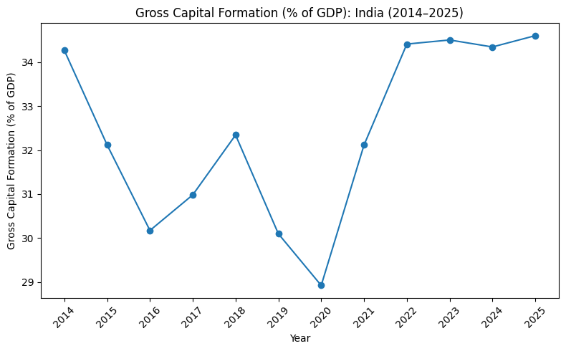
Based on this chart, we can surmise that the period of 2014-2025 saw a W-shaped recovery.

Key Observations for the chart:
- Gross Capital Formation (% of GDP) declined from 34.26% in 2014 to 30.16% in 2016, indicating a slowdown in investment activity.
- Investment recovered gradually between 2016 and 2018, before declining again and reaching its lowest point of 28.91% in 2020, primarily due to the COVID-19 pandemic.
- From 2021 onwards, Gross Capital Formation rebounded sharply, indicating a strong recovery in investment activity.
- Between 2022 and 2025, the indicator remained relatively stable at around 34–35% of GDP, suggesting sustained capital formation.
- Overall, the trend exhibits a W-shaped recovery, with two distinct periods of decline followed by strong recoveries.
- The post-2021 recovery suggests improved investor confidence and increased investment in productive assets following the pandemic-induced slowdown.

Core reasons for the Decline (2014-2016):

Excess Capacity and Low Demand
Twin Balance Sheet Problem
Policy and Implementation Issues
Policy and Implementation Issues
Core Reasons

1. Twin Balance Sheet Problem (Primary Reason)
During the boom years (2003–2011), many companies borrowed heavily to finance infrastructure and industrial projects. As growth slowed, many of these projects generated lower-than-expected returns, making it difficult for firms to repay their loans. At the same time, banks were burdened with rising NPAs, making them reluctant to issue new credit. This reduced private investment and slowed capital formation.
2. Excess Capacity & Weak Demand
Many industries were already operating below their production capacity due to weak domestic and global demand. Since existing capacity was underutilized, firms had little incentive to invest in new plants, machinery, or expansion.
3. Policy & Implementation Challenges
Delays in project approvals, land acquisition, and environmental clearances increased uncertainty for businesses. Combined with several stalled infrastructure projects, this discouraged fresh private investment.
4. Shift in Household Savings
Household savings gradually shifted away from productive assets towards valuables such as gold. As a result, a smaller share of savings was directed towards investments that could expand the economy's productive capacity.

Economic Phases
Phase I — Investment Slowdown (2014–2016)
Trend
Gross Capital Formation declined steadily during this period.
Possible Reasons
- Twin Balance Sheet Problem
- Weak private investment
- Excess industrial capacity
- Weak domestic and global demand

Phase II — Gradual Recovery (2017–2019)
Trend
Investment gradually recovered after the slowdown.
Possible Reasons
- Resolution of stressed assets gradually improved investor confidence.
- Credit conditions slowly improved.
- Business activity began recovering after earlier structural challenges.

Phase III — COVID-19 Shock (2020)
Trend
Gross Capital Formation experienced its sharpest decline during the study period.
Possible Reasons
- Nationwide lockdowns
- Supply chain disruptions
- Sharp fall in business activity
- High uncertainty leading to delayed investments

Phase IV — Post-COVID Recovery (2021–2025)
Trend
Investment recovered strongly and remained relatively stable.
Possible Reasons
- Economic reopening
- Recovery in domestic demand
- Increased infrastructure investment
- Improved investor confidence

Why Gross Capital Formation (% of GDP)?
Gross Capital Formation (GCF) is one of the key indicators of investment activity within an economy. It measures the addition of fixed assets such as infrastructure, machinery, buildings and equipment that contribute to future economic growth.
Since investment is one of the primary drivers of GDP, analysing Gross Capital Formation provides insights into how investment activity has evolved over time and how major economic events have influenced India's growth trajectory.

Research Question
How has Gross Capital Formation (% of GDP) changed in India between 2014 and 2025, and what major economic events influenced this trend?

Questions to Explore
Instead of randomly plotting the graph, ask a few questions first.
1. Did investment increase or decline between 2014 and 2025?
This helps identify the overall trend in capital formation.

2. Were there any significant turning points during the study period?
The objective is to identify years where investment either sharply increased or declined.

3. Do these turning points correspond to major economic events?
Rather than assuming causation, compare the observed trend with well-documented economic events.

4. How resilient was investment after periods of economic slowdown?
This helps understand whether investment recovered quickly or remained weak over time.

