PROJECT NAME

RETAIL SALES DATA PROCESSING AND BUSINESS INSIGHTS GENERATION

SUBMITTED BY,

SAYAN MONDAL
COLLEGE: CMRIT, Bangalore
DATE: 02/06/2026

TABLE OF CONTENTS
- Project Summary

- Business Problem Statement

- System Architecture

- Dataset Overview
  - Raw Dataset Overview
  - Final Dataset Overview

- Data Pipeline
  - Data Ingestion
  - Data Exploration
  - Data Quality Validation
  - PII Protection
  - Data Transformation
  - Final Data Output

- Data Model
  - Fact Tables
  - Dimension Tables
  - Relationships

- Business KPIs

- Dashboard Overview
  - Revenue Analysis
  - Product Analysis
  - Category Trends
  - Regional Analysis

- Business Insights
  - Revenue Performance
  - Product Performance
  - Category Trends
  - Customer Purchasing Behavior
  - Regional Performance

- Assumptions
- Challenges Faced
- Conclusion

- PROJECT SUMMARY

ABC Retail Solutions collects retail transaction data from multiple source systems to support business reporting and decision-making. However, inconsistencies within the datasets, including duplicate transactions, missing values, inconsistent product naming conventions, invalid quantities, varying date formats, and exposure of Personally Identifiable Information (PII), create significant challenges in generating accurate and reliable business insights.
To address these challenges, an end-to-end data engineering solution was designed and implemented using Azure cloud services and modern data processing technologies. The solution ingests retail transaction data and product reference data from source files through Azure Data Factory and stores the raw datasets in Azure Data Lake Storage Gen2. Azure Databricks with PySpark is then used to perform data validation, quality checks, cleansing, transformation, standardization, and PII masking.
The transformation process includes handling missing values, removing duplicate records, standardizing product information, validating transaction data, and securing sensitive customer information through hashing techniques. The processed data is then structured into business-ready datasets and stored in Azure Data Lake Storage for analytical consumption.
To support business intelligence and reporting requirements, curated datasets are integrated with Power BI, where interactive dashboards are developed to provide insights into revenue performance, category-wise sales, regional trends, product performance, and other key business metrics. The solution enables stakeholders to monitor business performance through visually rich dashboards and data-driven KPIs.
The overall architecture follows a scalable and modular design, incorporating Azure Data Factory for orchestration, Azure Databricks for distributed data processing, Azure Data Lake Storage Gen2 for data storage, Azure Monitor for pipeline monitoring, Logic Apps for notifications, and Power BI for visualization and reporting. This approach ensures improved data quality, enhanced data governance, secure handling of sensitive information, and a reliable foundation for business analytics and future scalability.

- BUSINESS PROBLEM STATEMENT

ABC Retail Solutions is a multinational retail organization that operates across multiple cities through both online and offline sales channels. The company collects large volumes of transactional data from different source systems to support business reporting, performance monitoring, and strategic decision-making.
However, the retail datasets received from multiple sources contain several data quality issues that negatively impact the accuracy and reliability of business insights. These issues include duplicate transactions, missing values, inconsistent product naming conventions, invalid transaction quantities, varying date formats, and the presence of sensitive customer information such as email addresses and phone numbers.
Due to these inconsistencies, the organization faces challenges in generating accurate reports and analyzing key business metrics such as total revenue, category-wise sales performance, city-wise revenue distribution, and product-level performance. Inaccurate or incomplete data can lead to incorrect business decisions, reduced operational efficiency, and unreliable reporting outcomes.
To address these challenges, there is a need to develop a robust end-to-end data engineering solution capable of ingesting, validating, cleansing, transforming, and securing retail transaction data before it is consumed for analytics and reporting. The solution must ensure data quality, maintain customer privacy through appropriate PII masking techniques, and produce business-ready datasets that can support reliable business intelligence and visualization.
PROJECT OBJECTIVES
- Ingest retail transaction and product reference data into a centralized storage solution.
- Perform data quality validation and cleansing.
- Handle missing values, duplicates, and invalid records.
- Standardize product and transaction information.
- Implement PII masking for customer email addresses and phone numbers.
- Create business-ready datasets for reporting and analytics.
- Calculate key business KPIs such as Total Revenue, Revenue by Category, and Revenue by City.
- Develop interactive Power BI dashboards for business insights.
- Ensure scalability, maintainability, and data governance throughout the solution

- SYSTEM ARCHITECTURE

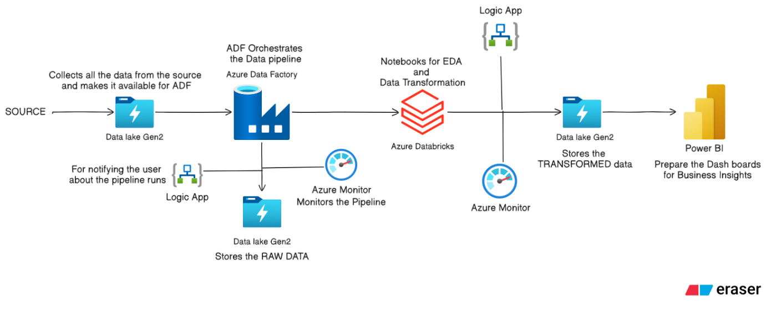
The solution follows a structured and scalable data engineering architecture designed to ingest, process, transform, and visualize retail sales data efficiently.

FIGURE 1: SYSTEM ARCHITECTURE DIAGRAM
The source datasets are initially stored in the Landing Data container within Azure Data Lake Storage Gen2. This layer acts as the entry point for all incoming files and preserves the original source data received from the business.
Azure Data Factory (ADF) is used to orchestrate the data ingestion process. Using the Copy Activity, the source Excel files are converted into CSV format and stored in the Raw Data container. This conversion ensures a standardized file format for downstream processing. Azure Monitor is integrated with the pipeline to track execution status, while Azure Logic Apps are used to send notifications upon successful or failed pipeline execution.
The data stored in the Raw Data container is then processed using Azure Databricks notebooks. Databricks is utilized for Exploratory Data Analysis (EDA), data quality assessment, cleansing, transformation, standardization, and PII masking. After all transformation rules are applied, the curated datasets are stored in the Transformed Data container in Azure Data Lake Storage Gen2.
The transformed datasets serve as the business-ready data layer and are directly connected to Power BI for reporting and visualization. Interactive dashboards are created to analyze key business metrics such as revenue performance, category-wise sales, product performance, and regional sales trends.
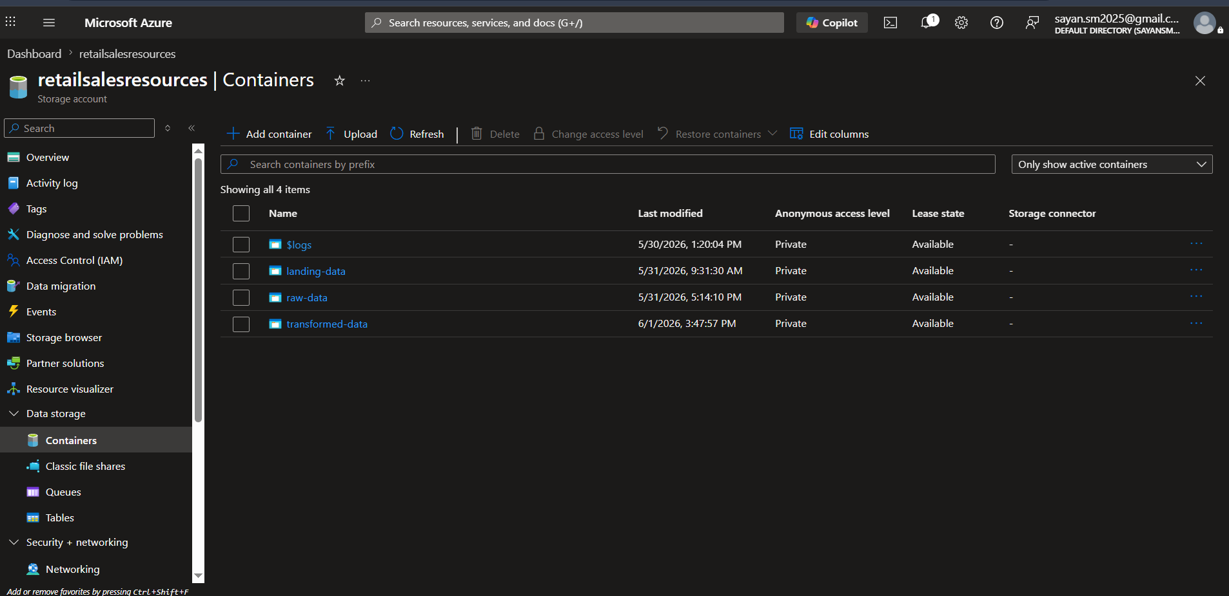
To ensure operational reliability, Azure Monitor continuously tracks pipeline and notebook executions, while Logic Apps provide automated notifications, enabling proactive monitoring of the entire data pipeline.

FIGURE 2: AZURE DATA LAKE STORAGE GEN2
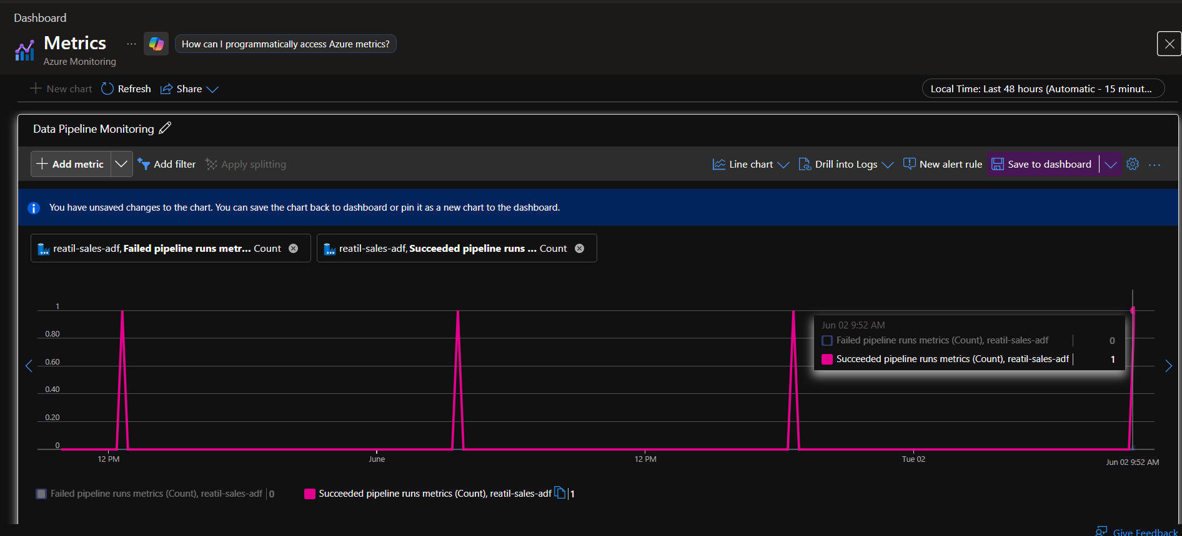

FIGURE 3: AZURE MONIRTOING (DATA PIPELINE MONITORING)

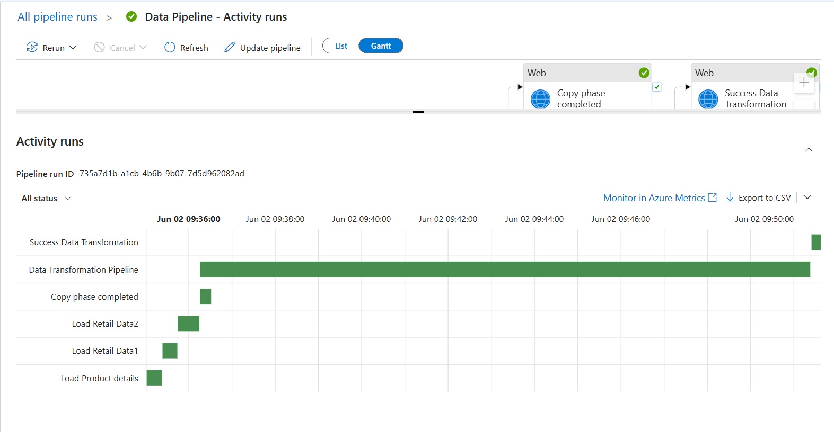

FIGURE 4: AZURE MONIRTOING (DATA PIPELINE MONITORING)

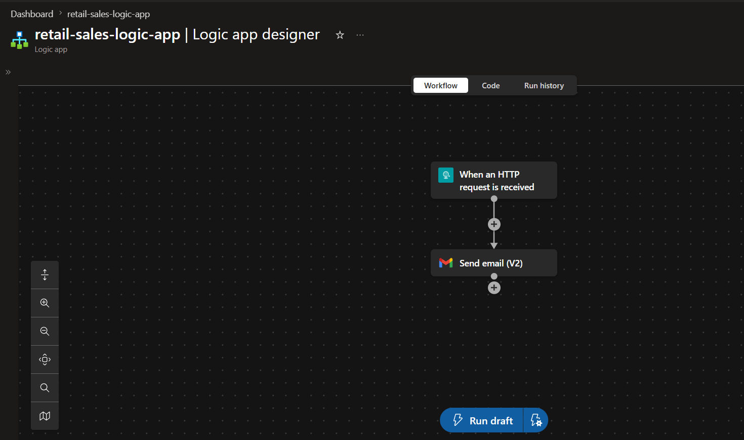

FIGURE 5: LOGIC APP (NOTIFYING SYSTEM)



FIGURE 6: SAMPLE GMAIL

TECHNOLOGY STACK:
- Programming Language: Python
- Cloud Platform: Microsoft Azure
- Data Ingestion & Orchestration: Azure Data Factory (ADF)
- Data Storage: Azure Data Lake Storage Gen2
- Data Processing & Transformation: Azure Databricks
- Data Engineering Framework: Apache Spark (PySpark)
- Pipeline Monitoring: Azure Monitor
- Notifications: Azure Logic Apps
- Data Visualization & Reporting: Power BI
- File Formats: Excel, CSV
- Version Control: GitHub

- DATASET OVERVIEW

RAW DATASET OVERVIEW
The raw dataset was provided in an Excel workbook containing three sheets:
1. PRODUCT DETAILS
This sheet contains the standardized product reference information and includes the following columns:
- product_id
- product_name
- category
- price

2. RETAIL DATA 1
This sheet contains retail transaction records collected from the first source system and includes the following columns:
- transaction_id
- product_id
- product_name
- price
- category
- customer_id
- customer_name
- city
- purchase_location
- transaction_date
- quantity
- discount
- email
- phone
- payment_method
- payment_status

3. RETAIL DATA 2
This sheet contains retail transaction records collected from the second source system. It has the same structure and columns as Retail Data 1.

FINAL DATASET OVERVIEW
After data cleaning, transformation, validation, and PII masking, three business-ready datasets were generated in CSV format.
1. PRODUCTS TABLE
This table contains the standardized product information and includes the following columns:
- product_id
- product_name
- category
- price

2. CUSTOMERS TABLE
This table contains customer information with sensitive data protected using SHA hashing.
Columns:
- customer_id
- customer_name
- email
- phone

3. SALES TABLE
This table contains the cleansed and transformed sales transactions and includes the following columns:
- transaction_id
- customer_id
- product_id
- quantity
- valid_quantity
- city
- transaction_date
- purchase_mode
- payment_method
- discount
- valid_discount
- payment_status

- DATA PIPELINE
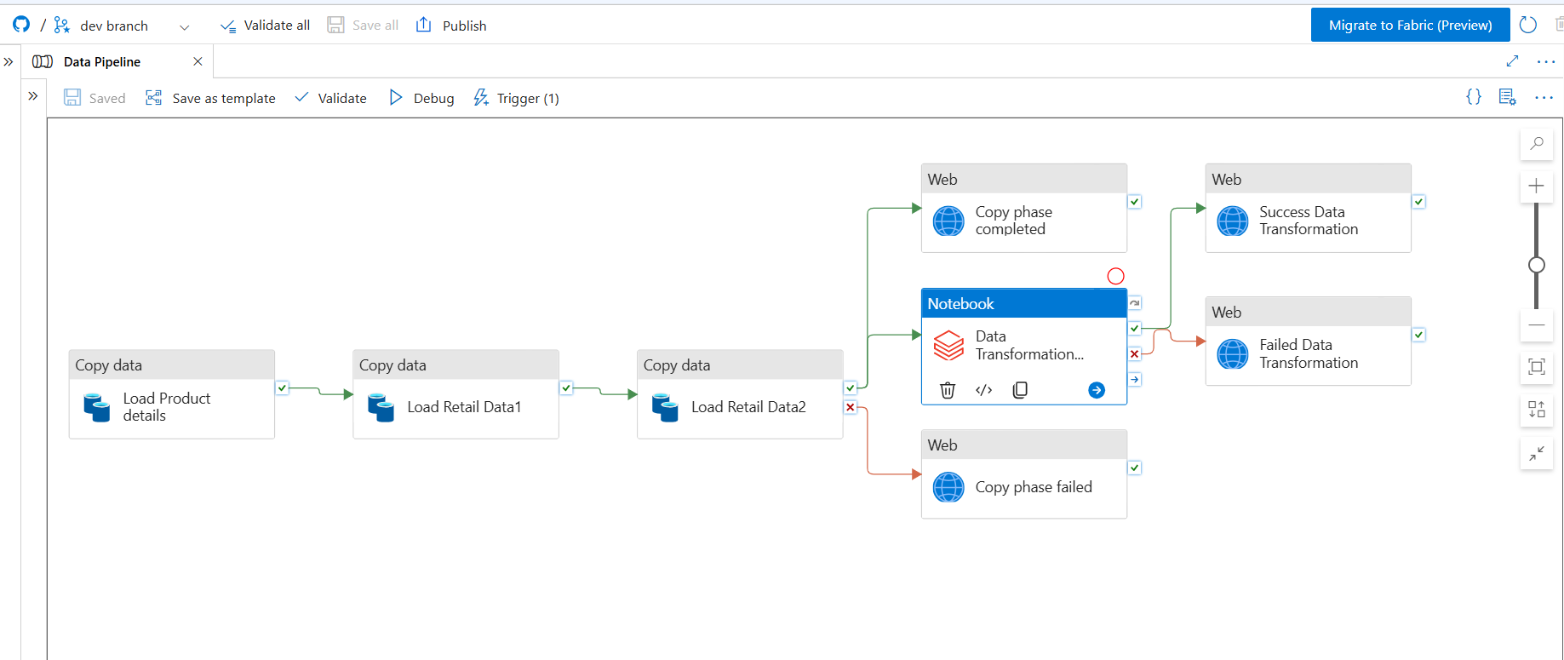

FIGURE 7: DATA PIPLEINE WORKFLOW
DATA INGESTION:
The source data was provided in an Excel workbook containing three sheets: Product Details, Retail Data 1, and Retail Data 2. Azure Data Factory (ADF) was used to ingest the data from the Landing Data container and convert the Excel sheets into CSV format using the Copy Activity. The converted files were then stored in the Raw Data container for further processing. Azure Monitor and Logic Apps were used to track pipeline execution and send notifications upon completion.
DATA EXPLORATION:
Exploratory Data Analysis (EDA) was performed on all three datasets: Product Details, Retail Data 1, and Retail Data 2. The analysis focused on understanding the dataset structure, identifying missing values, detecting duplicate records, validating data formats, and identifying data quality issues. The complete EDA process and findings are available in the Databricks notebooks provided in the GitHub repository.

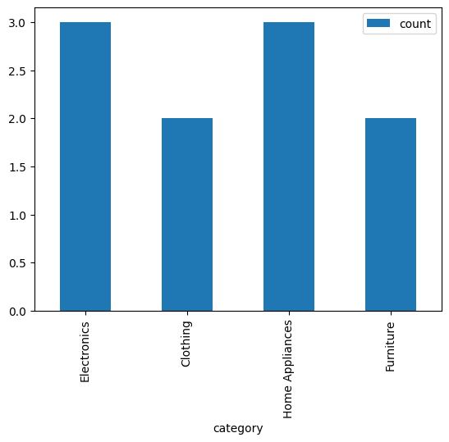
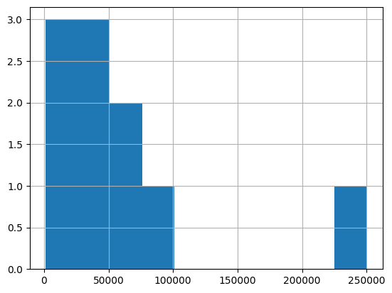

FIGURE 8: PRODUCT PRICE DISTRIBUTION

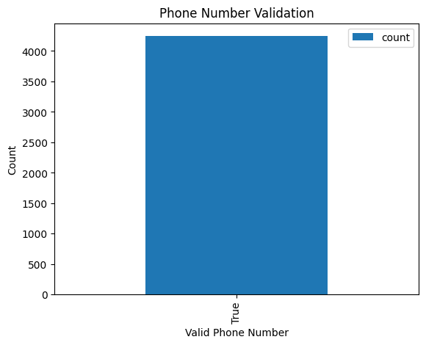
FIGURE 9: PRODUCT CATEGORY DISTRIBUTION
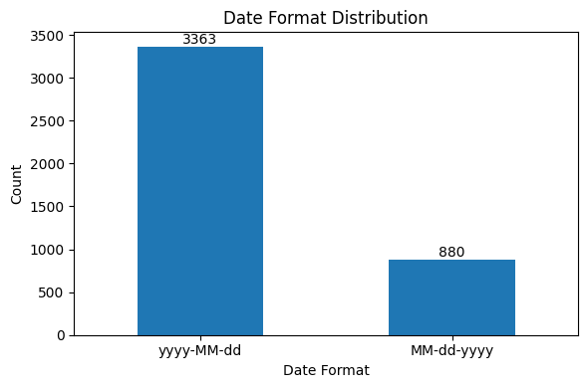

FIGURE 11: DATE FORMAT DISTRIBUTION
FIGURE 10: PHONE NUMBER VALIDATION

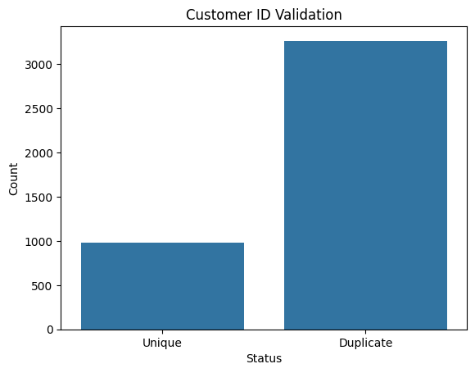
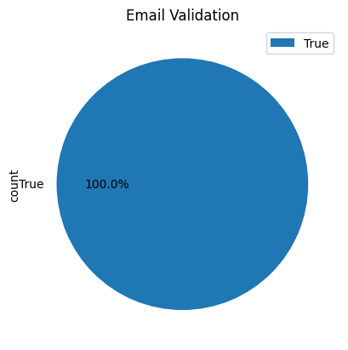

FIGURE 12: EMAIL VALIDATION
FIGURE 13: CUSTOMER ID VALIDATION
DATA QUALITY VALIDATION:
Data quality checks were performed on all datasets to identify and handle potential data issues before transformation. The validation process included checking for missing values, duplicate records, invalid email addresses, invalid phone numbers, invalid quantity values, invalid discount values, inconsistent date formats, and mismatches in product and category information.

PII PROTECTION:
To protect sensitive customer information, email addresses and phone numbers were validated and hashed using SHA. A separate Customers table was created to store customer information independently, reducing the number of records requiring PII masking and improving processing efficiency.

DATA TRANSFORMATION:
Based on the findings from the EDA, the following transformations were performed:
- The product_name and category columns were removed from Retail Data 1 and Retail Data 2 due to a high number of mismatched values when compared with the Product Details reference data.
- The price column was removed from the retail datasets because it contained a large number of missing values.
- A separate Customers table was created to store unique customer records independently from transaction data.
- Creating a separate Customers table reduced the dataset from 8,494 records to 1,963 unique customer records, improving data quality and reducing processing overhead.
- Product and customer reference validation was performed to ensure only valid records were included in the final datasets.
- The transaction_date column was standardized into a consistent format to support reporting and analysis.
- Additional columns, valid_quantity and valid_discount, were created to indicate the validity of quantity and discount values for analytical purposes.

FINAL DATA OUTPUT:
After all validation, cleaning, and transformation steps were completed, the curated datasets were stored in the Transformed Data container in CSV format. These business-ready datasets serve as the source for reporting, analytics, and Power BI dashboard development.

- DATA MODEL
The final data model follows a star schema design, where the Sales table acts as the central fact table and is connected to multiple dimension tables. This structure improves query performance and simplifies analytical reporting in Power BI.
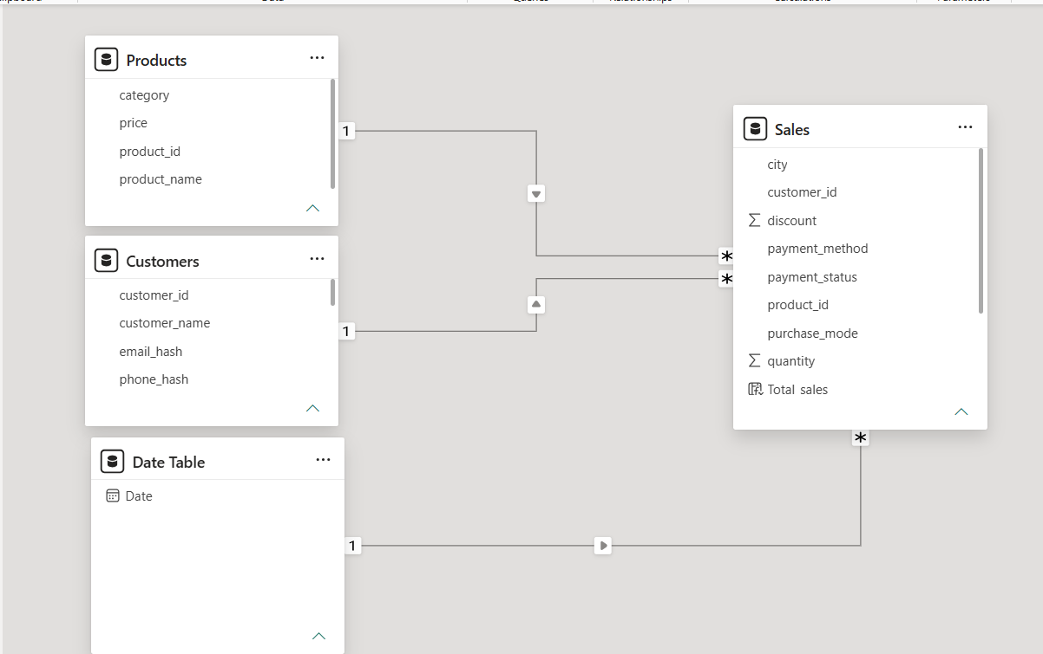

FIGURE 14: DATA MODEL DIAGRAM

FACT TABLES
SALES:
The Sales table contains the transactional data and serves as the central fact table in the model. It stores information related to customer purchases, product sales, quantities, discounts, payment details, purchase modes, and transaction dates.

DIMENSION TABLES
PRODUCTS:
The Products table contains standardized product information, including product identifiers, product names, categories, and prices. It is linked to the Sales table through the product_id column.
CUSTOMERS:
The Customers table contains unique customer records, including customer identifiers and customer names. Sensitive information such as email addresses and phone numbers is stored in hashed format to ensure data privacy. It is linked to the Sales table through the customer_id column.
DATE:
The Date table provides calendar information used for time-based analysis and reporting. It is linked to the Sales table through the transaction date field and enables trend analysis across different time periods.
RELATIONSHIPS
- Products → Sales : One-to-Many relationship using product_id
- Customers → Sales : One-to-Many relationship using customer_id
- Date Table → Sales : One-to-Many relationship using the transaction date
This model enables efficient analysis of sales performance across products, customers, and time dimensions while maintaining a clean and scalable reporting structure.

- BUSINESS KPIs
The following Key Performance Indicators (KPIs) were implemented to measure overall sales performance and support business decision-making.
1. TOTAL REVENUE
Measures the total revenue generated from all sales transactions.
Formula:
Revenue = Quantity × Product Price

2. REVENUE BY CATEGORY
Measures the revenue contribution of each product category and helps identify the best-performing categories.
Formula:
SUM(Revenue) grouped by Category
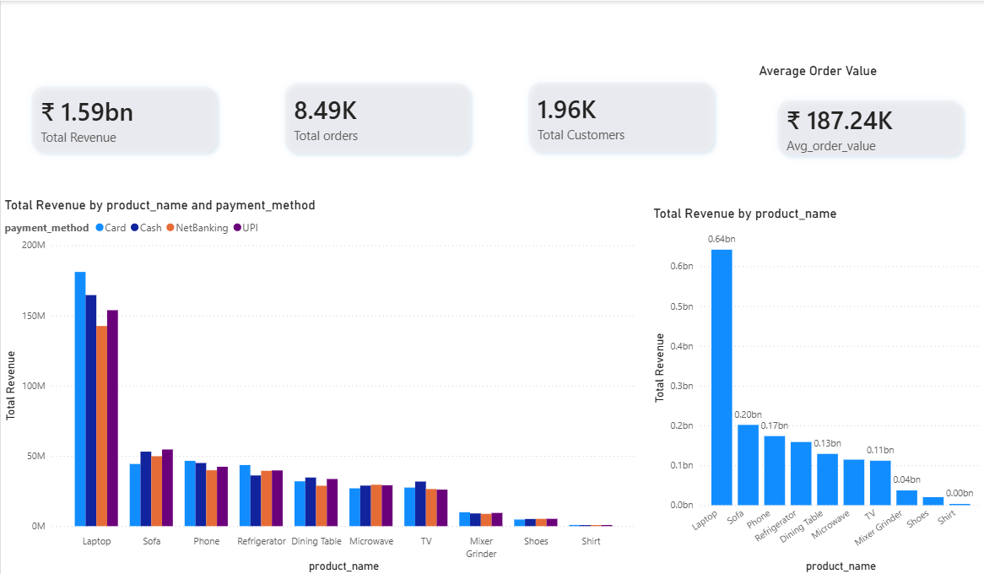

FIGURE 15: BUSINESS KPI

3. REVENUE BY CITY
Measures revenue generated across different cities to identify regional sales performance.
Formula:
SUM(Revenue) grouped by City

4. TOTAL ORDERS
Measures the total number of sales transactions processed.
Formula:
COUNT(Transaction ID)

5. TOTAL CUSTOMERS
Measures the total number of unique customers who made purchases.
Formula:
DISTINCTCOUNT(Customer ID)
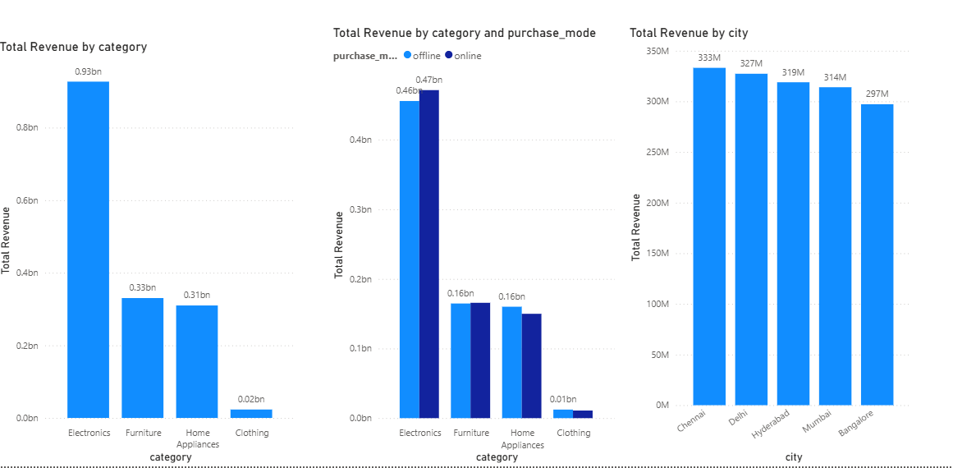

FIGURE 16: BUSINESS KPI

6. AVERAGE ORDER VALUE
Measures the average revenue generated per order.
Formula:
Total Revenue ÷ Total Orders

7. TOP SELLING PRODUCTS
Identifies products generating the highest sales revenue.
Formula:
SUM(Revenue) grouped by Product

8. REVENUE BY PURCHASE MODE
Measures revenue generated through different purchase channels such as online and offline sales.
Formula:
SUM(Revenue) grouped by Purchase Mode

9. REVENUE BY PAYMENT METHOD
Measures revenue distribution across different payment methods.
Formula:
SUM(Revenue) grouped by Payment Method
- DASHBOARD OVERVIEW
The Power BI dashboard is organized into multiple analytical sections to provide insights into sales performance, product trends, category performance, and regional sales distribution. Interactive filters and slicers are available throughout the dashboard to enable dynamic analysis.

REVENUE ANALYSIS
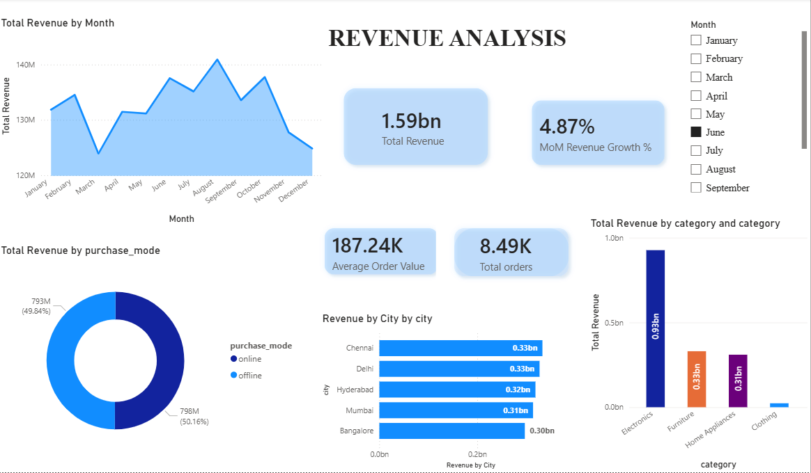
FIGURE 17: REVENUE ANALYSIS

The Revenue Analysis page provides a high-level overview of overall business performance. It includes key KPIs such as Total Revenue, Total Orders, Average Order Value, and Month-over-Month Revenue Growth. The page also visualizes monthly revenue trends, revenue distribution by purchase mode, revenue by city, and revenue contribution by product category, helping stakeholders understand overall sales performance and growth patterns.

PRODUCT ANALYSIS
The Product Analysis page focuses on product-level performance. It highlights the top-selling product, top revenue-generating product, top revenue category, and average discount offered across products. The page includes visualizations for quantity sold by product and purchase mode, revenue generated by each product, category-wise performance, and a detailed product summary table to support product performance evaluation.

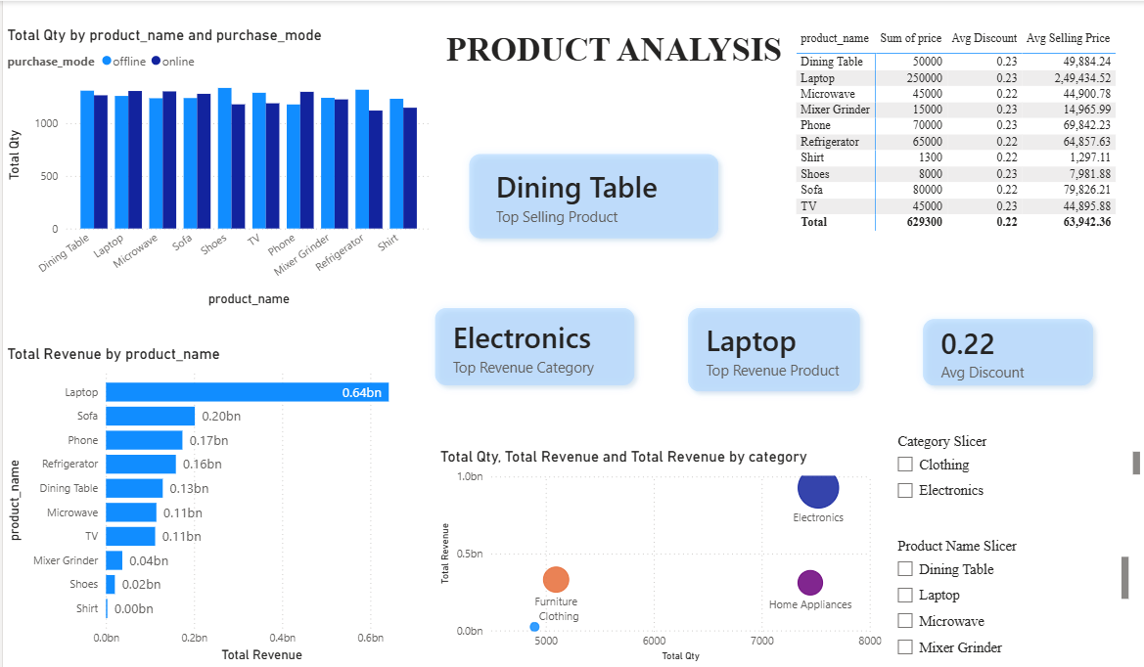

FIGURE 18: PRODUCT ANALYSIS

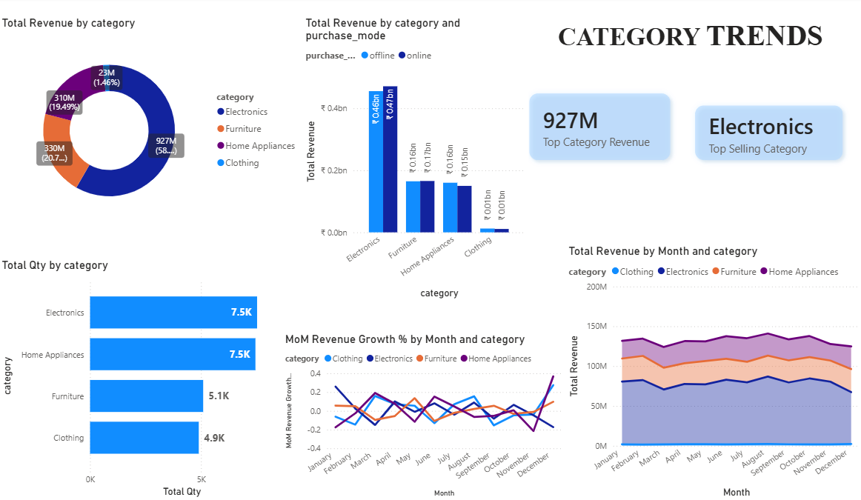
CATEGORY TRENDS

FIGURE 19: CATEGORY TRENDS

The Category Trends page analyzes category-level sales performance and revenue contribution. It includes visualizations showing revenue distribution across categories, quantity sold by category, revenue by purchase mode within each category, monthly revenue trends, and month-over-month revenue growth. Key KPI cards highlight the highest revenue-generating category and its total revenue contribution.
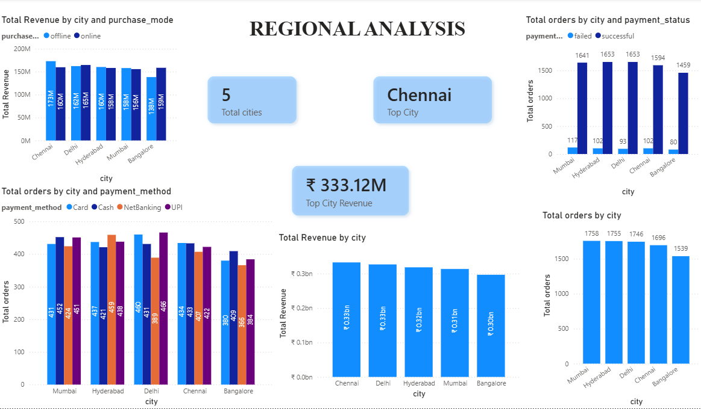
REGIONAL ANALYSIS

FIGURE 20: REGIONAL ANALYSIS

The Regional Analysis page focuses on geographical sales performance across different cities. It includes revenue and order analysis by city, purchase mode, payment method, and payment status. KPI cards highlight the top-performing city, its revenue contribution, and the total number of cities included in the analysis. These insights help identify high-performing regions and support location-based business decision-making.

- BUSINESS INSIGHTS
The analysis of the retail sales data revealed several important business insights:
REVENUE PERFORMANCE
- The business generated a total revenue of approximately 1.59 billion across all transactions.
- Revenue remained relatively stable throughout the year, with peak performance observed during August and October.
- The Month-over-Month Revenue Growth was approximately 4.87% (JUNE), indicating positive sales growth.
PRODUCT PERFORMANCE
- Laptop was the highest revenue-generating product.
- Dining Table recorded the highest quantity sold among all products.
- Electronics emerged as the top-performing category in terms of overall revenue contribution.
- Products in the Electronics category consistently generated significantly higher revenue compared to other categories.
CATEGORY TRENDS
- Electronics contributed the largest share of total revenue, accounting for more than half of overall sales.
- Home Appliances and Furniture were the next highest contributing categories.
- Clothing generated the lowest revenue among all categories.
- Revenue contribution from online and offline purchase modes remained relatively balanced across categories.
CUSTOMER PURCHASING BEHAVIOR
- Online and offline purchase channels contributed almost equally to overall revenue.
- The average order value was approximately 187.24K, indicating a relatively high transaction value per order.
REGIONAL PERFORMANCE
- Revenue generation was distributed across multiple cities, with certain cities contributing significantly higher sales than others.
- Regional analysis helps identify high-performing markets and supports location-based business decision-making.

- ASSUMPTIONS
The following assumptions were made during the implementation of the data pipeline:
- The provided source datasets were treated as the source of truth for all data processing, transformation, and reporting activities.
- Phone numbers were assumed to be valid 10-digit numbers and not contain leading zeros.
- Transaction dates were assumed to follow either the “yyyy-MM-dd” or “MM-dd-yyyy” format and were standardized accordingly during data processing.
- Customer PII information was not required for business analysis; therefore, email addresses and phone numbers were hashed to ensure data privacy and protection.
- All products present in the retail transaction datasets were assumed to have corresponding entries in the Product Details reference table. No additional products outside the Product Details dataset were expected.
- Business analysis was assumed to be performed using a dimensional data model rather than a single denormalized table. Therefore, separate Products, Customers, and Sales tables were created to support efficient reporting and analytics.

- CHALLENGES

During the implementation of the project, the following challenges were encountered:
- Setting up the project environment was initially challenging, as it was my first experience working with Azure services and Databricks for building a data pipeline.
- Converting the source Excel files into CSV format using Azure Data Factory required additional troubleshooting and understanding of the Copy Activity behavior.
- Establishing a connection between Azure Blob Storage and Power BI was challenging due to connectivity and data loading issues. This was resolved by clearing cached connections and validating the data pipeline output.
- While working with PySpark, challenges were faced in filtering data, handling duplicates, retrieving unique values, and managing data overwrites during transformations.
- Understanding how Spark stores and manages output files initially caused confusion when reading and transforming data. This was resolved after gaining familiarity with Spark's file storage structure.
- Since Databricks was a new platform for me, some time was required to become comfortable with notebook development, cluster usage, and data processing workflows.

- CONCLUSION

This project successfully implemented an end-to-end data engineering pipeline for processing retail sales data using Azure Data Factory, Azure Data Lake Storage Gen2, Azure Databricks, PySpark, and Power BI. The solution ingests data from multiple source systems, performs data quality validation, applies necessary transformations, and generates business-ready datasets for reporting and analysis.
Data quality issues such as missing values, inconsistent product information, invalid records, and varying date formats were identified and addressed through a structured transformation process. Customer PII information was secured using hashing techniques to ensure data privacy and compliance with data governance requirements.
The final curated datasets were modeled using a star schema design and integrated with Power BI to create interactive dashboards for revenue analysis, product performance, category trends, and regional insights. The solution enables accurate business reporting, supports data-driven decision-making, and provides a scalable foundation for future analytical requirements.
Overall, this project strengthened my understanding of modern data engineering practices and provided hands-on experience with Azure services, Databricks, PySpark, data modeling, and business intelligence reporting.

