**What is RabbitMQ**

[RabbitMQ](https://www.rabbitmq.com/) is an open-source message broker that enables applications to communicate with each other asynchronously. By acting as a middleman between applications, it decouples the sending and receiving processes, allowing them to operate independently and reliably.

**How RabbitMQ works:**

The core components of RabbitMQ work together in a structured flow to manage and deliver messages.

* Producer: An application that creates and sends messages to the RabbitMQ broker.
* Exchange: Receives messages from producers and routes them to the appropriate queues based on rules called "bindings". There are several types of exchanges for different routing behaviors, including:
  + Direct: Routes a message to queues whose "binding key" perfectly matches the message's "routing key".
  + Fanout: Broadcasts a message to all queues bound to the exchange, ignoring the routing key.
  + Topic: Uses a pattern-matching system to route messages to queues.
* Queue: A buffer that stores messages until they are ready to be sent to a consumer.
* Consumer: An application that receives and processes messages from a queue. It sends an acknowledgment to RabbitMQ once a message is successfully processed, which then deletes the message from the queue.

### 

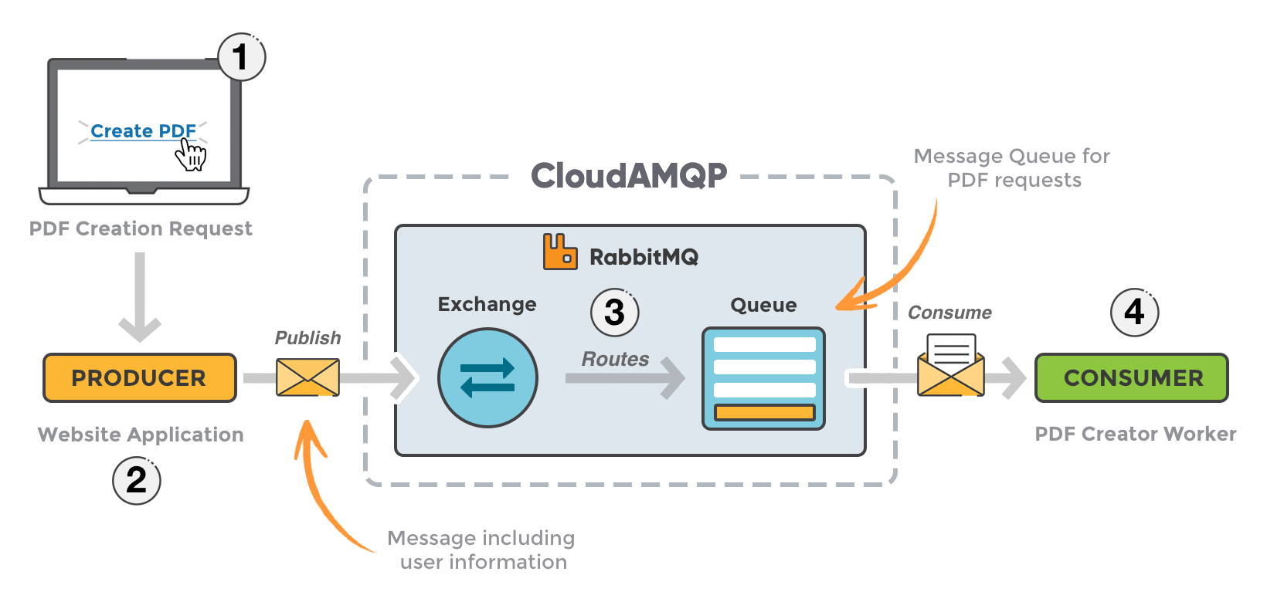

**Simplified Definition of RabbitMQ**

RabbitMQ is a middleman for your applications. Instead of different parts of a system having to talk to each other directly, they can send messages to RabbitMQ, which then reliably delivers those messages to the correct recipient.

You can think of RabbitMQ as a digital post office for your applications.

* You (the Producer) write a message and give it to the post office. You don't need to know where the recipient is or if they are currently home.
* The Post Office (RabbitMQ) receives your message. It uses the address to determine where to send the message and stores it until the recipient is ready.
* The Recipient (the Consumer) later checks their mailbox and finds your message. The recipient can then read it and take action.

**Why use a "post office" for your applications?**

* Keeps tasks from slowing things down: For long-running tasks, like processing an image upload or sending out a mass email, your application can quickly send the request to RabbitMQ and move on. Another service can then process the task in the background, keeping your main application fast and responsive.
* Reliable and safe: If one part of your system goes offline, messages sent to it won't be lost. RabbitMQ stores the messages safely and delivers them when the system comes back online.
* Organizes communication: Different applications or microservices can communicate without being directly linked. This makes the overall system more flexible and easier to update or change.

**Real World Use Case of RabbitMQ**

### 1. Netflix

Use Case: Asynchronous Event Processing for Video Streaming

* Netflix uses RabbitMQ to handle asynchronous messaging for various microservices like recommendations, playback tracking, and user activity events.
* This helps Netflix scale millions of user interactions without blocking the streaming service, ensuring smooth playback and personalized experiences.

### 2. Mozilla

Use Case: Telemetry Data Collection and Processing

* Mozilla collects telemetry data from Firefox browsers worldwide. They use RabbitMQ to queue this data and process it asynchronously.
* This architecture allows handling huge volumes of data reliably without affecting browser performance.

### 

### 3. Instagram

Use Case: Push Notifications and Feed Updates

* Instagram reportedly uses RabbitMQ to send notifications and update user feeds asynchronously.
* This decoupling ensures real-time updates without slowing down the main app’s performance.

### 4. SoundCloud

Use Case: Background Job Processing

* SoundCloud uses RabbitMQ to manage background tasks like transcoding audio files, indexing, and analytics.
* Offloading heavy processing tasks keeps the main user interface responsive and scalable.

**RabbitMQ is an open-source message broker software that enables applications, systems, or services to communicate with each other by sending and receiving messages asynchronously through queues.**

### **Why Do We Use Queues in Real-Time Systems?**

Queues are used in real-time systems to enable reliable, asynchronous communication between components by buffering messages, decoupling producers and consumers, and ensuring smooth handling of variable workloads. This improves system scalability, fault tolerance, and responsiveness by allowing tasks to be processed independently and in a controlled manner without losing or blocking data flow.

### 1. Decoupling Components

* Queues act as a buffer between different parts of a system.
* Producers (senders) and consumers (receivers) don’t have to interact directly or be available at the same time.
* This decoupling makes the system more modular and easier to maintain or scale.

### 2. Handling Variable Load (Load Buffering)

* Real-time systems often face spikes or bursts of data/events.
* Queues absorb these spikes, so consumers can process messages at their own pace without being overwhelmed.
* This prevents system crashes or slowdowns.

### 3. Asynchronous Processing

* Many real-time tasks don’t need immediate processing.
* Using queues allows the system to process tasks in the background, improving responsiveness.
* For example, sending emails, processing payments, or updating analytics can be deferred without blocking the main workflow.

### 4. Reliability and Fault Tolerance

* Queues provide mechanisms to ensure messages aren’t lost if a service goes down.
* Messages can be retried, persisted, or moved to dead-letter queues for later inspection.
* This guarantees that important events are processed eventually, critical for real-time systems.

### 5. Load Balancing

* When multiple consumers pull from the same queue, messages get distributed evenly.
* This helps scale processing horizontally and maximizes resource utilization.

### 6. Smooth Workflow and Ordering

* Queues can guarantee message ordering (depending on the implementation).
* This is crucial for real-time systems where events must be processed in the exact sequence they occurred.

### 

### 7. Temporal Decoupling

* Real-time systems often integrate with external or slow systems.
* Queues enable these slow services to catch up without blocking the entire system.

**Queues in real-time systems help build scalable, resilient, and maintainable architectures by managing timing mismatches, handling bursts, and ensuring reliable message delivery.**