Initialisation:
- The SSH files prevented the project from being cloned
Deleted
- Following the USER_INSTRUCTIONS (devtools::load_all → run_app()) didn’t work unless the second-level, empty “eVAT-v2” folder was removed.
*Note that the following points are based on the project with the inner “eVAT-v2” removed
Removed
Issues raised by Bayer:
- Issue #2 | Graph legend labels sometimes get reset to ENZ and Ra-223 after “run_model” finishes, e.g., when the “reset” has been clicked beforehand.
Likely because the observeEvent for “run_model” is doing too much, including the observeEvent for “reset”.
The reset event has been moved outside the run_model event.
- Issue #4 |
Clifton Insight validation comment: The main reason is likely the two missing arguments: “dist_pfs_intervention” and “dist_os_intervention” in “app_server_generic.R” for treatment_cost_only = f_wrapper_generic(…). The same are also missing when calling f_wrapper_generic() for “treatment_cost_only_ra223”, “treatment_cost_only_enz”, and “treatment_cost_only_third”.
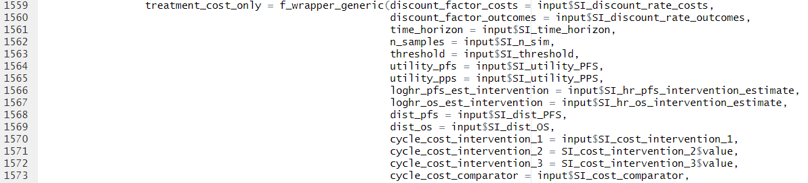
This has now been fixed.
Clifton Insight validation comment: The other possible reason, which has smaller effect, is that set.seed should be reset for AE costs and health state costs in “generate_model_parameters_generic.R” to ensure the number of random numbers used not differ due to if statement.
We’ve put a set.seed at the top of this function to resolve
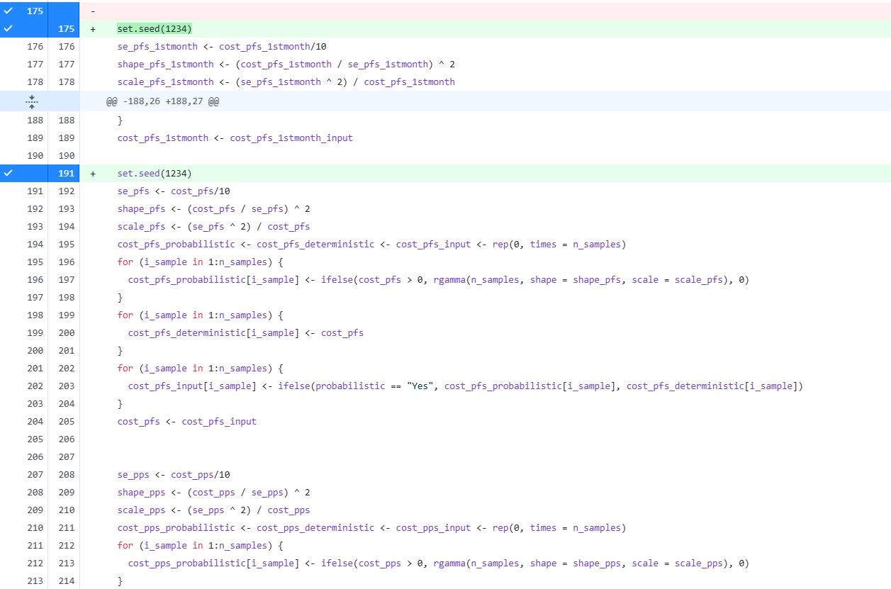
Clifton Insight internal validation identified issues:
- The download buttons for comparator doesn’t work. Consider using different ID for ui.
Now fixed.
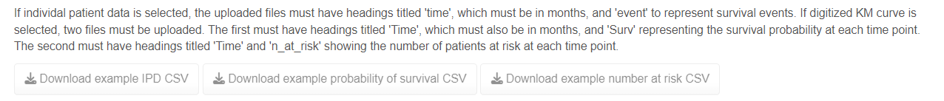
- Cannot find an option for deterministic model. The below error appears if “PSA runs” = 1
Now fixed so model will run with PSA runs = 1
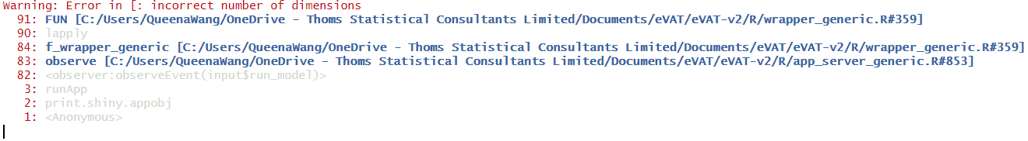
- The error below appears when the PFS or OS data have different formats between the two tabs. For example, one with a sequence column and the other without.
Now fixed so that only relevant columns are used.
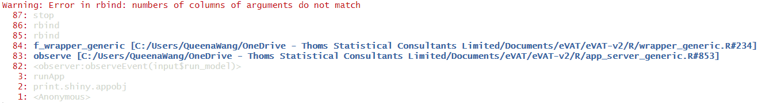
- Should all the “aes_included = …” in “app_server_generic.R” for calculating cost breakdown be aes_included$value instead of hardcoded “Yes”?
Yes, thanks for spotting this. This has now been fixed.
- Likely typos in “generate_model_parameters_generic.R”
This was a typo, thanks.
- In “generate_state_occupancy_1.R”, the argument is “background_mortality”, while the function uses “background_mortality_os”.
In the call to the function in wrapper_generic.R background mortality is set to background_mortality_os so this is OK.
Using the same settings for intervention and comparator (same IPD data or HR = 1, same cost settings, joint models == No, not including AE), cannot return exactly the same results, including costs, LYs (slightly different in CIs), QALYs, PFS curves, etc. (results pasted next page)
For OS, the very small difference is likely due to the location of set.seed, where both arms use the same seed but sample separately.
For PFS, the difference is mainly due to the following screenshotted code,
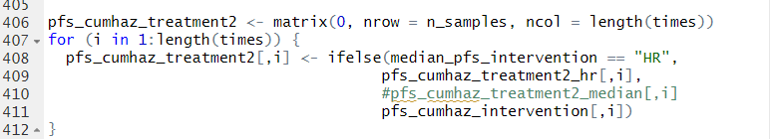
which might reconstruct the data differently, as temporarily changing it to the following gives at least visible overlapping lines.
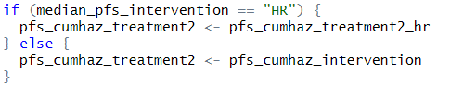
Now fixed code and locations of set.seed so that using same data generates identical results.
