- Air Quality Clustering Analysis Using DBSCAN
- Dataset and Feature Preparation
The dataset contains 200 valid monitoring-station observations. The clustering input features are PM2.5, PM10, NO2, and SO2.
- Standardization Observation
Z-score standardization is necessary because DBSCAN uses distance-based neighborhoods. The pollutant variables can have different numerical scales, so unscaled variables with larger ranges could dominate the distance calculation.
- DBSCAN Results
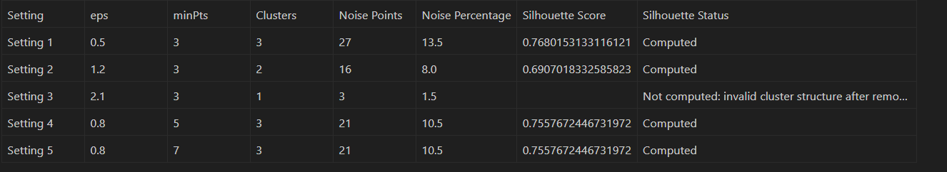
- Effect of eps and minPts

Increasing eps expands the neighborhood radius, which usually connects more observations into clusters and reduces noise. Decreasing eps makes DBSCAN stricter and may create more noise points or fragmented clusters. Increasing minPts requires denser local neighborhoods, which generally increases noise detection and can reduce the number of clusters.

- Cluster Visualizations
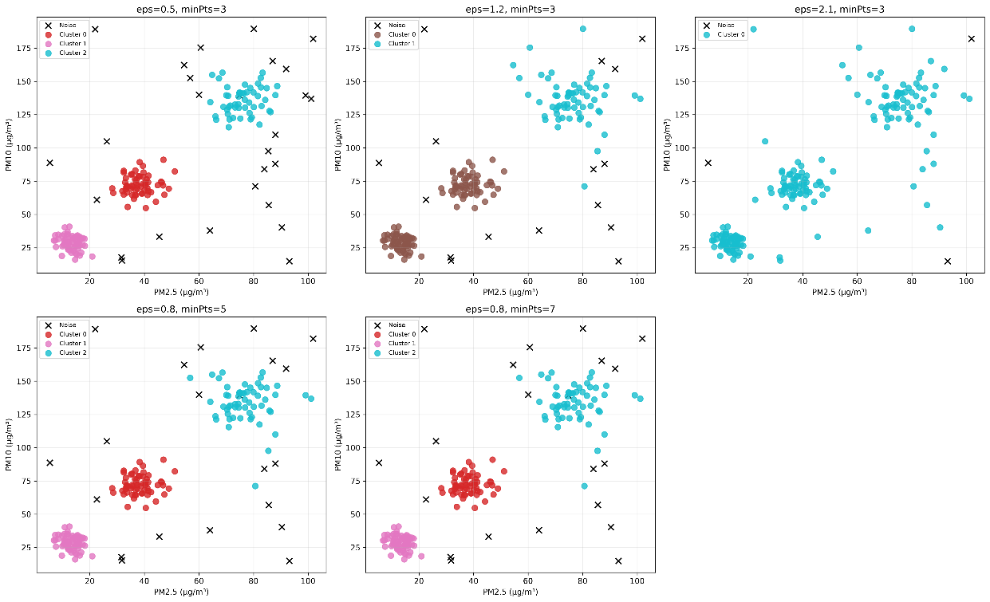
The scatter plots show PM2.5 against PM10 for every DBSCAN parameter setting. Points marked with black crosses are noise points. Cluster separation indicates groups of monitoring stations with similar particulate-matter concentrations.
- Pollutant Concentration Characteristics

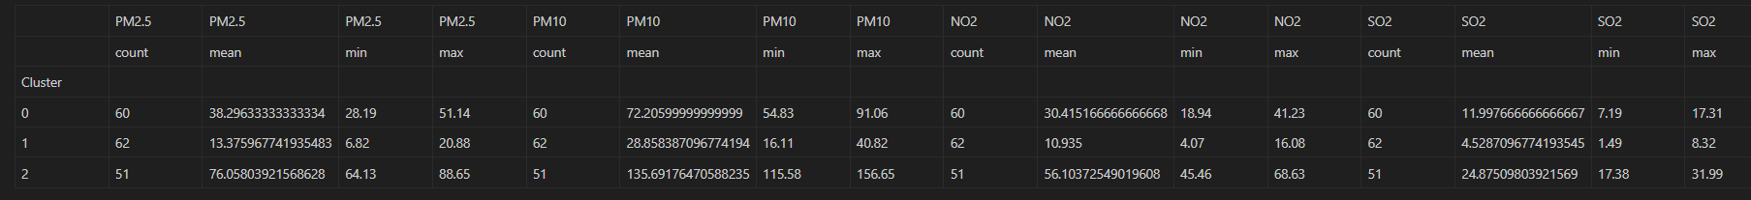

- 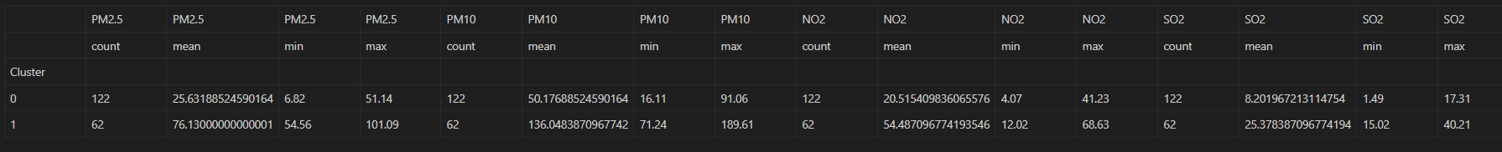

- 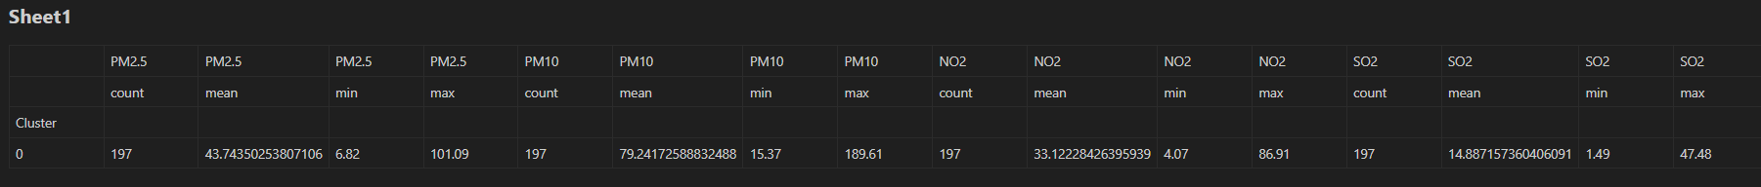

- 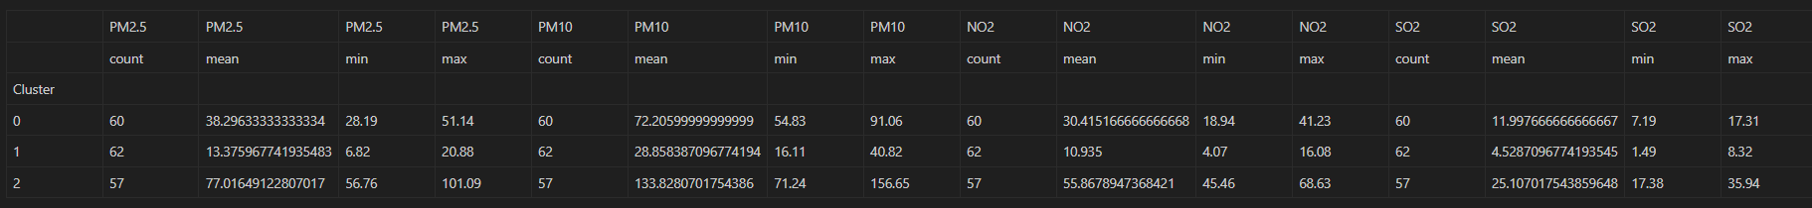

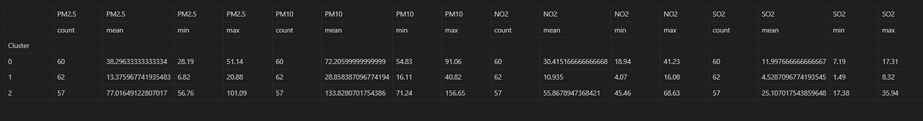
No clusters were formed. all observations were classified as noise.
- Silhouette Score and Noise Points
Silhouette Score is computed only after removing DBSCAN noise points. Noise points have label -1 and do not represent a cluster, so they should not be included in silhouette evaluation. The score cannot be computed when fewer than two valid clusters remain, when the number of clusters is not less than the number of evaluated observations, or when a cluster has only one observation.

- Conclusion
DBSCAN identifies dense groups of monitoring stations with similar pollutant concentrations and labels isolated observations as unusual measurements. The selected eps and minPts values directly control how strict the definition of a dense air-quality group is and how many observations are classified as noise.

