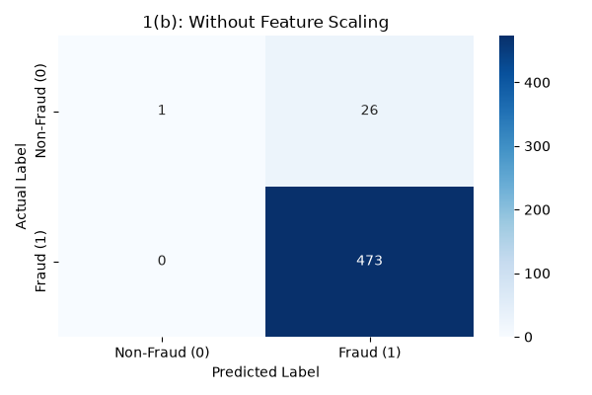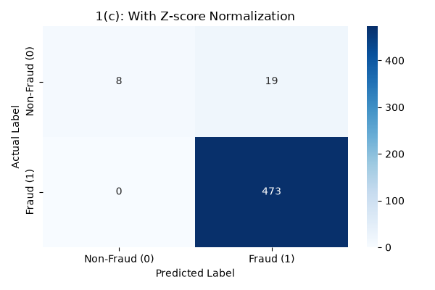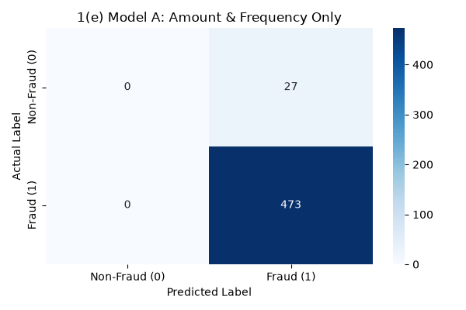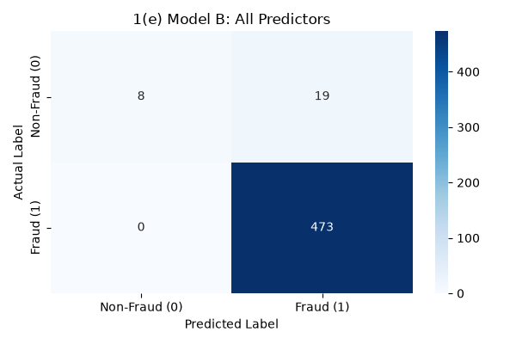

============================================================
1(b): Without Feature Scaling
============================================================
Overall Acc Acc(Non-Fraud) Acc(Fraud) Precision Recall
Fold 1 0.95 0.000000 1.0 0.950000 1.0
Fold 2 0.96 0.000000 1.0 0.960000 1.0
Fold 3 0.95 0.166667 1.0 0.949495 1.0
Fold 4 0.94 0.000000 1.0 0.940000 1.0
Fold 5 0.94 0.000000 1.0 0.940000 1.0

--- Mean Metrics (Across 5 Folds) ---
Overall Acc 0.948000
Acc(Non-Fraud) 0.033333
Acc(Fraud) 1.000000
Precision 0.947899
Recall 1.000000
dtype: float64

--- Combined Confusion Matrix ---
[[ 1 26]
[ 0 473]]
Saved confusion matrix plot as: CM_1b_Without_Scaling.png

============================================================
1(c): With Z-score Normalization
============================================================
Overall Acc Acc(Non-Fraud) Acc(Fraud) Precision Recall
Fold 1 0.96 0.333333 1.0 0.959184 1.0
Fold 2 0.99 0.666667 1.0 0.989796 1.0
Fold 3 0.95 0.166667 1.0 0.949495 1.0
Fold 4 0.95 0.285714 1.0 0.948980 1.0
Fold 5 0.96 0.200000 1.0 0.959596 1.0

--- Mean Metrics (Across 5 Folds) ---
Overall Acc 0.962000
Acc(Non-Fraud) 0.330476
Acc(Fraud) 1.000000
Precision 0.961410
Recall 1.000000
dtype: float64

--- Combined Confusion Matrix ---
[[ 8 19]
[ 0 473]]
Saved confusion matrix plot as: CM_1c_With_Scaling.png

============================================================
1(e) Model A: Amount & Frequency Only
============================================================
Overall Acc Acc(Non-Fraud) Acc(Fraud) Precision Recall
Fold 1 0.96 0.0 1.0 0.96 1.0
Fold 2 0.96 0.0 1.0 0.96 1.0
Fold 3 0.95 0.0 1.0 0.95 1.0
Fold 4 0.94 0.0 1.0 0.94 1.0
Fold 5 0.92 0.0 1.0 0.92 1.0

--- Mean Metrics (Across 5 Folds) ---
Overall Acc 0.946
Acc(Non-Fraud) 0.000
Acc(Fraud) 1.000
Precision 0.946
Recall 1.000
dtype: float64

--- Combined Confusion Matrix ---
[[ 0 27]
[ 0 473]]
Saved confusion matrix plot as: CM_Model_A.png

============================================================
1(e) Model B: All Predictors
============================================================
Overall Acc Acc(Non-Fraud) Acc(Fraud) Precision Recall
Fold 1 0.95 0.285714 1.0 0.948980 1.0
Fold 2 0.98 0.500000 1.0 0.979592 1.0
Fold 3 0.93 0.125000 1.0 0.929293 1.0
Fold 4 0.98 0.500000 1.0 0.979592 1.0
Fold 5 0.97 0.250000 1.0 0.969697 1.0

--- Mean Metrics (Across 5 Folds) ---
Overall Acc 0.962000
Acc(Non-Fraud) 0.332143
Acc(Fraud) 1.000000
Precision 0.961431
Recall 1.000000
dtype float64

--- Combined Confusion Matrix ---
[[ 8 19]
[ 0 473]]
Saved confusion matrix plot as: CM_Model_B.png

OBSERVATIONS FOR PART (g):
1. Without scaling (1b), SGD struggles massively because of large gradient
updates caused by features with massive scales (e.g., balance up to 100,000).
The loss tends to oscillate or overflow, resulting in a poor or random model.
2. With Z-score normalization (1c), the model achieves proper convergence,
yielding significantly higher overall accuracy, precision, and recall.
3. Comparing Model A (2 predictors) and Model B (All predictors):
Model B provides the best predictive performance because it captures complex
patterns utilizing the full set of information (Balance, Time since last,
Total transactions) available for predicting fraudulent activities.

