📘 SALES PERFORMANCE ANALYSIS
AI-Driven Sales Forecasting Dashboard

ABSTRACT
This project focuses on analyzing historical sales data to derive meaningful business insights and predict future sales trends. Businesses often struggle to convert raw sales data into actionable insights due to static reporting and lack of predictive analysis. To address this problem, Python was used for data cleaning, exploratory data analysis, and machine learning model development, while Power BI was used to design an interactive dashboard. A Linear Regression model was applied to forecast monthly sales based on historical trends. The final dashboard presents key performance indicators, regional and category-level sales analysis, and a comparison between actual and predicted sales. This solution enables stakeholders to make informed, data-driven decisions efficiently.

1. INTRODUCTION
In today’s data-driven business environment, organizations generate large volumes of sales data on a daily basis. However, raw sales data alone does not provide meaningful insights unless it is properly analyzed and visualized. Traditional reporting methods often lack interactivity, flexibility, and predictive capabilities, making it difficult for decision-makers to understand trends and plan future strategies.
Sales performance analysis helps businesses identify top-performing regions, products, and categories, while also highlighting areas that require improvement. With the integration of machine learning and interactive dashboards, businesses can not only analyze past performance but also forecast future sales trends. This project demonstrates how data analysis, machine learning, and business intelligence tools can be combined to build an effective sales performance analysis system.

2. PROBLEM STATEMENT
Businesses struggle to convert raw sales data into actionable insights for strategic decision-making. Traditional reporting methods lack interactivity, predictive capabilities, and real-time analysis. This project aims to analyze historical sales data, visualize key business metrics, and predict future sales trends using machine learning, enabling stakeholders to make data-driven decisions efficiently.

3. DATASET DESCRIPTION
The dataset used in this project is a Superstore sales dataset containing approximately 5,000 records. It represents realistic retail sales data and includes the following key attributes:
- Order Date
- Ship Date
- Region, State, City
- Category and Sub-Category
- Product Name
- Sales
- Quantity
- Discount
- Profit
The dataset provides sufficient information to perform sales trend analysis, regional performance evaluation, product analysis, and sales forecasting.

4. TOOLS AND TECHNOLOGIES USED
- Programming Language: Python
- Data Analysis: Pandas, NumPy
- Data Visualization: Matplotlib, Seaborn
- Machine Learning: Scikit-learn
- Dashboard & Reporting: Power BI
- Version Control: GitHub

5. METHODOLOGY
5.1 Data Cleaning
Data cleaning was performed using Pandas to ensure data quality and consistency. Duplicate records were removed, missing values were handled appropriately, and date columns were converted into datetime format. Business rules were validated to ensure sales and profit values were realistic. A cleaned dataset was saved separately to preserve the raw data.

5.2 Exploratory Data Analysis (EDA)
Exploratory Data Analysis was conducted to understand sales patterns and business performance. Various visualizations were created to analyze monthly sales trends, regional sales distribution, category-wise contribution, and product-level performance. The analysis revealed seasonal sales patterns and highlighted top-performing regions and categories.

5.3 Feature Engineering
For machine learning, time-based features were extracted from the order date, including Year and Month. Sales data was aggregated on a monthly basis to reduce noise and make it suitable for forecasting. A lag feature representing previous month sales was also created to help the model capture temporal dependencies.

5.4 Machine Learning Model
Two regression models, Linear Regression and Random Forest, were implemented to forecast monthly sales. Performance was evaluated using Mean Absolute Error (MAE) and R² score. Linear Regression achieved an MAE of 50,873.17 and an R² score of 0.63, while Random Forest showed poorer performance with an MAE of 103,310.90 and a negative R² value (-0.29). Therefore, Linear Regression was selected as the final forecasting model and integrated into the Power BI dashboard.
6. DASHBOARD IMPLEMENTATION (POWER BI)
Power BI was used to design an interactive dashboard with three main pages:
6.1 Executive Overview
This page displays key performance indicators such as Total Sales, Total Profit, and Total Orders. It also includes a monthly sales trend chart to provide a high-level overview of business performance.
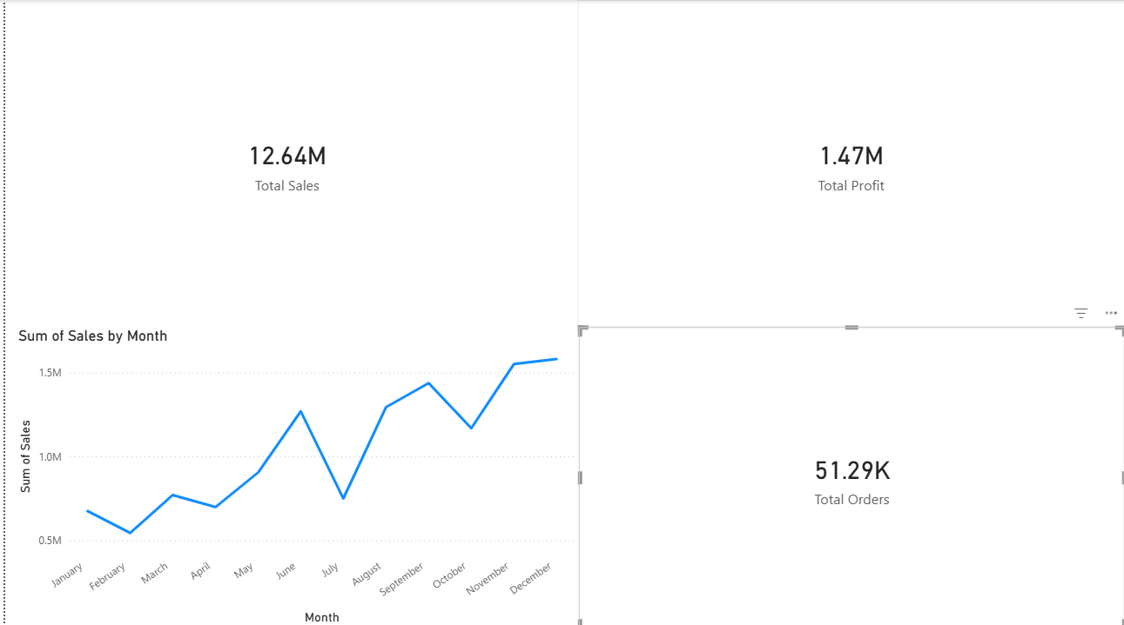
6.2 Sales Performance Analysis
This page analyzes sales by region, category, and product. Bar charts and donut charts are used to highlight top-performing regions and categories, helping stakeholders identify revenue drivers.
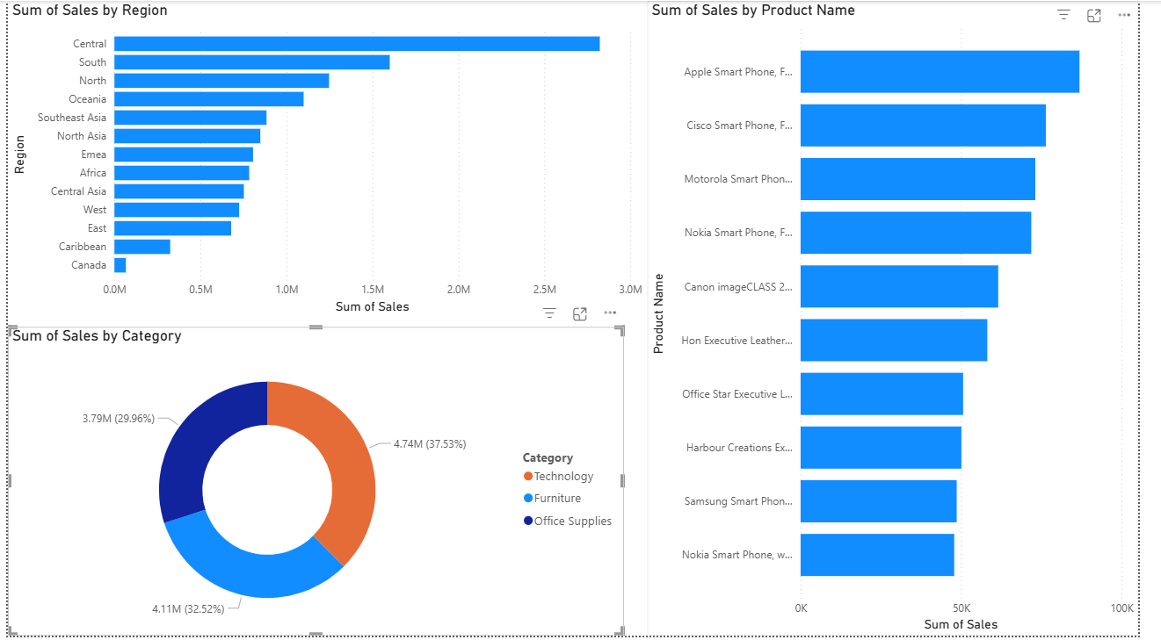
6.3 Sales Forecast
This page compares actual monthly sales with machine-learning-predicted sales. The visualization demonstrates how the model captures overall trends while smoothing short-term fluctuations, providing insights into future sales behavior.
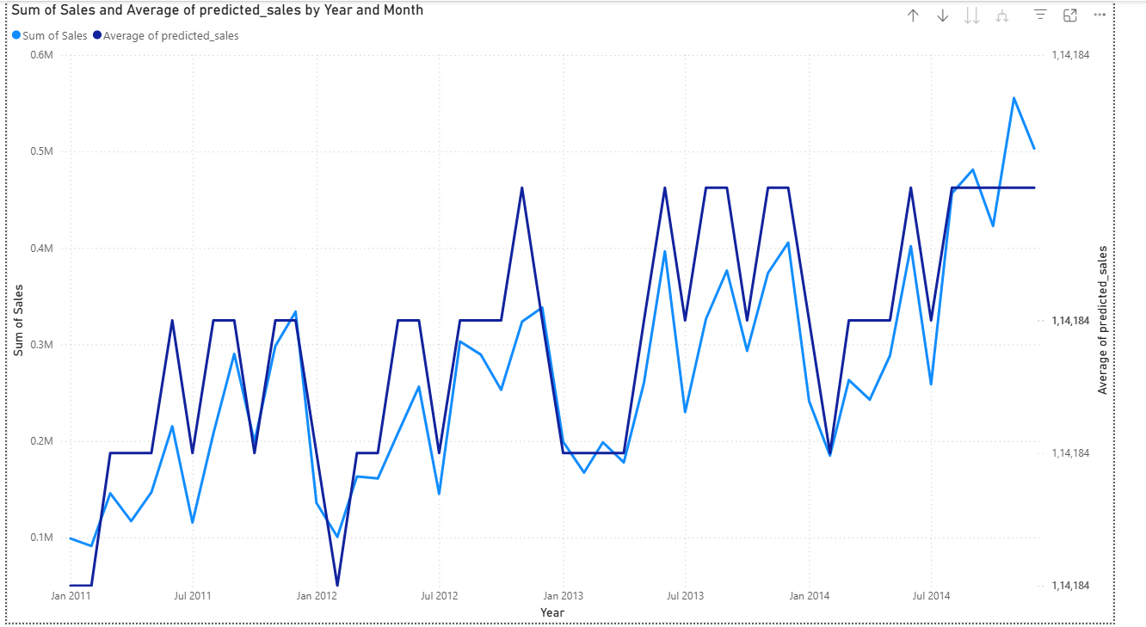

7. RESULTS AND INSIGHTS
- The Central region generated the highest sales among all regions.
- The Technology category contributed the largest share of total sales.
- Monthly sales show a seasonal increase toward the end of the year.
- The machine learning model successfully captured overall sales trends and seasonality.
- Predicted sales closely follow actual sales trends, supporting strategic planning.

8. LIMITATIONS AND FUTURE SCOPE
The model predictions are based solely on historical sales data and do not account for external factors such as promotions, marketing campaigns, economic conditions, or holidays. Prediction accuracy can be further improved by incorporating additional features such as discounts, marketing spend, and customer behavior. Future work may also explore advanced time-series models for enhanced forecasting accuracy.

9. CONCLUSION
This project successfully demonstrates how data analysis, machine learning, and business intelligence tools can be integrated to analyze sales performance and forecast future trends. The AI-driven dashboard provides clear, actionable insights into business performance and supports data-driven decision-making. The solution is scalable and can be extended with additional data sources and advanced models in the future.

10. REFERENCES
- Scikit-learn Documentation
- Power BI Official Documentation
- Pandas Documentation

