A Face Recognition System – An Approach using Local Binary Patterns Histograms

Sayan Saha

*University of Engineering & Management, Kolkata*

*B/5, Plot No. III, Action Area - III, New Town, University Area*

*Kolkata, West Bengal 700156*

*sahasayan98@gmail.com*

***Abstract-* Face recognition is a form of biometric identification that relies on data acquired from the face of an individual. In recent years it has gained popularity among many researchers spanning areas of several disciplines such as image processing, pattern recognition, neural networks. This paper deals with different images of the same person taken in a slightly different angle and reaction of the individual.** **This paper deals with the detection of the face from a face and then recognizing it with the help of LBPH algorithm. The dataset includes some pictures of 5 individuals taken from the internet. The outcome is more or less satisfactory.**

***Keywords – Local Binary Patterns, Histograms***

1. INTRODUCTION

Face recognition is an intrinsic issue in the field of biometric and security system development. Applications of it encompasses the sectors like surveillance, biometric security

situations, government and business

related reliable issues to criminal identification without violation of privacy of the recognized individual. The availability of numerous commercial face recognition systems attests to the significant progress achieved in the research field. Despite these achievements, face recognition continues to be an active topic in computer vision research. This is due to the fact that current systems perform well under relatively controlled environments but tend to suffer when variations in different factors (such as pose, illumination etc.) are present. Therefore, the goal of the ongoing research is to increase the robustness of the systems against different factors. Ideally, we aim to develop a face recognition system which mimics the remarkable capabilities of human visual perception. Before attempting to reach such a goal, one needs to continuously learn the strengths and weaknesses of the proposed techniques in order to determine new directions for future improvements.

In this work, we introduce a new approach for face recognition which considers both shape and texture information to represent the face images. A straightforward extraction of the face feature vector (histogram) is adopted in our algorithm. The face image is first divided into small regions from which the Local Binary Pattern (LBP) features are extracted and concatenated into a single feature histogram efficiently representing the face image. The textures of the facial regions are locally encoded by the LBP patterns while the whole shape of the face is recovered by the construction of the face feature histogram. The idea behind using the LBP features is that the face images can be seen as composition of micro-patterns which are invariant with respect to monotonic grey scale transformations. Combining these micro-patterns, a global description of the face image is obtained.

1. METHODOLOGY

The original LBP operator, introduced by Ojala et al, is a powerful means of texture description. The operator labels the pixels of an image by thresholding the 3x3-neighbourhood of each pixel with the center value and considering the result as a binary number. Then the histogram of the labels can be used as a texture descriptor.

Later the operator was extended to use neigbourhoods of different sizes. Using circular neighbourhoods and bilinearly interpolating the pixel values allow any radius and number of pixels in the neighbourhood. For neighbourhoods we will use the notation (P, R) which means P sampling points on a circle of radius of R.

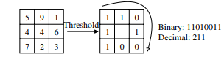

Fig. 1. The basic LBP operator.

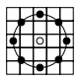

Fig. 2. The circular (8,2) neigbourhood. The pixel values are bilinearly interpolated whenever the sampling point is not in the center of a pixel.

Another extension to the original operator uses so called uniform patterns. A Local Binary Pattern is called uniform if it contains at most two bitwise transitions from 0 to 1 or vice versa when the binary string is considered circular. For example, 00000000, 00011110 and 10000011 are uniform patterns. Ojala et al. noticed that in their experiments with texture images, uniform patterns account for a bit less than 90 % of all patterns when using the (8,1) neighbourhood and for around 70 % in the (16,2) neighbourhood.

We use the following notation for the LBP operator: LBPu2P,R. The subscript represents using the operator in a (P, R) neighbourhood. Superscript u2 stands for using only uniform patterns and labelling all remaining patterns with a single label.

A histogram of the labeled image fl(x, y) can be defined as



in which n is the number of different labels produced by the LBP operator and



This histogram contains information about the distribution of the local micropatterns, such as edges, spots and flat areas, over the whole image. For efficient face representation, one should retain also spatial information. For this purpose, the image is divided into regions R0, R1,...Rm−1 and the spatially enhanced histogram is defined as

 

In this histogram, we effectively have a description of the face on three different levels of locality: the labels for the histogram contain information about the patterns on a pixel-level, the labels are summed over a small region to produce information on a regional level and the regional histograms are concatenated to build a global description of the face.

From the pattern classification point of view, a usual problem in face recognition is having a plethora of classes and only a few, possibly only one, training sample(s) per class. For this reason, more sophisticated classifiers are not needed but a nearest-neighbour classifier is used. Several possible dissimilarity measures have been proposed for histograms:

– Histogram intersection:



– Log-likelihood statistic:



– Chi square statistic (χ2):



All of these measures can be extended to the spatially enhanced histogram by simply summing over i and j. When the image has been divided into regions, it can be expected that some of the regions contain more useful information than others in terms of distinguishing between people. For example, eyes seem to be an important cue in human face recognition. To take advantage of this, a weight can be set for each region based on the importance of the information it contains. For example, the weighted χ2 statistic becomes



in which ꞷj is the weight for region j.

1. DATASET

The dataset has been taken from the site:

<https://cswww.essex.ac.uk/mv/allfaces/index.html>

There are four directories present and we have used the dataset from the directory named “faces94”. The details of the dataset:

* Total number of individuals: 395
* Number of images per individual: 20
* Total number of images: 7900
* Gender:  contains images of male and female subjects
* Race:  contains images of people of various racial origins
* Age Range:  the images are mainly of first year undergraduate  students, so the majority of individuals are between 18-20 years old but some older individuals are also present.
* Glasses: Yes
* Beards: Yes
* Image format: 24bit colour JPEG
* Camera used: S-VHS camcorder
* Lighting: artificial, mixture of tungsten and fluorescent overhead

1. RESULT ANALYSIS

To assess the effectiveness of the proposed system, we have calculated some values:

1. Recall value:

The precise definition of recall is the number of true positives divided by the number of true positives plus the number of false negatives. The recall value obtained here is 1.0.

1. Precision value:

Precision is defined as the number of true positives divided by the number of true positives plus the number of false positives. The precision value obtained here is 1.0.

1. F1 score:

The F1 score is the harmonic mean of precision and recall taking both metrics into account in the following equation:

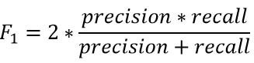

The F1 score obtained here is 1.0.

We have also shown the confusion matrix as below:

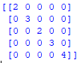

Also to find out the frequency distribution we plot the histogram as well:

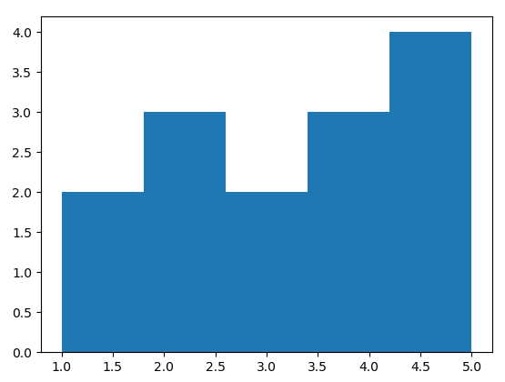

1. FUTURE SCOPE

Although we clearly showed the simplicity of LBP-based face representation extraction and its robustness with respect to facial expression, aging, illumination and alignment, some improvements are still possible. For instance, one drawback of our approach lies in the length of the feature vector which is used for face representation. Indeed, using a feature vector of considerably greater length slows down the recognition speed especially, for very large face databases. A possible direction is to apply a dimensionality reduction to the face feature vectors. However, due to the good results we have obtained, we expect that the methodology presented here is applicable to several other object recognition tasks as well.

1. REFERENCES

* Face Recognition with Local Binary Patterns :Timo Ahonen, Abdenour Hadid, and Matti Pietik¨ainen(2006)
* Phillips, P., Grother, P., Micheals, R.J., Blackburn, D.M., Tabassi, E., Bone, J.M.: Face recognition vendor test 2002 results. Technical report (2003)
* Zhao, W., Chellappa, R., Rosenfeld, A., Phillips, P.J.: Face recognition: a literature survey. Technical Report CAR-TR-948, Center for Automation Research, University of Maryland (2002)
* Phillips, P.J., Wechsler, H., Huang, J., Rauss, P.: The FERET database and evaluation procedure for face recognition algorithms. Image and Vision Computing 16 (1998) 295–306
* Turk, M., Pentland, A.: Eigenfaces for recognition. Journal of Cognitive Neuroscience 3 (1991) 71–86
* Etemad, K., Chellappa, R.: Discriminant analysis for recognition of human face images. Journal of the Optical Society of America 14 (1997) 1724–1733
* Wiskott, L., Fellous, J.M., Kuiger, N., von der Malsburg, C.: Face recognition by elastic bunch graph matching. IEEE Transaction on Pattern Analysis and Machine Intelligence 19 (1997) 775–779
* Moghaddam, B., Nastar, C., Pentland, A.: A bayesian similarity measure for direct image matching. In: 13th International Conference on Pattern Recognition. (1996) II: 350–358
* Ojala, T., Pietik¨ainen, M., M¨aenp¨a¨a, T.: Multiresolution gray-scale and rotation invariant texture classification with local binary patterns. IEEE Transactions on Pattern Analysis and Machine Intelligence 24 (2002) 971–987
* Ojala, T., Pietik¨ainen, M., Harwood, D.: A comparative study of texture measures with classification based on feature distributions. Pattern Recognition 29 (1996) 51–59