**Introduction**

Medicinal plants have played a crucial role in human healthcare for centuries, serving as a rich source of therapeutic compounds with diverse pharmacological properties. These plants contribute significantly to traditional medicine systems worldwide and have been the foundation for the development of numerous pharmaceutical drugs. According to **IUCN (International Union for Conservation of Nature)** records, many medicinal plants are on the verge of extinction, so employing image processing and computer vision algorithms to distinguish proof of medicinal plants is critical. As a result, the digitalization of beneficial therapeutic plants is critical for biodiversity preservation.

The traditional methods of plant identification rely heavily on botanical expertise and often involve manual examination of morphological features. However, these methods can be resource-intensive, prone to human error, and may not be feasible for individuals without specialized training. Machine learning, particularly in combination with image processing techniques, offers a transformative solution to address these challenges.

Researchers in Indonesia[1] utilized local binary patterns to extract the leaf texture of 30 different medicinal plants and then applied probabilistic Neural Networks to automatically classify the herbal leaves, achieving a classification accuracy of just over 56%. In Reference [2], the researchers utilized a support vector machine (SVM) and DL Neural Networks to automatically classify 20 different herbs found in Malaysia, using a mobile application. The mobile application reported spending only 2 s for processing the input leaf image and returning the classification results, with a classification accuracy of 93%. Similarly, in Reference [3], a fusion of fuzzy local binary pattern and fuzzy colour histogram, using product decision rules, was performed to enable the automatic identification of 51 medicinal plant species commonly found in Indonesia. Probabilistic Neural Networks were used to classify colour histograms, reportedly achieving an accuracy of just over 74%.

In this comprehensive report, our approach centres around the utilization of a simplified Convolutional Neural Network (CNN) model for the purpose of classifying medicinal plants. To achieve this objective, various pre-trained CNN models, including ResNet, EfficientNet, and MobileNet, have been implemented and rigorously evaluated. Subsequent sections of this report meticulously elucidate the project's intricacies, outlining its overarching objectives, the dataset employed in our endeavours, and a thorough examination of the implementations, as well as a detailed analysis of the performance metrics of the deployed models.

**Aim**

The primary aim of this project is to develop and implement a robust system for the identification of medicinal plants through the utilization of image processing techniques and state-of-the-art machine learning algorithms. This entails achieving high accuracy and efficiency in the classification of diverse medicinal plant species, contributing to the advancement of automated plant identification systems and supporting applications in biodiversity conservation, herbal medicine, and pharmacological research.

**Objectives**

1. Dataset Acquisition and Preprocessing

-Collect a comprehensive and relevant dataset for the classification project encompassing images of all medicinal plants.

- Utilize data preprocessing techniques to load the dataset into a structured dataframe, addressing data skewness and implementing necessary preprocessing steps.

- Conduct a preliminary examination of sample images, including an assessment of their shapes, to enhance the understanding of the dataset's characteristics.

2. Implementation of Classification Models

- Develop and implement classification models based on Convolutional Neural Networks (CNNs) for the accurate identification of medicinal plants.

- Employ pre-trained CNN models such as ResNet, EfficientNet, and MobileNet to enhance the classification performance.

- Fine-tune the models as needed to achieve optimal results.

3. Evaluation and Analysis

- Conduct a comprehensive evaluation of the trained classification models, employing various performance metrics such as accuracy, precision, recall, and F1 score.

- Analyze the effectiveness of different CNN models, comparing their performances to identify the most suitable approach for medicinal plant classification.

- Provide insights and recommendations based on the evaluation results to guide further improvements or applications.

**Software Requirements**

|  |  |
| --- | --- |
| Distribution | Annaconda and Google Colab |
| API | Keras |
| Framework | Tensorflow |
| Packages | Matplotlib, Numpy, Pandas, Scikit-Learn, Seaborn |
| Language | Python 3.11 |
| IDE | Jupyter Notebook |
| GPU Architecture | Google Colab |
| Applications | Labelling, Tensorboard |

**Data Acquisition and Preprocessing**

**Materials/Resources**

In this study, we leverage a dataset sourced from Kaggle, specifically curated for medicinal plant leaf classification. This dataset encompasses imagery representative of 40 distinct Indian leaf varieties, celebrated for their significant medicinal attributes. The utilization of such a dataset presents a valuable opportunity to contribute to the domains of healthcare, botanical research, and the application of machine learning methodologies.

The dataset comprises a total of 5945 raw, manually captured images of medicinal plants. Each plant class within the dataset is meticulously represented, with an average of 150 images per class. This comprehensive dataset is instrumental in facilitating the training and evaluation of our machine learning models for accurate medicinal plant classification. Some sample images are shown randomly from the dataset:

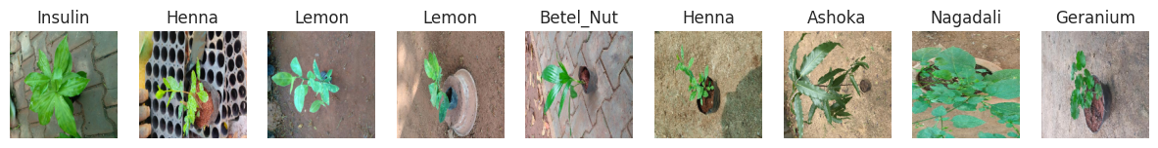

[Dataset Link](https://www.kaggle.com/datasets/warcoder/indian-medicinal-plant-image-dataset)

**Preprocessing**

Pre-processing is taken into account, a really common process in computer vision applications. Preprocessing techniques are designed to stress the image aspect, which might help the popularity process or be useful within the deep learning training phase to eliminate unwanted noise. The preprocessing procedure applied to the pictures extracted from JPG files is as follows:

• Normalizing the pixel values of images.

• Cropping the images to remove any zero-valued pixels surrounding the images.

We transformed all of the photographs to the same size of 224 by 224 pixels because the information set is not uniform, and the images are of varying sizes. As a result of the RGB reordering, the final input to the proposed model is delivered as 224 x 224 x 3 pictures. It is worth noting that the data set is restricted. As a result, we used a 20-degree rotation range for the data augmentation. The JPG photos were flipped horizontally and vertically to expand the knowledge set considerably

We spilt the data images into (training + validation) and test datasets in 0.1 test size ratio. To do that we use train_test_split() function from scikit-learn.

Table of 3 datasets:

|  |  |  |
| --- | --- | --- |
| **Dataset** | **Number of Images** | **Resolution** |
| Training | 4208 | 224 x 224 x 3 |
| Validation | 1052 | 224 x 224 x 3 |
| Testing | 585 | 224 x 224 x 3 |

**Implementation of Classification Model**

**Proposed Model**

Analyzing the efficiency of deep learning across a wide range of tasks involving medicinal plants and identifying the dominant deep learning classifier algorithms employed for these tasks poses an intricate difficulty. An analysis of primary research reveals that deep learning methods, encompassing families like VGG16 ([Paulson and Ravishankar, 2020](https://ieeexplore.ieee.org/document/9489112)), CNN ([Akter and Hosen, 2020](https://www.researchgate.net/publication/366445600_HERBAL_LEAF_RECOGNITION_USING_MASK-REGION_CONVOLUTIONAL_NEURAL_NETWORK_MASK_R-CNN);  [Paulson and Ravishankar, 2020](https://www.researchgate.net/publication/366445600_HERBAL_LEAF_RECOGNITION_USING_MASK-REGION_CONVOLUTIONAL_NEURAL_NETWORK_MASK_R-CNN))have attained accuracy levels surpassing 90% for tasks linked to categorizing, recognizing, and segmenting Medicinal Plant Species.

The transfer learning method is utilized to educate a convolutional neural network in this article (CNN). This paper provides an upgraded convolutional neural network mobile net v2 algorithm based on deep learning to achieve this purpose. The methodology for detecting medical plants supported by photos that have been proposed is described. We have extended the architecture of the mobile net v2 family and used photos to train the models. The proposed method comprises image processing algorithms for detecting leaves and extracting significant leaf attributes for a few deep learning classifiers. When it comes to categorizing leaf images with typical plant traits, including shape, vein, texture, and several features, these deep learning classifiers are grouped based on their performance.

Hence as per the theoretical studies so far, we used the [MobileNetv2](https://tfhub.dev/google/tf2-preview/mobilenet_v2/feature_vector/4) pretrained model from the keras-hub.

**Why use MobileNetv2 (For Feature Extraction)**

MobileNetV2 builds upon the success of its predecessors by introducing novel design strategies to enhance performance in terms of accuracy and speed. Leveraging depth wise separable convolutions, efficient inverted residuals, and linear bottlenecks, MobileNetV2 achieves a remarkable balance between model complexity and computational efficiency.

In the context of our classification project, MobileNetV2 serves as a robust feature extractor. Its ability to capture intricate patterns and representations within images makes it particularly suitable for tasks like medicinal plant classification. The pretrained weights of MobileNetV4, learned from large-scale datasets, enable the model to understand hierarchical features and nuances present in diverse plant images.

While MobileNetV2 provides a strong foundation, fine-tuning the model on our medicinal plant dataset enables it to adapt to the specific features and characteristics of the plant images. This fine-tuning process further enhances the model's ability to accurately classify different medicinal plant species.

**Implementation**

In the concluding phase of our classification model training, a systematic approach was adopted. The input images were directed through the MobileNetV2 model, serving as a proficient feature extractor. Subsequently, the feature vectors were channelled through a fully connected dense layer and culminated in the final softmax layer for classification purposes. The selection of the Adam optimizer was deemed optimal, aligning with the standard practice for classification tasks due to its adaptive learning rate properties and efficacy in handling non-stationary data distributions.

Notebook Link – [Click Here](https://colab.research.google.com/drive/1ge2mYgl1LOUHXhlN_dXvkxZGky2bwmzY?usp=sharing)

The structural composition of the model, along with details regarding trainable and non-trainable parameters, is meticulously delineated below:

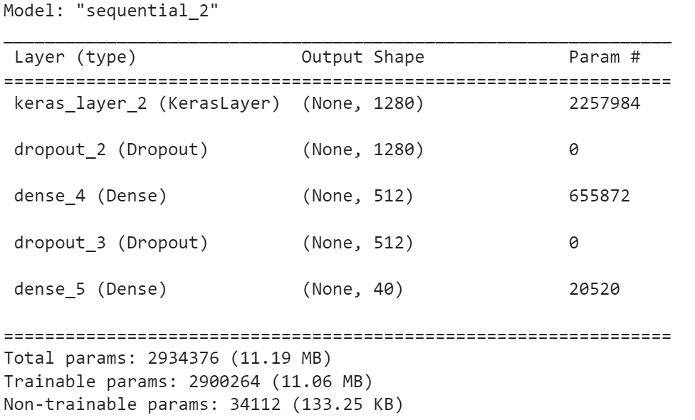

Here keras_layer_2 refers to the MobileNetv2 layer. This design configuration aims to strike a balance between computational efficiency and model performance, ensuring a robust and accurate classification framework for the identification of medicinal plants.

**Determination of Optimal Learning Rate**

Learning Rate Range Test

To identify the optimal learning rate, a comprehensive Learning Rate Range Test was conducted. Commencing with a minute LR value, the LR was incrementally increased over successive epochs. The resultant loss values were meticulously monitored, leading to the construction of a learning rate versus loss plot. This visual representation facilitated the discernment of the LR value at which the model exhibited the most rapid decrease in loss, indicative of an optimal learning rate for convergence.

**Evaluation and Analysis**

The comprehensive evaluation and analysis of the trained model involve a meticulous examination of its performance metrics, with a primary focus on training and validation data loss and accuracy trends. The insights derived from these metrics are instrumental in gauging the model's generalization capabilities and identifying potential areas for improvement.

Upon conducting the training phase using both the training and validation datasets, our model yields noteworthy results. The culmination of this iterative process reveals that the optimal model achieved an accuracy exceeding 95%. This outcome underscores the efficacy and proficiency of the trained model in accurately classifying instances from unseen data, demonstrating its aptitude for the intended task.

To get the HDF5 file of our best model- [Click here](https://drive.google.com/file/d/1gxxicDPFvb2ZBFC_5igK7tCeRq1w72p6/view?usp=sharing)

Training vs. Validation Data Loss and Accuracy Graphs

The training and validation data loss and accuracy graphs serve as vital visual representations of the model's learning dynamics over successive epochs.

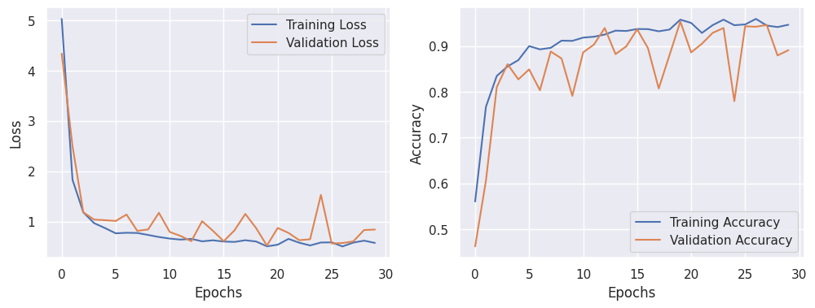

Through a comprehensive analysis of the graphical representations, it is evident that the loss graph experiences a consistent decline from epoch 0 to 10. This signifies the model's adeptness in assimilating intricate patterns inherent in the dataset. Concurrently, the substantial ascent in accuracy and its sustained high values suggest that further refinement through hyperparameter tuning is imperative. The observed fluctuations can be attributed primarily to the dynamic adjustments of the learning rate facilitated by the Learning Rate Scheduler, underscoring the ongoing quest for the optimal learning rate.

As the evaluation phase transitions, our attention shifts towards scrutinizing the model's performance on the testing dataset. This pivotal step involves subjecting the trained model to entirely unseen images, offering insights into its real-time efficacy and aptitude for generalization in practical scenarios. The ensuing evaluation aims to unveil the model's adaptability to diverse, real-world instances and fortify its potential applications beyond the training domain.

Test Loss: 0.8671

Test Accuracy: 0.8821

**Conclusion**

Classifying medicinal plant species through digital images poses inherent challenges, demanding innovative solutions. The proposed and designed method outlined in this paper has yielded noteworthy results, achieving a commendable accuracy exceeding 95%. The focus of this study revolves around a comprehensive review of state-of-the-art convolutional neural network (CNN) pretrained models, specifically MobileNetV2, within the domain of medicinal plant species classification and recognition.

This paper contributes to the field by presenting a systematic review of primary studies pertaining to deep learning in the context of medicinal plant classification and recognition. The assessment considered various factors, including the geographical distribution of the studies, medicinal plant dataset sources, dataset pre-processing techniques, feature extraction methods, deep learning classifiers, and performance metrics employed for measurement.

The study underscores the significance of leveraging deep learning methodologies in the intricate task of medicinal plant classification, acknowledging the influence of geographical diversity and dataset characteristics. The outlined approach provides valuable insights into the nuanced process of model development and evaluation within this domain.

Looking ahead, the roadmap involves a commitment to further refinement and optimization. Future endeavours will focus on fine-tuning the model to enhance efficiency, addressing evolving challenges, and exploring avenues for continuous improvement in the realm of medicinal plant species classification and recognition.

**References**

1. Muneer A., Fati S.M. -[Efficient and Automated Herbs Classification Approach Based on Shape and Texture Features using Deep Learning](https://ieeexplore.ieee.org/document/9239938). *IEEE Access.*2020;8:196747. doi: 10.1109/ACCESS.2020.3034033.
2. Herdiyeni Y., Wahyuni N.K.S. [Mobile application for Indonesian medicinal plants identification using fuzzy local binary pattern and fuzzy color histogram](https://ieeexplore.ieee.org/document/6468742)
3. Paulson and Ravishankar, 2020; Pudaruth et al., 2021)- <https://ieeexplore.ieee.org/document/9489112>
4. [HERBAL LEAF RECOGNITION USING MASK-REGION CONVOLUTIONAL NEURAL NETWORK MASK R-CNN](https://www.researchgate.net/publication/366445600_HERBAL_LEAF_RECOGNITION_USING_MASK-REGION_CONVOLUTIONAL_NEURAL_NETWORK_MASK_R-CNN)
5. [Deep learning for medicinal plant species classification and recognition: a systematic review](https://www.ncbi.nlm.nih.gov/pmc/articles/PMC10796487/#B3)

# 6.[Identification of Medicinal Plants in Ardabil Using Deep learning](https://www.researchgate.net/publication/360345332_Identification_of_Medicinal_Plants_in_Ardabil_Using_Deep_learning)