**1. Write a shell program to display the content of a file after reading the file.**

**Code :-**

*echo "Enter Location of your file : "*

*read x*

*cat $x*

***Output :-***

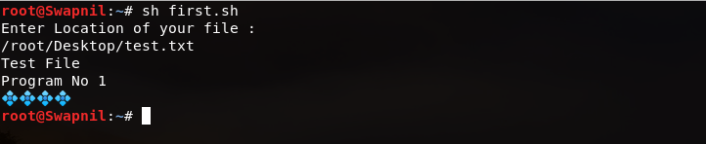

**2. Write a shell program to display the first three lines of a file.**

**Code :-**

*echo "Enter Location of your file : "*

*read x*

*head -3 $x*

***Sample Output :-***

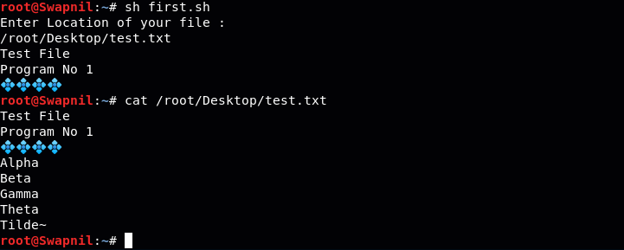

**3. Write a shell program to perform the swapping between two numbers taken from user during run time.**

***Code :-***

*echo "Enter two numbers : "*

*read x*

*read y*

*echo "Numbers are $x and $y"*

*z=$x*

*x=$y*

*y=$z*

*echo "Numbers are $x and $y"*

**Sample output :-**

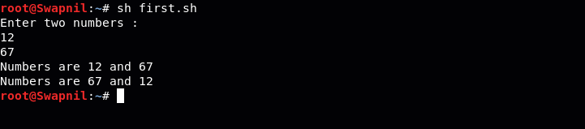

**4. Write a shell program to print the largest among three numbers by passing the numbers through command line arguments.**

**Code :-**

*echo "Enter three numbers : "*

*read x*

*read y*

*read z*

*if [ $x -gt $y ]*

*then*

*if [ $x -gt $z ]*

*then*

*echo "$x is greatest"*

*else*

*echo "$z is greatest"*

*fi*

*else*

*if [ $y -gt $z ]*

*then*

*echo "$y is greatest"*

*else*

*echo "$z is greatest"*

*fi*

*fi*

**Sample Output :-**

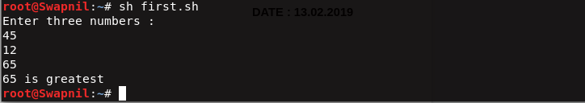

**5. Write a shell program to display the following mark sheets of students by taking the input marks of student through the terminal**

**Marks range Grade**

**90>=M<=100 A**

**70>=M<=89 B**

**40>=M<=69 C**

**M<40 F**

**Code :-**

*echo "Enter Marks : "*

*read M*

*if [ $M -lt 100 ]&&[ $M -gt 90 ]*

*then*

*echo "Grade A"*

*elif [ $M -lt 89 ]&&[ $M -gt 70 ]*

*then*

*echo "Grade B"*

*elif [ $M -lt 69 ]&&[ $M -gt 40 ]*

*then*

*echo "Grade C"*

*else*

*echo "Grade F"*

*fi*

**Sample Output :-**

