**1. Write a shell program to calculate the factorial of a number.**

**Source Code : -**

*echo "Enter Number : "*

*read x*

*temp=1*

*if [ $x -eq 0 ]*

*then*

*echo "Factorial is : 1";*

*else*

*for var in `seq 1 $x`*

*do*

*temp=`expr $var \* $temp`*

*done*

*echo "Factorial is : $temp"*

*fi*

**Sample Output :-**

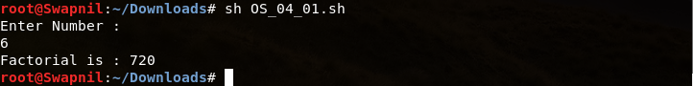

**2. Write a shell menu driven program to do the following:**

**a. Display the current working directory.**

**b. Check whether an input number is even or odd.**

**c. Display the number of counts of all the files in the directory.**

**d. Print the long listing of all the files.**

**Source Code :-**

*op=0*

*while [ $op != 5 ]:*

*do*

*echo "01. Display Current Working Directory"*

*echo "02. Check number is odd or even"*

*echo "03. Display No of files in the directory"*

*echo "04. Long Listing of all Files"*

*echo "05. Exit"*

*read op*

*case $op in*

*1)*

*var=$(pwd)*

*echo $var*

*;;*

*2)*

*read x*

*if [ $(( $x % 2 )) -eq 0 ]*

*then*

*echo "$x is Even"*

*else*

*echo "$x is Odd"*

*fi*

*;;*

*3)*

*v=$(ls | wc -l)*

*echo "$v"*

*;;*

*4)*

*va=$(ls -la)*

*echo $va*

*;;*

*esac*

*done*

**Sample Output :-**

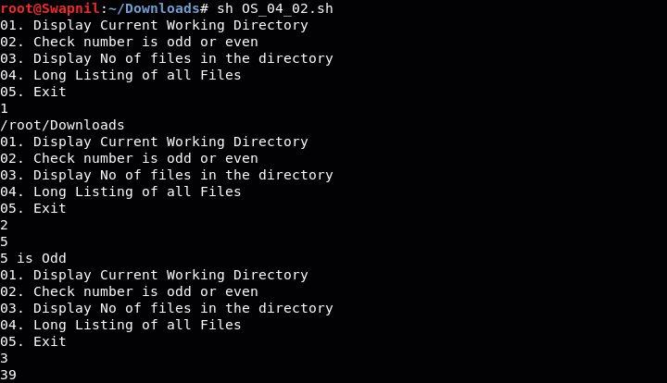

**3. Write a shell program to display all the prime numbers between 1 to 100 using while loop.**

**Source Code :-**

*temp=1*

*for var in `seq 2 100`*

*do*

*flag=1*

*les=`expr $var - 1`*

*for val in `seq 2 $les`*

*do*

*if [ $(($var % $val)) -eq 0 ]*

*then*

*flag=0*

*fi*

*done*

*if [ $flag -eq 1 ]*

*then*

*echo $var*

*fi*

*done*

**Sample Output :-**



**4. Write a menu program to find out whether a given letter is vowel or not.**

**Source Code :-**

*echo -n "Enter a alphabet : "*

*read x*

*case $x in*

*a) echo "It is a vowel" ;;*

*e) echo "It is a vowel" ;;*

*i) echo "It is a vowel" ;;*

*o) echo "It is a vowel" ;;*

*u) echo "It is a vowel" ;;*

*\*) echo "It is a consonant" ;;*

*esac*

**Sample Output :-**

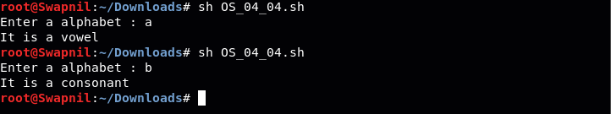

**5. Write a shell script which will generate the output as follows:**

**\***

**\* \***

**\* * \***

**\* * * \***

**Source Code :-**

*echo "Enter a Number : "*

*read n*

*for i in `seq 1 $n`*

*do*

*for var in `seq 1 $i`*

*do*

*echo -n "* "*

*done*

*echo ""*

*done*

**Sample Output :-**

