**1. a. Display the current time in 12-hour format.**

**b. With a user-specified date, display only the day of the week (e.g. Tuesday)**

**Sol :-**

**a)**



**b)**



**02. Write the command to find the square root of 4.**

**Sol :-**



**3. Show how we can calculate the following expression in the terminal of UNIX A=5, b=6,z=15 Total = (A*b) + (z/A) Display the Total.**

**Sol :-**



**4. How can we sort a list of numbers in a file (both ascending and descending order)?**

**Sol :-**

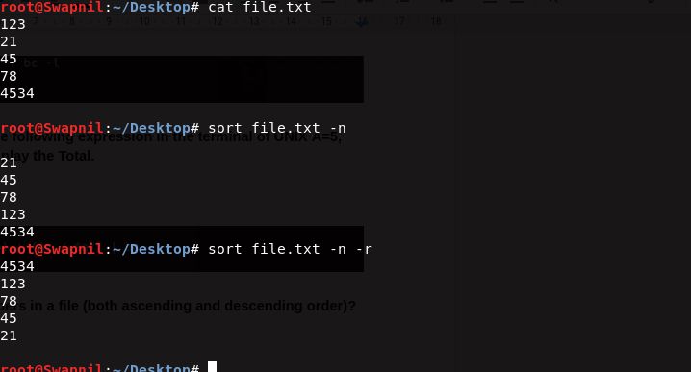

**5. Create the file student.dat as follows:**

**Roll | Name | Dept | Year**

**105 | Anik | CSE | 1st**

**101 | Debesh | CSE | 2nd**

**108 | Aniket | IT | 1st**

**200 | Mainak | ECE | 2nd**

**105 | Anik | CSE | 1st**

**a. Sort the data according to Roll.**

**b. Sort the data according to Dept.**

**c. Show only the records of students from the CSE Dept.**

**Sol : -**

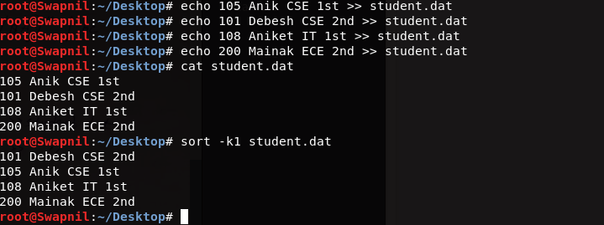

**6. Show the last 2 lines of the file animals.txt.**

**7. Show the first 3 lines of the file animals.txt.**

**Sol :-**

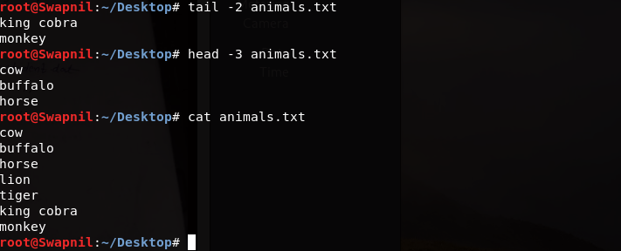

**8. (Re-Visit) List only the directory files in your current directory.**

**Sol :-**

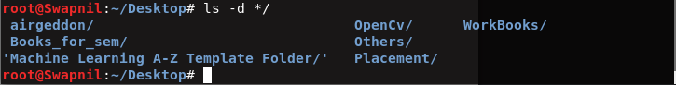

**9. Count the number of directories in your current directory.**

**Sol :-**

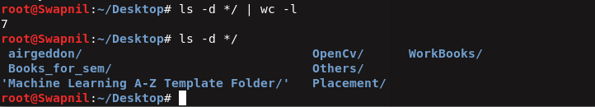

**10. Dog is a domestic animal**

**Dog hates cat**

**Cat drinks milk**

**Dog is bigger than Cat**

**Cat is also a domestic animal**

**a. Find the total number of lines contains the word ‘Dog’ in animals.txt.**

**b. Also find the total number of lines does not contain the word ‘Dog’ in animals.txt.**

**c. Display the lines in animals.txt that end with the word 'cat'.**

**Sol : -**

