**1.Provide a short write-up (1 or 2 paragraphs) on the following:**

**> History of Unix and Linux**

**> Kernel of an Operating System**

**> Multi-Tasking OS**

**> Multi-User OS**

**⇒ History of Unix and Linux :**

The Unix operating system is a set of programs that act as a link between the computer and the user.

The computer programs that allocate the system resources and coordinate all the details of the

computer's internals is called the operating system or the kernel.

> Unix was originally developed in 1969 by a group of AT&T employees Ken Thompson,

Dennis Ritchie, Douglas McIlroy, and Joe Ossanna at Bell Labs.

> There are various Unix variants available in the market. Solaris Unix, AIX, HP Unix and

BSD are a few examples. Linux is also a flavor of Unix which is freely available.

**> Kernel Of an Operating System :**

The kernel is the heart of the operating system. It interacts with the hardware and

most of the tasks like memory management, task scheduling and file management.

**> Multi Tasking OS :**

As the name itself suggests, multi tasking refers to execution of multiple tasks (say processes, programs, threads etc.) at a time. In the modern operating systems, we are able to play MP3 music, edit documents in Microsoft Word, surf the Google Chrome all simultaneously, this is accomplished by means of multi tasking.

Multitasking is a logical extension of multi programming. The major way in which multitasking differs from multi programming is that multi programming works solely on the concept of context switching whereas multitasking is based on time sharing alongside the concept of context switching.

**> Multi User OS :**

A multi-user is a OS that allows multiple users on different computers or terminals to access a single system with one OS on it.

**2. List all the files and directories of ‘/bin’ with detail information from your current directory.**

**⇒**

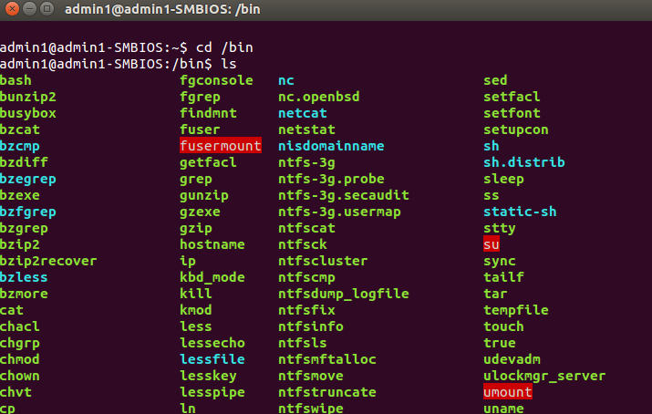

First : cd /bin to enter that folder

Second : ls to view all the files

**3. List all the files including hidden files in your parent directory.**

**⇒**

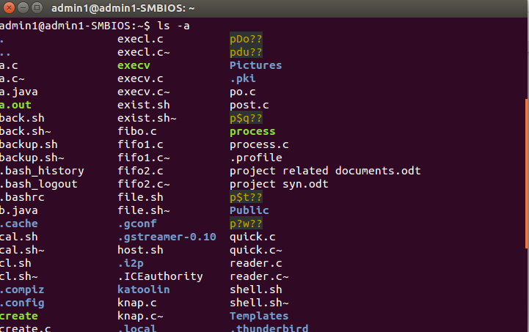

All we have to do is to just enter **ls -a,** it will list all the files hidden along with the unhidden ones.

**4. List only the directory files in your current directory.**

**⇒**



Command := **ls -d */**  will list all the directories in the current folder.

**5. Create a file ‘text 1’ by taking input from the keyboard.**

**⇒**

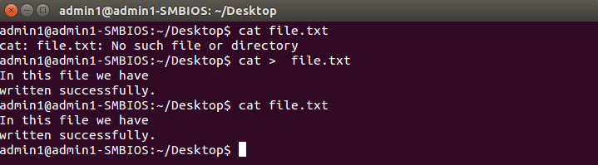

Command := In this we create the file using cat > file.txt then we write our text then Ctrl + D to save.

**6. Copy the contents of file’ text1’ to another file ‘text2’.**

**⇒**

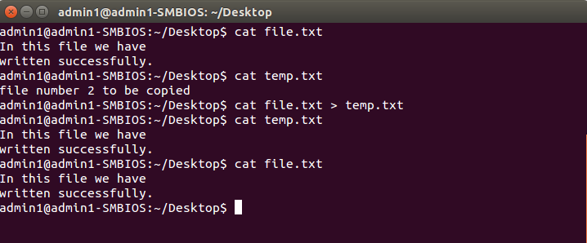

Command := In this we used cat sourcefile > destinationfile to copy the contents.

**7. Append the contents of file ‘text2 ‘to file ‘text1’.**

**⇒**

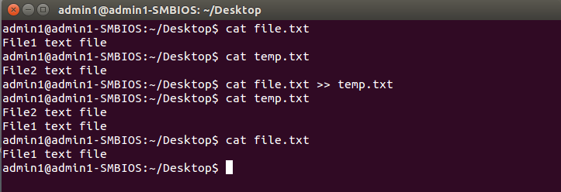

Command : cat [Source File ] >> [Destination File]

**8. Count the number of lines in the file ‘text1’.**

**⇒**

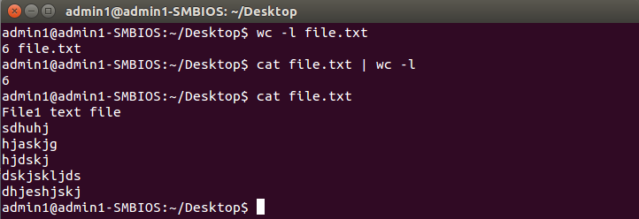

Command := We can use either **wc -l file.txt** or use **cat file.txt | wc -l**