**Serpent 2D**

The traditional snake game made using pygame

**PYTHON :**

**About Python:**

* Python is a high-level, general-purpose, open source, strictly typed programming language. The language provides constructs intended to enable clear programs on both a small and large scale.
* Python was created By Guido van Rossum.
* The Python Software Foundation (PSF) is the organization behind Python.
* Python is an interpreted, object-oriented, high-level programming language with dynamic semantics. Its high-level built in data structures, combined with dynamic typing and dynamic binding, make it very attractive for Rapid Application Development, as well as for use as a scripting or glue language to connect existing components together. Python's simple, easy to learn syntax emphasizes readability and therefore reduces the cost of program maintenance.
* Python supports modules and packages, which encourages program modularity and code reuse. The Python interpreter and the extensive standard library are available in source or binary form without charge for all major platforms, and can be freely distributed.

**Python features:**

Some of the features of python include :-

* Easy to understand
* GUI Programming Support
  + Dynamic
  + Portable Language
  + Integrated and Interpreted
  + Large Standard Library
  + Object oriented
  + Multipurpose
  + Strongly typed
  + Open Source

**Python is mainly used in many domains:**

* Web Development
* Data Analysis
* Machine Learning
* Internet Of Things
* GUI Development
* Image processing
* Data visualization
* Game Development

**Packages**

A package is a hierarchical file directory structure that defines a single Python application environment that consists of modules and sub-packages and sub-sub-packages, and so on.

**Packages used:**

**Pygame:** Pygame is a free and open-source cross-platform library for the development of multimedia applications like video games using Python. It uses the Simple DirectMedia Layer library and several other popular libraries to abstract the most common functions, making writing these programs a more intuitive task.

**Time:** Python time module allows to work with time in Python. It allows functionality like getting the current time, pausing the Program from executing, etc.

**Random:** Python Random module is an in-built module of Python that is used to generate random numbers in Python. These are pseudo-random numbers means they are not truly random. This module can be used to perform random actions such as generating random numbers, printing random a value for a list or string, etc.

**Screenshots**

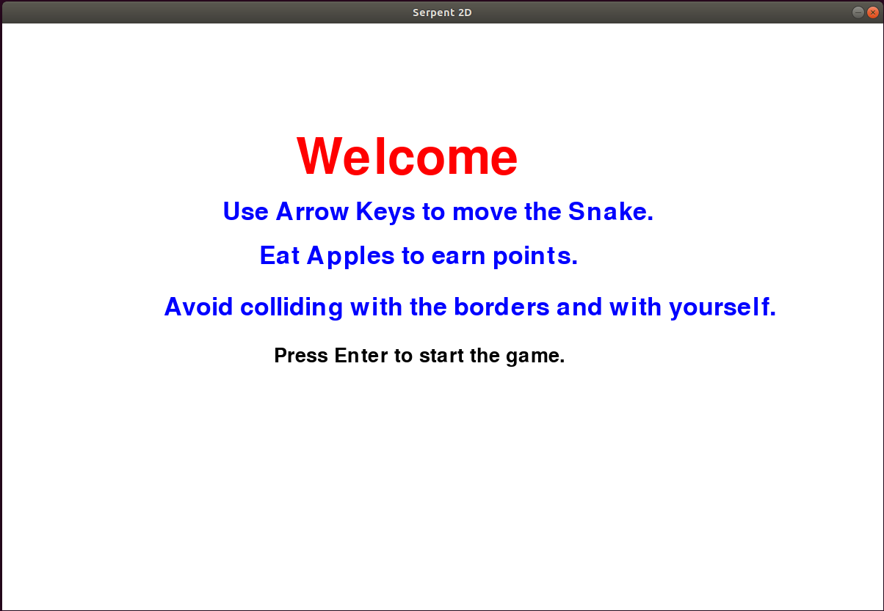**Welcome Screen**

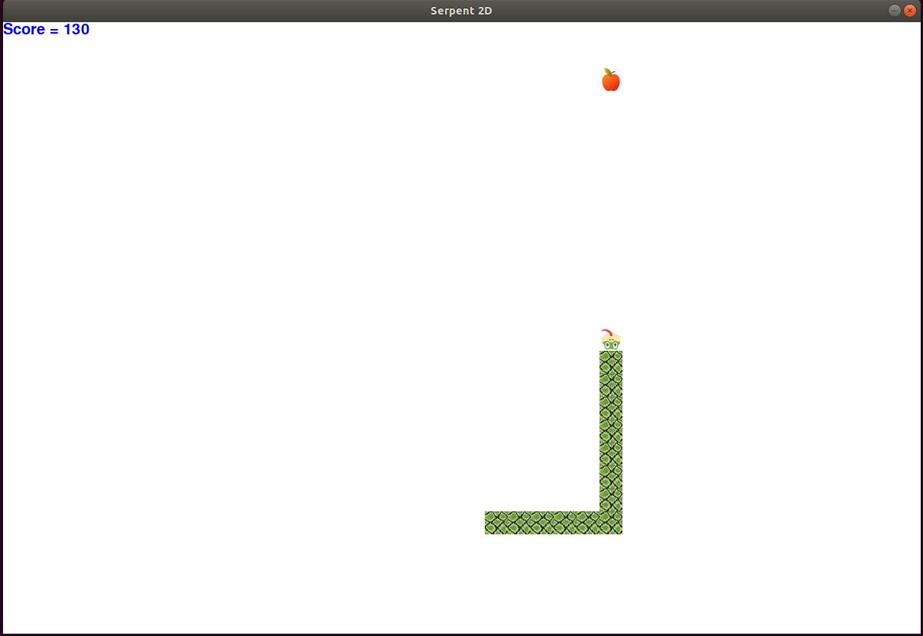**Game Screen**

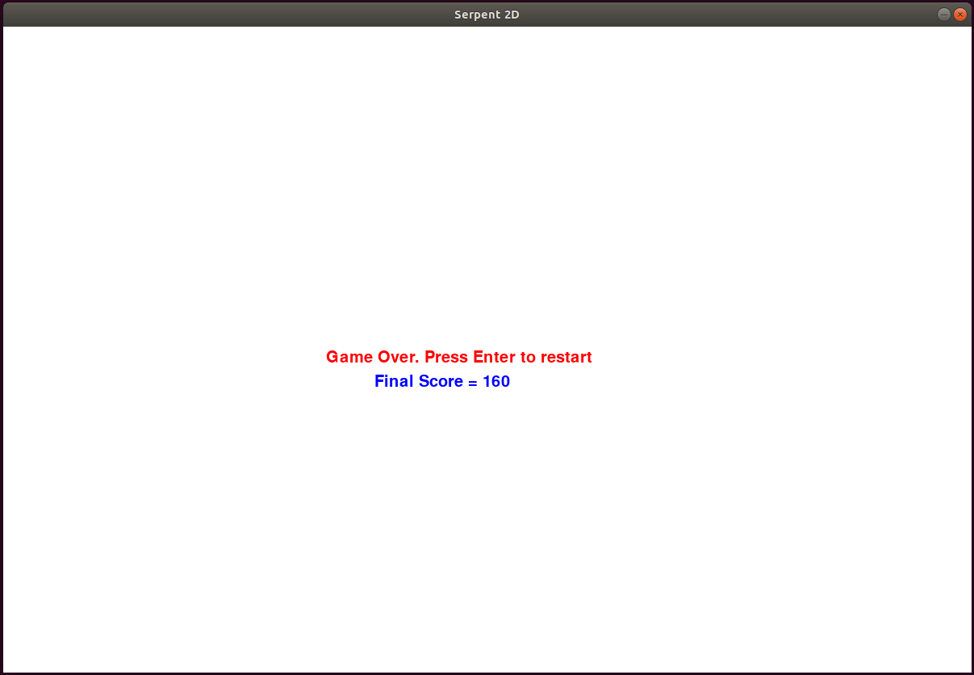**Game Over Screen**

**Conclusion**

This project is mainly built for entertainment purpose. It is a simple snake game where the user can play as a snake and try to eat as many items (apples) as possible without letting the snake colide with the borders and itself.

**References**

1. <https://pypi.org/project/pygame/>
2. <https://docs.python.org/3/library/time.html>
3. <https://docs.python.org/3/library/random.html>