**Medical Insurance charge prediction Using Machine Learning Model**

**Objective:**

* Which features are the strongest for insurance charge Prediction
* Which model can predict better if a new dataset of similar kind is provided.

**Target Variable:**

Charges

**Predictor Variables:**

* Age
* Sex
* Bmi
* Children
* Smoker
* Region

**Exploratory Data ANALYSIS:**

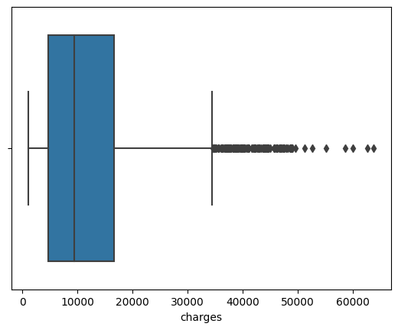

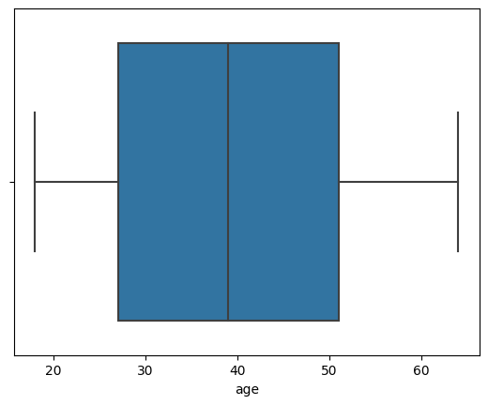

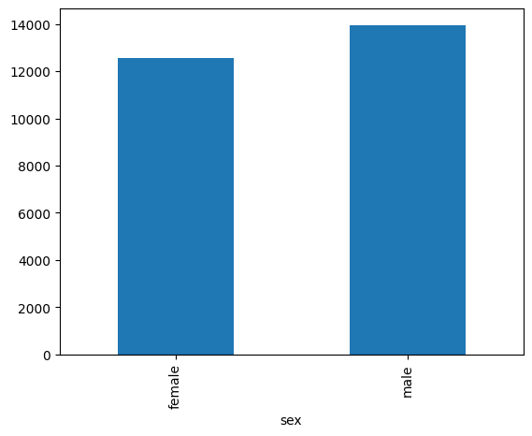

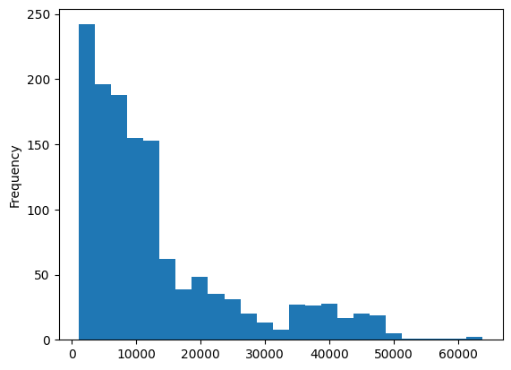

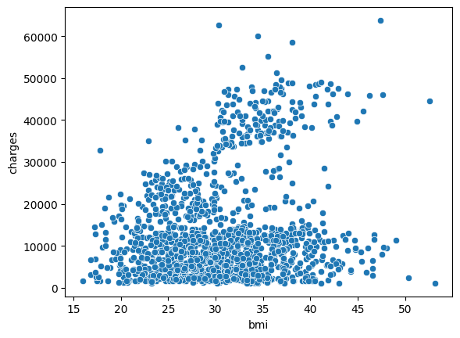

**Feature Engineering:**

* Indexing Categorical Variables
* Encoding Categorical Variables
* Vectorising
* Scaling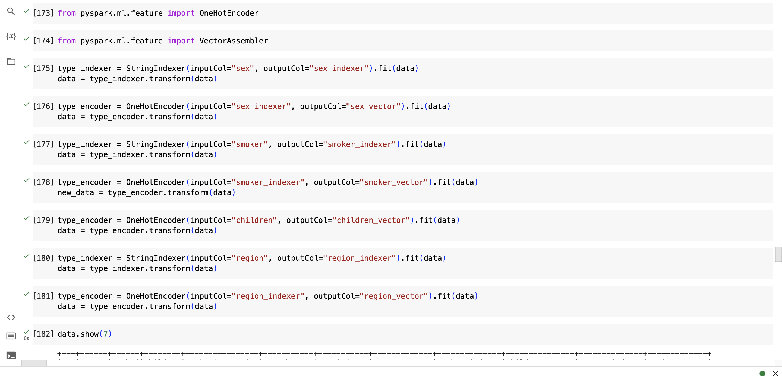

**Modelling:**

**Linear Model**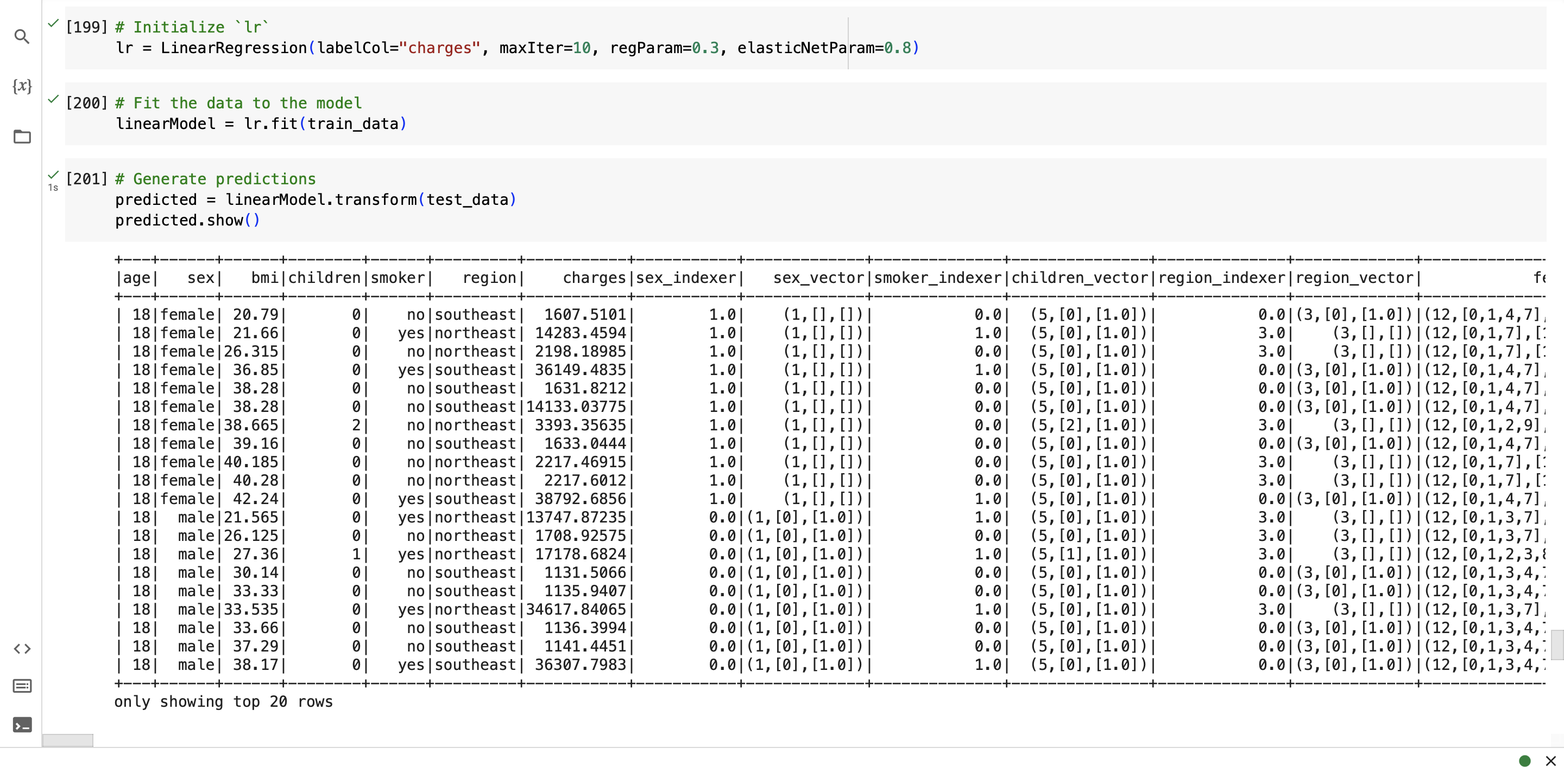

**Decision Tree**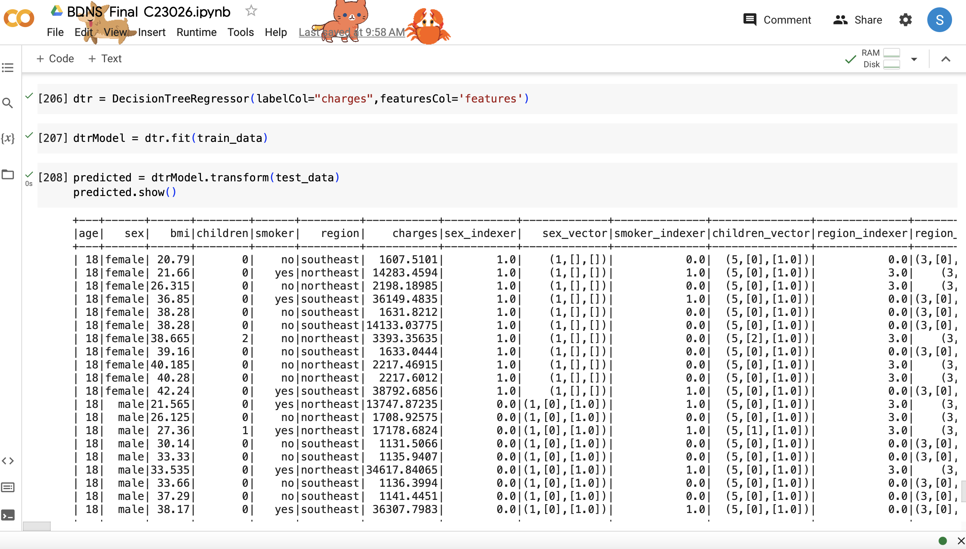

**Model Comparison**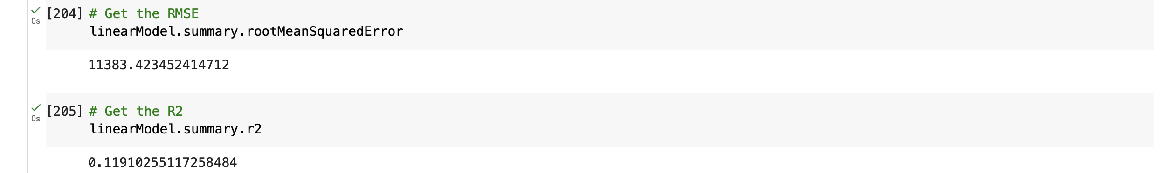

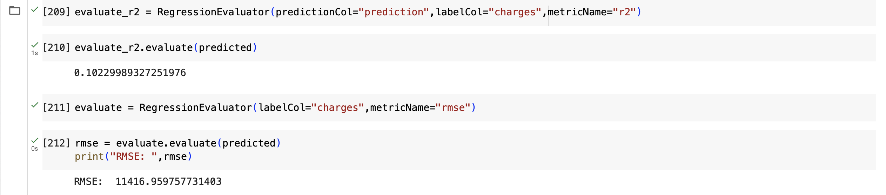

**Conclusion:**

Linear Regression Model has given the better result with lower RMSE and higher R2