Smart Retail Supply Chain Analytics
Inventory Optimization, Demand Forecasting & Pricing Intelligence
PROJECT REPORT

IBM SkillsBuild Data Analytics with AI Academic Internship Program
Conducted by BharatCares in association with AICTE

Submitted by | Sayan Ghorai
Project File | SayanGhorai_SmartRetailSupplyChain.ipynb
Dataset | Retail Store Inventory Forecasting Dataset (Kaggle)
Year | 2026

This report documents the complete analytics, machine learning, validation, reproducibility, and decision-support workflow developed for the internship project.

Abstract
This project presents an end-to-end retail supply chain analytics workflow that combines business analysis, product segmentation, inventory risk assessment, machine learning demand forecasting, and forecast-based decision validation. The study uses a synthetic retail inventory dataset containing 73,100 store-product-date records across 731 dates, 5 stores, 20 products, 5 product categories, and 4 regions. Because the dataset is synthetic, all business findings are demonstrations of analytical methodology rather than claims about a real retailer.
The analytical component evaluates demand, sales, inventory, pricing, discounts, competitor pricing, promotions, weather, and seasonality. ABC analysis is used to prioritize products by estimated net sales contribution, while XYZ analysis classifies products by monthly demand variability. A historical inventory-risk framework then combines the dataset-provided demand forecast with product-specific uncertainty buffers to identify shortage, tight-coverage, adequate, and excess-inventory situations.
For independent demand prediction, the target variable is Units Sold. The supplied Demand Forecast and Units Ordered fields are deliberately excluded from model inputs to reduce leakage and decision-time bias. A chronological split trains models on 2022-01-01 through 2023-09-30 and evaluates them on the unseen 2023-10-01 through 2023-12-31 period. Linear Regression, Random Forest, and Histogram Gradient Boosting are compared. Linear Regression is retained as the selected experimental model with test MAE 68.946, RMSE 87.923, and R² 0.3390.
The dataset-provided forecast performs much better on the same test records (MAE 8.347 and RMSE 10.035), but its generation methodology and information availability are undocumented, so it is treated only as an external benchmark rather than a like-for-like leakage-free model. A high-demand diagnostic shows a critical limitation of the independently trained model: for 924 records with actual demand of at least 300 units, average actual demand is 362.58 while the model predicts 212.78, with a high-demand MAE of 149.80 and a 100% underforecast rate. The final conclusion is therefore methodological rather than deployment-oriented: forecast accuracy must be validated before forecasts are allowed to drive inventory decisions.
Core project contribution
The project connects exploratory analytics, ABC-XYZ segmentation, inventory risk analysis, independent machine learning, an external forecast benchmark, and forecast decision validation in one reproducible workflow. The final ML model is preserved as an interpretable baseline and learning artifact, not presented as production-ready forecasting logic.

Table of Contents
1 | Introduction | 4
2 | Dataset and Data Understanding | 4
3 | Methodology and Analytical Architecture | 6
4 | Exploratory Data Analysis and Business Insights | 7
5 | ABC-XYZ Inventory Segmentation | 8
6 | Historical Inventory Risk and Replenishment Analysis | 10
7 | Machine Learning Demand Forecasting | 11
8 | External Forecast Benchmark and Error Analysis | 13
9 | Forecast Decision Validation | 14
10 | Model Interpretation | 15
11 | Reproducibility and Project Outputs | 15
12 | Limitations | 16
13 | Conclusion and Recommendations | 16
14 | Future Work | 17
 | References | 17
 | Appendix A - Final Submission Package | 17

Figures Included in This Report
- Figure 1. Daily Retail Demand Trend with 30-Day Moving Average
- Figure 2. Estimated Net Sales by Product Category
- Figure 3. ABC-XYZ Inventory Segmentation Matrix
- Figure 4. Historical Inventory Risk Status Distribution
- Figure 5. Final Model: Actual vs Predicted Daily Average Demand

Abbreviations
Abbreviation | Meaning
ABC | Product value classification based on estimated net sales contribution
XYZ | Demand variability classification based on monthly coefficient of variation
MAE | Mean Absolute Error
RMSE | Root Mean Squared Error
R² | Coefficient of determination
CV | Coefficient of Variation
ML | Machine Learning

1. Introduction

1.1 Background
Retail supply chains must balance product availability against the cost and operational burden of holding too much inventory. Demand varies across products, stores, dates, regions, promotions, prices, weather conditions, and seasonal periods. A useful analytics workflow must therefore do more than calculate sales totals: it should connect demand patterns with product prioritization, inventory exposure, forecasting, and operational decision support.
This project was developed within the IBM SkillsBuild Data Analytics with AI Academic Internship Program conducted by BharatCares in association with AICTE. It demonstrates how a data analyst can move from raw retail records to structured business insights, inventory segmentation, forecast evaluation, machine learning, and reproducible project outputs suitable for reporting and further application development.

1.2 Problem Statement
The project addresses three connected analytical questions. First, what patterns can be identified in retail demand, pricing, category performance, inventory, promotions, and seasonal conditions? Second, which products deserve the greatest inventory-management attention based on value contribution and demand variability? Third, how reliable are different demand forecasts when they are translated into inventory risk and replenishment decisions?

1.3 Project Objectives
- Analyze historical demand, sales, inventory, pricing, competitor pricing, discounts, promotions, weather, and seasonal patterns.
- Create business-focused KPIs and visualizations that summarize the retail operating environment.
- Segment products using ABC value contribution and XYZ demand variability.
- Evaluate the dataset-provided Demand Forecast as an external benchmark and quantify forecast uncertainty.
- Identify historical shortage risk, tight coverage, adequate inventory, and excess inventory.
- Develop independent machine learning models for Units Sold while controlling leakage and decision-time bias.
- Compare Linear Regression, Random Forest, and Histogram Gradient Boosting on a chronological holdout period.
- Validate whether forecast behavior is suitable for downstream inventory decisions, especially during high demand.
- Produce reusable CSV outputs and serialized model artifacts for reproducibility and optional downstream dashboards.

1.4 Scope and Interpretation
The project is intentionally analytics-heavy, with machine learning used as one component of a broader supply-chain analysis. It does not claim to implement an optimized enterprise replenishment engine. Supplier lead times, minimum order quantities, holding costs, ordering costs, service-level targets, lost-sales costs, and real purchase-order constraints are not available in the dataset. The replenishment calculations are therefore decision-support estimates rather than final procurement instructions.
Synthetic data disclosure
The source dataset is synthetic. The numerical findings are useful for demonstrating data analytics and machine learning methodology, but they should not be interpreted as the measured performance of a real retail company.

2. Dataset and Data Understanding

2.1 Dataset Source
The project uses the Kaggle dataset “Retail Store Inventory Forecasting Dataset” by Anirudh Singh Chauhan. The source contains retail observations at the Date + Store ID + Product ID level. The canonical project copy is maintained as data/retail_cleaned_data.csv so the notebook can run locally, while the notebook also contains logic for locating the dataset in a Kaggle environment.
The source covers 2022-01-01 through 2024-01-01. The final date contains only one observed day for January 2024, so that incomplete period is excluded from full-month comparisons, historical inventory-risk evaluation, and the machine learning holdout window where appropriate.

2.2 Dataset Structure
Field | Type / Role | Analytical Use
Date | Date | Chronology, calendar features, train/test separation
Store ID | Categorical | Store-level behavior and model input
Product ID | Categorical | Product performance, segmentation, model input
Category | Categorical | Category-level demand and sales analysis
Region | Categorical | Regional analysis and model input
Inventory Level | Numeric | Current stock and inventory-position analysis
Units Sold | Numeric target | Historical demand and ML prediction target
Units Ordered | Numeric | Inventory position; excluded from ML inputs
Demand Forecast | Numeric benchmark | External benchmark; excluded from ML inputs
Price | Numeric | Pricing analysis and engineered features
Discount | Numeric (%) | Promotion/pricing analysis and effective price
Weather Condition | Categorical | Contextual demand factor and model input
Holiday/Promotion | Binary | Promotion indicator and model input
Competitor Pricing | Numeric | Relative pricing analysis and model input
Seasonality | Categorical | Seasonal analysis and model input

2.3 Data Coverage and Quality Audit
Metric | Result
Rows | 73,100
Original columns | 15
Unique dates | 731
Stores | 5
Products | 20
Categories | 5
Regions | 4
Missing values | 0
Exact duplicate rows | 0
Duplicate Date + Store + Product combinations | 0
Expected store-product-date combinations | 73,100
Negative original Demand Forecast values | 673

The combination of 731 dates, 5 stores, and 20 products produces 73,100 expected store-product-date observations, exactly matching the dataset row count. This confirms complete grid coverage. Negative values occur only in the supplied Demand Forecast field. The original forecast is preserved for traceability, while a clipped non-negative version is created for benchmark and inventory analysis because physical demand cannot be negative.

2.4 Business and Time Feature Engineering
The analysis layer adds calendar and business variables including Year, Month, Month Name, Quarter, Day of Week, Week of Year, Is Weekend, Gross Sales, Effective Price, Estimated Net Sales, Competitor Price Gap, inventory-to-sales ratios, and available inventory measures. Estimated Net Sales is used as a practical value proxy because product acquisition cost or cost of goods sold is not available.
Estimated Net Sales: Units Sold × Price × (1 − Discount / 100)
Competitor Price Gap: Price − Competitor Pricing

3. Methodology and Analytical Architecture
The project is organized as a sequence of connected analytical stages rather than as a single forecasting exercise. This structure allows business insights, inventory segmentation, independent model development, and operational validation to be evaluated separately and then connected at the decision-support stage.
Stage | Purpose | Primary Output
Exploratory Analytics | Understand demand, sales, inventory, pricing and operating patterns | Business KPIs and visualizations
ABC-XYZ Segmentation | Prioritize products by value and variability | Product management segments
Historical Inventory Risk | Identify shortage, tight, adequate and excess conditions | Risk and replenishment analysis
Independent ML Forecasting | Train leakage-controlled demand models | Selected Linear Regression model
External Forecast Benchmark | Measure dataset-provided forecast performance | Benchmark accuracy and uncertainty
Forecast Decision Validation | Test impact of forecast choice on inventory decisions | Risk comparison and limitations

3.1 Analytical Principles
- Chronology is preserved in model evaluation; random train/test splitting is avoided.
- Demand Forecast is excluded from ML training and retained only as an external benchmark.
- Units Ordered is excluded from ML inputs because replenishment decisions may encode prior demand expectations.
- ABC-XYZ classes prioritize management attention; they do not alter machine learning predictions.
- Historical inventory analytics and test-period forecast validation are reported separately to avoid mixing analytical purposes.
- Model accuracy is evaluated before any forecast is treated as operationally trustworthy.

3.2 Evaluation Metrics
Model performance is assessed using MAE, RMSE, and R². MAE is the primary selection metric because it has a direct interpretation in units of demand. RMSE provides additional sensitivity to larger errors, and R² describes the proportion of target variance explained by the model. Train-test gaps are also reviewed to detect overfitting or unstable generalization.

4. Exploratory Data Analysis and Business Insights

4.1 Executive Business KPIs
KPI | Value
Total Units Sold | 9,975,582
Total Units Ordered | 8,041,327
Average Daily Units Sold | 13,646.49
Gross Sales Value | $550,228,884.91
Estimated Net Sales | $494,971,374.95
Average Inventory Level | 274.47 units
Average Units Sold per Record | 136.46 units
Average Product Price | $55.14
Average Discount | 10.01%
Zero-sales Records | 360 (0.49%)
Promotion/Holiday Records | 36,353 (49.73%)

4.2 Demand Trend Over Time
Daily demand is volatile at the individual-date level, so a 30-day moving average is used to show the underlying pattern. Across the complete daily series, average daily demand is 13,646.49 units. The highest daily demand is 17,239 units on 2022-06-21, while the lowest is 10,642 units on 2023-03-08. Among complete months, July 2023 records the highest demand at 437,919 units and February 2023 the lowest at 385,168 units.
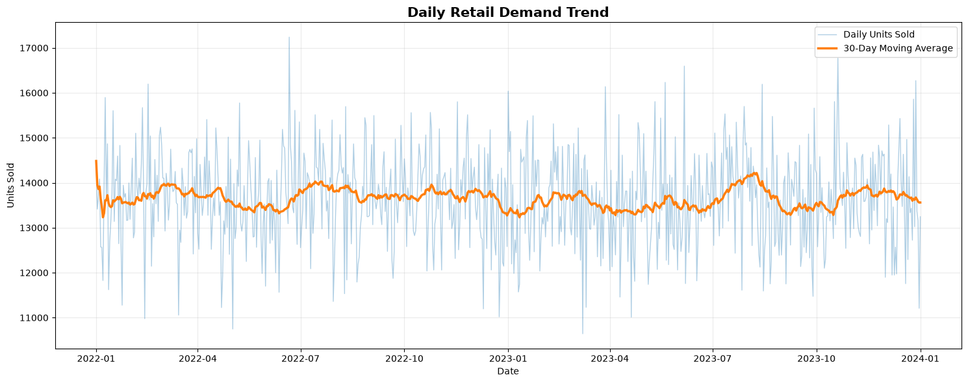
Figure 1. Daily Retail Demand Trend with 30-Day Moving Average.
The moving average remains within a relatively narrow band compared with daily fluctuations, indicating a stable overall demand level with shorter-term peaks and troughs. This supports using both aggregate business analytics and record-level forecasting rather than relying on a single overall trend statistic.

4.3 Category Performance and Estimated Net Sales
Category-level demand is broadly balanced, but Furniture leads both total units sold and estimated net sales. Furniture records 2,025,017 units and approximately $100.23 million in estimated net sales. Electronics has the lowest total units sold among the five categories at 1,960,432 units and approximately $97.39 million in estimated net sales. The narrow range across categories indicates a diversified synthetic retail mix rather than dominance by one category.
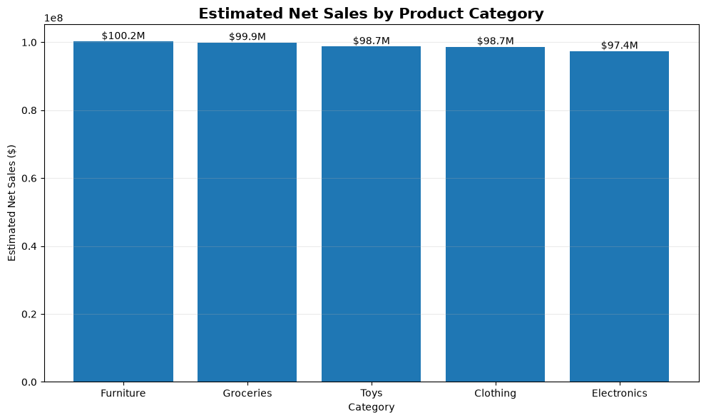
Figure 2. Estimated Net Sales by Product Category.
Category | Units Sold | Estimated Net Sales
Furniture | 2,025,017 | $100,230,824.04
Groceries | 2,000,482 | $99,948,968.32
Toys | 1,990,485 | $98,729,216.66
Clothing | 1,999,166 | $98,676,779.98
Electronics | 1,960,432 | $97,385,585.94

5. ABC-XYZ Inventory Segmentation

5.1 ABC Value Classification
ABC analysis ranks products by Estimated Net Sales and calculates cumulative value contribution. The classification uses approximate cumulative thresholds of 80% for A, the next 15% for B, and the final 5% for C. Because acquisition cost or COGS is unavailable, estimated net sales is used as the value proxy. The resulting distribution contains 15 A-class products, 3 B-class products, and 2 C-class products.
ABC Class | Products | Total Units Sold | Estimated Net Sales | Product Share
A | 15 | 7,503,431 | $373,291,681.84 | 75.00%
B | 3 | 1,480,703 | $72,828,650.87 | 15.00%
C | 2 | 978,204 | $48,222,899.46 | 10.00%

5.2 XYZ Demand Variability Classification
XYZ analysis uses the complete 2022-2023 period, giving 24 monthly observations for every product. For each product, the coefficient of variation of monthly demand is calculated. The 20 products are then split using dataset-relative tertiles: X indicates relatively stable monthly demand, Y moderate variability, and Z relatively high variability. These thresholds are relative to this dataset rather than universal industry cutoffs.

5.3 Combined ABC-XYZ Matrix
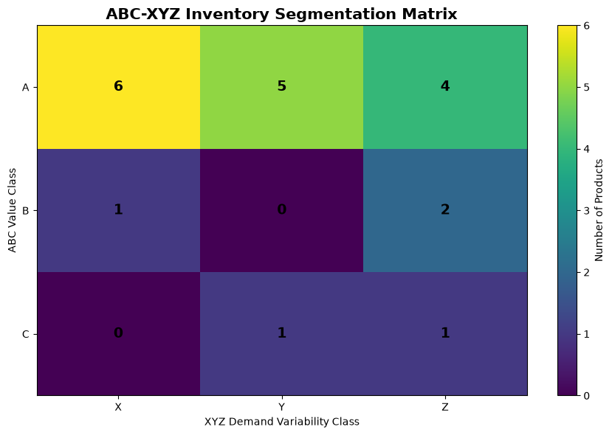
Figure 3. ABC-XYZ Inventory Segmentation Matrix.
Segment | Products | Interpretation
AX | 6 | High value - stable demand
AY | 5 | High value - moderate variability
AZ | 4 | High value - high variability
BX | 1 | Medium value - stable demand
BY | 0 | Medium value - moderate variability
BZ | 2 | Medium value - high variability
CX | 0 | Lower value - stable demand
CY | 1 | Lower value - moderate variability
CZ | 1 | Lower value - high variability

The matrix shows that most products are A-class by value contribution, while demand variability is spread across X, Y, and Z. The six AX products combine high value with relative stability and are therefore strong candidates for consistent service-level attention. AZ products also contribute high value but have greater variability, making them especially important for monitoring forecast error and safety-stock behavior.

6. Historical Inventory Risk and Replenishment Analysis

6.1 External Forecast Uncertainty Buffer
The historical inventory-risk analysis uses the complete 2022-01-01 through 2023-12-31 period, containing 73,000 records. The original supplied Demand Forecast achieves MAE 8.339, RMSE 10.016, and R² 0.9915 over this historical period. A non-negative clipped version is used for physical inventory calculations. Forecast-error percentiles are also examined to estimate uncertainty buffers.
Coverage Percentile | Additional Buffer
50% | 0.00 units
75% | 2.35 units
90% | 6.83 units
95% | 8.42 units
99% | 9.69 units

The 90th-percentile global buffer rounds to 7 units. Product-specific 90% underforecast buffers are used where available, with the global value as a fallback. This converts forecast uncertainty into an inventory requirement while preserving the supplied forecast as an external benchmark rather than an ML feature.

6.2 Inventory Decision Logic
Inventory Position: Inventory Level + Units Ordered
Risk-Adjusted Demand: Clipped Forecast + Product-Specific Safety Buffer
Inventory Gap: Inventory Position − Risk-Adjusted Demand
Recommended Replenishment: max(Risk-Adjusted Demand − Inventory Position, 0)
Historical risk status is assigned using the inventory gap and safety buffer. A negative gap is Shortage Risk. If the requirement is covered but the remaining surplus is no more than one safety buffer, the record is Tight Coverage. Larger positive gaps are Adequate unless surplus exceeds the entire risk-adjusted demand requirement, in which case the record is classified as Excess Inventory.

6.3 Historical Inventory Risk Results
Risk Status | Records | Share
Shortage Risk | 4 | 0.01%
Tight Coverage | 37 | 0.05%
Adequate | 22,287 | 30.53%
Excess Inventory | 50,672 | 69.41%

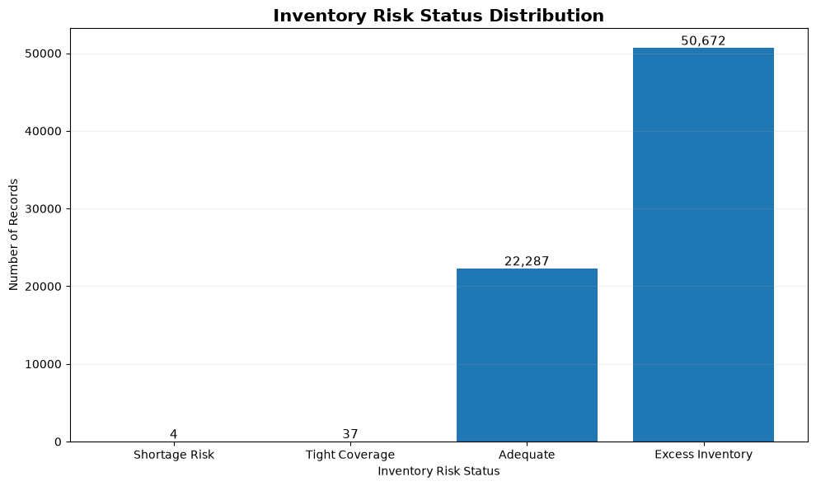
Figure 4. Historical Inventory Risk Status Distribution.
The dominant historical condition is excess inventory, representing 69.41% of records. Only four shortage-risk records are identified, and the total additional replenishment recommended across these historical shortage cases is 8 units, averaging 2 units per shortage case. These results suggest that, under the project’s demand requirement and inventory-position definitions, the synthetic system generally carries more stock coverage than is required by the benchmark forecast.
Decision-support limitation
These quantities are not optimized purchase orders. Supplier lead time, minimum order quantity, service-level cost, holding cost, ordering cost, and stockout penalty are not available, so the inventory logic is a transparent analytical framework rather than a complete optimization model.

7. Machine Learning Demand Forecasting

7.1 Target and Leakage Control
Units Sold is the prediction target. The modeling dataset contains 21 input features: 15 numeric and 6 categorical. The supplied Demand Forecast is excluded from all model inputs and retained only for external benchmarking. Units Ordered is also excluded because replenishment decisions may already reflect expectations about demand. The raw Date column is replaced by calendar-derived features, and Units Sold itself is excluded from inputs as the target.
Feature Group | Included Features
Numeric (15) | Inventory Level; Price; Discount; Competitor Pricing; Holiday/Promotion; Year; Month; Day; Day_of_Week; Week_of_Year; Quarter; Is_Weekend; Effective_Price; Competitor_Price_Gap; Competitor_Price_Ratio
Categorical (6) | Store ID; Product ID; Category; Region; Weather Condition; Seasonality
Explicit exclusions | Date; Units Sold; Demand Forecast; Units Ordered

7.2 Chronological Train/Test Split
Dataset | Period | Records | Average Units Sold
Training | 2022-01-01 to 2023-09-30 | 63,800 | 136.39
Testing | 2023-10-01 to 2023-12-31 | 9,200 | 137.00
Excluded | 2024-01-01 | 100 | Incomplete January 2024 period

This split preserves chronological order: the latest training date is 2023-09-30 and the earliest test date is 2023-10-01. The preprocessing pipeline is fitted only on training data, preventing information from the future test period from influencing preprocessing decisions.

7.3 Preprocessing
Numeric variables use median imputation and categorical variables use most-frequent imputation followed by one-hot encoding with unknown categories ignored. The combined ColumnTransformer expands the 21 original features into 57 processed model features. There are no missing values in the final modeling inputs, but the imputation pipeline keeps the model package robust to missing values in future compatible inputs.

7.4 Candidate Models
Three regression approaches are trained on the same processed training data: Linear Regression as an interpretable baseline, Random Forest as a non-linear ensemble capable of interactions, and Histogram Gradient Boosting as a stronger non-linear challenger. The models are evaluated on the same unseen October-December 2023 test period.

7.5 Model Performance and Selection
Model | Train MAE | Test MAE | Train RMSE | Test RMSE | Train R² | Test R²
Linear Regression | 68.831 | 68.946 | 87.930 | 87.923 | 0.3496 | 0.3390
Histogram Gradient Boosting | 67.755 | 68.966 | 86.221 | 88.021 | 0.3746 | 0.3376
Random Forest | 57.757 | 70.645 | 73.399 | 89.020 | 0.5468 | 0.3224

Linear Regression has the lowest test MAE and RMSE and the highest test R² of the three candidates, although Histogram Gradient Boosting is extremely close. Random Forest fits the training set more strongly but its MAE increases from 57.757 in training to 70.645 in testing, producing the largest generalization gap and indicating greater overfitting. Linear Regression therefore remains the selected model for the final project workflow.
Why the selected model is still a baseline
Selection means “best among the tested independent models under this experimental design,” not “ready for production.” The later high-demand diagnostics reveal a serious underprediction problem that prevents treating the model as an operational replenishment forecast without further redesign and validation.

A recurrent neural network such as LSTM was not added simply because the dataset contains dates. The project does not construct lagged sequence windows or a true sequence-to-future forecasting target; the implemented experiment is a leakage-controlled tabular demand-prediction problem. Classical models therefore provide a clearer and more defensible baseline for the current scope.

7.6 Actual vs Predicted Test-Period Behavior
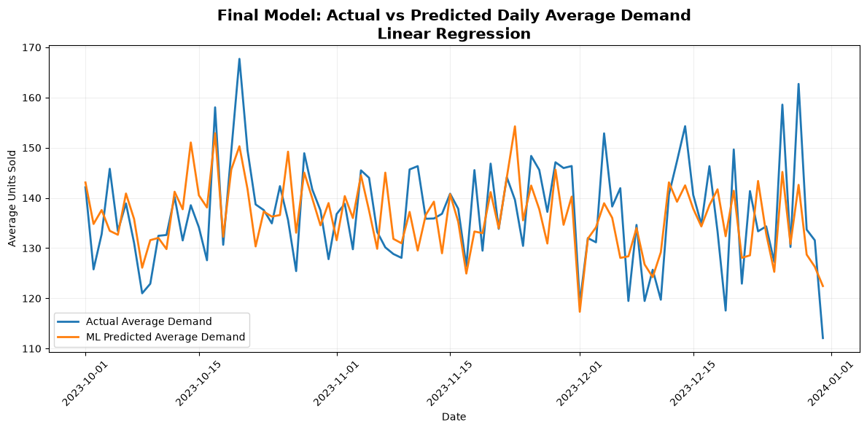
Figure 5. Final Model: Actual vs Predicted Daily Average Demand (Linear Regression).
At the daily-average level, the selected model follows the general center of demand reasonably well, but this aggregation hides substantial record-level errors. The median absolute test error is 55.12 units, the 90th percentile is 151.57 units, and the 95th percentile is 178.38 units. This motivates the deeper demand-level error analysis reported in the next section.

8. External Forecast Benchmark and Error Analysis

8.1 Same-Period Forecast Accuracy Comparison
Forecast Source | MAE | RMSE | R²
Independent Linear Regression | 68.946 | 87.923 | 0.3390
Dataset-Provided Demand Forecast | 8.347 | 10.035 | 0.9914

The supplied forecast is dramatically more accurate on the same 9,200 test records. However, its generation methodology, feature availability, model training process, and prediction timing are not documented in the dataset. It could contain information unavailable to an independently trained model at forecast time. For that reason, the project does not present the comparison as proof that the supplied forecast is a superior leakage-free model. It is treated as an external benchmark.

8.2 High-Demand Diagnostic
The most important limitation appears in the upper demand range. Using the final threshold of Actual Units Sold ≥ 300, the test set contains 924 high-demand records. In this subset, the selected model underforecasts every record. The mean model prediction is far below the actual mean, while the supplied benchmark remains close to actual demand.
High-Demand Metric (Actual ≥ 300) | Result
Records | 924
Average actual demand | 362.58
Average ML forecast | 212.78
Average supplied forecast | 367.51
Average inventory position | 542.80
ML high-demand MAE | 149.80
Supplied forecast high-demand MAE | 8.39
ML underforecast rate | 100.00%

The model’s overall mean forecast is close to overall mean actual demand, but its distribution is compressed. On the full test set, actual demand has a 90th percentile of 300 and maximum of 494, while ML predictions have a 90th percentile of 226.38 and maximum of 251.00. This explains why average-level plots may look acceptable even though the model fails to represent demand spikes. For inventory use, this failure is more important than the near-zero overall mean bias.

9. Forecast Decision Validation

9.1 Common Test-Period Decision Rules
To isolate the effect of forecast source, both the supplied forecast and the selected ML forecast are evaluated on the same 9,200 test records using the same inventory position, product-level safety buffer, and coverage-ratio rules. The common classification uses shortage for a coverage ratio below 1.00, tight coverage from 1.00 to below 1.25, adequate coverage from 1.25 through 2.00, and excess inventory above 2.00.
Coverage Ratio: Inventory Position / Buffered Demand

9.2 Forecast Source Impact on Inventory Classification
Risk Status | Supplied Forecast | Selected ML Forecast
Shortage Risk | 0 | 0
Tight Coverage | 308 | 0
Adequate | 2,502 | 0
Excess Inventory | 6,390 | 9,200

Under the common rules, the ML forecast classifies every test record as excess inventory because its buffered demand estimate is low relative to inventory position. The supplied forecast produces a more varied risk distribution. The two forecast sources agree on risk classification for 69.46% of test records and differ on 30.54%. Neither forecast source produces a positive replenishment recommendation during this test period under the chosen rules.
A counterfactual diagnostic using actual demand - used only to understand the thresholds, not as a future forecast - produces 240 tight-coverage records, 2,416 adequate records, and 6,544 excess-inventory records. This confirms that the all-excess ML result is not only a property of the inventory thresholds; it is also connected to the model’s compressed upper-demand predictions.
Operational lesson
A demand model can have acceptable-looking average behavior while still being unsafe for operational use if it systematically misses the high-demand tail. Forecast validation must therefore include demand-segment diagnostics and downstream decision impact, not only global MAE or R².

10. Model Interpretation

10.1 Linear Regression Coefficients
The selected model’s 57 processed features allow coefficient-based interpretation. The largest-magnitude business-related coefficient is Competitor_Price_Ratio at approximately −4.1695. Other positive coefficients include Inventory Level (+0.4961), while Effective Price (−0.1881), Discount (−0.1162), and Holiday/Promotion (−0.3663) are negative in the fitted model. These signs describe associations learned after accounting for the other included features.
Business Feature | Coefficient | Direction
Competitor_Price_Ratio | -4.1695 | Negative
Inventory Level | +0.4961 | Positive
Holiday/Promotion | -0.3663 | Negative
Effective_Price | -0.1881 | Negative
Price | +0.1164 | Positive
Discount | -0.1162 | Negative
Competitor_Price_Gap | +0.0884 | Positive
Competitor Pricing | +0.0281 | Positive

The coefficients must not be interpreted as causal effects. Numeric variables were not standardized and therefore use different scales; correlated pricing features can distribute influence across multiple coefficients; and the categorical variables were one-hot encoded without dropping a reference category. The coefficient table is best used as an association-oriented interpretation aid rather than a causal business rule.

11. Reproducibility and Project Outputs

11.1 Analytical Outputs
The notebook exports structured CSV assets covering ABC-XYZ segmentation, historical inventory risk, model predictions and errors, forecast-source comparisons, executive KPIs, final findings, project architecture, and feature influence. Large record-level files are kept locally and excluded from Git tracking where appropriate, while smaller summary outputs are tracked for reproducibility and review.

11.2 Serialized Model Package
Model Artifact | Purpose
linear_regression_model.joblib | Selected fitted Linear Regression estimator
preprocessor.joblib | Fitted preprocessing ColumnTransformer
retail_demand_model_bundle.joblib | Combined deployment bundle with model, preprocessor, schema, and target
processed_feature_names.csv | Names of the 57 processed features
model_metadata.json | Training period, test period, metrics, exclusions, and package metadata

The saved bundle is reloaded inside the notebook and tested on a validation sample. Reloaded predictions reproduce the original predictions with a maximum difference of 0.000000000000, confirming that the serialized model and preprocessing pipeline are internally consistent. A separate local portability script also reproduces the final 9,200-record test metrics.

11.3 Project Repository Structure
The project repository separates source data, generated outputs, model artifacts, reusable test code, documentation, and visual assets. The final required submission files are kept at the project root so they are easy to identify and submit. The README documents the dataset link, project overview, technologies, setup instructions, results, limitations, and repository organization.

12. Limitations
- The dataset is synthetic; findings demonstrate methodology and should not be generalized to a real retailer without validation on real operational data.
- The dataset-provided Demand Forecast has undocumented generation logic, so its strong accuracy cannot be treated as a transparent leakage-free benchmark model.
- The independent ML model lacks lagged demand features and therefore does not model temporal autoregressive structure directly.
- The selected Linear Regression model substantially underpredicts high-demand records and is not suitable for direct replenishment deployment in its current form.
- Inventory decision rules do not include supplier lead time, service-level targets, holding cost, ordering cost, stockout cost, minimum order quantity, case-pack size, or procurement constraints.
- Estimated Net Sales is a proxy for product value because COGS and inventory acquisition cost are unavailable.
- Inventory position is simplified to current inventory plus units ordered; shipment timing, backorders, cancellations, and in-transit uncertainty are not modeled.
- The experiment uses one chronological holdout window rather than rolling-origin cross-validation across multiple future periods.

13. Conclusion and Recommendations
The project successfully builds a complete retail supply-chain analytics workflow from source-data validation through business analysis, segmentation, historical inventory risk, independent machine learning, benchmark comparison, and operational forecast validation. The dataset contains complete store-product-date coverage with no missing values or duplicate business keys, enabling a consistent analytical foundation.
The business analysis shows approximately 9.98 million units sold and $494.97 million in estimated net sales across the synthetic dataset. Category performance is relatively balanced, with Furniture leading both units sold and estimated net sales. ABC-XYZ analysis identifies 15 A-class products and places 6 products in AX, 5 in AY, and 4 in AZ, giving a practical product-management framework for prioritizing high-value items by stability and variability.
Historical inventory analysis indicates that excess inventory is the dominant condition under the external benchmark and safety-buffer logic, accounting for 50,672 of 73,000 complete historical records. The independent machine learning experiment then demonstrates the importance of leakage control and chronological evaluation. Linear Regression slightly outperforms the two non-linear challengers on the unseen test period and generalizes with a very small train-test gap.
However, the final decision-support validation shows why model selection cannot stop at global metrics. The selected model compresses the upper tail of demand and underforecasts all 924 records with actual demand of at least 300 units. As a result, it drives every test-period record into the excess-inventory class under common coverage rules. The recommended interpretation is therefore to retain the model as an explainable baseline and reproducible ML component, while withholding it from operational replenishment use until high-demand forecasting is materially improved.

13.1 Practical Recommendations
- Use ABC-XYZ segments to prioritize inventory review, with special attention to high-value and high-variability products such as AZ items.
- Treat the full historical inventory-risk analysis as the primary inventory analytics result; keep the test-period risk comparison as a model-validation experiment.
- Do not deploy the current independent ML predictions directly into replenishment rules because the high-demand tail is systematically underestimated.
- When future models are evaluated, include demand-level error tables and downstream inventory classifications in addition to MAE, RMSE, and R².
- Maintain the supplied Demand Forecast only as an external benchmark unless its generation process and time-of-availability are documented.

14. Future Work
The next improvement should focus on forecast design rather than simply increasing model complexity. A stronger forecasting dataset could include lagged Units Sold, rolling averages, rolling volatility, store-product histories, and explicitly defined forecast horizons. These features would allow the model to learn temporal persistence and demand spikes that are not represented by the current tabular feature set.
- Create lag features such as 1-day, 7-day, 14-day, and 28-day demand, with strict chronological generation to avoid leakage.
- Use rolling-origin or walk-forward validation across multiple time windows instead of one holdout period.
- Evaluate tree boosting methods and sequence models only after a proper future-forecast target and lagged input structure are defined.
- Test quantile or probabilistic forecasts so safety stock can be tied directly to forecast uncertainty rather than a single point forecast.
- Incorporate lead time, service level, holding cost, stockout cost, and MOQ data to move from decision support toward inventory optimization.
- Build an optional Streamlit dashboard for executive KPIs, ABC-XYZ segments, inventory risk, and forecast diagnostics after the mandatory internship deliverables are finalized.

References
[1] Anirudh Singh Chauhan. “Retail Store Inventory Forecasting Dataset.” Kaggle. https://www.kaggle.com/datasets/anirudhchauhan/retail-store-inventory-forecasting-dataset
[2] Project repository: https://github.com/SayanGhorai/smart-retail-supply-chain
[3] scikit-learn documentation for LinearRegression, RandomForestRegressor, HistGradientBoostingRegressor, preprocessing pipelines, and regression metrics.
[4] pandas documentation for tabular data manipulation, aggregation, datetime operations, and CSV export.
[5] Matplotlib documentation for analytical visualization.

Appendix A - Final Submission Package
The internship instruction requires four files. The project has been organized so these files are complete, clearly named, and easy to submit independently.
Required File | Final Filename | Status / Purpose
Code File | SayanGhorai_SmartRetailSupplyChain.ipynb | Complete notebook with analytics, ML, exports, and validation
Requirements File | requirements.txt | Pinned Python dependencies required to run the project
Project Report | SayanGhorai_ProjectReport.docx | This complete project documentation
README File | README.md | Project overview, dataset link, technologies, setup, execution, results, and key information

Appendix A.1 Final Project Position
The final project should be understood as a reproducible analytics and decision-support study. Its strongest components are data quality validation, business analytics, ABC-XYZ segmentation, historical inventory-risk analysis, leakage-controlled chronological model evaluation, transparent comparison with an external benchmark, and explicit documentation of the selected model’s high-demand limitation. This positioning keeps the project technically honest while still demonstrating a complete data analytics with AI workflow.

