Generative AI & Deep Learning

Project Report: Retinal OCT Classification using Vision Transformer (ViT)

CSBS 6th Semester
Batch: 2022-2026

Team Members:
Anumoy Pathak (11)
Sayan Saha (26)
Padwanava Biswas (35)
Riddhima Chanda (40)
Roshni Roy Banik (45)

1. Title
Retinal Disease Classification using Vision Transformer on OCT Images
2. Introduction
CNV (Choroidal Neovascularization), DME (Diabetic Macular Edema), DRUSEN, and NORMAL are some common eye diseases which may lead to visual impairment. Hence it is very important to detect these conditions early. We have a solution to improve treatment outcomes by using Optical Coherence Tomography (OCT). Our project applies the Vision Transformer (ViT) model to classify retinal OCT images using deep learning techniques into the four mentioned disease categories specified early.

3. Objective
We have developed an image classification model using Vision Transformer (ViT) for accurate diagnosis of retinal OCT scans by classifying them into:
- CNV (Choroidal Neovascularization)
- DME (Diabetic Macular Edema)
- DRUSEN
- NORMAL
4. Dataset
Kaggle Dataset: https://www.kaggle.com/paultimothymooney/kermany2018

5. Data Preprocessing
To adapt OCT grayscale images for Vision Transformer input:
- Resized all images to 224x224 pixels
- Converted grayscale images to RGB (ViT expects 3 channels)
- Normalized pixel values with mean and std = [0.5, 0.5, 0.5]
- Applied transformations using PyTorch torchvision.

6. Model Architecture
- Backbone: google/vit-base-patch16-224-in21k
- Model: Pretrained Vision Transformer (ViT) from Hugging Face Transformers
- Modified Head: Final classification layer adjusted to 4 output classes
- Loss Function: CrossEntropyLoss
- Optimizer: Adam (learning rate = 1e-4)
7. Code

The full source code in available in the Github link given below :-

https://github.com/SayanSaha11/DL-GenAI/blob/main/code.py

8. Output

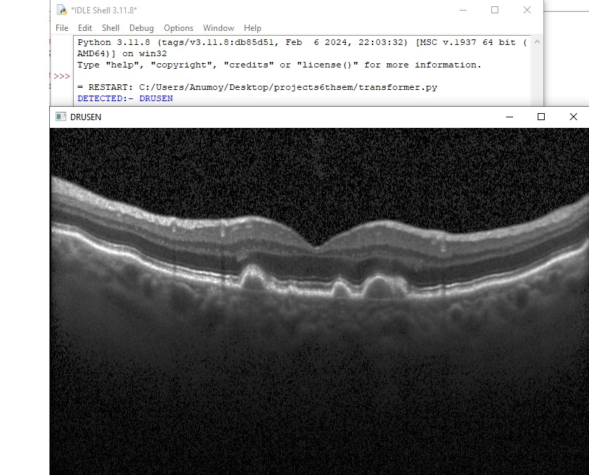

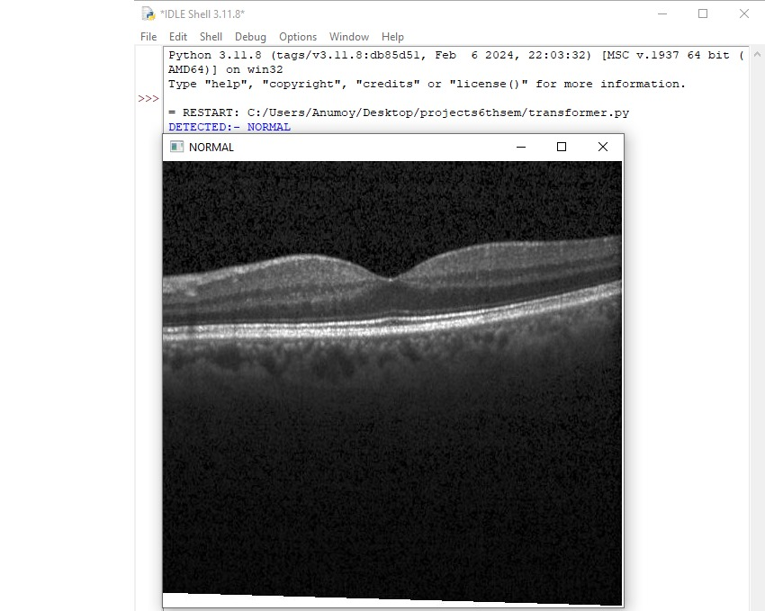

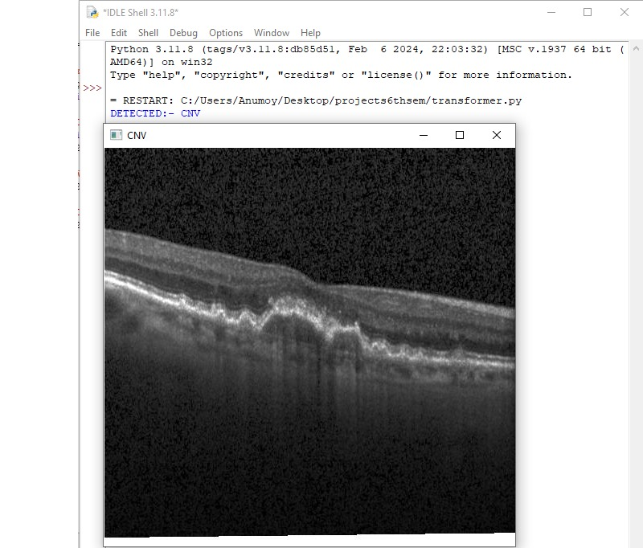

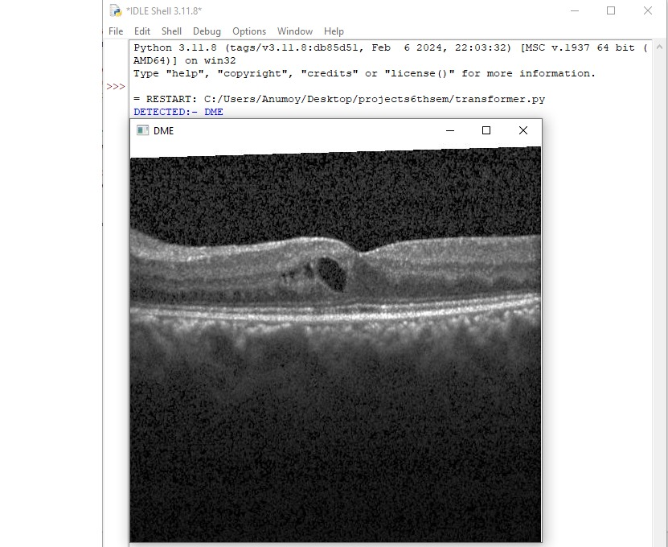

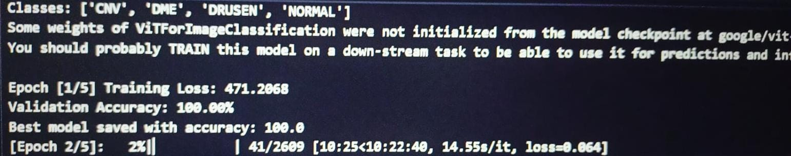

9. Observations
- Drusen - Yellowish extracellular deposits under the retina.
- Normal - Uniform retinal layers with no structural abnormalities.
- CNV - Disruption in the RPE layer and irregular fluid-like regions beneath the retina
- DME - Retinal thickening with cystoid spaces

10. Conclusion
• Our deep learning model has demonstrated high accuracy and clinical relevance in classifying Retinal OCT images into the four major categories namely Drusen, Normal, CNV & DME.
• Our model has been able to accurately differentiate between normal and pathological retinas, with visual evidence aligning with known biomarkers for each condition.
• Our approach aids in early screening and potentially reducing diagnostic workload and speeding up treatment timelines.

