Q-1)

Perform the following tasks:

a. Create Student table with following attributes (STUDENT_ID , FIRST_NAME, LAST_NAME, PHONE_NUMBER, MARKS, COURSE_ID).

b. Create Course table with following attributes (COURSE_ID, COURSE_NAME).

c. Write a SQL statement to insert 8 records with your own value into the tables.

d. Write a query to get the number of students with the same course.

f. Write a query to get the student name, course name and marks of the students.

g. Write a query to get the Average marks of students course wise.

Query :-

**create database sampledemo1;**

**use sampledemo1;**

**create table Students(Student_id int primary key Not NULL, First_Name varchar(30) Not NULL,**

**Last_Name varchar(30)Not NULL, Phone_No varchar(30) Not NULL,**

**Marks double Not NULL, Course_id Varchar(15) Not NUll);**

**select * from Students;**

**insert into Students values(1001,'Amit', 'Mondal',9146789502,85.4,'E3015');**

**insert into Students values(1002,'Rohit', 'Sharma',9144589502,98.4,'M4012');**

**insert into Students values(1003,'Priyanka', 'Gandhi',9146789010,45.8,'G3016');**

**insert into Students values(1004,'Pappu', 'Gandhi',9146745002,50.7,'M4012');**

**insert into Students values(1005,'Rohan', 'Bhati',9146736902,70.9,'G3016');**

**insert into Students values(1006,'Rabindra', 'Singh',9146786212,89.8,'M4012');**

**insert into Students values(1007,'Anil', 'Sen',9146789452,88.4,'E3015');**

**insert into Students values(1008,'Rahul','Ghosh',9149589502,64.4,'M4012');**

**create table course(Course_id varchar(20), course_name varchar(50));**

**select * from course;**

**insert into course values('M4012','Advance Jva Programming');**

**insert into course values('E3015','Python learning');**

**insert into course values ('G3016', 'Machine learning');**

**select Students.First_name,Students.Last_name,Students.Marks,course.course_name**

**from Students inner join course on Students.Course_id=course.course_id;**

**SELECT Course_id,COUNT(*) AS Student_Count FROM Students GROUP BY course_id;**

**SELECT Course.course_name,AVG(Students.Marks) AS Average_Marks**

**FROM Students JOIN Course ON Students.Course_id = course.course_ID GROUP BY Course.Course_name;**

a),b),C) Create Student table with following attributes

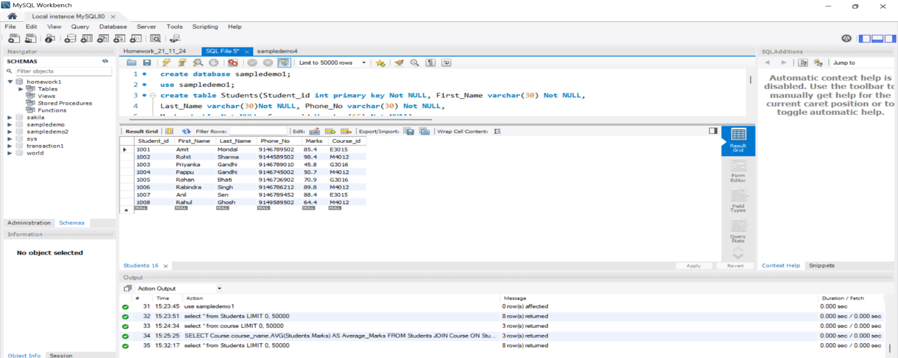 (STUDENT_ID , FIRST_NAME, LAST_NAME, PHONE_NUMBER, MARKS, COURSE_ID) And with 8 data entries.

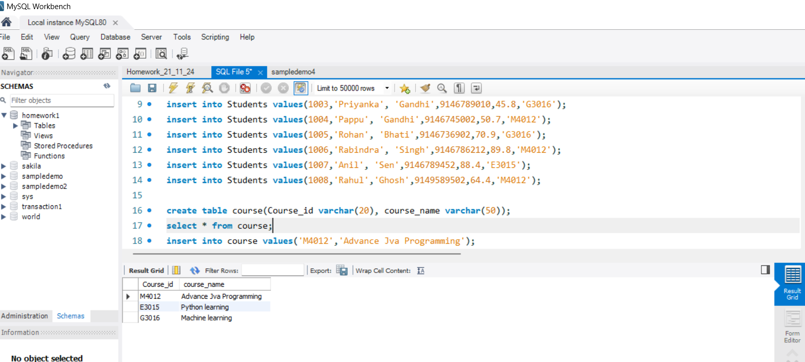

d) Write a query to get the number of students with the same course

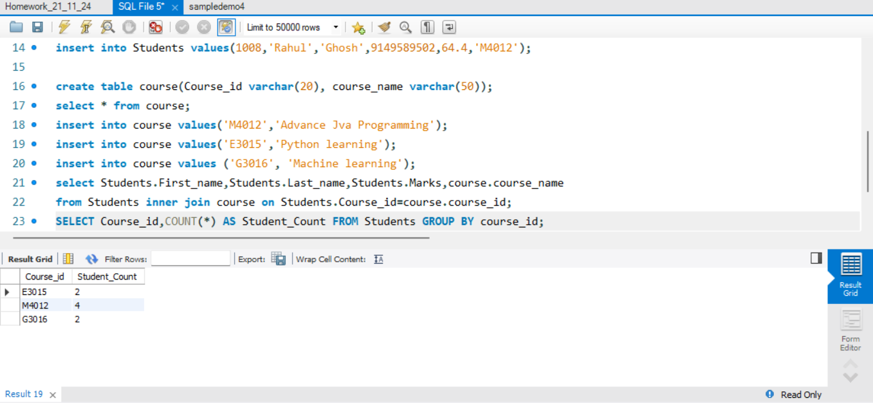

e) Write a query to get the student name, course name and marks of the students.

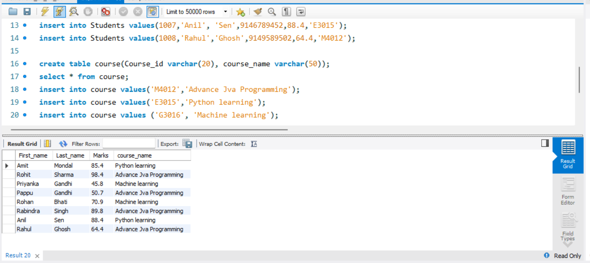

f) Write a query to get the Average marks of students course wise.

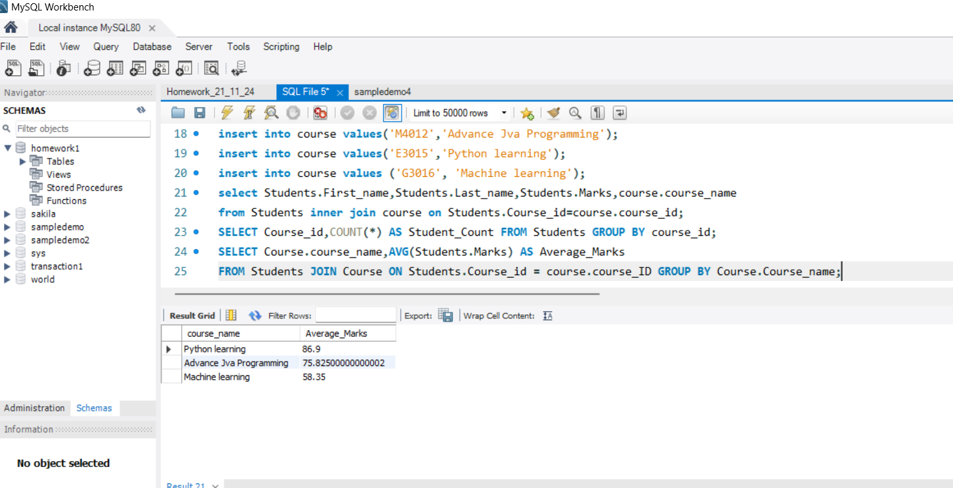

Q-2)

 Create database for hospital management system & Perform the following tasks:

a. Create HEALTH CARE WORKERS table with following attributes (EMPLOYEE_ID , FIRST_NAME, LAST_NAME,EMAIL, PHONE_NUMBER, HIRE_DATE, SALARY, DESIGNATION).

b. Create PATIENT table with following attributes (PATIENT_ID,NAME, PHONE_NUMBER).

c. Write a SQL statement to insert 10 records with your own value into the tables.

d. Write a query to get the names (first_name, last_name),Designation, salary.

e. Write a query to get the number of employees with the same Designation

f. Write a query to get employee name who are getting salary more than 25000.

g. Fetch HEALTH CARE WORKERS name using their employee id.

**Query :-**

**// using the same database**

**use sampledemo1;**

**Create table HEALTH_CARE_WORKERS (EMPLOYEE_ID INT PRIMARY KEY,FIRST_NAME VARCHAR(50),LAST_NAME VARCHAR(50),**

**EMAIL VARCHAR(100),PHONE_NUMBER VARCHAR(15),HIRE_DATE DATE,SALARY double,DESIGNATION VARCHAR(50));**

**select * from HEALTH_CARE_WORKERS;**

**insert into HEALTH_CARE_WORKERS values (1, 'Alice', 'Smith', 'alice.smith@hospital.com', '1234567890', '2021-01-10', 30000.00, 'Doctor');**

**insert into HEALTH_CARE_WORKERS values(2, 'Bob', 'Brown', 'bob.brown@hospital.com', '2345678901', '2020-05-15', 28000.00, 'Nurse');**

**insert into HEALTH_CARE_WORKERS values(3,'Charlie', 'Johnson','charlie.johnson@hospital.com', '3456789012', '2019-08-01', 40000.00,'Surgeon');**

**insert into HEALTH_CARE_WORKERS values(4,'Daisy', 'Taylor', 'daisy.taylor@hospital.com', '4567890123', '2022-03-20', 25000.00, 'Technician');**

**insert into HEALTH_CARE_WORKERS values(5, 'Eve', 'Wilson', 'eve.wilson@hospital.com', '5678901234', '2023-06-10', 35000.00, 'Doctor');**

**insert into HEALTH_CARE_WORKERS values(6, 'Frank', 'White', 'frank.white@hospital.com', '6789012345', '2021-12-01', 22000.00, 'Receptionist');**

**insert into HEALTH_CARE_WORKERS values(7, 'Grace', 'Lee', 'grace.lee@hospital.com', '7890123456', '2020-09-15', 26000.00, 'Nurse');**

**insert into HEALTH_CARE_WORKERS values(8, 'Hank', 'Walker', 'hank.walker@hospital.com', '8901234567', '2018-11-30', 45000.00, 'Surgeon');**

**insert into HEALTH_CARE_WORKERS values(9, 'Ivy', 'Adams', 'ivy.adams@hospital.com', '9012345678', '2022-07-05', 28000.00, 'Technician');**

**insert into HEALTH_CARE_WORKERS values(10, 'Jack', 'Davis', 'jack.davis@hospital.com', '0123456789', '2021-04-18', 32000.00, 'Pharmacist');**

**CREATE TABLE PATIENT (PATIENT_ID INT PRIMARY KEY,NAME VARCHAR(100),PHONE_NUMBER VARCHAR(15));**

**select * from PATIENT;**

**insert into PATIENT values(1, 'John Doe', '1112223333');**

**insert into PATIENT values(2, 'Jane Smith', '2223334444');**

**insert into PATIENT values(3, 'Michael Brown', '3334445555');**

**insert into PATIENT values(4, 'Emily Davis', '4445556666');**

**insert into PATIENT values(5, 'Chris Wilson', '5556667777');**

**insert into PATIENT values(6, 'Emma Taylor', '6667778888');**

**insert into PATIENT values(7, 'Liam Johnson', '7778889999');**

**insert into PATIENT values(8, 'Sophia Lee', '8889990000');**

**insert into PATIENT values(9, 'Oliver White', '9990001111');**

**insert into PATIENT values(10, 'Isabella Walker', '0001112222');**

**select FIRST_NAME, LAST_NAME, DESIGNATION, SALARY FROM HEALTH_CARE_WORKERS;**

**select DESIGNATION, COUNT(*) AS Employee_Count FROM HEALTH_CARE_WORKERS GROUP BY DESIGNATION;**

**SELECT FIRST_NAME, LAST_NAME,SALARY from HEALTH_CARE_WORKERS where SALARY > 25000;**

**SELECT FIRST_NAME, LAST_NAME FROM HEALTH_CARE_WORKERS WHERE EMPLOYEE_ID = 1 ;**

a. Create HEALTH CARE WORKERS table with following attributes (EMPLOYEE_ID , FIRST_NAME, LAST_NAME,EMAIL, PHONE_NUMBER, HIRE_DATE, SALARY, DESIGNATION).

b. Create PATIENT table with following attributes (PATIENT_ID,NAME, PHONE_NUMBER).

c. Write a SQL statement to insert 10 records with your own value into the tables.

d. Write a query to get the names (first_name, last_name),Designation, salary.

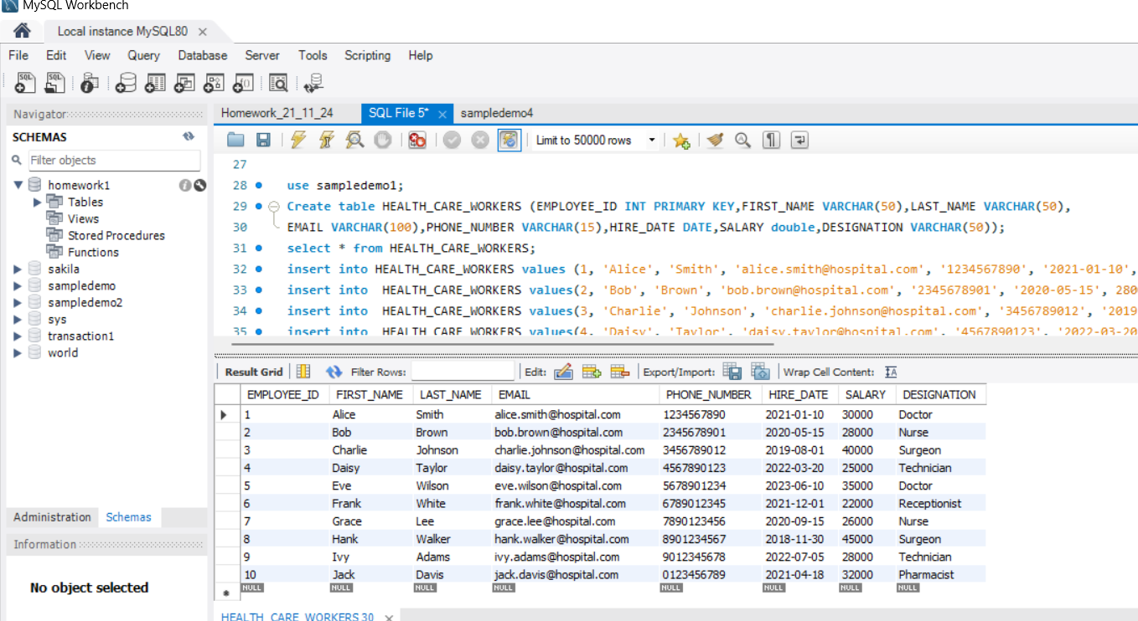

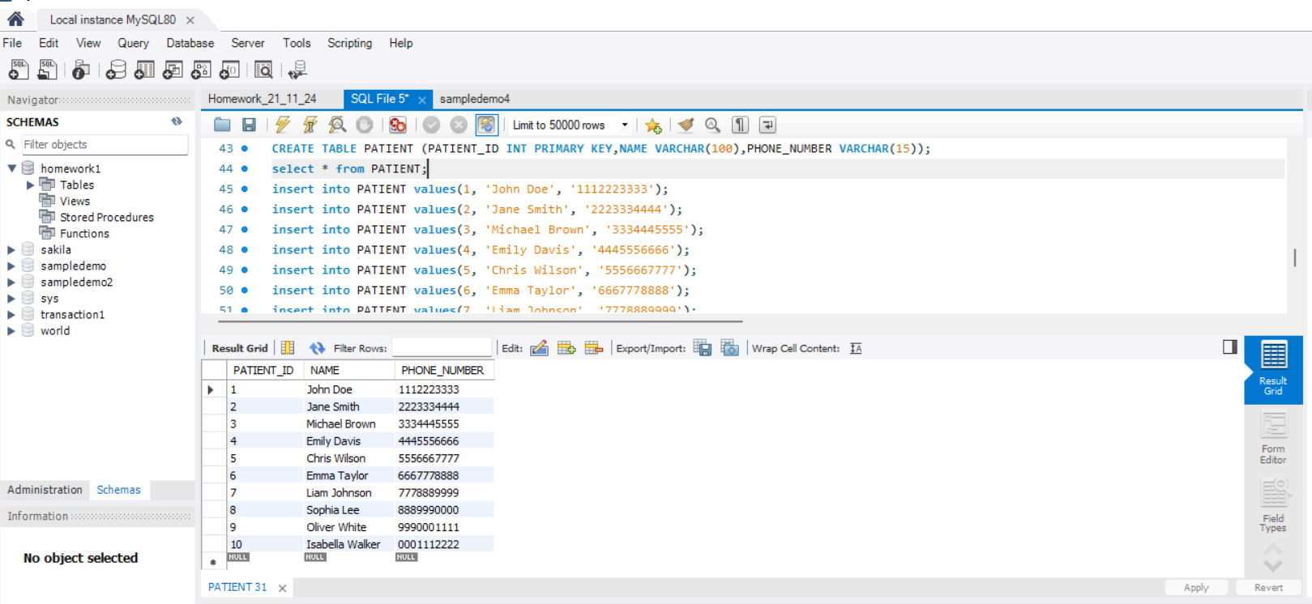

d) Write a query to get the names (first_name, last_name),Designation, salary.

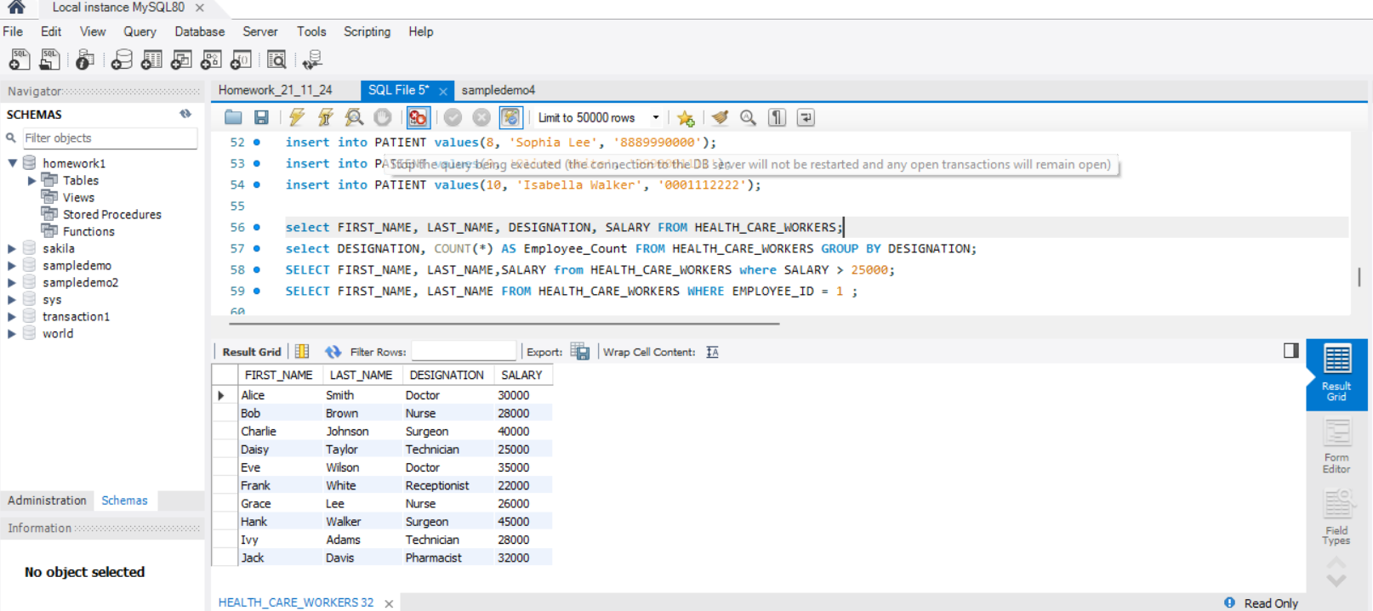

e) Write a query to get the number of employees with the same Designation

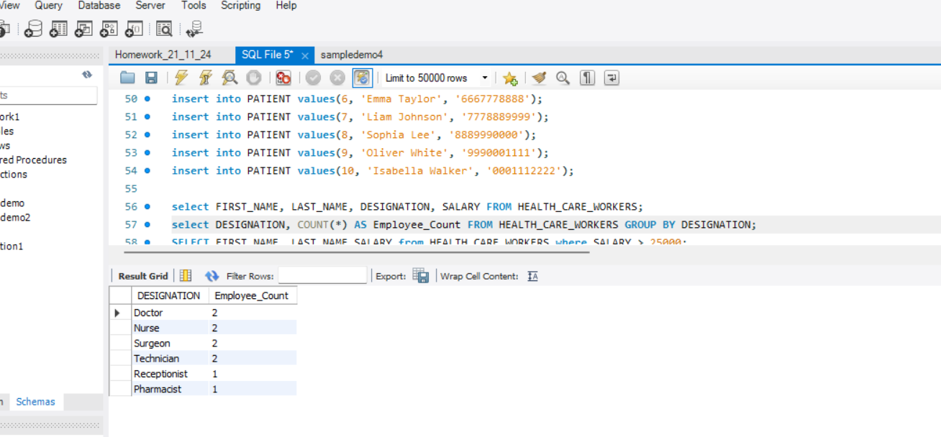

f) Write a query to get employee name who are getting salary more than 25000.

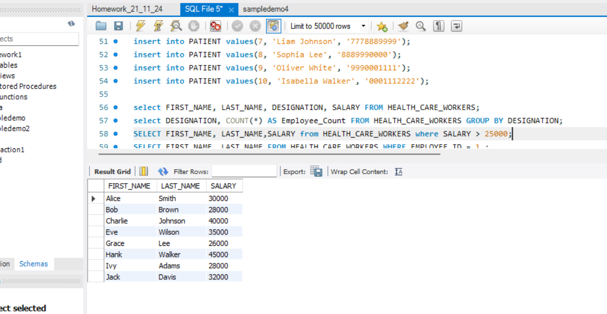

g) Fetch HEALTH CARE WORKERS name using their employee id.

