**St. Thomas’ College of Engineering and Technology**

Industrial Training report on

**“Android- News Application”**

Department of Information Technology

7th Sem , 4th Year

Group No. – 02

Group Member Roll No.

Reeyam Biswas 7

Deepa Biswas 6

Rounak Bhoumick 5

Sayan Chakrabarty 8

**INDEX**

* About Project
* Technologies Involved
* Methodolgy
* System Design
* Database Schema
* Screenshots of Application
* Future Scope
* Conclusion

**About the Project :**

In this project , we have created an android based News application.

A cursory view of the daily global news is shown on a time basis through the application.

User can know the time of the news and the place of its occurence.

**TECHNOLOGIES INVOLVED:**

* Android SDK(Android 8.1 API 28)
* Java Programming language
* XML

**METHODOLOGY**

**For building this project, firstly we have fetched data using the API provided. The fetched data is in JSON format.**

**Coming into the showing of news, We have implemented ListView which will show the news in a list manner i.e. the fetched information is then used to populate the ListView. This in a way sums up the design of Java classes.**

**For the xml design, we have opted for Linear Layout and constraint Layout where we can arrange the UI Elements in a smooth way .We have also used Picasso which is very simple and powerful library for image downloading and caching.**

**SYSTEM DESIGN:**

Our News Application design is following a sequence of steps through moving between different activities.

* **Linear Layout** – Linear Layout is a view group that aligns all children in a single direction, vertically or horizontally. All children of a Linear Layout are stacked one after the other, so a vertical list will only have one child per row, no matter how wide they are, and a horizontal list will only be one row high (the height of the tallest child, plus padding). A Linear Layout respects margins between children and the gravity (right, center, or left alignment) of each child.
* **Constraint Layout**- Constraint Layout allows you to create large and complex layouts with a flat view hierarchy (no nested view groups). it's very flexible and easier to use with Android Studio's Layout Editor. All the power of Constraint Layout is available directly from the Layout Editor's visual tools, because the layout API and the Layout Editor were specially built for each other. So we can build our layout with Constraint Layout entirely by drag-and-dropping instead of editing the XML.
* **Listview** – Displays a vertically-scrollable collection of views, where each view is positioned immediately below the previous view in the list. A list view is an **Adapter view** that does not know the details, such as type and contents, of the views it contains. Instead list view requests views on demand from a **ListAdapter** as needed, such as to display new views as the user scrolls up or down.
* **Picasso**-Picasso is an image loading/processing library developed and maintained by **Square Inc.** It’s immensely popular since it often requires just one line of code and has a similar style of coding for each of its features.
* **Intent**-Intent is a simple message object that is used to communicate between android components such as activities, content providers, broadcast receivers and services. Intents are also used to transfer data between activities.

**SCREENSHOTS OF APP**

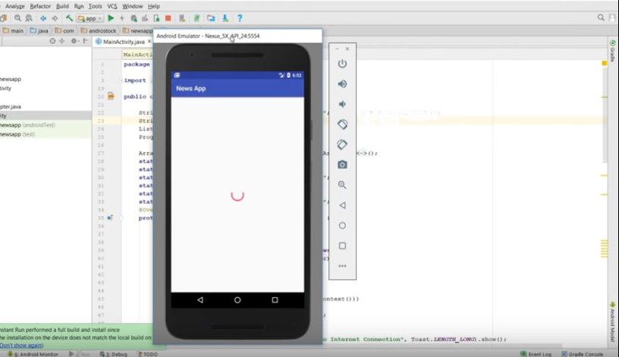

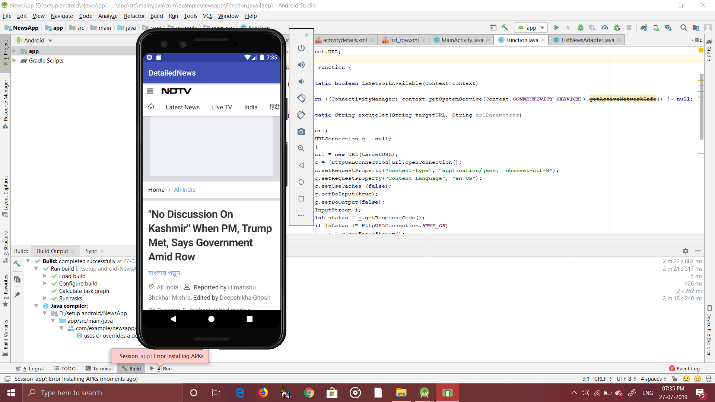

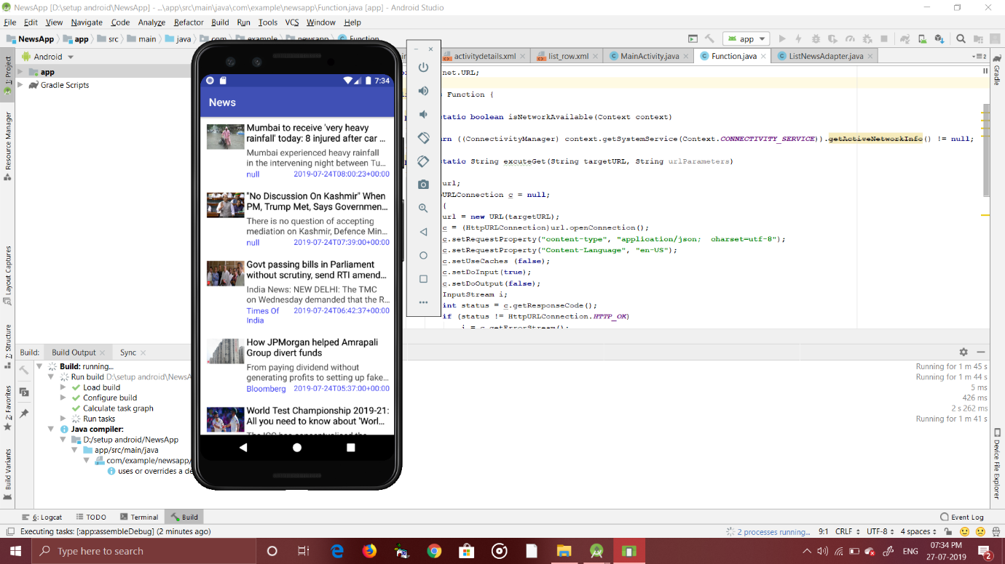**FUTURE SCOPE**

As future projects, one can imagine many improvisations, not only directly concerning the News application. Of course, some minor adjustments have to be done to this app, if it should be ready to be deployed via the Android market. The UI could be improvised a bit to match the design of modern mobile applications. Additionally, some modifications can be done, mainly in the area of saving the desired news articles for future reference, to guarantee a user-friendly atmosphere.

Nevertheless one of the big strengths of this project are definitely the amount of easily, reusable Java packages. As the whole code is open sourced, all parts can be used to build other news-based applications.

**CONCLUSION**

Several goals were accomplished while working on this team project. First of all an application was created which supports a user’s day planning with the following implemented functionalities:

* Generate everyday news, which is taking place all over the world in a short and precise format.
* Images related to the news are display along with the news description.

The task management functionality of this app is also strongly encapsulated and can therefore be reused easily in any Java project.