Food Coma Study
Why Do We Feel Sleepy After Eating? — ML Classification Report (Lab)
127 respondents | 8 features | Models: Random Forest, SVM, Logistic Regression | Train/Test: 101 / 26



Course Code: BI453
Course: Machine Learning and Data Analytics

Made by:

Akanksha Upadhyay Sayandeep Majumdar Vajid Sayyad
25LSMI14 25LCMS07 25LCMS05

1. Problem Statement
Post-meal drowsiness (postprandial somnolence, or "food coma") is a common but poorly understood phenomenon. This project uses machine learning to predict whether a person will feel drowsy after a meal, based on self-reported survey data. The task is framed as binary classification: the target variable is "Did you feel drowsy after your meal?" (Yes = 1, No = 0). Of 127 respondents, 84 (66%) reported drowsiness and 43 (34%) did not — a moderate class imbalance handled using class_weight='balanced' across all models. Three core questions guided the study:

- Can post-meal drowsiness be reliably predicted from simple self-reported features?
- Which features — meal size, carbohydrate content, stress, sleep quality, etc. — are the strongest predictors?
- Which model (Random Forest, SVM, or Logistic Regression) performs best on this data?
2. Dataset Description
Data was collected via a Google Form survey with 127 responses across 31 columns. After dropping some non-informative columns (like Timestamp, Email) and two high-missingness columns (nap duration, drowsiness onset time), eight features were selected for modelling. The Data cleaning involved regex-based age extraction, height unit normalisation (cm / feet-inches / decimal feet), weight stripping, and BMI derivation. Missing values were handled by median imputation for numerics and mode/constant imputation for categoricals.

The 8 features used were: Meal Size (ordinal), Carb Content (ordinal), Protein Content (ordinal), Stress Level (ordinal), Sleep Quality (numeric, 1–5), Meal Heaviness (numeric, 1–5), Meal Type (nominal, one-hot encoded), and Pre-Meal Activity (nominal, one-hot encoded). The dataset was 91 Male and 36 Female respondents, predominantly university students aged 18–30.

Key EDA findings: Very Large meals had a 100% drowsiness rate. Lunch had the highest drowsiness by meal type (79%) while Snacks had the lowest (33%). High Carb Content was associated with 77% drowsiness. Medium stress (84%) showed a higher drowsy rate than High stress (76%), suggesting a non-linear relationship.

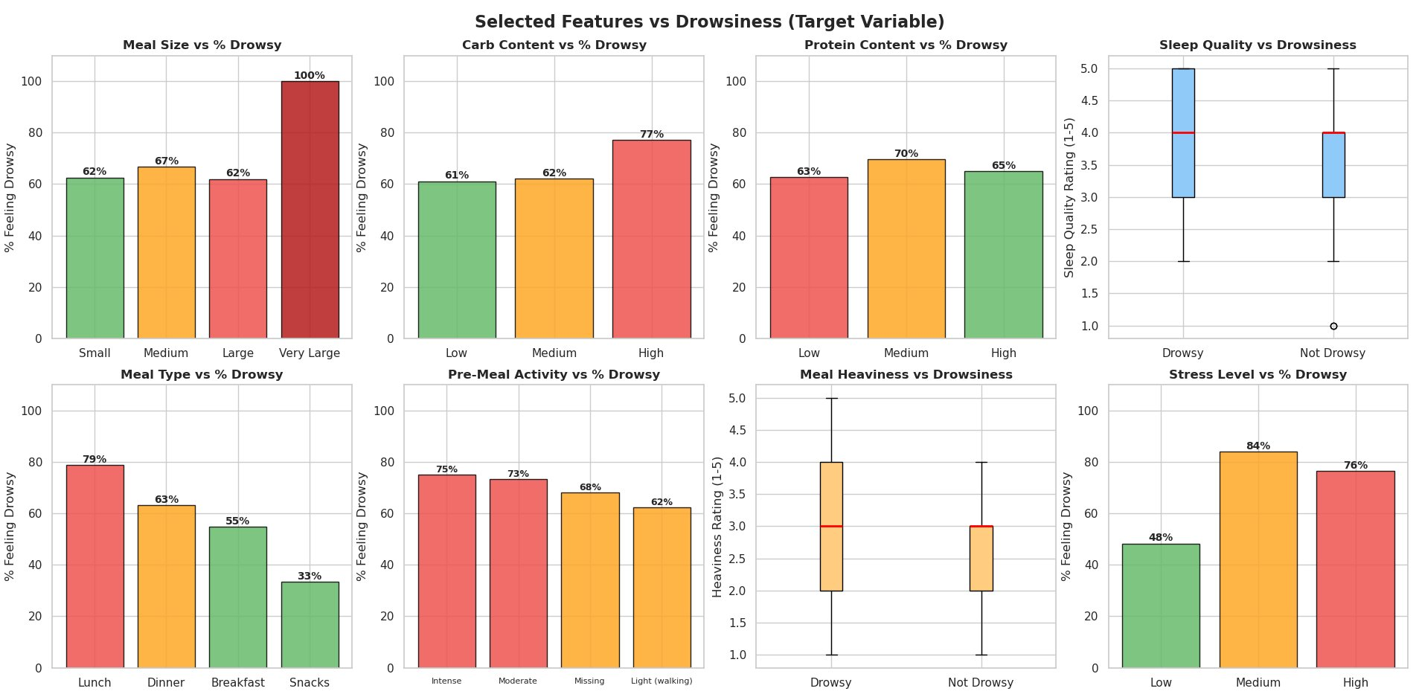
Figure 1 — All 8 selected features vs. drowsiness target variable

3. Models Used
All three classifiers were wrapped in a scikit-learn Pipeline with a shared ColumnTransformer preprocessor (StandardScaler for numeric, OrdinalEncoder for ordinal, OneHotEncoder for nominal features). An 80/20 stratified train/test split gave 101 training and 26 test samples.

- Random Forest — 100 trees, max_depth=5. Uses bootstrap sampling and random feature subsets; supports native Gini/MDI feature importance.
- SVM (RBF kernel) — C=1, probability=True. Finds a maximum-margin hyperplane in a higher-dimensional space; best performer in this study.
- Logistic Regression — C=0.1 (L2 regularisation), max_iter=1000. Linear decision boundary; fast and interpretable baseline.
4. Results
4.1 Classification Performance

Model | Accuracy | Precision | Recall | F1 Score | ROC AUC
Random Forest | 0.731 | 0.750 | 0.882 | 0.811 | 0.771
SVM | 0.808 | 0.833 | 0.882 | 0.857 | 0.830
Logistic Regression | 0.769 | 0.824 | 0.824 | 0.824 | 0.778

Table 1 — Evaluation metrics for all three models on the test set (26 samples)
SVM achieved the best overall performance with the highest Accuracy (0.808), F1 Score (0.857), and ROC AUC (0.830). All three models tied on Recall (0.882), correctly identifying ~88% of actual drowsy cases — important in a health-awareness context. Random Forest had the lowest accuracy and precision, suggesting it struggled more with the non-drowsy minority class.

4.2 Confusion Matrices & ROC Curves
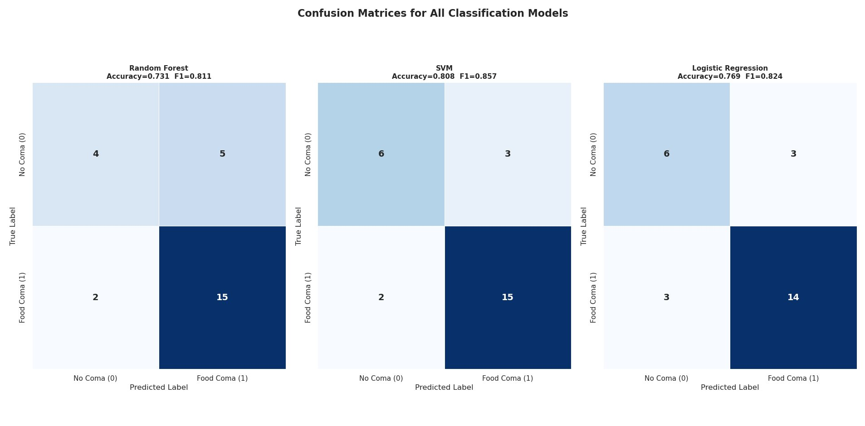
Figure 2 — Confusion matrices: SVM and LR correctly classified 6/9 non-drowsy cases; all models predicted 15/17 drowsy cases
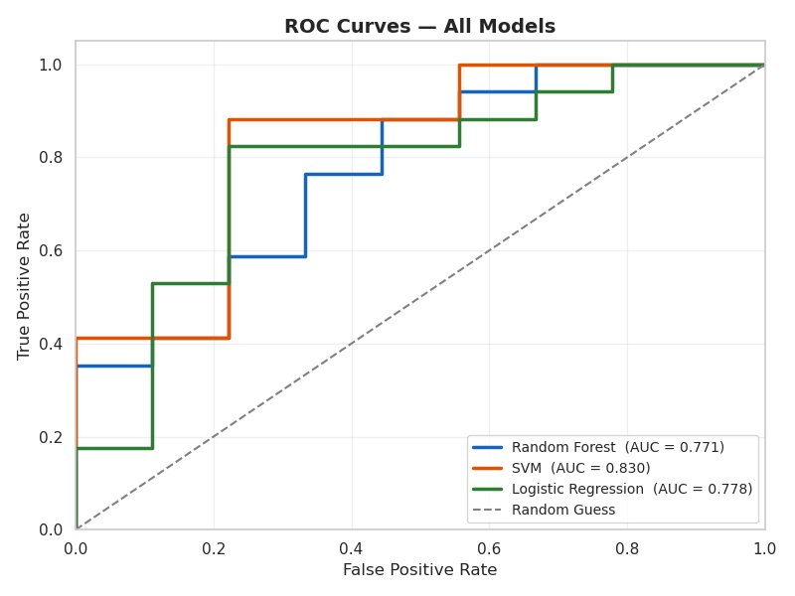  Figure 3 — ROC Curves (SVM AUC=0.830 best) | 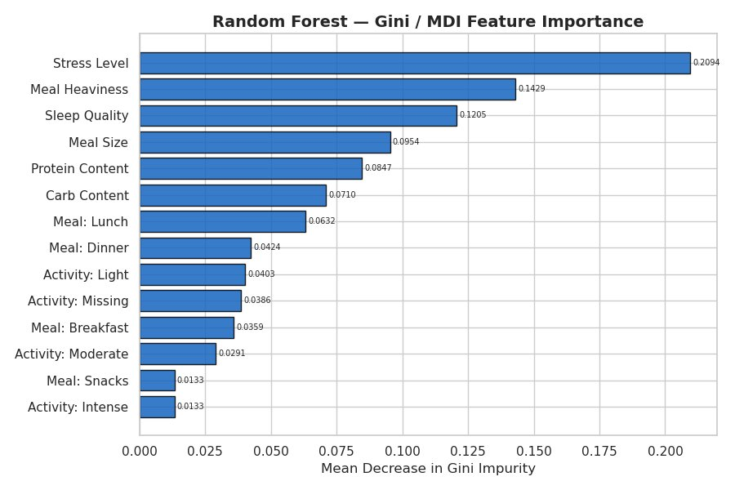  Figure 4 — RF Gini/MDI Importance (Stress Level top)

4.3 Feature Importance
Three complementary importance methods were applied. All these three consistently rank Stress Level as the dominant predictor, followed by Meal Heaviness and Sleep Quality. The Random Forest Gini/MDI plot shows Stress Level with a score of 0.2094 — nearly 1.5× Meal Heaviness (0.1429). Permutation importance on the test set confirms this ranking across all three models, with SVM showing the cleanest signal. The Mean SHAP value plot (applied to Random Forest) corroborates the global ranking, with Stress Level at ~0.115 mean absolute SHAP value, far ahead of all other features.

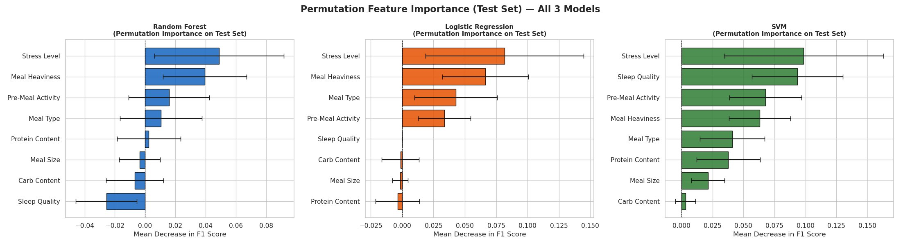
Figure 5 — Permutation Feature Importance on Test Set for all 3 models
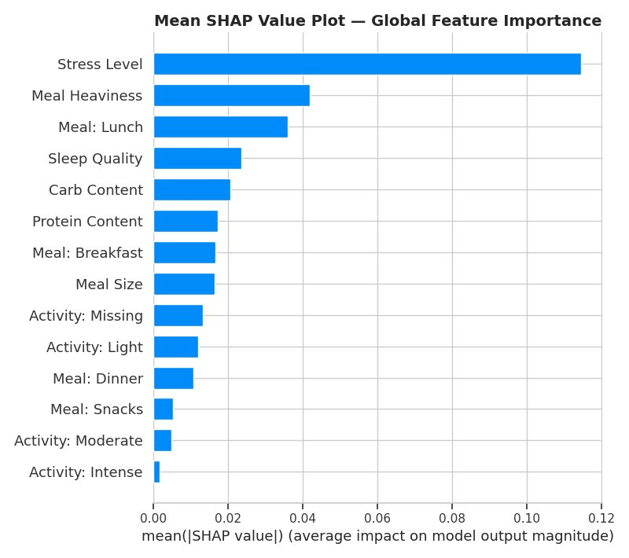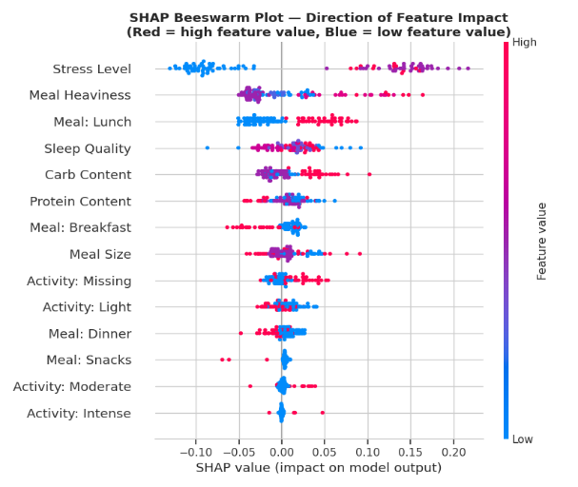
Figure 6 — Mean SHAP Value Plot (Global Feature Importance, Random Forest)
4.4 Key Takeaways
- SVM is the best-performing model: Accuracy = 0.808, F1 = 0.857, AUC = 0.830
- All three models achieve the same Recall (0.882), correctly catching ~88% of drowsy cases
- Stress Level is the single most important predictor across Gini, permutation, and SHAP
- Meal Heaviness and Sleep Quality are consistent second- and third-tier predictors
- Dataset is small (127 rows, 26 test samples) — larger datasets needed to confirm findings

