**Project 3**

**Scenario**

Your company wants to distribute their content in the form of a website to their global offices. However, due to some legal restrictions, you cannot distribute the content in France and Australia. You need to find a way to prevent these offices from accessing the data.

The content does not change very often; however, some of the files are very large, and you have to find a solution to minimize end user latency.

The last requirement is that the audit department wants to track whoever is accessing the website.

Following are the steps for implementing this project:

Action Points:

1. Set up a static website using Amazon S3.

o Create a bucket and enable static website hosting.

o Enable logging.

To create an S3 bucket, following steps are taken:

* From S3 dashboard, select createbucket
* Select bucket name as [simpliproj3s3bucket](https://s3.console.aws.amazon.com/s3/buckets/simpliproj3s3bucket?region=us-east-1)
* Select region as US East (N. Virginia) us-east-1
* Turn off Block all public access
* In advance setting disable WORM lock
* Create bucket

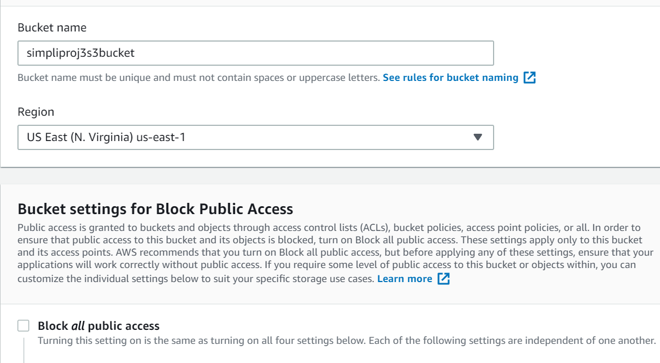

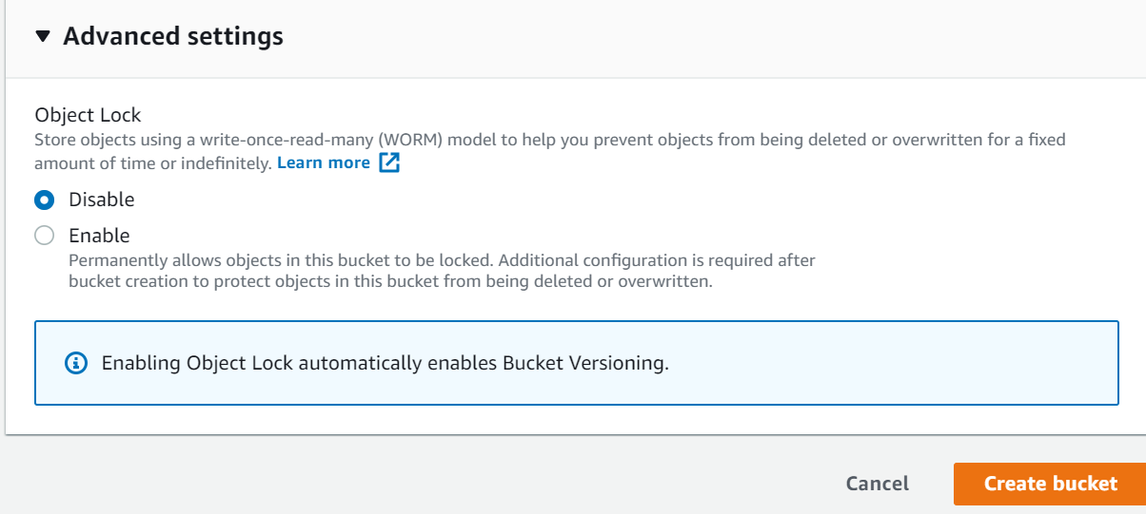

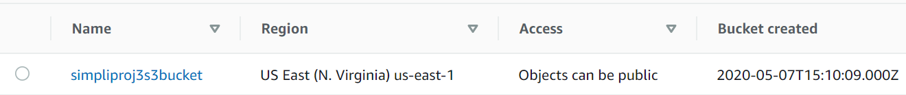

* Go inside the bucket
* Go to Properties tab
* Go to Static Hosting
* Turn on Use this bucket to host a website
* Give the default page name in Index document
* Then Save

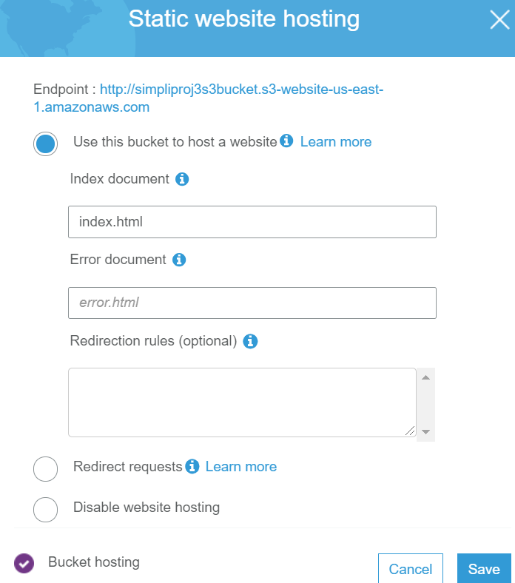

* Go to Object-level logging
* We have to choose an existing cloudtrail
* To create a trail, go to Cloudtrail console
* From cloudtrail dashboard, select create trail
* Trail name as simpliproj3trail
* Select region as N. Virginia
* Select read/write events as ALL
* Log AWS KMS events as Yes
* In the Data events section, select our project bucket simpliproj3s3bucket as S3 bucket name
* In the Storage location section, select our project bucket simpliproj3s3bucket as S3 bucket name
* Tag the trail with name as simpliproj3trail

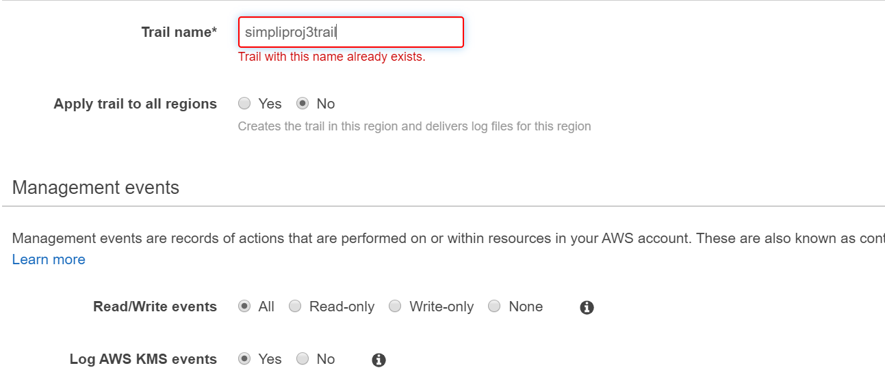

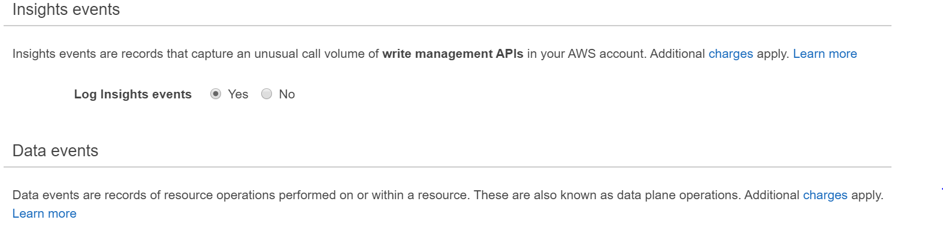

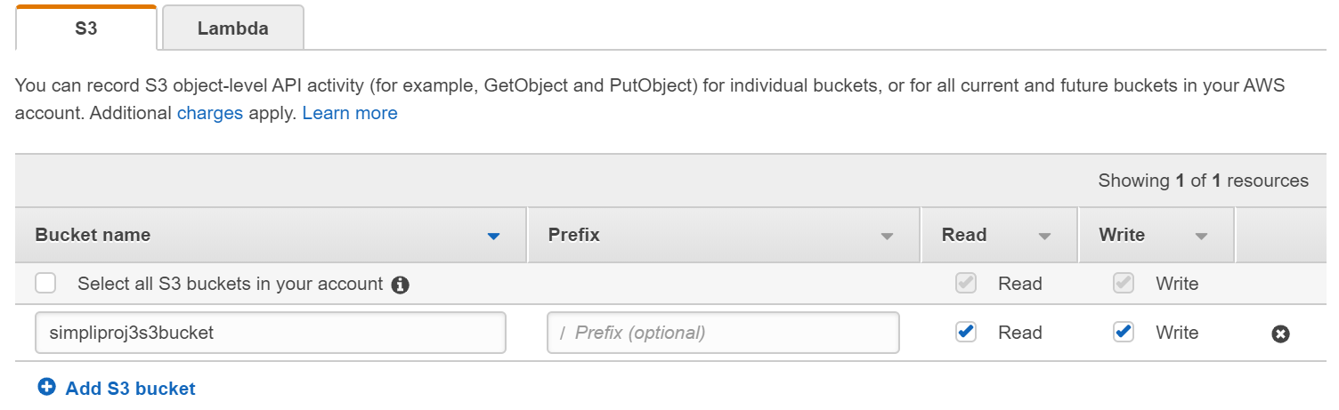

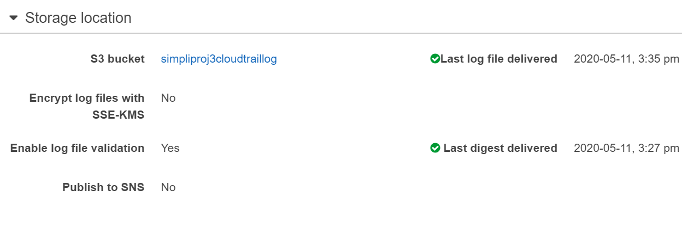

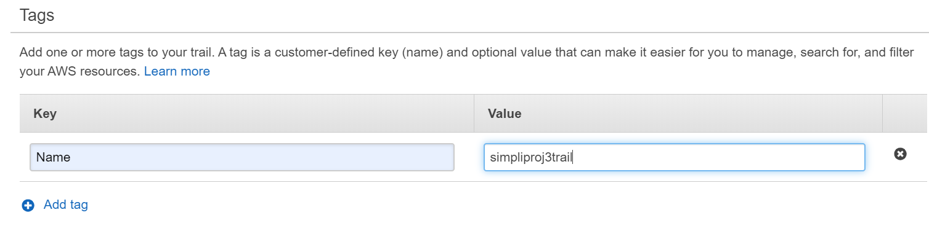

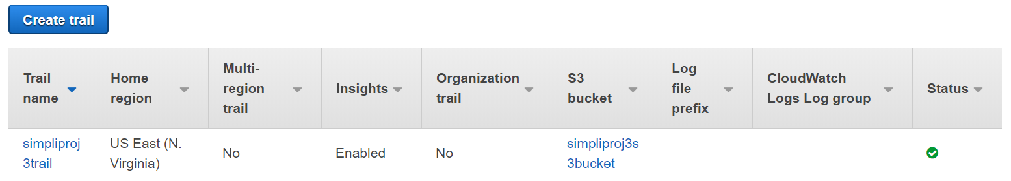

* Go back to s3
* Select the cloudtrail in the object-level logging

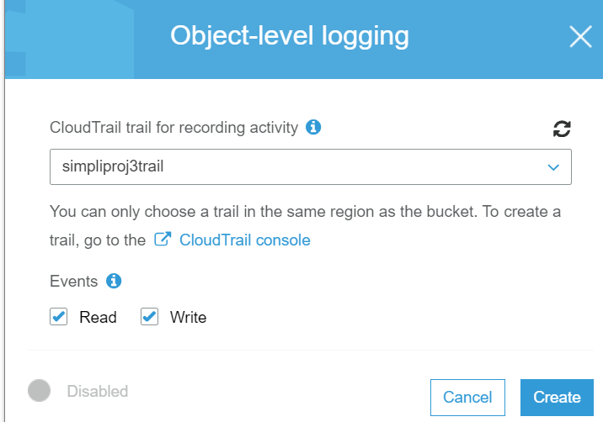

* To create CloudFront distributed, from CloudFront dashboard, created distribution

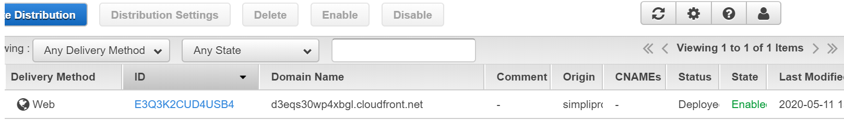

* Go inside the distribution, and go to Restriction tab

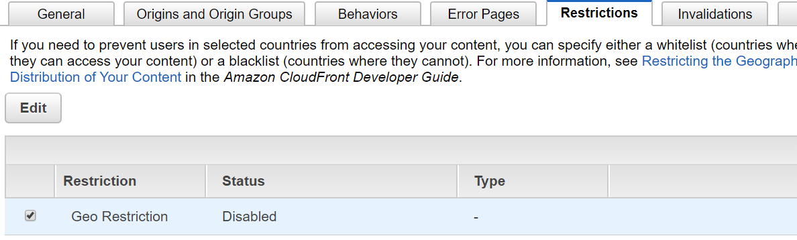

* Edit Geo location, blacklist France and Australia

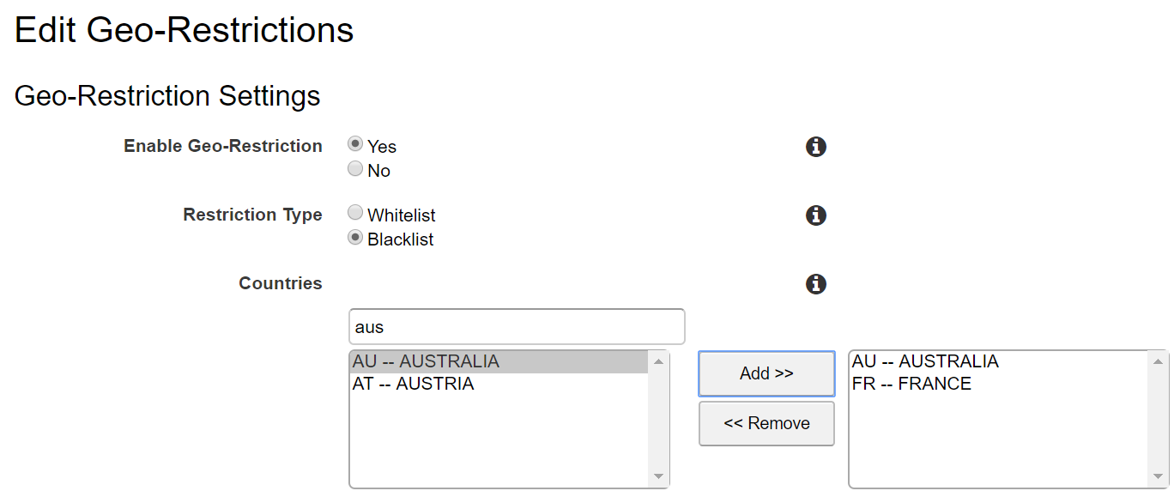

* Now when I hit the URL provided by CloudFront ‘d3eqs30wp4xbgl.cloudfront.net’ I can see the log is getting generated in in CloudTrail

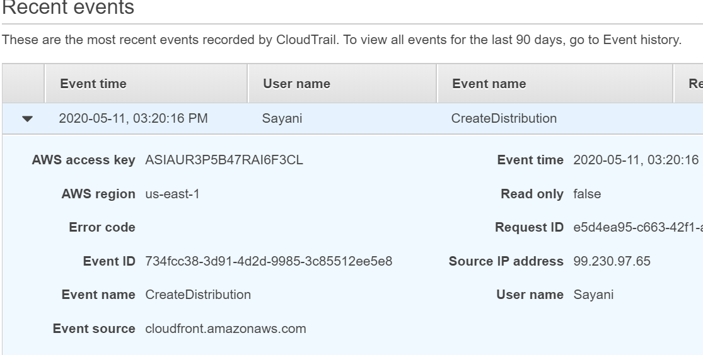

* Also, the log can be viewed in the designated S3 bucket ‘simpliproj3cloudtraillog’ which I am using as the storage location for this cloudtrail

