SOFTWARE REQUIREMENT SPECIFICATION (SRS)
Cloud Infrastructure Automation Using Terraform with Remote State Management on AWS

1. Introduction
1.1 Purpose
The purpose of this project is to automate the provisioning and management of AWS cloud infrastructure using Terraform. The project implements Infrastructure as Code (IaC) principles with modular architecture, remote state management using Amazon S3, and state locking using DynamoDB.

1.2 Scope
This project automates AWS infrastructure deployment including:
- VPC Creation
- Subnet Configuration
- EC2 Instance Provisioning
- Security Group Configuration
- Remote Backend Setup
- DynamoDB State Locking
The project improves infrastructure consistency, automation, and scalability.

1.3 Objectives
- Automate AWS infrastructure provisioning
- Reduce manual configuration
- Implement Infrastructure as Code
- Configure remote backend
- Enable state locking
- Improve infrastructure management

2. Overall Description
2.1 Existing System
Traditional infrastructure management is manual and time-consuming. Manual provisioning often leads to:
- Human errors
- Configuration inconsistencies
- Slow deployment
- Difficult infrastructure management

2.2 Proposed System
The proposed system automates infrastructure provisioning using Terraform with modular architecture and remote backend management.
Features:
- Automated deployment
- Reusable Terraform modules
- Remote state management
- Infrastructure consistency
- Faster provisioning

3. Functional Requirements
The system should:
- Create AWS VPC
- Create Subnet
- Configure Security Group
- Launch EC2 Instance
- Store Terraform state in S3
- Implement state locking using DynamoDB
- Manage infrastructure using Terraform modules

4. Non-Functional Requirements
Performance
- Faster infrastructure deployment
- Reduced manual effort
Security
- Secure AWS access
- Controlled infrastructure provisioning
Reliability
- Consistent infrastructure deployment
- State locking to prevent conflicts
Scalability
- Modular infrastructure design
- Reusable Terraform configurations

5. Hardware Requirements
- Processor: Intel i3/i5 or above
- RAM: 4 GB or above
- Hard Disk: 20 GB free space
- Internet Connection

6. Software Requirements
- Windows/Linux Operating System
- Terraform
- AWS CLI
- Git
- GitHub
- VS Code
- AWS Account

7. Feasibility Study
Technical Feasibility
The project is technically feasible because Terraform and AWS provide reliable cloud infrastructure automation services.
Economic Feasibility
The project uses AWS Free Tier resources and open-source Terraform, reducing implementation cost.
Operational Feasibility
The system is easy to operate and manage through Terraform commands and AWS services.

8. SDLC Model
Agile SDLC Model
The Agile model is used in this project because it supports:
- Continuous improvement
- Faster development
- Easy modifications
- Incremental deployment
SDLC Phases
- Requirement Analysis
- System Design
- Development
- Testing
- Deployment
- Maintenance
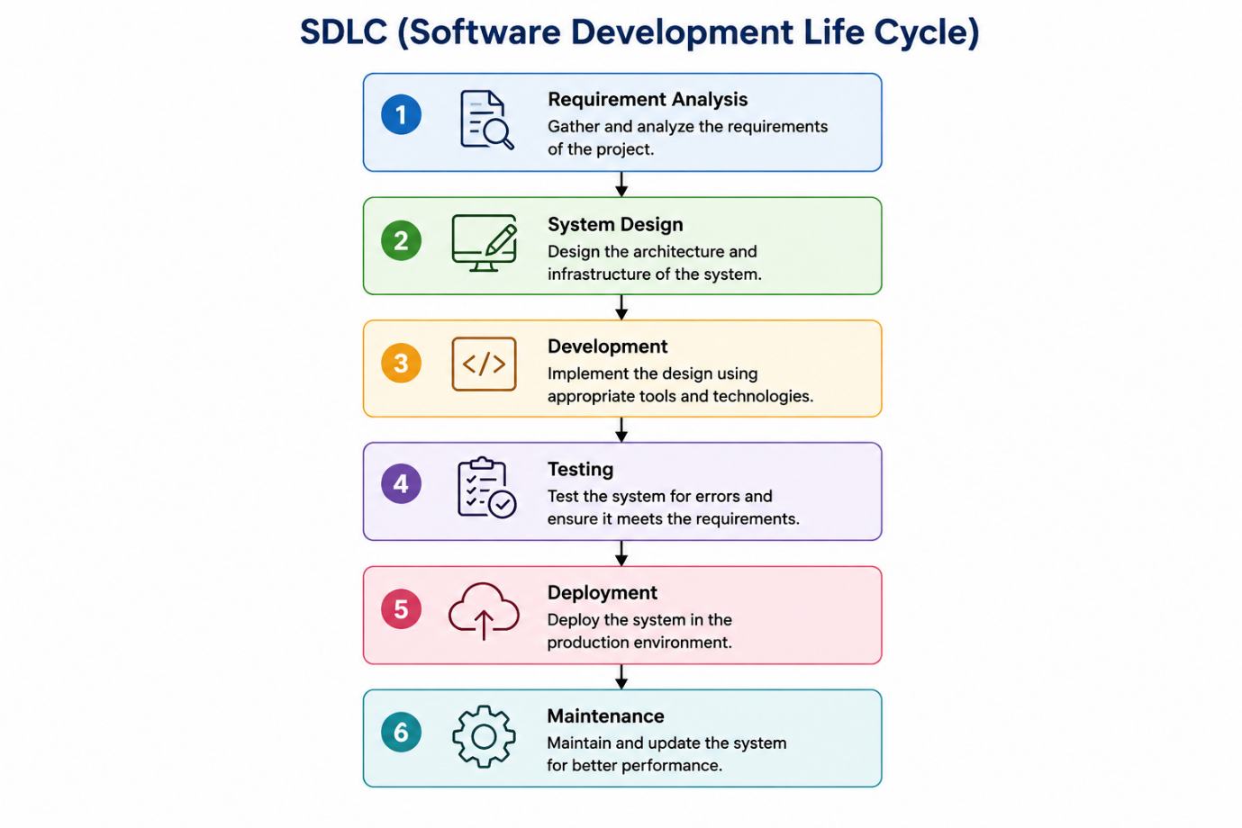

9. Testing
Types of Testing Performed
Unit Testing
Individual Terraform modules were tested separately.
Integration Testing
All Terraform modules were integrated and tested together.
System Testing
Complete infrastructure provisioning was tested on AWS.
Validation Testing
Terraform validation commands were used to verify infrastructure configuration.

10. Advantages of the Project
- Automated infrastructure provisioning
- Faster deployment
- Infrastructure consistency
- Reusable infrastructure code
- Improved collaboration
- Secure remote state management

11. Limitations
- Requires internet connectivity
- AWS account dependency
- Basic infrastructure deployment only

12. Future Scope
- Jenkins CI/CD integration
- Kubernetes deployment
- Monitoring using Prometheus and Grafana
- Multi-cloud deployment
- Auto Scaling implementation

13. Conclusion
This project successfully demonstrates Infrastructure as Code implementation using Terraform on AWS. The project automates cloud infrastructure provisioning with secure remote state management and state locking mechanisms.

