SYNOPSIS
Cloud Infrastructure Automation Using Terraform with Remote State Management on AWS

Introduction
Cloud computing has become an essential part of modern IT infrastructure. Managing cloud resources manually can lead to configuration errors, increased deployment time, and infrastructure inconsistency. Infrastructure as Code (IaC) is a modern approach that automates infrastructure provisioning and management using code.
This project focuses on automating AWS cloud infrastructure provisioning using Terraform. The project also implements remote state management using Amazon S3 and state locking using DynamoDB to improve infrastructure consistency, collaboration, and reliability.

Objective of the Project
The main objective of this project is to automate cloud infrastructure provisioning on Amazon Web Services (AWS) using Terraform.
The project aims to:
- Implement Infrastructure as Code (IaC)
- Automate AWS resource creation
- Configure remote backend using AWS S3
- Implement state locking using DynamoDB
- Create reusable Terraform modules
- Reduce manual configuration effort
- Improve infrastructure consistency and scalability

Problem Statement
Manual cloud infrastructure provisioning is time-consuming and prone to human errors. Managing infrastructure manually also creates difficulties in maintaining consistency across environments. This project solves these problems by automating infrastructure deployment using Terraform with modular architecture and secure state management.

Scope of the Project
The project automates the provisioning and management of AWS cloud infrastructure resources including:
- Virtual Private Cloud (VPC)
- Subnet
- EC2 Instance
- Security Group
- Remote Backend Storage
- State Locking Mechanism
The project demonstrates Infrastructure as Code principles using Terraform with AWS cloud services.

Technologies Used
Technology | Purpose
Terraform | Infrastructure Automation
AWS EC2 | Virtual Server
AWS VPC | Network Infrastructure
AWS S3 | Remote Backend
AWS DynamoDB | State Locking
GitHub | Version Control
VS Code | Development Environment

Hardware Requirements
- Processor: Intel i3/i5 or above
- RAM: 4 GB or above
- Hard Disk: 20 GB free space
- Internet Connection

Software Requirements
- Windows/Linux Operating System
- Terraform
- AWS CLI
- Git
- GitHub
- VS Code
- AWS Account

Modules of the Project
- VPC Module
- EC2 Module
- Security Group Module
- Remote Backend Configuration
- DynamoDB State Locking
- Infrastructure Automation

Architecture Diagram
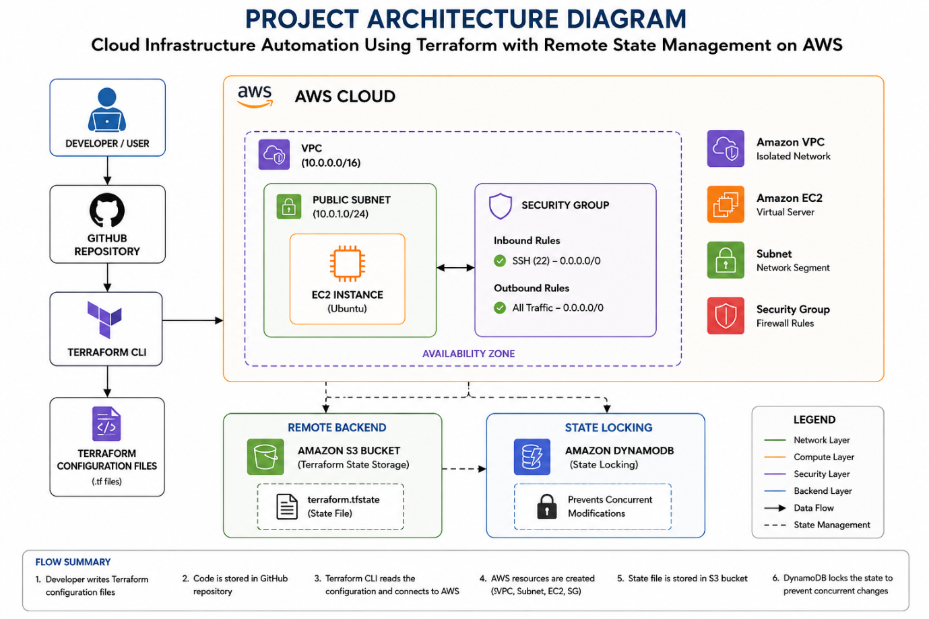

Expected Outcome
The project will successfully automate AWS cloud infrastructure provisioning using Terraform with secure remote state management and state locking mechanisms. The project will reduce manual effort, improve deployment consistency, and demonstrate Infrastructure as Code implementation in cloud environments.

Advantages of the Project
- Faster infrastructure provisioning
- Improved infrastructure consistency
- Reusable infrastructure code
- Reduced manual configuration
- Better collaboration using remote backend
- Secure state management
- Automated cloud deployment

Future Scope
- Jenkins CI/CD Integration
- Kubernetes Deployment
- Monitoring using Prometheus and Grafana
- Multi-Environment Deployment
- Auto Scaling Implementation

Conclusion
This project demonstrates the implementation of Infrastructure as Code using Terraform on AWS. The use of remote backend configuration and state locking improves infrastructure management, collaboration, and deployment reliability.

