**INTERNSHIP/TRAINING AT DIRECTORATE OF ORDNANCE(C&S)**

MINISTRY OF DEFENCE

REPORT ON

ONLINE ANNUAL APPRISAL REPORT WEBSITE

BY

~Sayan Nath

DEPSARTMENT OF COMPUTER SCIENCE AND ENGG(CORE)

5th Semister

VELLORE INSTITUTE OF TECHNOLOGY, CHENNAI

DATE-13-10-2023

**ACKNOWLEDGEMENT**

This is to acknowledge that myself SAYAN NATH, a 3rd year student of Vellore Institute of Technology, Chennai persuing B.Tech in Computer science and Engineering(CORE) has completed my project on making an ONLINE ANNUAL APPRISAL REPORT WEBSITE. I have created the website and a report about it.

During my internship/training, I was guided by extremely knowledgeable and skilled officers of IT division of DOO(C&S). I am extremely thankful for the whole hearted support and skillsful guidance of the following mentor/Officers:

1. Smt. Sunita Mansukhani, DDG/IT

2. Shri. Tausif Ahmed, DD/IT

3. Shri Mithun Kumar Das, HOS/IT

4. Shri Rupam Banarjee, JWM/IT

5. Shri Ravi Shankar Majumdar, JWM/IT

6. Shri Amit Choudhary, JWM/IT

During this internship/training, I had to learn a new computer language called ‘PHP’ in order to prepare the website. During my training, I encountered difficulties at various levels, which I was able to overcome with the assistance of my mentors. I have learnt several new things during this training, which has enhanced my knowledge, and will help me in career.

I again convey my heartfelt thanks to everyone of DoO(C&S), Kolkata who have helped me a lot in executing my entrusted jobs.

~Sayan Nath

**PROJECT OVERVIEW: DEVELOPING AN ONLINE APPRAISAL REPORT WEBSITE**

An online appraisal report website is a web-based platform that allows organizations to manage and automate their employee performance appraisal process. It provides a centralized repository for all appraisal-related data, including employee goals, performance reviews, and development plans. It also streamlines the appraisal process by automating tasks such as sending reminders, collecting feedback, and generating reports.

The development of an online appraisal report website is a significant undertaking aimed at modernizing and streamlining the appraisal process. This project aims to create a user-friendly platform that allows individuals and organizations to easily generate comprehensive appraisal reports for various purposes, such as real estate, art, antiques, and more. The website will leverage cutting-edge technology to automate and simplify the traditionally labor-intensive and time-consuming task of creating appraisal reports.

The primary goal of this project is to provide employees with a convenient and efficient tool for conducting appraisals. Users will be able to input relevant information about the item or property they wish to appraise, and the website will generate a professional and standardized appraisal report in a matter of minutes. This will not only save users valuable time but also ensure the accuracy and consistency of appraisal reports.

Key features of the online appraisal report website will include a user-friendly interface, secure data storage, and integration with valuation databases and resources. Additionally, the website will prioritize data security and privacy to protect sensitive information.

Atfirst Employees need to fill the appraisal form and then they have to Review and submit the form. After that Manager can able to see the Employee’s Apprisal and then they can do their appraisal and then they have to do Review and submit the form after that Teamlead have to do the same process.

In summary, the development of an online appraisal report website represents a forward-looking approach to the appraisal industry. By harnessing the power of technology, this project aims to make the appraisal process more accessible, efficient, and reliable for individuals and businesses seeking accurate and professionally crafted appraisal reports.

**FLOW OF THE PROJECT**

Employee interface:

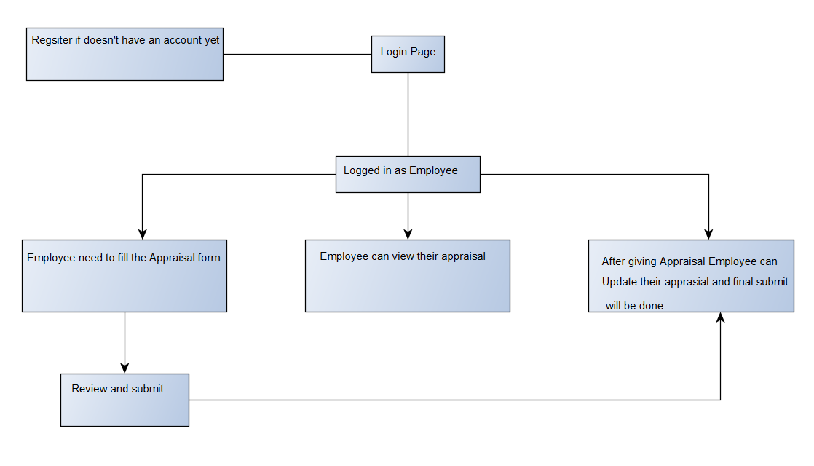

Manager interface:

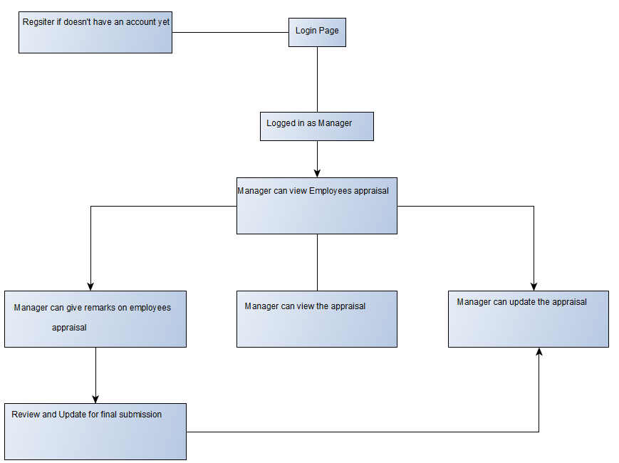

**Teamlead interface:**

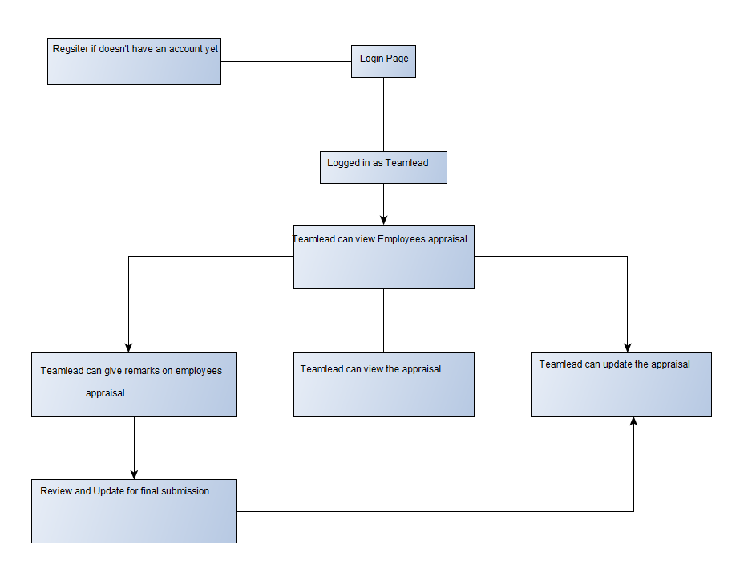

**TECHNICAL PREREQUISITES: LANGUAGE AND RESOURCE REQUIREMENTS FOR AN EFFECTIVE ONLINE ANNUAL APPRISAL FORM**

**FRONTEND:**

HTML: Hyper Text Markup Language or HTML is the standard markup language for documents designed to be displayed in a web browser. It defines the meaning and structure of web content. It is often assisted by technologies such as Cascading Style Sheets and scripting languages such as JavaScript.

CSS: Cascading Style Sheets is a style sheet language used for describing the presentation of a document written in a markup language such as HTML or XML.

**BACKEND:**

PHP: Hypertext Pre-Processor, is the most widely used open source and general purpose server side scripting language used mainly in web development to create dynamic websites and applications.

MYSQL: It is an open-source relational database management system.

For the frontend, I have used html to create the login page, signup page, forget password page, Apprisal form page for Employee, Manager and Teamlead interface. And have styled the pages using css on it.

And for the backend, I've used PHP to connect my databases to the server. I used mysql to create the database directory, and added the necessary tables for the server. Here, all data will be saved in a specific pattern, making it easier to retrieve, store, update, and perform various queries on it.

**EXPLORING THE FEATURES AND CAPABILITIES OF THE WEB SERVER CONTENT**



Atfirst User have to choose their position and click accordingly.

**FOR EMPLOYEE:**

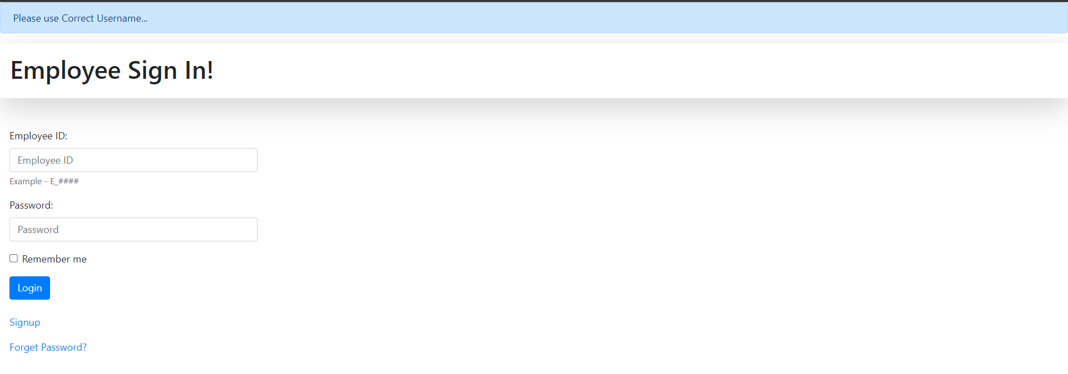

This is the Employee login page. Employee will enter their Employee id and Password to login into User interface. If Employee doesnot have an account can click on ‘SIGNUP’ below to make a new registration and if Employee forget their password then they have to click on ‘FORGET PASSWORD’ to update their password.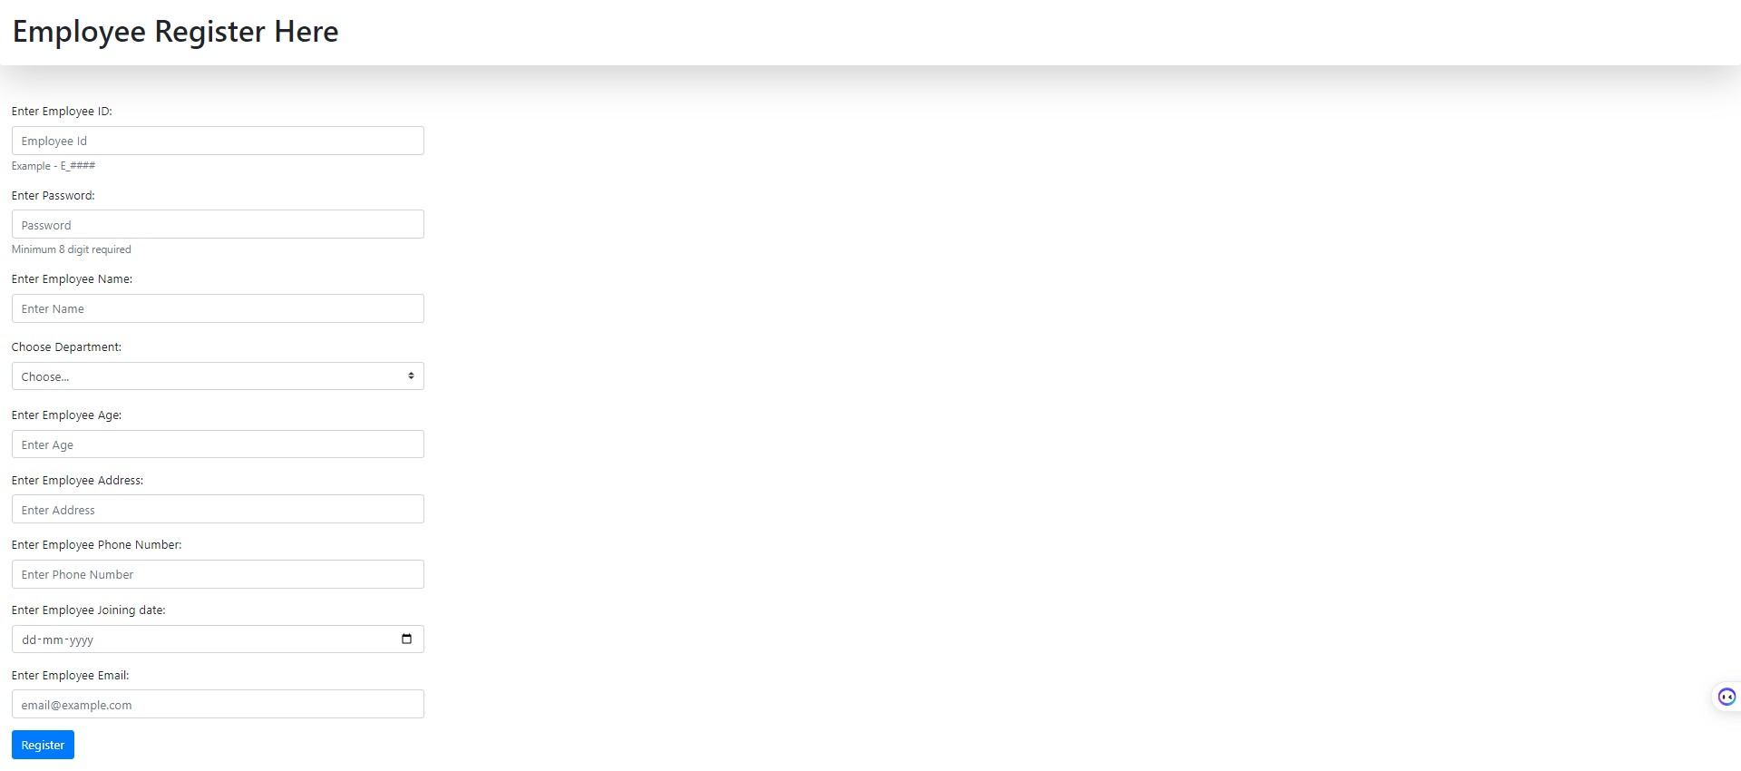

This is the signup form. Employee can Register if they don’t have Employee account.

Employee Interface:



Employee can choose their purpose from here. To fillup Appraisal form Employee have to click on “APPRAISAL FORM”, and after Apprisal, if they want to view their Appraisal, they can click on ‘SEE YOUR REVIEW’ and if Employee want to Update their appraisal, they have to click on ‘UPDATE APPRISAL’.

**Employees Appraisal Form:**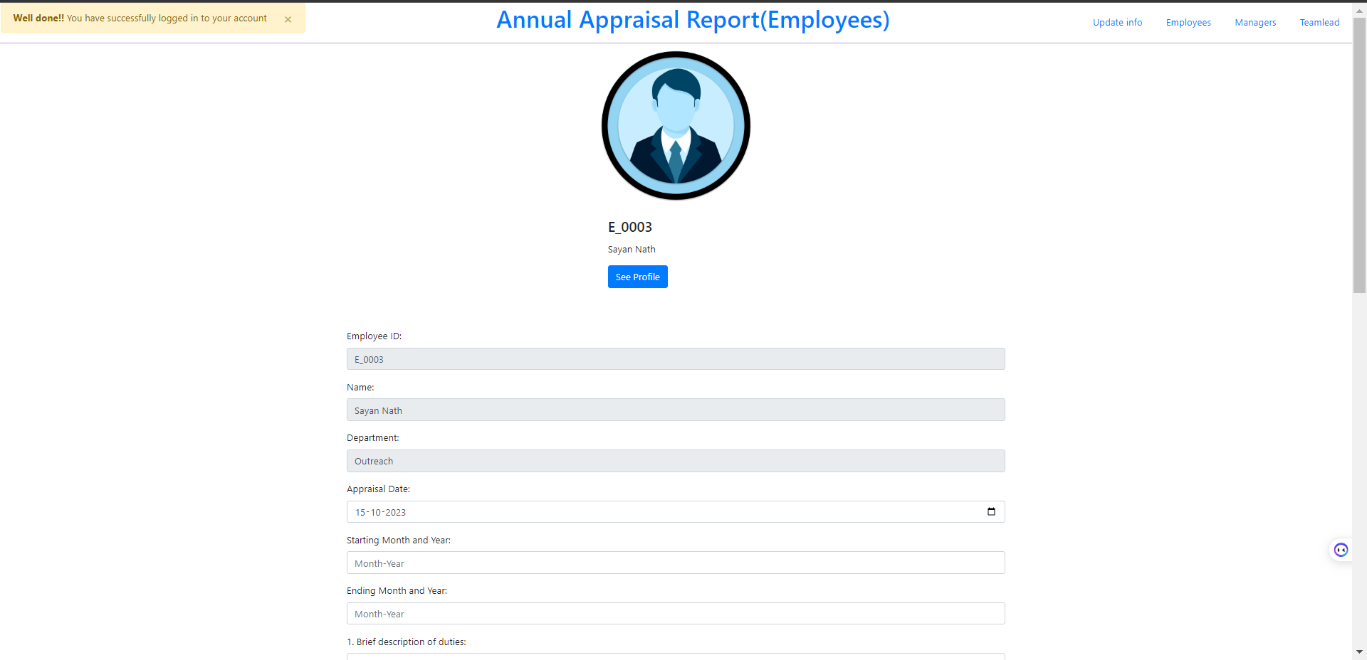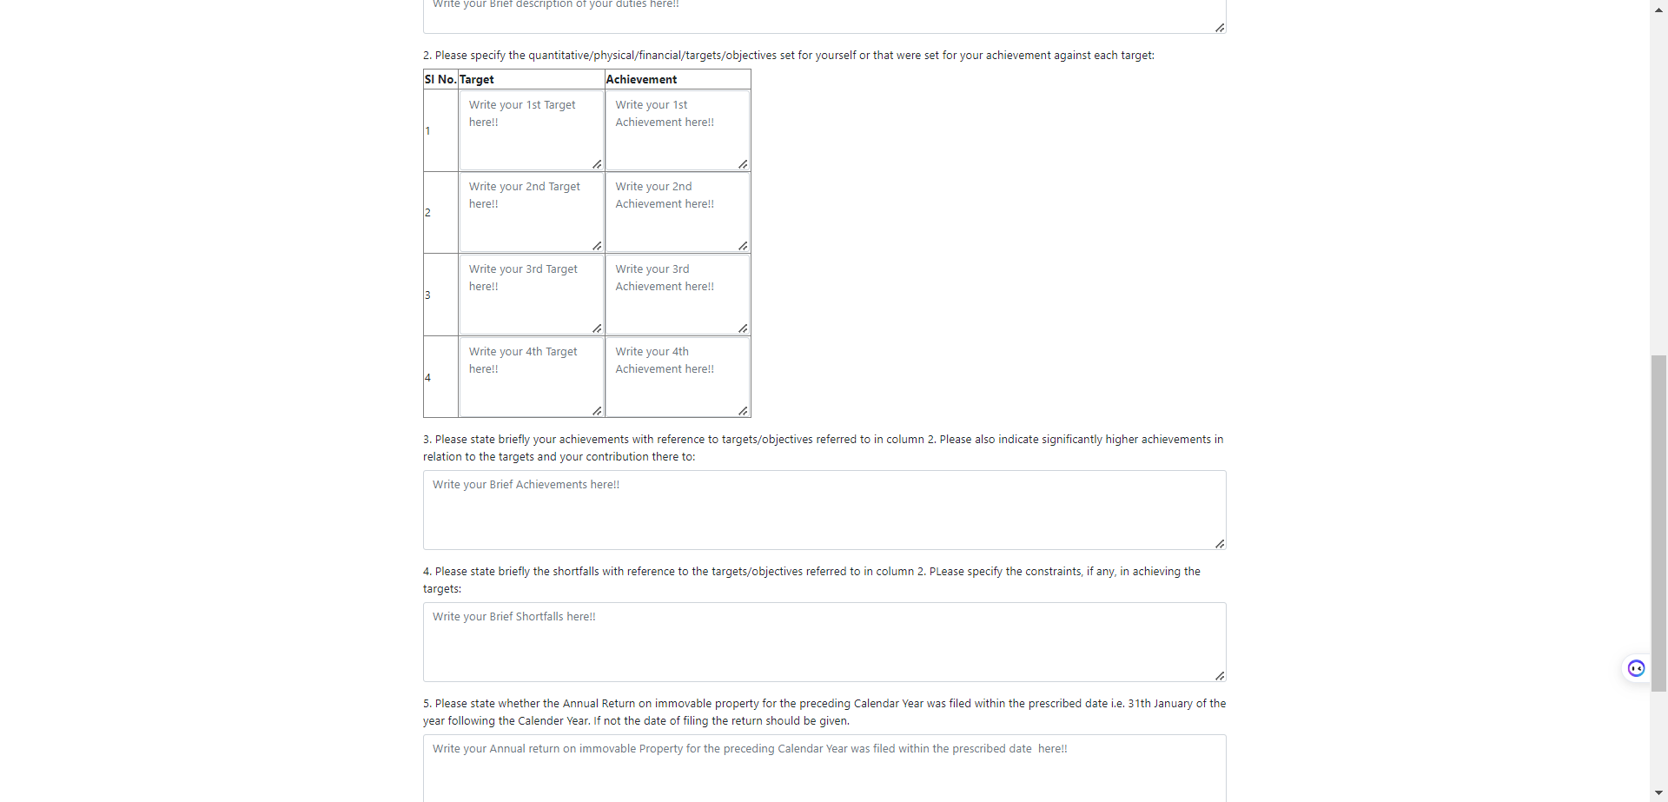

This is the Appraisal form that Employee have to fill.

**Header of the form:**



At the header of this page, there are many navbars. To show other Employee, Manager, Teamlead name, they need to press accordingly. And to Update their details then they have to click on ‘Update Info’.

See Profile:



By clicking on ‘See Profile’, Employee can see their details like this..



After submitting Appraisal Form:

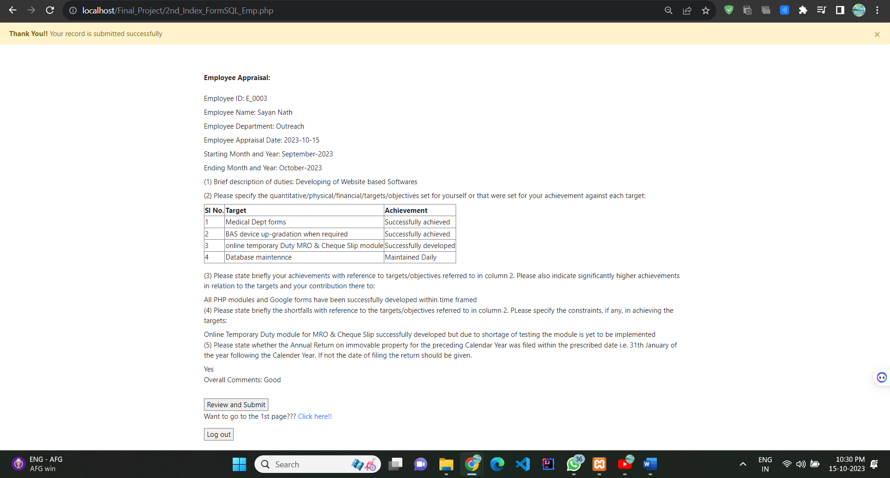

Employee have to press Review and submit button for the final submission else user have to click on the hyperlink ‘Click here’ if they want to finally submit their form or to update their form and finally submit it.



Update appraisal/Review and submit form:

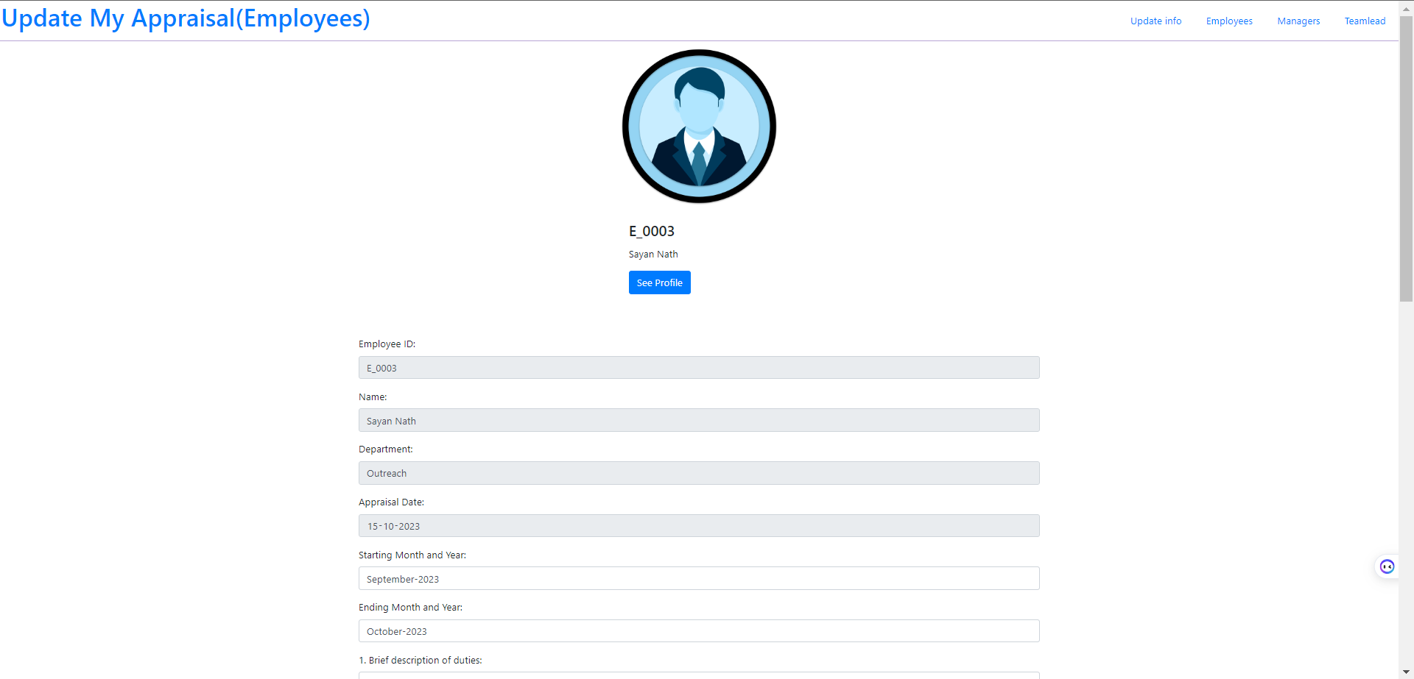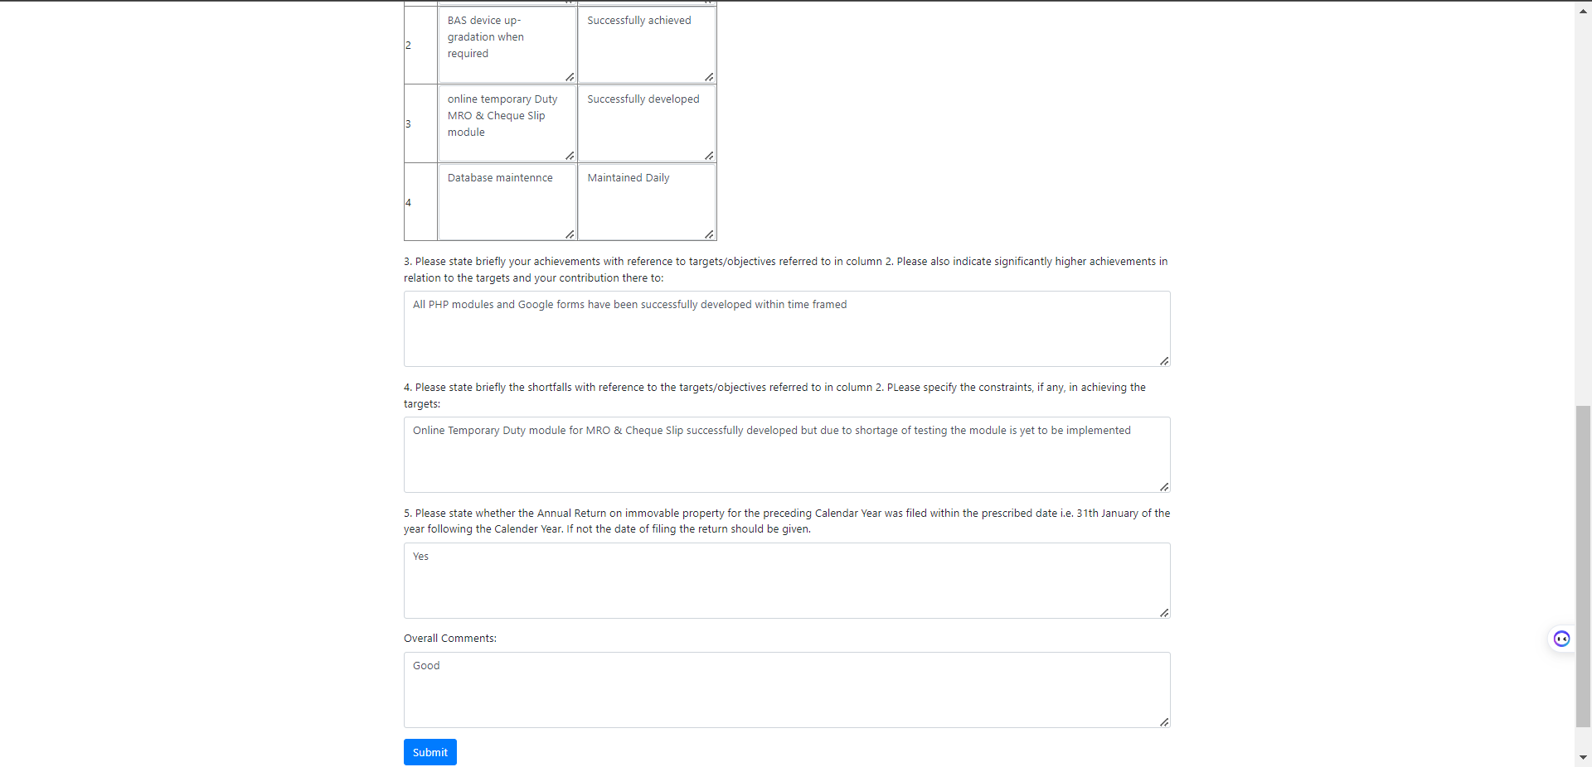

After Final submit:



**FOR MANAGER:**

Manager’s Login page:

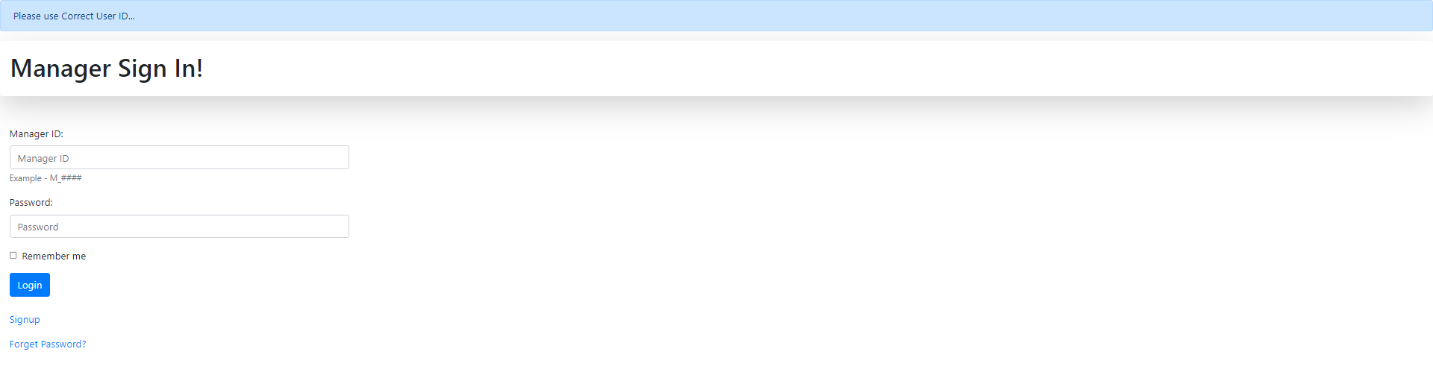

Same as Employee, Manager has their own login page, signup option and if they forget their password, they can update their password by ‘Forget Password’ hyperlink. Manager need to give the correct credentials to login in his account.

After login Manager will see all the Employee’s Appraisal and the Review link also

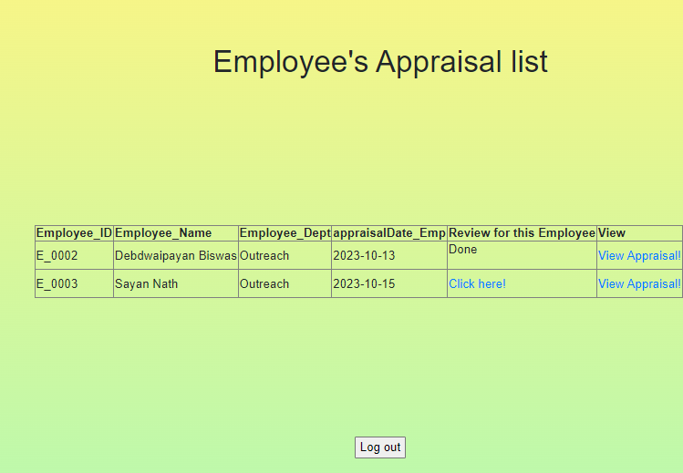

Manager can able to Review for the Employee for single time, So after Review, the Review Hyperlink will be vanished and it will be show ‘Done’. But Manager can able to Update the form.

Manager’s Apprisal Form:

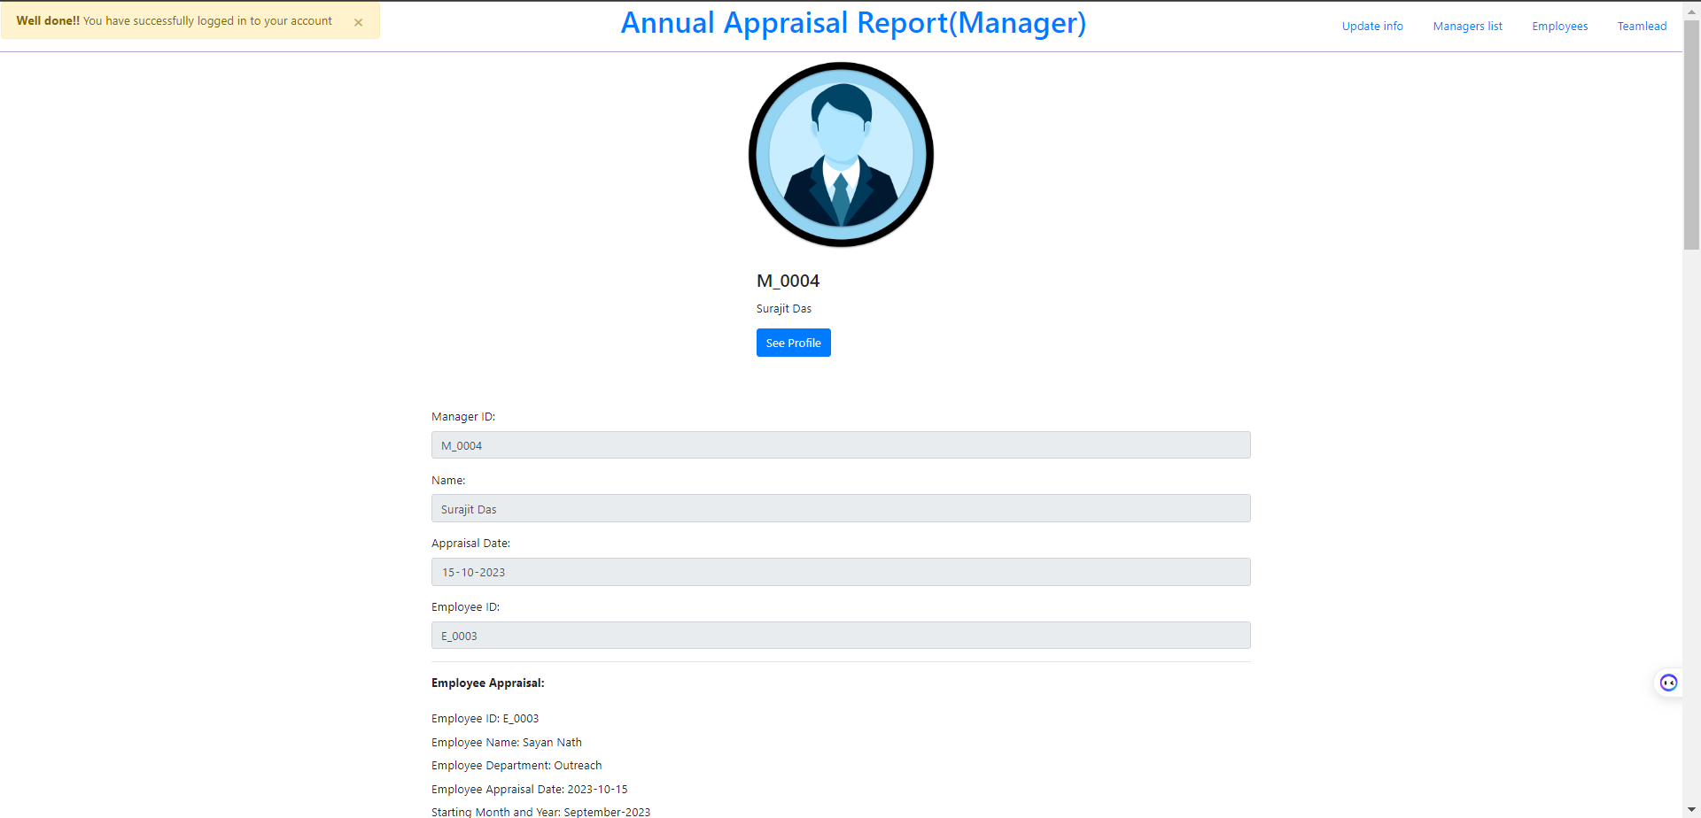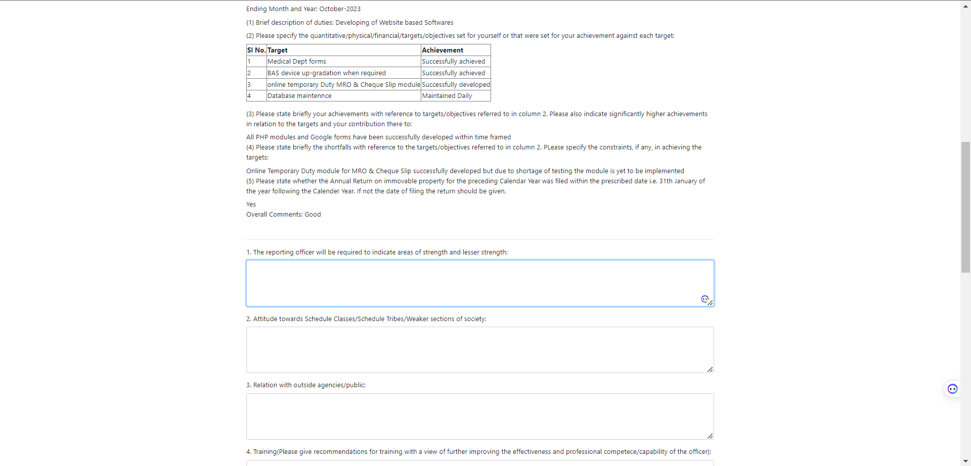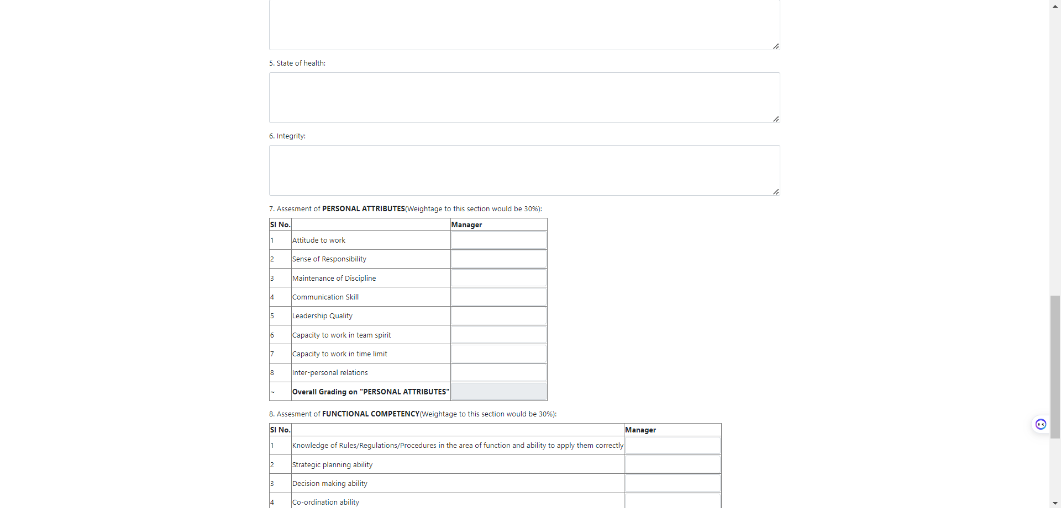

After Submitting Review Page: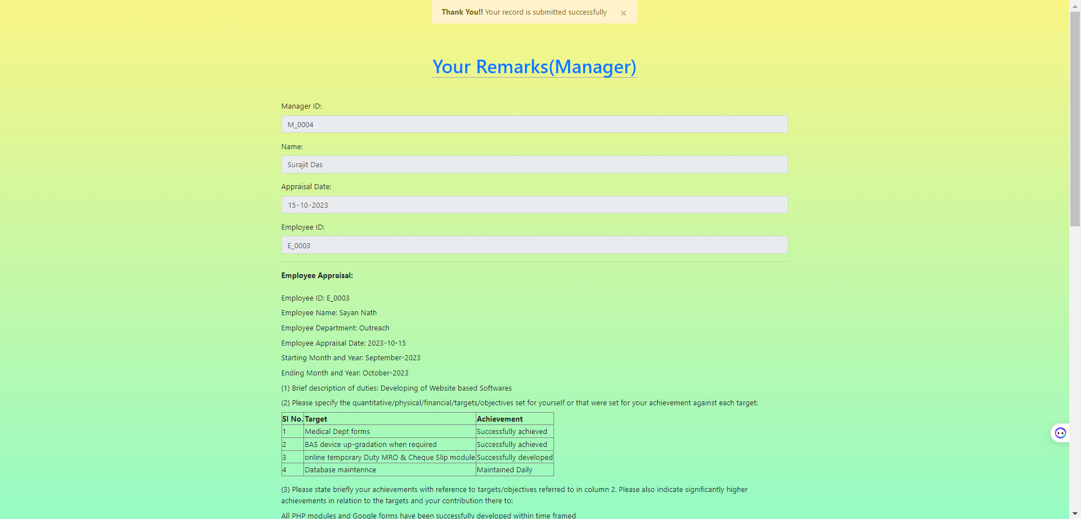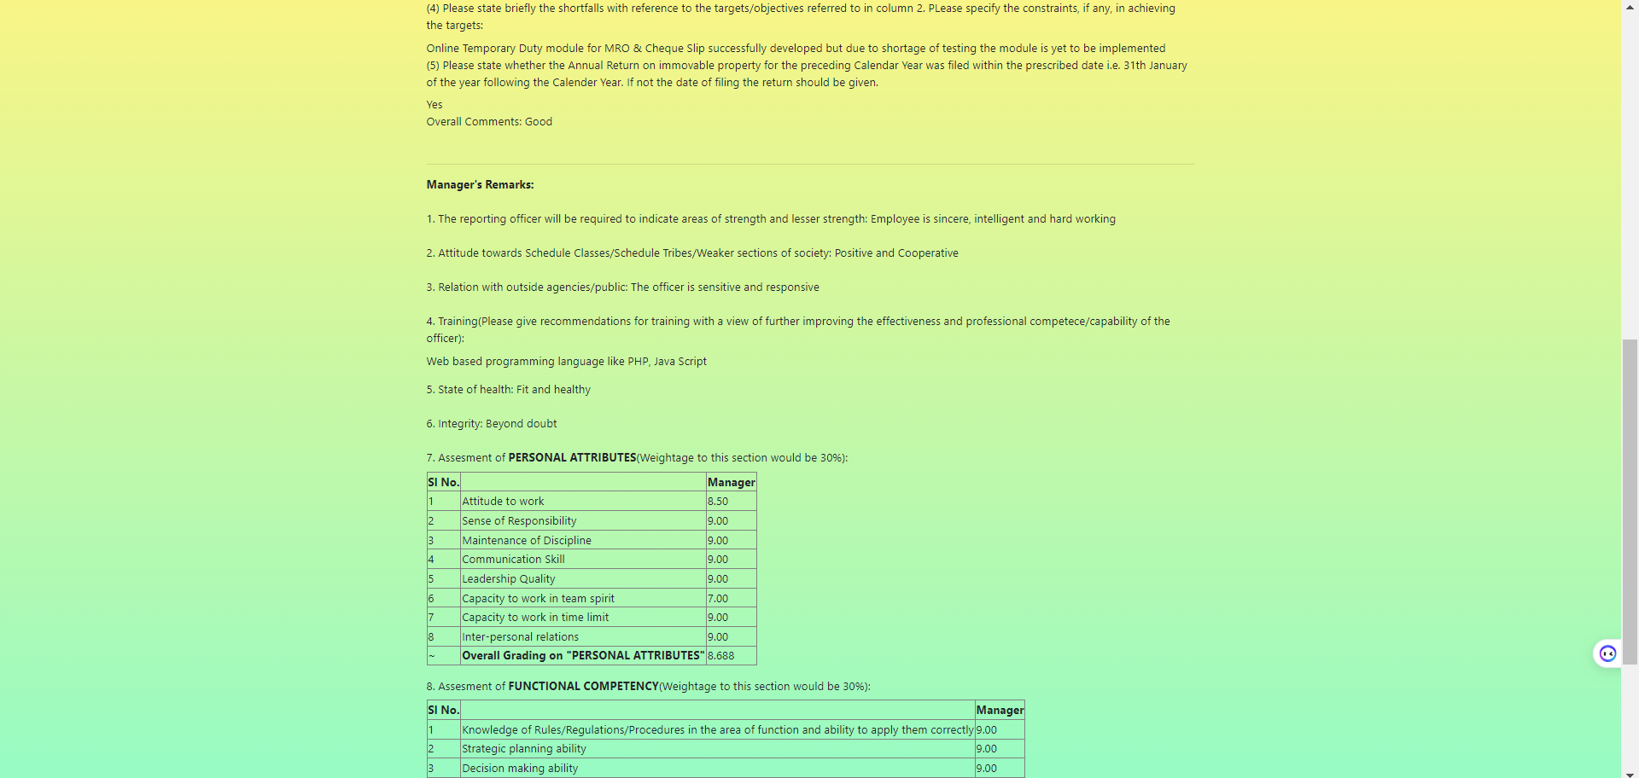

Here we can see that The Overall grade is automatically calculated. After that we can click Review and Update for Final Submit or we can go to 1st page by clicking this hyperlink ‘Click me’ for Submit Finally later.



Here in Update column The link is active because The Appraisal is not finally submitted. So for final submit We have to click on the Update hyperlink and then submit button for final submit.

After Doing Review and update the Employee’s Apprisal list page :

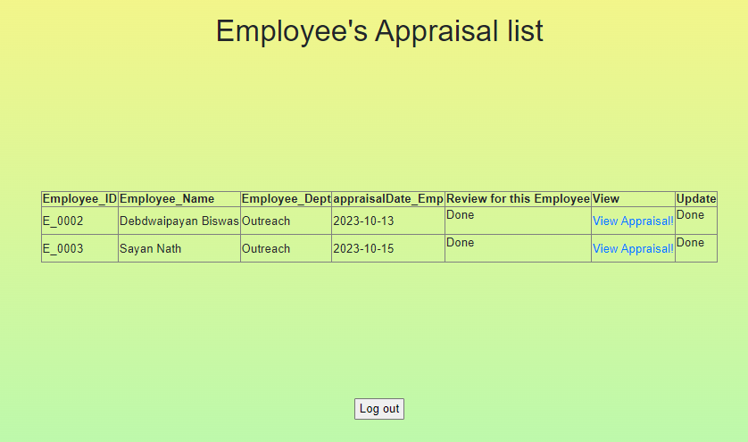

Now Manager’s are not able to Update the Appraisal form again because it has submitted finally.

**Teamlead:**

Teamlead login Page:

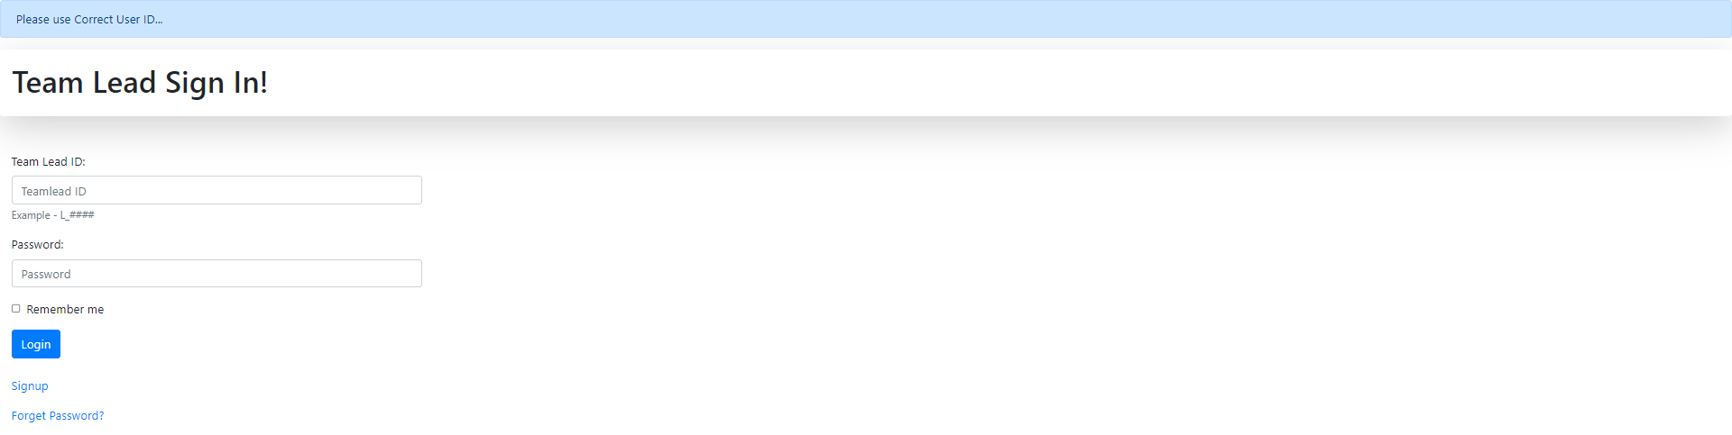

Same as Employee, Manager, Teamlead also have their own login page. Here Teamlead need to put their correct credentials to login their account and there is ‘Forget Password’ option, if they forget their password, then they can update their password.

After login Teamlead have to choose Appraisal for remarks.



Teamlead’s Appraisal Page: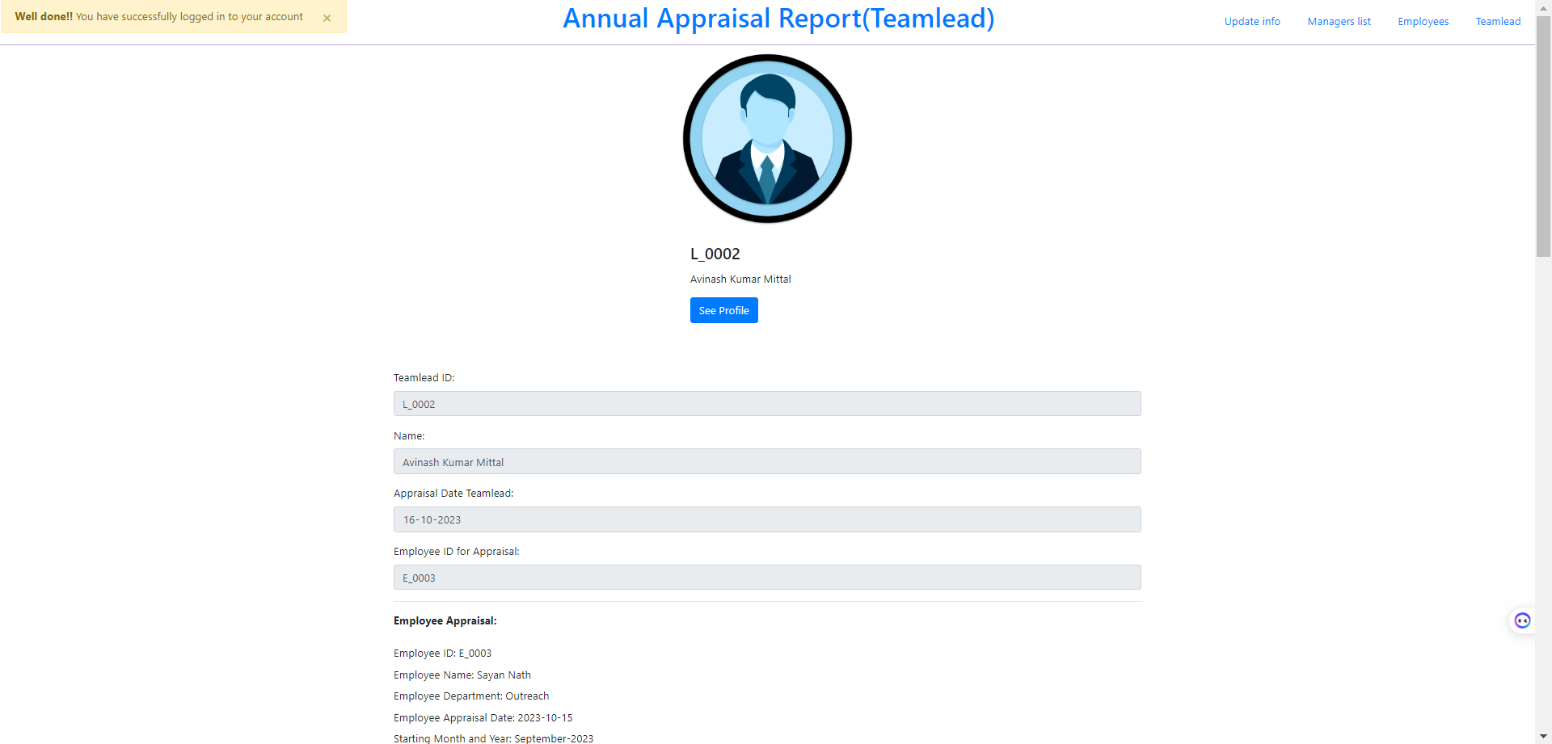 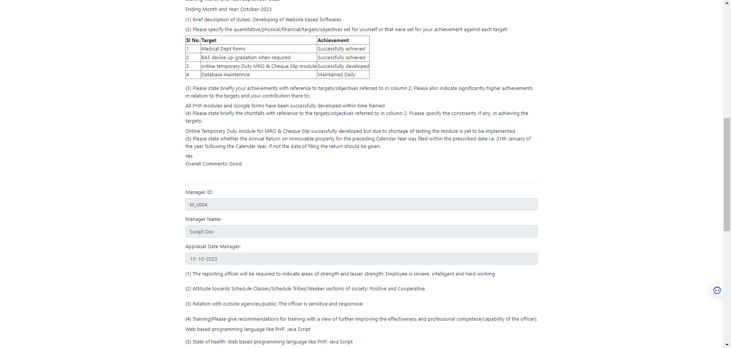 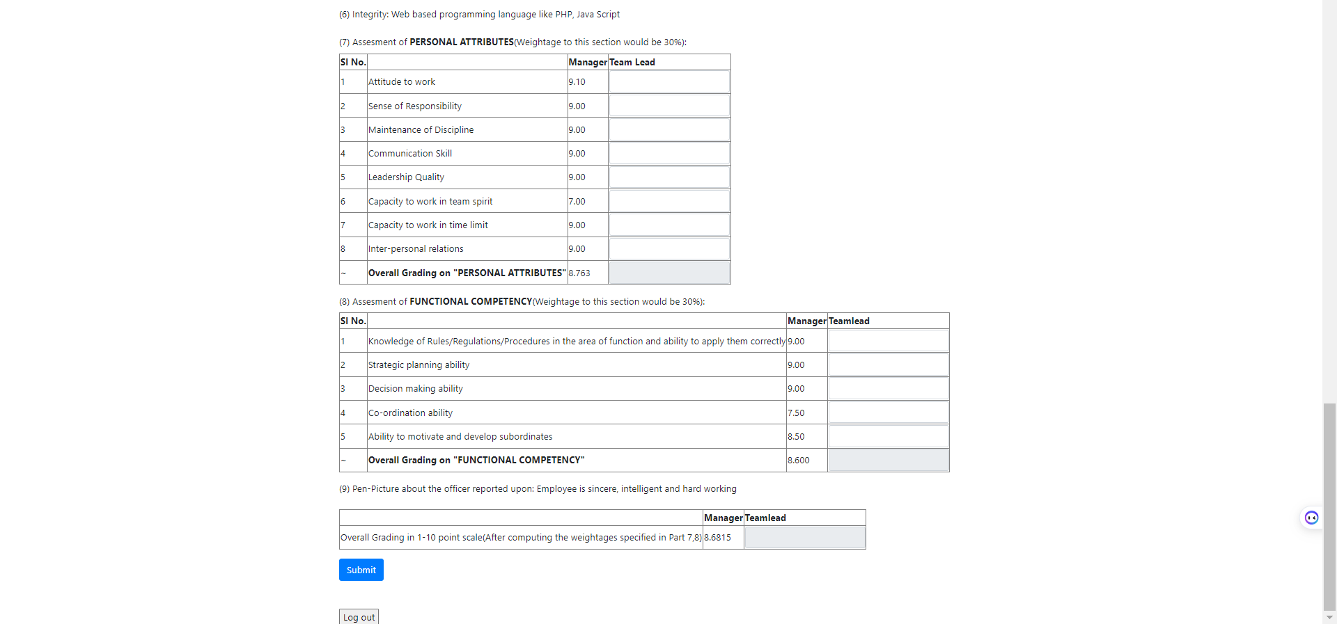

After Submitting Apraisal: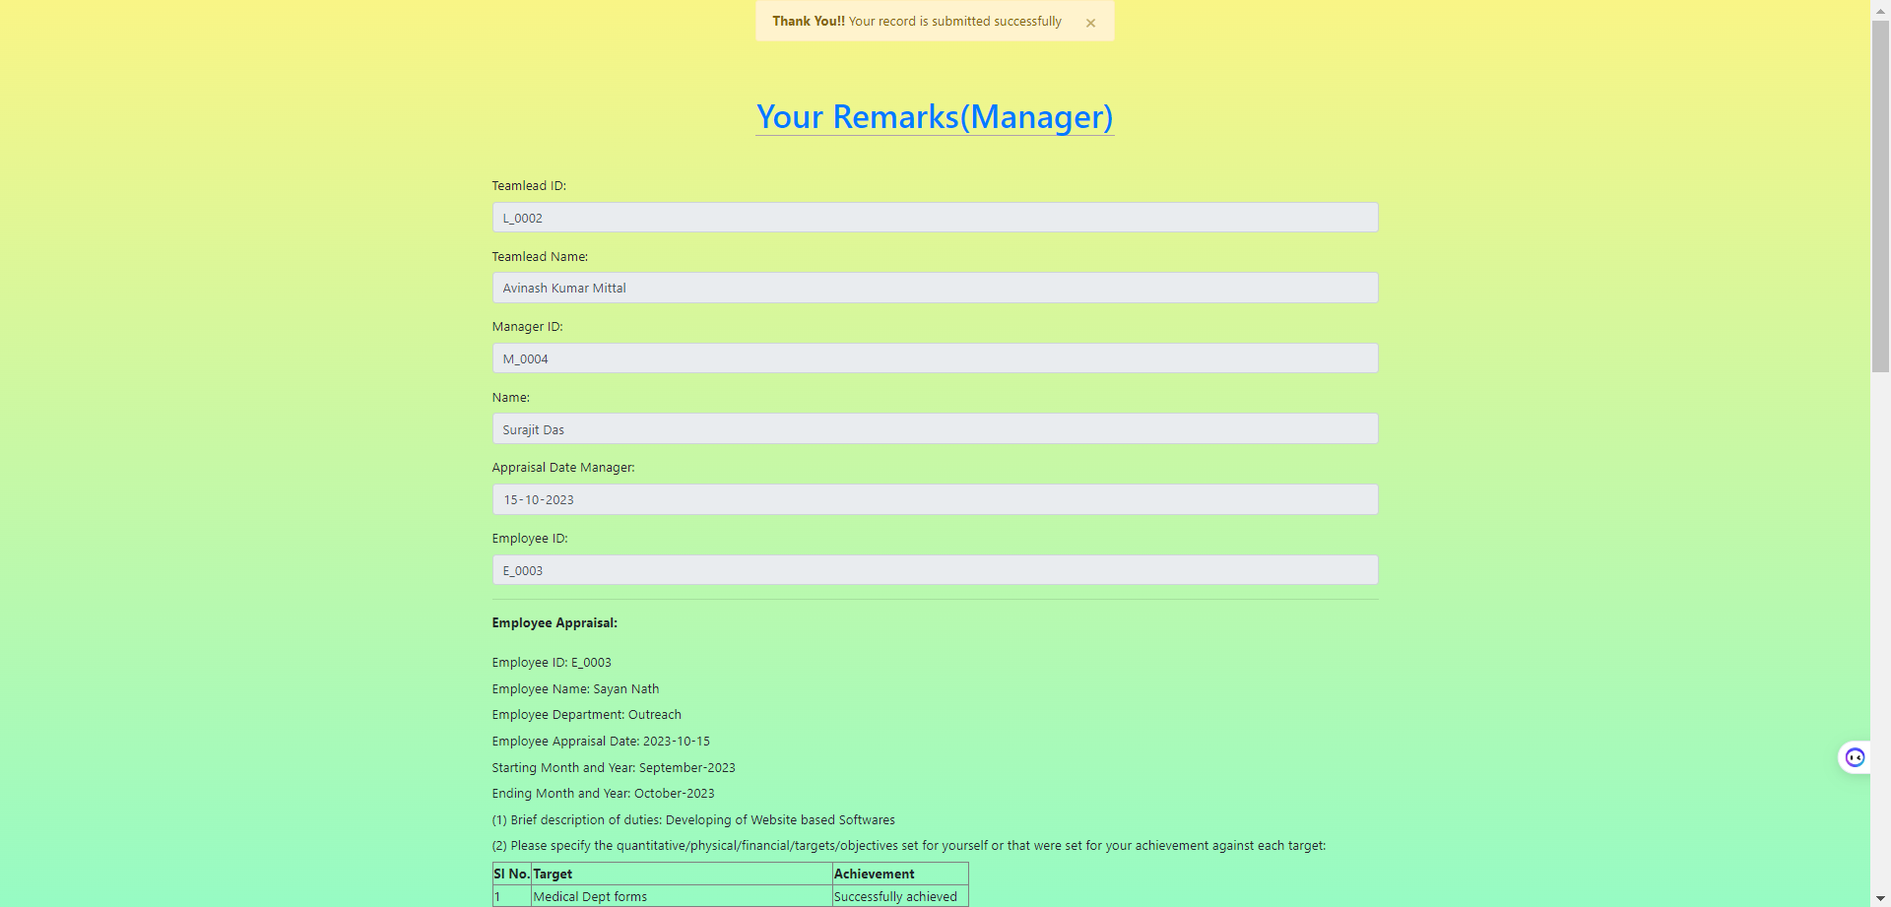 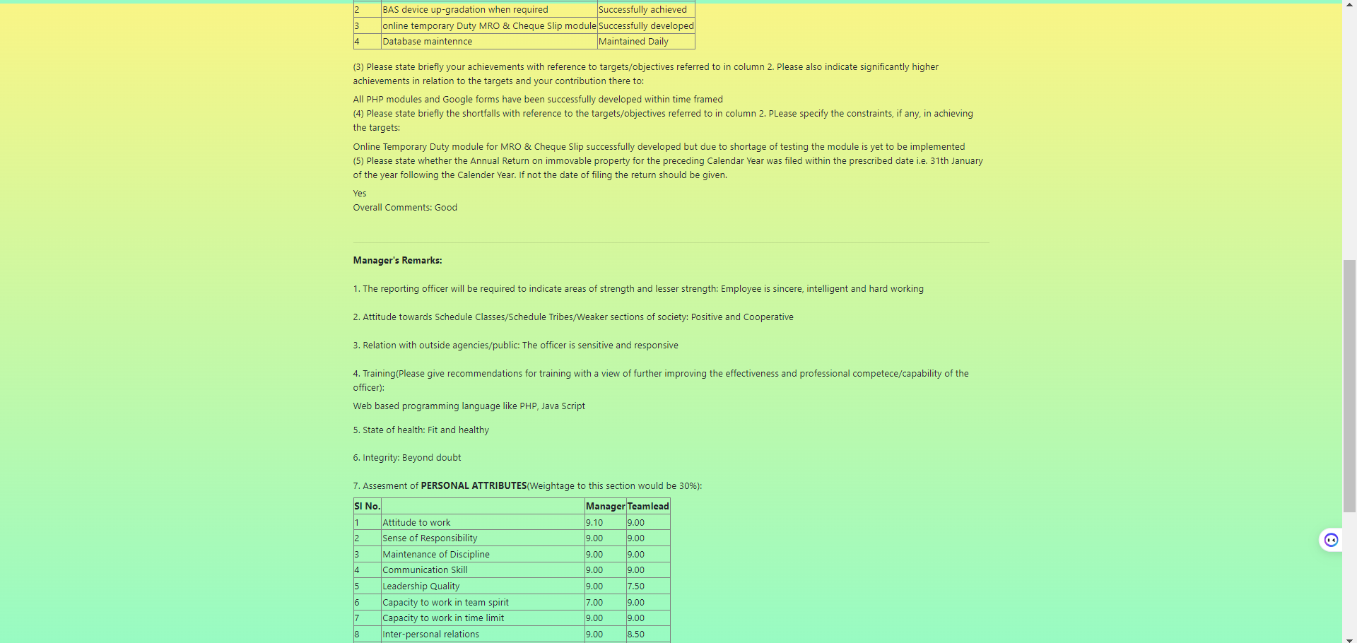 

Here we can see that The Overall grade is automatically calculated. After that we can click Review and Update for Final Submit or we can go to 1st page by clicking this hyperlink ‘Click me’ for Submit Finally later.

After giving Appraisal, Their will be the update and final submit hyperlink .



To update and final submit, Teamlead have to click on ‘Update Appraisal’ and then teamlead have to click on submit for Final submit.

We have coded the backend in such process, that if the user leaves the interface, he/she will be automatically logged out from the server. And have to re login again to enter.

DATABASES AND TABLES:

We have used a demo database, Project.

**Tables:**

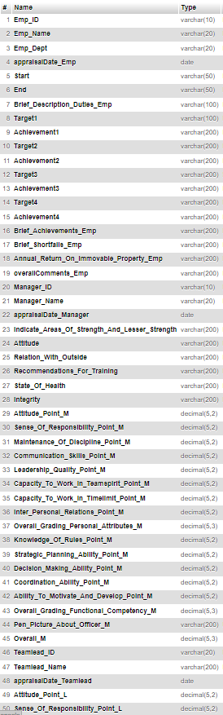Employee Table: Appraisal Table: Choose Table:

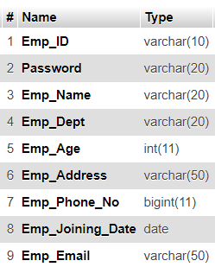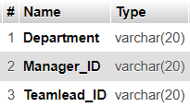

Manager Table:

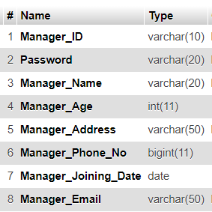

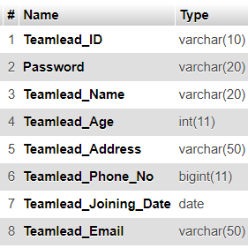Teamlead Table:

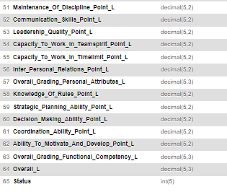

**CONCLUSION:**

Throughout this report, we have explored the implementation and analysis of an online appraisal form website, aimed at streamlining the appraisal process and enhancing the employee, manager and teamlead’s experience.

An online appraisal form website streamlines and modernizes the employee evaluation process. It enhances efficiency by enabling employees to request appraisals, supervisors to assign appraisers, and appraisers to submit evaluations. Managers and Teamlead can efficiently review and give a grade to the employee, and employees receive prompt feedback on their performance. Additionally, the platform accommodates feedback and improvements through employee comments and Manager and Teamlead review. This digital solution simplifies and centralizes appraisal management, ensuring a more transparent and productive appraisal process, ultimately benefiting both employees and organizations by fostering a culture of continuous improvement and performance excellence.