Full Adder Simulation Results

1. Full Adder Simulation using Clock Inputs
This simulation uses periodic clock-driven inputs with different duty cycles:
- A: 50% duty cycle clock
- B: 30% duty cycle clock
- Cin: 80% duty cycle clock
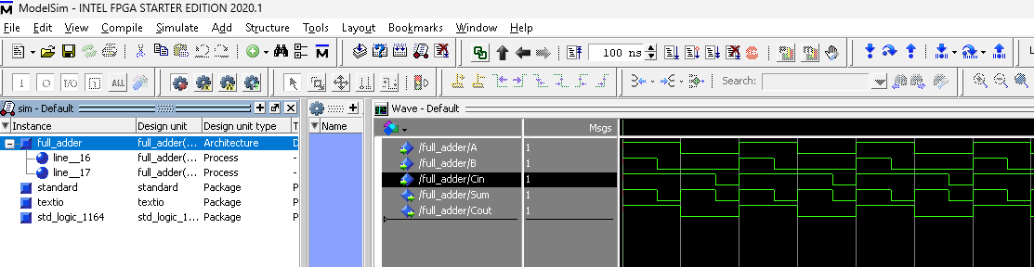

2. Full Adder Simulation using Forced Input Values
This simulation verifies the full adder by manually forcing input values from the ModelSim Transcript using commands.
