BRAINWARE UNIVERSITY
PROJECT-BASED LEARNING REPORT (WEEK 1)
1. Basic Information
Title of the Project: | Student Grade Management System
Name(s) of Student(s): | Student1 (Student1_ID)  Student2 (Student2_ID)  Student3 (Student3_ID)
Programme & Semester: | [Programme & Semester]
Course Name & Code: | [Course Name & Code]
Name of the Guide/Supervisor: | [Guide/Supervisor Name]

2. Introduction and Background
Managing student academic records by hand is slow and error-prone, especially as the number of students and subjects grows. This project builds a menu-driven, terminal-based Student Grade Management System in Python that lets a user add, view, search, update, and delete student grade records, and automatically computes totals, percentages, and letter grades.
Week 1 focuses on establishing the project foundation: designing the overall program structure, defining the core data model for storing student records in memory, building the grade-calculation logic, and implementing a working command-line menu system. These activities form the base upon which validation, persistent storage, and further features will be built in the coming weeks.
3. Objectives of the Project (Week 1)
• Design the overall program structure and menu-driven flow
• Define the in-memory data model for storing student roll numbers, names, and subject marks
• Implement grade-calculation logic based on percentage thresholds
• Build the Add, View, Search, Update, and Delete student operations
• Add basic input validation for roll numbers and marks
• Perform an initial manual test run of the menu system to confirm each option works
4. Problem Statement / Driving Question
How can we build a simple, reliable command-line application that lets a user record, update, and review student marks across multiple subjects, and automatically produce an accurate total, percentage, and grade for each student?
5. Methodology (Week 1 Activities)
The following tasks were completed during Week 1:
1. Program Structure Setup:
• Defined constants for the subject list (Python, DBMS, COA) and console display width
• Built reusable box-drawing helper functions for consistent bordered console output
• Set up an in-memory STUDENTS dictionary keyed by roll number to hold each record
2. Grade Calculation Logic:
• Implemented calculate_grade() to map a percentage to a letter grade (A+ down to F)
• Implemented get_report() to compute total marks and percentage from stored subject scores
• Implemented format_report() to lay out an individual student's report card
3. Menu-Driven Console Application:
• Built the main() loop presenting a numbered menu: Add, View All, Search, Update, Delete, Exit
• Added input validation so marks must be numeric and within 0-100
• Verified duplicate roll numbers are rejected when adding a new student
• Manually tested each menu option end-to-end in the terminal
6. Expected Outcomes / Deliverables (Week 1)
• A working command-line menu system with all six options wired up
• Grade-calculation logic producing correct totals, percentages, and letter grades
• Basic input validation for roll numbers and marks
• In-memory storage of student records for the current session
• Defined project plan for Weeks 2-4
• Week 1 project report
7. Core Logic
The two functions below sit at the heart of the system: one converts a percentage into a letter grade, and the other assembles a student's total, percentage, and grade from their stored subject marks. Comments explain each step.
def calculate_grade(percentage):
# Map a percentage score to a letter grade using fixed thresholds
if percentage >= 90:
return "A+"
elif percentage >= 80:
return "A"
elif percentage >= 70:
return "B+"
elif percentage >= 60:
return "B"
elif percentage >= 50:
return "C"
elif percentage >= 40:
return "D"
else:
return "F" # below 40% is a fail

def get_report(roll):
# Look up the student record and total their marks across all subjects
student = STUDENTS[roll]
total = sum(student["marks"].values())
max_total = 100 * len(SUBJECTS)
percentage = (total / max_total) * 100 # scale total to a percentage
grade = calculate_grade(percentage) # convert to a letter grade
return student, total, percentage, grade

8. Sample Output / Screenshot
A sample terminal session below shows a student being added and then listed through the View All Students option, confirming the grade-calculation logic and menu flow work as intended.
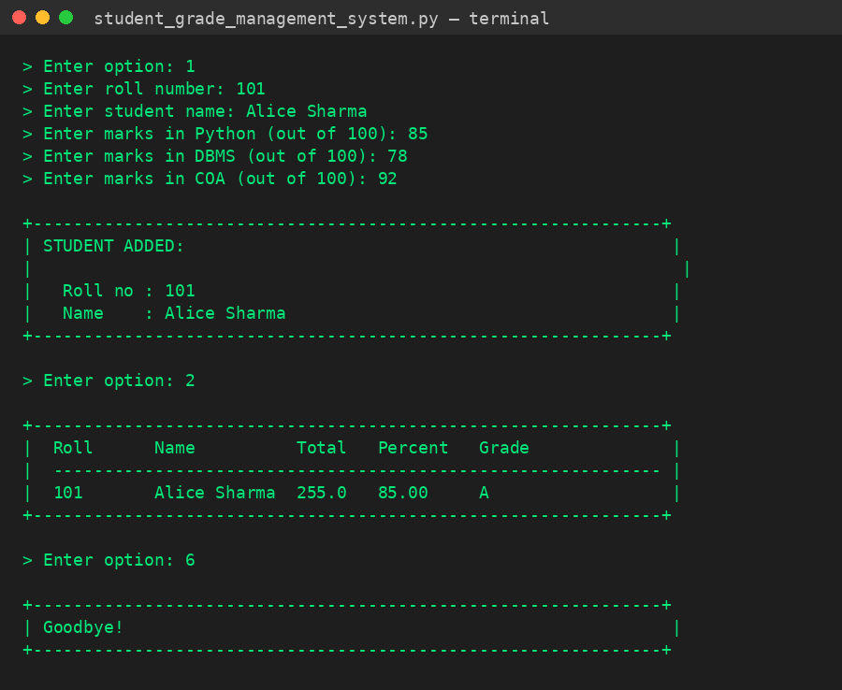
Fig 1: Sample console run - adding and viewing a student record
9. Project Timeline
Week | Activity & Status
Week 1 (Current) | Program Structure, Grade Logic & Menu System - Completed
Week 2 (Upcoming) | Input Validation Hardening, Search & Update Features
Week 3 (Upcoming) | File-Based Persistence (CSV/JSON) & Report Export
Week 4 (Upcoming) | Testing, Error Handling & Final Documentation

10. Tools & Technologies Used
Tool / Technology | Purpose
Python 3.x | Primary programming language for the application
Built-in dict | In-memory data structure for storing student records
input() / print() | Console-based user interaction and output formatting
f-strings | Formatted, aligned console output for tables and reports
Git | Version control for collaborative development - planned
VS Code | Code editor used for development and testing

11. References
• Python Official Documentation: https://docs.python.org/3/
• Python String Formatting (f-strings): https://docs.python.org/3/reference/lexical_analysis.html#f-strings
• Python Dictionaries: https://docs.python.org/3/tutorial/datastructures.html#dictionaries
• [Course/University] - Programming Lab Guidelines

12. Signatures
Signature of Student(s): | Date of Submission:
Signature of Guide/Supervisor:

