BRAINWARE UNIVERSITY
PROJECT-BASED LEARNING REPORT (WEEK 2)
1. Basic Information
Title of the Project: | Bank Management System
Name(s) of Student(s): | Student1 (Student1_ID)  Student2 (Student2_ID)  Student3 (Student3_ID)
Programme & Semester: | [Programme & Semester]
Course Name & Code: | [Course Name & Code]
Name of the Guide/Supervisor: | [Guide/Supervisor Name]

2. Introduction and Background
Manual handling of customer accounts, balances, and transactions is slow and prone to error, especially as the number of account holders grows. This project builds a menu-driven, terminal-based Bank Management System in Python that lets a user create an account, check balance, deposit funds, and withdraw funds, with PIN-based authentication protecting every account.
Week 1 covered project planning and environment setup. Week 2 builds on that foundation by implementing the core banking logic: the in-memory data model for account holders, unique account-number generation, PIN-based authentication, and the deposit/withdrawal operations, all wired up behind a working command-line menu. These activities form the base upon which stronger validation, persistent storage, and further features will be built in the coming weeks.
3. Objectives of the Project (Week 2)
• Implement the in-memory data model for storing account holders, PINs, and balances
• Implement unique random account-number generation for new customers
• Build the Create Account, Check Balance, Deposit, and Withdraw operations
• Add PIN-based authentication before any balance-affecting operation
• Wire the operations into a working command-line menu system
• Perform an initial manual test run of the menu system to confirm each option works
4. Problem Statement / Driving Question
How can we build a simple, reliable command-line application that lets a user open a bank account, authenticate with a PIN, and safely deposit, withdraw, and check the balance on that account, while preventing overdrawn withdrawals and unauthorized access?
5. Methodology (Week 2 Activities)
The following tasks were completed during Week 2, building on the Week 1 setup:
1. Program Structure Setup:
• Defined the console display width and reusable box-drawing helper functions for bordered output
• Set up an in-memory USERS dictionary keyed by account number to hold each customer's name, PIN, and balance
• Maintained an ACCOUNTS list to track all issued account numbers
2. Account & Transaction Logic:
• Implemented generate_account() to produce a unique random account number on each signup
• Implemented create_account() to register a new customer with a starting balance of zero
• Implemented authenticate() to verify an account number and PIN pair before any transaction
• Implemented deposit() and withdraw() to safely update a customer's balance, blocking overdrawn withdrawals
3. Menu-Driven Console Application:
• Built the main() loop presenting a numbered menu: Create Account, Check Balance, Withdraw, Deposit, Exit
• Added PIN authentication prompts before balance, deposit, and withdrawal operations
• Added input validation so deposit/withdrawal amounts must be numeric
• Manually tested each menu option end-to-end in the terminal
6. Expected Outcomes / Deliverables (Week 2)
• A working command-line menu system with all five options wired up
• Unique account-number generation for every new customer
• PIN-based authentication guarding balance, deposit, and withdrawal operations
• Withdrawal logic that correctly blocks transactions exceeding the available balance
• In-memory storage of account records for the current session
• Week 2 project report
7. Core Logic
The functions below sit at the heart of the system: one generates a unique account number, one authenticates a login attempt against the stored PIN, and the last two safely move money in and out of an account. Comments explain each step.
def generate_account():
# Keep generating a random account number until one is not already in use
while True:
num = math.floor(random.random() * (10 ** 10))
account_no = "A" + str(num)
if account_no not in ACCOUNTS:
return account_no # unique -> safe to hand out

def authenticate(account, pin):
# Confirm the account exists and the PIN entered matches the stored PIN
if account in USERS and USERS[account]['pin'] == pin:
return True
return False

def withdraw(account, amount):
# Only allow the withdrawal if funds are sufficient, otherwise reject it
if amount <= USERS[account]['balance']:
USERS[account]['balance'] -= amount
return True
return False # insufficient balance

8. Sample Output / Screenshot
A sample terminal session below shows a new account being created, a deposit being made, and the resulting balance being checked, confirming the authentication and transaction logic work as intended.
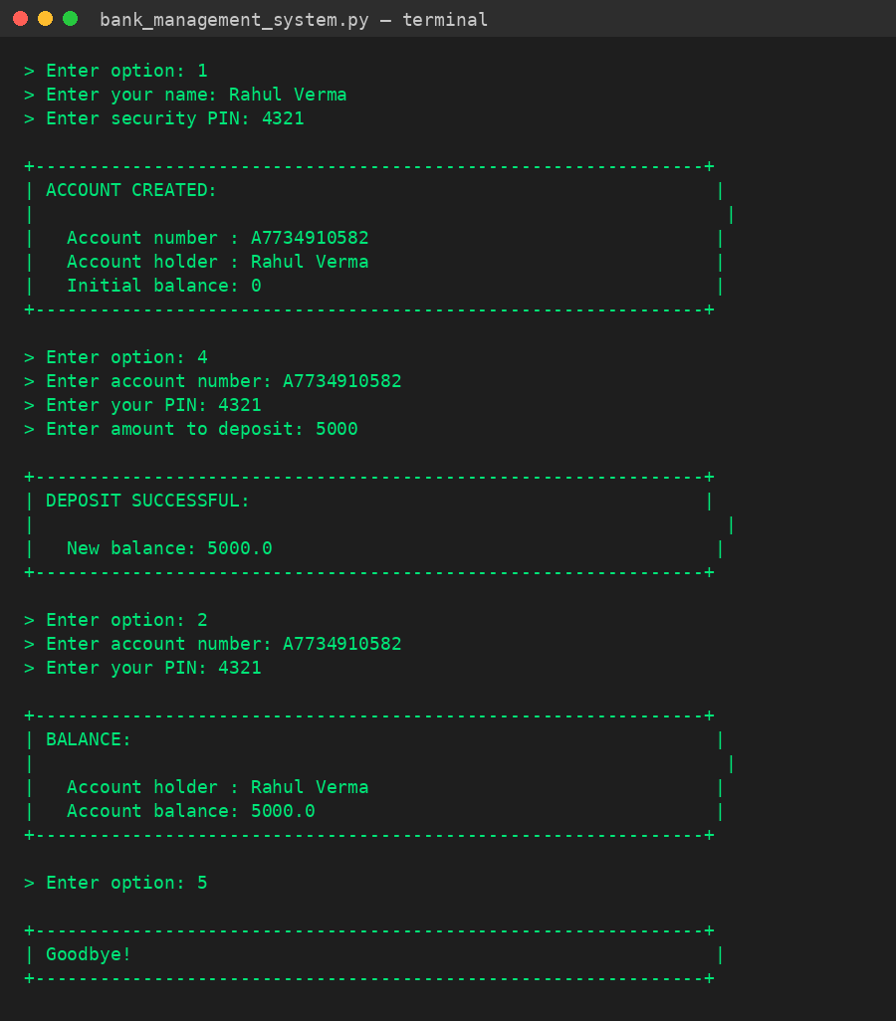
Fig 1: Sample console run - creating an account, depositing, and checking balance
9. Project Timeline
Week | Activity & Status
Week 1 (Completed) | Project Planning, Environment Setup & Program Design
Week 2 (Current) | Program Structure, Account Logic & Menu System - Completed
Week 3 (Upcoming) | Input Validation Hardening, Transaction History & Transfers
Week 4 (Upcoming) | File-Based Persistence (CSV/JSON) & Statement Export

10. Tools & Technologies Used
Tool / Technology | Purpose
Python 3.x | Primary programming language for the application
Built-in dict | In-memory data structure for storing account records
random / math | Used to generate unique random account numbers
input() / print() | Console-based user interaction and output formatting
f-strings | Formatted, aligned console output for menus and receipts
Git | Version control for collaborative development - planned
VS Code | Code editor used for development and testing

11. References
• Python Official Documentation: https://docs.python.org/3/
• Python random module: https://docs.python.org/3/library/random.html
• Python math module: https://docs.python.org/3/library/math.html
• Python Dictionaries: https://docs.python.org/3/tutorial/datastructures.html#dictionaries
• [Course/University] - Programming Lab Guidelines

12. Signatures
Signature of Student(s): | Date of Submission:
Signature of Guide/Supervisor:

