BRAINWARE UNIVERSITY
PROJECT-BASED LEARNING REPORT (WEEK 4 - PART 2)
1. Basic Information
Title of the Project: | Password Strength Checker
Name(s) of Student(s): | Student1 (Student1_ID)  Student2 (Student2_ID)  Student3 (Student3_ID)
Programme & Semester: | [Programme & Semester]
Course Name & Code: | [Course Name & Code]
Name of the Guide/Supervisor: | [Guide/Supervisor Name]

2. Introduction and Background
Weak, easily-guessed passwords remain one of the most common causes of account compromise. This project builds a menu-driven, terminal-based Password Strength Checker in Python that scores a password against five criteria - length, digits, lowercase letters, uppercase letters, and special characters - and gives the user a clear Weak / Medium / Strong verdict along with a visual progress bar and specific advice for improving the password.
This is the second small utility program built during Week 4, alongside the Email Validation System from Part 1. Both are compact, single-purpose console tools that reinforce the same core skills used across the earlier weeks: string inspection, condition-based validation, and clean bordered console output. This report covers the Password Strength Checker (Week 4 - Part 2): its data model, its scoring logic, and the menu-driven console interface that presents the result to the user.
3. Objectives of the Project (Week 4 - Part 2)
• Define the set of password strength criteria: length, digit, lowercase, uppercase, special character
• Implement password_validator() to check a password against all five criteria
• Classify the result into a Weak, Medium, or Strong rating with a helpful message
• Build a visual progress bar and pass/fail checklist for the console output
• Wire the checker into a simple two-option menu (Check Password / Exit)
• Manually test the checker against weak, medium, and strong sample passwords
4. Problem Statement / Driving Question
How can we build a simple command-line tool that instantly tells a user how strong their password is, shows exactly which requirements are missing, and gives a clear suggestion for making it stronger?
5. Methodology (Week 4 - Part 2 Activities)
The following tasks were completed for this part of Week 4:
1. Program Structure Setup:
• Defined the allowed SPECIAL_CHARS set and console display width
• Reused the box-drawing helper functions for consistent bordered console output
• Defined the STRENGTH_LABEL mapping for the Weak / Medium / Strong result tags
2. Password Scoring Logic:
• Implemented password_validator() to check length, digits, lowercase, uppercase, and special characters
• Combined the five checks into a strength rating (weak, medium, or strong) with a tailored message
• Implemented print_result() to render a progress bar, a pass/fail checklist, and word-wrapped advice
3. Menu-Driven Console Application:
• Built the main() loop presenting a two-option menu: Check Password, Exit
• Connected each password entry to password_validator() and print_result()
• Manually tested the checker with weak, medium, and strong sample passwords
6. Expected Outcomes / Deliverables (Week 4 - Part 2)
• A working command-line password checker with a clear menu
• Accurate Weak / Medium / Strong classification based on five criteria
• A visual progress bar and checklist showing exactly which criteria were met
• Specific, actionable advice for strengthening a weak or medium password
• Week 4 - Part 2 project report
7. Core Logic
The function below sits at the heart of the system: it inspects a password against five criteria and returns a strength rating, a helpful message, and a checklist of what passed or failed. Comments explain each step.
def password_validator(password):
# Check each requirement independently using simple character tests
has_num = any(ch.isdigit() for ch in password)
has_lower = any(ch.islower() for ch in password)
has_upper = any(ch.isupper() for ch in password)
has_special = any(ch in SPECIAL_CHARS for ch in password)
long_enough = len(password) >= 8

checks = {
"At least 8 characters": long_enough,
"Contains a number": has_num,
"Contains a lowercase letter": has_lower,
"Contains an uppercase letter": has_upper,
f"Contains a special character ({SPECIAL_CHARS})": has_special,
}

# Classify strength: too short is always weak, all 4 checks -> strong,
# number + lowercase only -> medium, otherwise weak
if not long_enough:
return "weak", "Password needs to have at least 8 characters.", checks
if has_num and has_lower and has_upper and has_special:
return "strong", "Password is Strong! Good to go.", checks
elif has_num and has_lower:
return "medium", "Try adding an uppercase letter and a special character.", checks
else:
return "weak", "Add a mix of numbers, lowercase, uppercase & special chars.", checks

8. Sample Output / Screenshot
A sample terminal session below shows the checker scoring a medium-strength password and then a strong password, confirming the criteria checks, progress bar, and advice messages all work as intended.
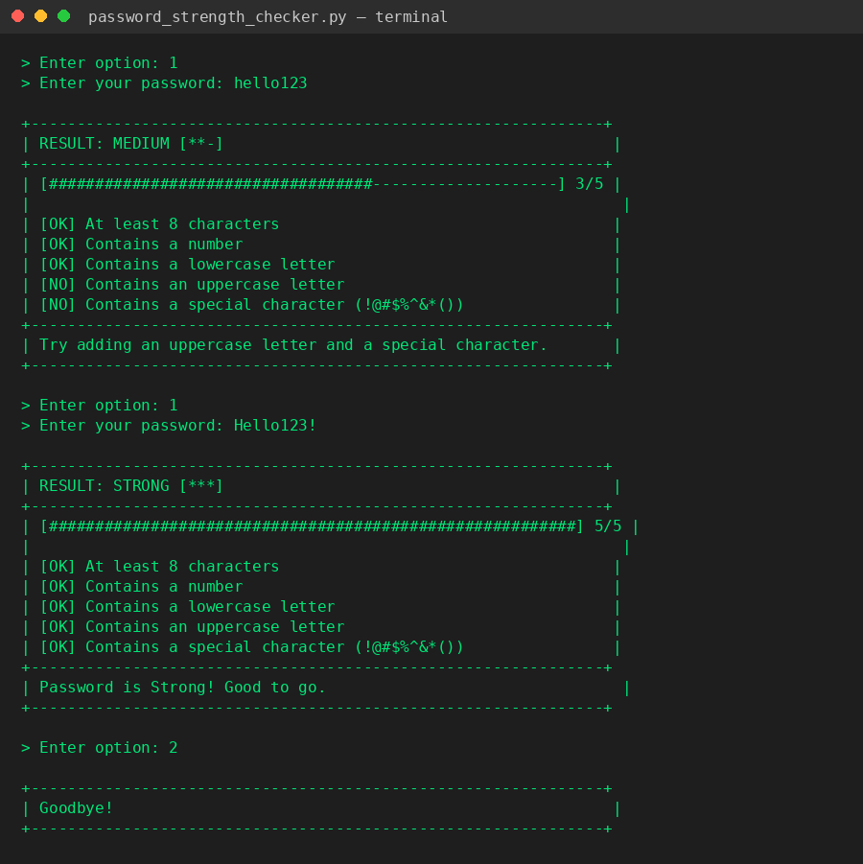
Fig 1: Sample console run - checking a medium and a strong password
9. Project Timeline
Week | Activity & Status
Week 1 (Completed) | Student Grade Management System
Week 2 (Completed) | Bank Management System
Week 3 (Completed) | Electricity Bill Calculator
Week 4 - Part 1 (Completed) | Email Validation System
Week 4 - Part 2 (Current) | Password Strength Checker - Completed

10. Tools & Technologies Used
Tool / Technology | Purpose
Python 3.x | Primary programming language for the application
str methods | isdigit(), islower(), isupper() used for character-type checks
Built-in dict | Stores the pass/fail checklist for each requirement
input() / print() | Console-based user interaction and output formatting
f-strings | Formatted, aligned console output for the result panel
Git | Version control for collaborative development - planned
VS Code | Code editor used for development and testing

11. References
• Python Official Documentation: https://docs.python.org/3/
• Python String Methods: https://docs.python.org/3/library/stdtypes.html#string-methods
• OWASP Password Guidance: https://owasp.org/www-community/controls/Password_Policy
• [Course/University] - Programming Lab Guidelines

12. Signatures
Signature of Student(s): | Date of Submission:
Signature of Guide/Supervisor:

