BRAINWARE UNIVERSITY
PYTHON PROJECT-BASED LEARNING REPORT (WEEK 1)

1. Basic Information
Title of the Project: | Student Grade Management System (Terminal-Based)
Name(s) of Student(s): | Soumyadwip Das (BWU/BTS/25/169)  Ankita Paul (BWU/BTS/25/180)  Sonia Naskar (BWU/BTS/25/195)  Joyeta Mondal (BWU/BTS/25/214)  Sayantan Bharati (BWU/BTS/25/503)
Programme & Semester: | B.Tech CSE & 3rd Semester
Course Name & Code: | Python Programming Lab (BES09013)
Name of the Guide/Supervisor: | MR. PRANAB GHARAI & MR. INDRANIL DAS

2. Introduction and Background
Student grade management is a common academic administration task that involves recording, calculating, and retrieving student performance data. This project explores building a lightweight, terminal-based application that allows a user to manage student marks across a fixed set of subjects without relying on an external database or file storage, keeping all records in memory during a session.
Week 1 focuses on developing the core of the console application: defining the in-memory data model, building the grade-calculation logic, designing a bordered text-based user interface, and implementing a menu-driven loop that supports adding, viewing, searching, updating, and deleting student records. These form the base functionality on which further validation, persistence, or reporting features can be built in later weeks.
3. Objectives of the Project (Week 1)
- Design a menu-driven, terminal-based application for managing student academic records
- Implement functionality to add, view, search, update, and delete student grade records
- Develop a grade-calculation module that maps percentage scores to letter grades
- Build a reusable, bordered text UI (box-drawing utilities) for a cleaner terminal experience
- Validate user input, including roll-number uniqueness and marks range (0-100)
- Test the core CRUD (Create, Read, Update, Delete) operations for correctness
4. Problem Statement / Driving Question
How can student academic records - including subject-wise marks, totals, percentages, and grades - be reliably stored, calculated, and managed through a simple, dependency-free terminal application?
5. Methodology (Week 1 Activities)
The following tasks were completed during Week 1:
1. Data Model & Storage:
- Defined an in-memory STUDENTS dictionary keyed by roll number, storing each student's name and subject-wise marks
- Defined a fixed SUBJECTS list (Python, DBMS, COA) used consistently across all operations
2. Grade Calculation Logic:
- Implemented calculate_grade() to map a percentage score to a letter grade (A+ through F) using threshold checks
- Implemented get_report() to compute total marks, percentage, and grade for a given student
- Implemented format_report() to lay out a student's full report as display-ready lines
3. Terminal UI & Menu System:
- Built reusable box-drawing helpers (box_top, box_bottom, box_divider, box_line, print_boxed) for a bordered console layout
- Implemented a main() menu loop with six options: Add, View All, Search, Update, Delete, and Exit
- Added input validation, including duplicate roll-number checks and marks-range/type validation with try/except
6. Expected Outcomes / Deliverables (Week 1)
- A working console application supporting Add, View, Search, Update, and Delete of student grade records
- A functioning calculate_grade() module producing consistent letter grades from percentage scores
- A bordered, readable terminal UI built from reusable box-drawing utilities
- Input validation for duplicate roll numbers, invalid marks, and non-numeric entries
- Week 1 project report

7. Core Logic
The core of the program is the grade-calculation logic, which converts a student's overall percentage into a letter grade, and the reporting logic, which aggregates a student's marks into a total, percentage, and grade. Both are shown below with the surrounding threshold and aggregation logic that drives the rest of the menu options.
def calculate_grade(percentage):
if percentage >= 90:
return "A+"
elif percentage >= 80:
return "A"
elif percentage >= 70:
return "B+"
elif percentage >= 60:
return "B"
elif percentage >= 50:
return "C"
elif percentage >= 40:
return "D"
else:
return "F"

def get_report(roll):
student = STUDENTS[roll]
total = sum(student["marks"].values())
max_total = 100 * len(SUBJECTS)
percentage = (total / max_total) * 100
grade = calculate_grade(percentage)
return student, total, percentage, grade

calculate_grade() checks the percentage against descending thresholds (90, 80, 70, 60, 50, 40) and returns the corresponding grade, defaulting to "F" below 40. get_report() sums the marks dictionary, derives the percentage against the maximum possible total, and calls calculate_grade() to attach a grade - this single function backs the View, Search, and Update-confirmation flows in the menu.

8. Output Screenshot
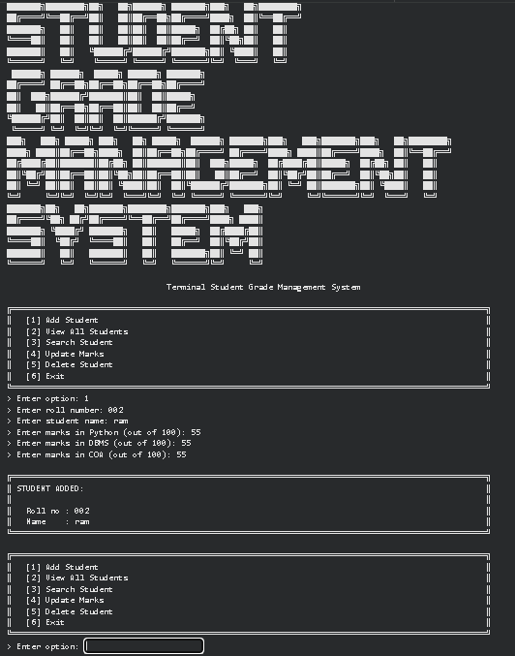

9. Project Timeline
Week | Date | Activity | Status
Week 1 | 10/07/2026 | Student Grade Management System | Current Week
Week 2 | 17/07/2026 | Program 1: Electricity Bill Calculator | Upcoming
Week 2 | 17/07/2026 | Program 2: ATM Transaction Simulator | Upcoming
Week 3 | 24/07/2026 | Program 1: Bank Management System | Upcoming
Week 3 | 24/07/2026 | Program 2: Hotel Booking System | Upcoming
Week 3 | 24/07/2026 | Program 3: Library Management System | Upcoming
Week 4 | 31/07/2026 | Program 1: Password Strength Checker | Upcoming
Week 4 | 31/07/2026 | Program 2: Email Validation System | Upcoming
Week 5 | TBD | Text Encryption & Decryption Tool | Upcoming

10. Tools & Technologies Used
Tool / Technology | Purpose
Python 3.x | Primary programming language used to implement the entire console application
Built-in Data Structures (dict) | In-memory storage of student records via the STUDENTS dictionary
Python Standard I/O (input/print) | Handling menu-driven user interaction in the terminal
Exception Handling (try/except) | Validating numeric marks input and catching ValueError
ASCII/Unicode Box-Drawing Characters | Building the bordered terminal UI (box_top, box_bottom, box_line, etc.)

11. References
- Python 3 Official Documentation: https://docs.python.org/3/
- Python Official Docs - Dictionaries: https://docs.python.org/3/tutorial/datastructures.html#dictionaries
- Python Official Docs - Errors and Exceptions: https://docs.python.org/3/tutorial/errors.html
- Unicode Box Drawing Characters Reference: https://en.wikipedia.org/wiki/Box-drawing_character
- Brainware University - Machine Learning Course Guidelines

12. Signatures
Signature of Student(s): Date of Submission:

Signature of Guide/Supervisor:

