Assignment 1 – Computer Organization and Architecture (BTS30101)

Question 1: Identify the content of R1 after the following instructions sequence is executed
MOV R1,#8
MOV R2,#3
ADD R3,R1,R2
SUB R2,R3,R1
MULT R4,R2,R2
ADD R2,R4,R1
Instruction | Effect / Register values
MOV R1,#8 | R1 = 8
MOV R2,#3 | R2 = 3
ADD R3,R1,R2 | R3 = R1+R2 = 8+3 = 11
SUB R2,R3,R1 | R2 = R3−R1 = 11−8 = 3
MULT R4,R2,R2 | R4 = R2×R2 = 3×3 = 9
ADD R2,R4,R1 | R2 = R4+R1 = 9+8 = 17
R1 is never re-assigned after the first instruction, so it keeps its initial value.
Answer: R1 = 8 (binary 1000)

Question 2: Divide 1010 (10) by 0010 (2) – Restoring and Non-Restoring Division
(a) Restoring Division
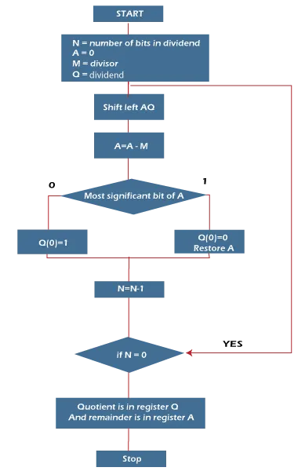
Step | A | Q | Operation
0 | 00000 | 1010 | Initial: A = 0, Q = 1010, M = 0010
1 | 00001 | 0100 | Shift AQ left → A=00001; A−M = 11111 (neg) → restore A=00001, Q0=0
2 | 00000 | 1001 | Shift AQ left → A=00010; A−M = 00000 (≥0) → Q0=1
3 | 00001 | 0010 | Shift AQ left → A=00001; A−M = 11111 (neg) → restore A=00001, Q0=0
4 | 00000 | 0101 | Shift AQ left → A=00010; A−M = 00000 (≥0) → Q0=1
Result: Quotient Q = 0101 (5), Remainder A = 0000 (0)

(b) Non-Restoring Division
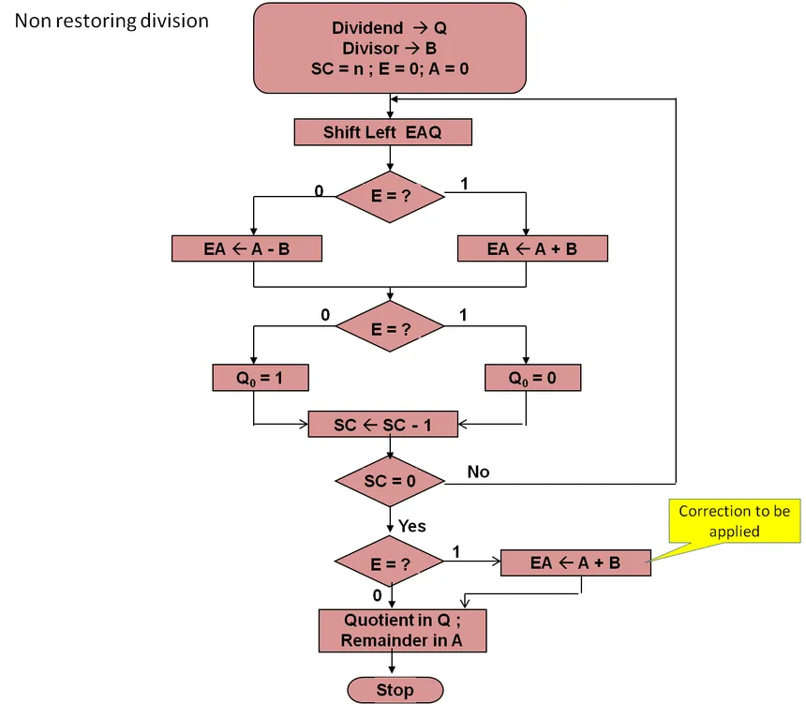
Step | A | Q | Operation
0 | 00000 | 1010 | Initial: A = 0, Q = 1010, M = 0010
1 | 11111 | 0100 | A≥0 → shift, A=A−M = 11111 (neg) → Q0=0
2 | 00000 | 1001 | A<0 → shift, A=A+M = 00000 (≥0) → Q0=1
3 | 11111 | 0010 | A≥0 → shift, A=A−M = 11111 (neg) → Q0=0
4 | 00000 | 0101 | A<0 → shift, A=A+M = 00000 (≥0) → Q0=1; A≥0 → no final correction
Result: Quotient Q = 0101 (5), Remainder A = 0000 (0)
Advantages
• Restoring division: Simple to understand and implement; the accumulator always holds a valid non-negative partial remainder after every step, which makes the control logic straightforward.
• Non-restoring division: Faster and more hardware-efficient, since it performs only one add/subtract per cycle and avoids the extra restoring addition step, reducing the total number of operations.

