DBMS Assignment 1 (BTS30102)
Integrated E-Commerce & Healthcare Platform — Database Design
Q1. Database Design — E-Commerce & Healthcare Platform
a) EER Diagram — Entities & Relationships (10 Entities)
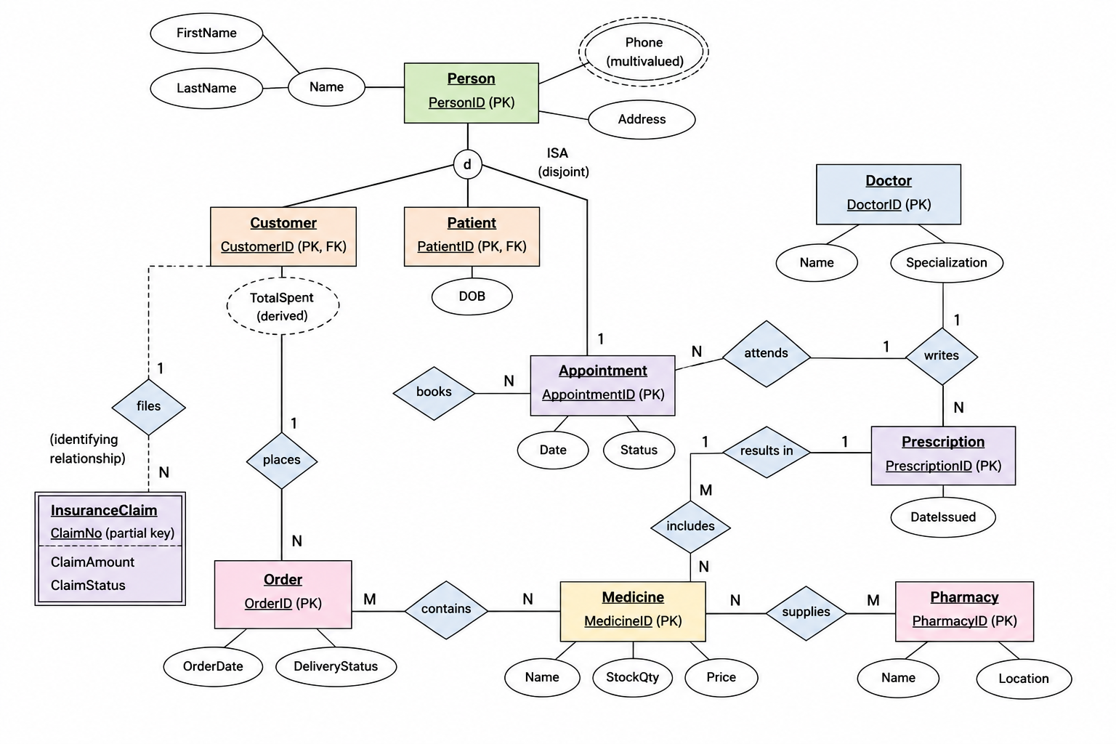
b) Relational Schema
CREATE TABLE Person (
PersonID PRIMARY KEY,FirstName,LastName,Address
);
CREATE TABLE PersonPhone (
PersonID,Phone,PRIMARY KEY (PersonID, Phone),
FOREIGN KEY (PersonID) REFERENCES Person(PersonID)
);
CREATE TABLE Customer (
CustomerID PRIMARY KEY,
FOREIGN KEY (CustomerID) REFERENCES Person(PersonID)
);
CREATE TABLE Patient (
PatientID PRIMARY KEY,DOB,
FOREIGN KEY (PatientID) REFERENCES Person(PersonID)
);
CREATE TABLE Doctor (
DoctorID PRIMARY KEY,Name,Specialization
);
CREATE TABLE Appointment (
AppointmentID PRIMARY KEY,PatientID,DoctorID,Date,Status,
FOREIGN KEY (PatientID) REFERENCES Patient(PatientID),
FOREIGN KEY (DoctorID) REFERENCES Doctor(DoctorID)
);
CREATE TABLE Prescription (
PrescriptionID PRIMARY KEY,AppointmentID UNIQUE,DateIssued,
FOREIGN KEY (AppointmentID) REFERENCES Appointment(AppointmentID)
);
CREATE TABLE Medicine (
MedicineID PRIMARY KEY,Name,StockQty,Price
);
CREATE TABLE Pharmacy (
PharmacyID PRIMARY KEY,Name,Location
);
CREATE TABLE Orders (
OrderID PRIMARY KEY,CustomerID,OrderDate,DeliveryStatus,
FOREIGN KEY (CustomerID) REFERENCES Customer(CustomerID)
);

CREATE TABLE OrderItem (
OrderID,MedicineID,Quantity,
PRIMARY KEY (OrderID, MedicineID),
FOREIGN KEY (OrderID) REFERENCES Orders(OrderID),
FOREIGN KEY (MedicineID) REFERENCES Medicine(MedicineID)
);
CREATE TABLE PrescriptionItem (
PrescriptionID,MedicineID,
PRIMARY KEY (PrescriptionID, MedicineID),
FOREIGN KEY (PrescriptionID) REFERENCES Prescription(PrescriptionID),
FOREIGN KEY (MedicineID) REFERENCES Medicine(MedicineID)
);
CREATE TABLE Supplies (
PharmacyID,MedicineID,
PRIMARY KEY (PharmacyID, MedicineID),
FOREIGN KEY (PharmacyID) REFERENCES Pharmacy(PharmacyID),
FOREIGN KEY (MedicineID) REFERENCES Medicine(MedicineID)
);
CREATE TABLE InsuranceClaim (
PatientID,ClaimNo,ClaimAmount,ClaimStatus,
PRIMARY KEY (PatientID, ClaimNo),
FOREIGN KEY (PatientID) REFERENCES Patient(PatientID)
););
c) Functional Dependencies
Consider the un-normalized relation used for order processing:
OrderDetails (OrderID, MedicineID, CustomerID, CustomerName, MName, Quantity, Price)
Candidate key: {OrderID, MedicineID}
- OrderID → CustomerID, CustomerName — partial dependency (depends on part of the key)
- MedicineID → MName, Price — partial dependency
- CustomerID → CustomerName — transitive dependency (OrderID → CustomerID → CustomerName)
- {OrderID, MedicineID} → Quantity — full functional dependency (no partial/transitive issue)
d) Normalization (1NF → 3NF)
- 1NF: All attributes above are already atomic (single-valued), so OrderDetails satisfies 1NF.
- 2NF: Remove partial dependencies → split into Orders(OrderID, CustomerID, CustomerName), Medicine(MedicineID, MName, Price) and OrderItem(OrderID, MedicineID, Quantity).
- 3NF: Remove transitive dependency CustomerID → CustomerName from Orders → split into Orders(OrderID, CustomerID) and Customer(CustomerID, CustomerName).
This removes insertion anomalies (a medicine's price can be added without an order), deletion anomalies (deleting the last order of a customer no longer deletes the customer's name), and update anomalies (customer name / medicine price is now updated in one place only).
Q2. Relational Algebra Expressions
(σ = select, π = project, ⋈ = join, γ = group-by/aggregate, using the schema from Q1)
i) Find high-value customers.
σTotalSpent>50000​(γCustomerID, SUM(Quantity×Price)→TotalSpent​(Orders⋈OrderItem⋈Medicine))
ii) Find delayed orders.
σ DeliveryStatus = 'Delayed' ( Orders )
iii) Find medicines with low or unavailable stock.
σ StockQty < 10 ( Medicine )
iv) Find rejected insurance claims.
σ ClaimStatus = 'Rejected' ( InsuranceClaim )
v) Find doctors with a high number of patient visits.
π DoctorID ( σ VisitCount > 50 ( γ DoctorID, COUNT(PatientID)→VisitCount ( Appointment ) ) )
vi) Find pharmacies supplying a particular medicine.
πPharmacy.Name​(Pharmacy⋈Supplies⋈σMedicine.Name=′Paracetamol′​(Medicine))

