1. NULL..

2. Data Independence
What it is: Data independence is the ability to change the schema at one level of a database without requiring changes at the next higher level. It's best understood through the three-level ANSI-SPARC architecture:
- Internal level – how data is physically stored (file structures, indexes, storage devices)
- Conceptual level – the logical structure of the whole database (tables, relationships, constraints)
- External level – individual user views (what a specific application or user sees)
Why it matters:
- Reduces maintenance cost – changes to storage or schema don't cascade into rewriting application code.
- Supports evolution – databases can grow and adapt (new features, optimizations, scaling) without breaking existing systems.
- Enables abstraction – application developers work with a stable logical view, without worrying about how/where data is physically stored.
- Improves reliability – fewer changes ripple through the system, lowering the risk of introducing bugs when the database evolves.

2.1 Types

Physical Data Independence
The ability to change the internal (physical storage) schema without affecting the conceptual schema or any application programs.
Example: A DBA decides to move the database from a traditional hard disk to an SSD, reorganize files, add a new index, or change how records are stored on disk. Applications and queries keep working exactly as before because they interact with the conceptual/logical model, not the physical storage details.
This is relatively easy to achieve because applications typically don't reference physical storage details directly.
- Change the internal/physical storage without changing the conceptual schema.
- Examples: adding an index, changing file organization, moving data to different storage, changing hashing or storage structures.
Logical table: Student(RollNo, Name, Dept)
Physical change: sequential file → B+ tree indexed file
User query: SELECT Name FROM Student; (still works)

Logical Data Independence
The ability to change the conceptual schema (e.g., add a new table, split a table, add a new attribute) without requiring changes to external schemas or application programs.
Example: If a new column email_verified is added to a Users table, existing applications that only query name and email shouldn't break — as long as their external view isn't affected.
Logical data independence is harder to achieve than physical, because applications are often more closely tied to the logical structure of the data.
- Change the conceptual schema without forcing changes to external views or application programs, provided those views/programs remain valid.
- Examples: adding an attribute, adding a relation, restructuring the logical schema while preserving required user views.

Before: Student(RollNo, Name, Dept)
After: Student(RollNo, Name, Dept, Phone)
Old program using RollNo/Name/Dept can continue through its view.

Point | Physical | Logical
Main concern | How data is stored | How data is logically organized
Between levels | Internal → Conceptual | Conceptual → External
Example | Add/change index | Add attribute/table
Memory line: Physical = HOW stored; Logical = WHAT the logical structure is.
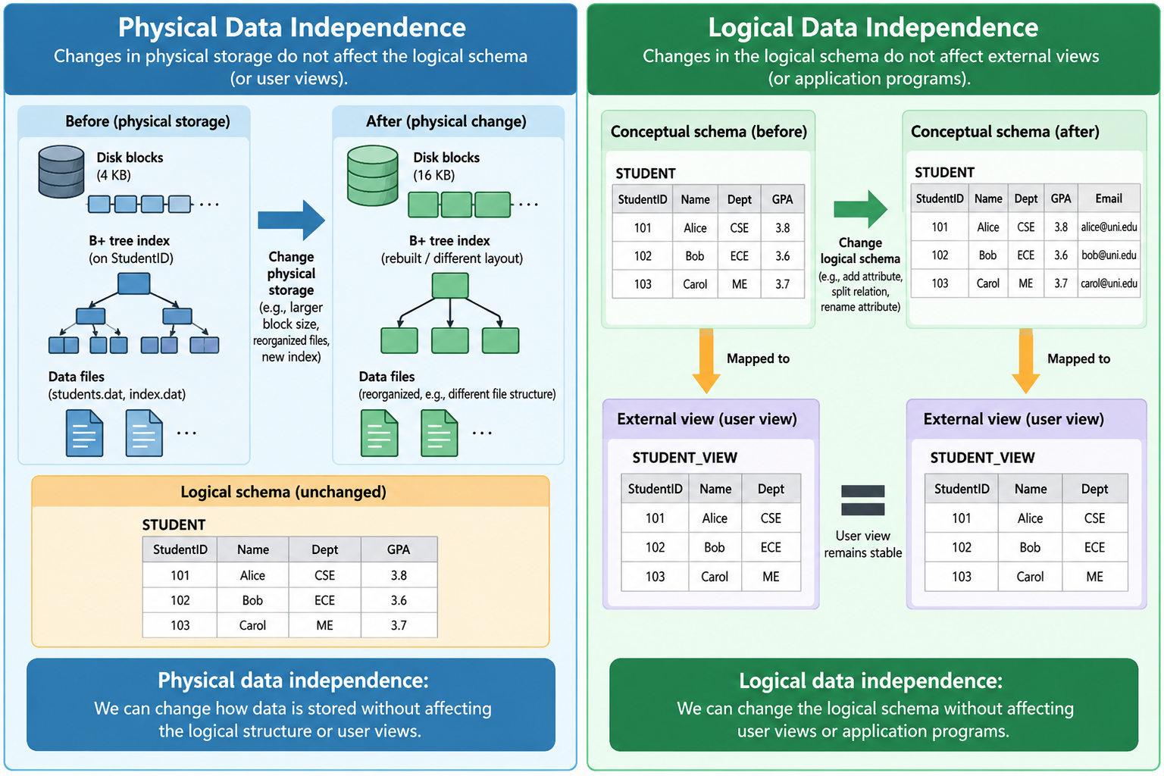
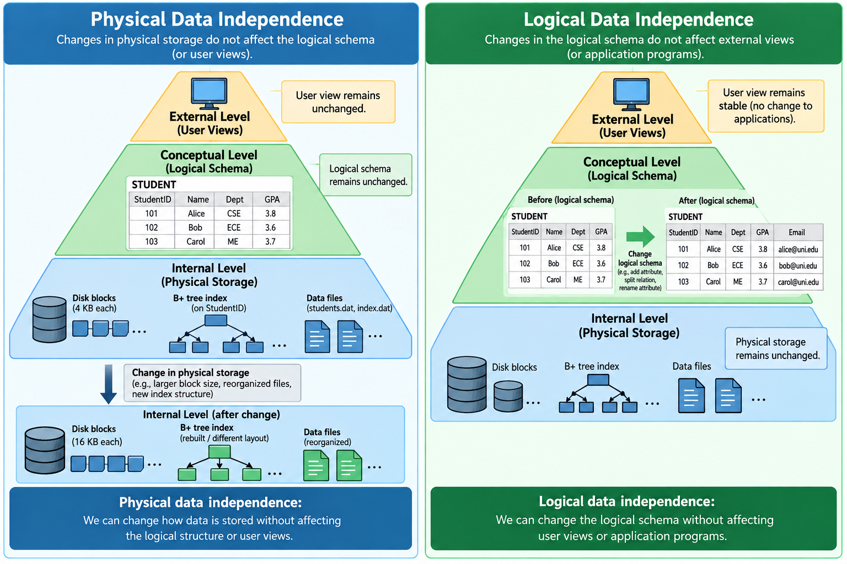

2.2 Real-world example
College database: A DBA may add an index to Student.RollNo or reorganize files for faster search. Students and teachers still use the same screens and queries. That is physical data independence.
Practical point: Logical data independence is generally harder because logical-schema changes can affect external views and application assumptions.

2.3 Exam Questions with Answers
Q1. Define data independence. [2 marks]
Answer: Data independence is the ability to modify the schema at one level without requiring changes at the next higher level. It reduces the impact of database changes on applications and user views.
Q2. Explain physical and logical data independence with suitable examples. [5 marks]
Answer: Physical data independence allows internal storage changes such as adding an index or changing file organization without changing the conceptual schema. Logical data independence allows conceptual-schema changes such as adding an attribute or relation without changing existing external views/programs that do not depend on the changed parts.
Q3. Differentiate between physical and logical data independence. [3–5 marks]
Answer: Physical: storage-oriented, internal-to-conceptual, examples include indexes and file organization. Logical: schema/view-oriented, conceptual-to-external, examples include adding attributes or relations. Logical independence is usually harder to achieve.
Q4. A DBA adds a B+ tree index to Student.RollNo. Which type of independence is shown? [2 marks]
Answer: Physical data independence, because the storage/access method changes while the logical table and user view remain the same.
Q5. Why is logical data independence more difficult? [2 marks]
Answer: Because changes in the conceptual schema may affect external views, queries, reports and application programs that depend on the logical organization of data.

3. Levels of Data Abstraction
What it is: Data abstraction hides unnecessary implementation details and presents only the information needed by a particular user or application. It works hand-in-hand with data independence and is organized into the same three-level ANSI-SPARC architecture, but viewed from the "how much detail is exposed" angle rather than the "what can change" angle.
a) Physical Level (Lowest level of abstraction)
Describes how data is actually stored — the lowest, most detailed level.
Includes: File organization, storage blocks, indexing structures (B-trees, hashing), data compression, pointers, and physical addresses.
Example: A Customer record might physically be stored as a 128-byte block at a specific disk offset, with an index file mapping customer_id to that offset.
Only database engineers/DBAs typically deal with this level.
b) Logical (Conceptual) Level
Describes what data is stored and the relationships among that data, without worrying about physical storage details.
Includes: Tables, columns, data types, keys, constraints, and relationships between entities.
Example: The conceptual level might define:
Customer(customer_id, name, email, phone)
Order(order_id, customer_id, order_date, total)
Database administrators work primarily at this level, deciding what data should be stored and how entities relate — without concern for how bits are laid out on disk.
c) View (External) Level
The highest level of abstraction — describes only the part of the database relevant to a specific user or application.
Includes: Custom views, filtered/joined data, computed fields, and restricted access to certain columns.
Example: A billing application might only see a view like:
CustomerBilling(customer_id, name, total_due)
even though the full Customer and Order tables contain much more data. A different application (e.g., customer support) might have a completely different view of the same underlying data.
Why It Matters (expanded)
- Simplifies interaction – users and applications don't need to understand complex storage or schema details to use the database.
- Enhances security – sensitive columns (like salary or SSN) can be hidden from views that don't need them.
- Supports multiple perspectives – different applications/users can have tailored views of the same underlying data simultaneously.
- Reduces complexity for developers – application code interacts with simple, relevant views rather than the entire raw schema.
Quick summary table:
Level | Abstraction Focus | Who Uses It
Physical | How data is stored | DBMS/storage engineers
Logical | What data is stored & relationships | DBAs, schema designers
View | What a specific user/app sees | End users, applications
Connecting Back to Data Independence
These two concepts are tightly linked:
- Physical data independence = changing the physical level without affecting the logical level
- Logical data independence = changing the logical level without affecting the view level
Together, abstraction defines the layers, and data independence defines the freedom to change one layer without breaking the others.
Users / Applications
↓
External (View) Level
↓
Conceptual (Logical) Level
↓
Internal (Physical) Level
↓
Storage

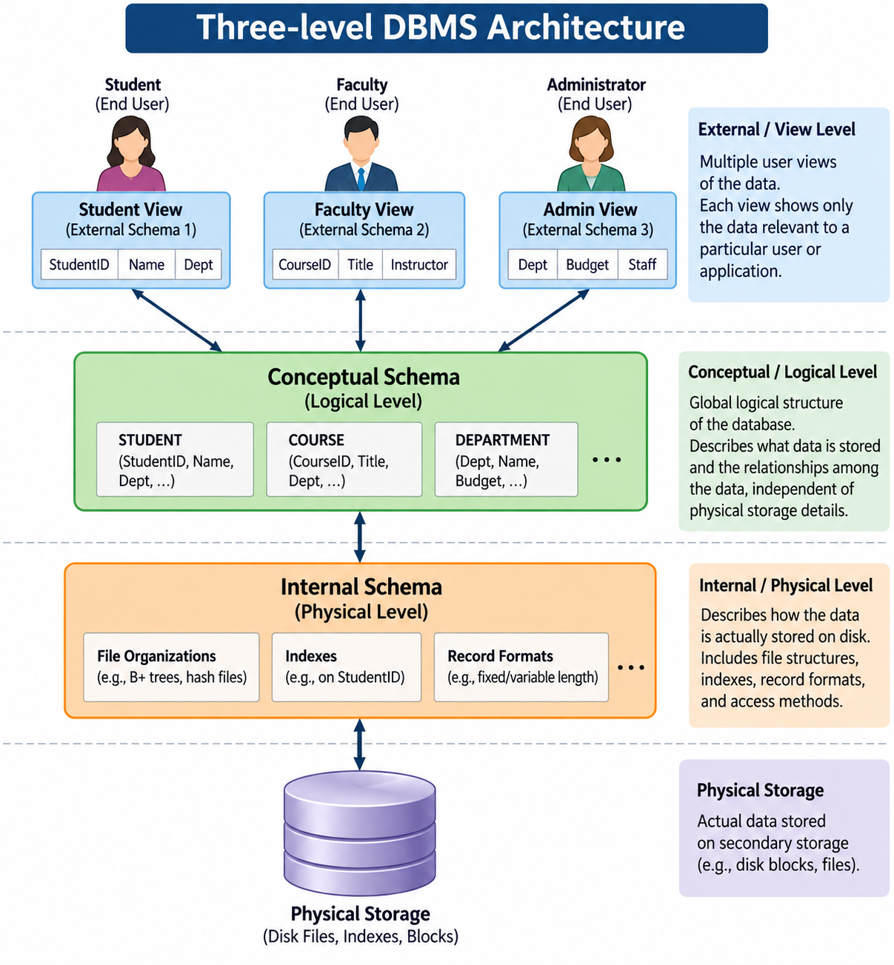

3.1 External Level (View Level)
- Highest level; shows only the data relevant to a particular user or application.
- Different users can have different views of the same database.
Example: A student sees marks and attendance; an accountant sees fees; a teacher sees class performance.

3.2 Conceptual Level (Logical Level)
- Describes the complete logical structure of the database.
- Contains entities, attributes, relationships and constraints.
STUDENT(Roll_No, Name, Dept)
COURSE(Course_ID, Course_Name)
ENROLLMENT(Roll_No, Course_ID)

3.3 Internal Level (Physical Level)
- Lowest level; describes how data is physically stored.
- Includes files, blocks, indexes, hashing, B-trees/B+ trees and record placement.
Key distinction: Conceptual tells what the database logically contains; internal tells how it is physically stored.
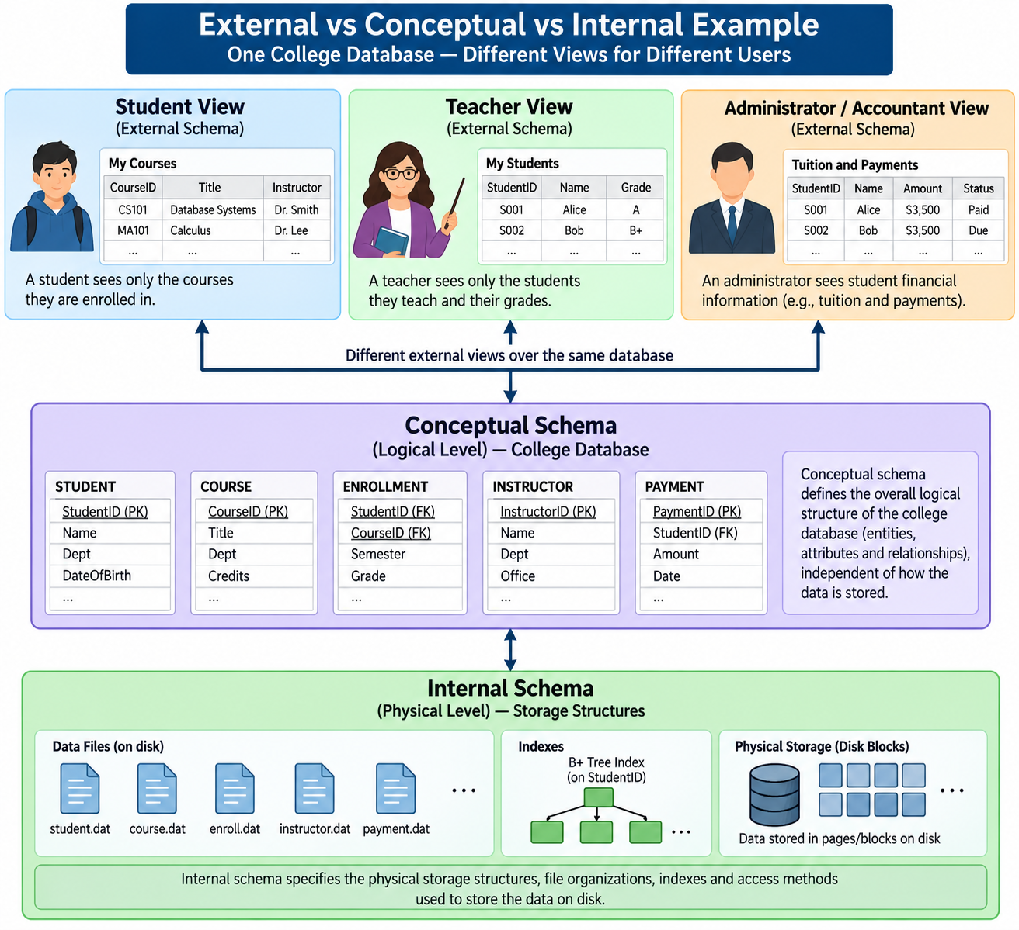

3.4 Real-world analogy
Restaurant analogy: Customer sees menu and price (view level); manager sees inventory and sales (logical/business level); kitchen deals with ingredients and preparation details (implementation level).

3.5 Exam Questions with Answers
Q6. What is data abstraction? [2 marks]
Answer: Data abstraction is the process of hiding unnecessary database implementation details and exposing only the required information to users. It simplifies interaction with the DBMS.
Q7. Explain the three levels of data abstraction with a neat diagram. [5 marks]
Answer: External/View level shows user-specific views; Conceptual/Logical level represents the complete logical database structure; Internal/Physical level describes physical storage structures. Draw them from top to bottom and mention that mappings between levels help provide data independence.
Q8. Why are multiple levels of abstraction required? [3 marks]
Answer: They simplify database use, hide implementation complexity, support customized views and security, and help isolate changes through data independence.
Q9. Which level describes physical storage? [1–2 marks]
Answer: The internal (physical) level.
Q10. A student sees only marks and attendance while an administrator sees complete records. Which concept is illustrated? [2 marks]
Answer: Data abstraction, specifically different external/view-level schemas for different users.

4. Lossless Join / Lossless Decomposition
What it is: A decomposition of relation R into smaller relations is lossless if joining the decomposed relations reconstructs exactly the original relation, without losing valid information or generating spurious tuples.
In other words, the decomposition preserves all the original data and allows the relations to be joined back without creating incorrect rows.
Key condition:
R₁ ⋈ R₂ = R
Lossless decomposition is important in normalization because it reduces redundancy while preserving the original information.
Why decomposition is used: To reduce redundancy and update, insertion and deletion anomalies during normalization.
Original:
EMPLOYEE(EmpID, EmpName, DeptID, DeptName)
Decompose:
EMPLOYEE(EmpID, EmpName, DeptID)
DEPARTMENT(DeptID, DeptName)
Join on DeptID → should reconstruct the intended original information.

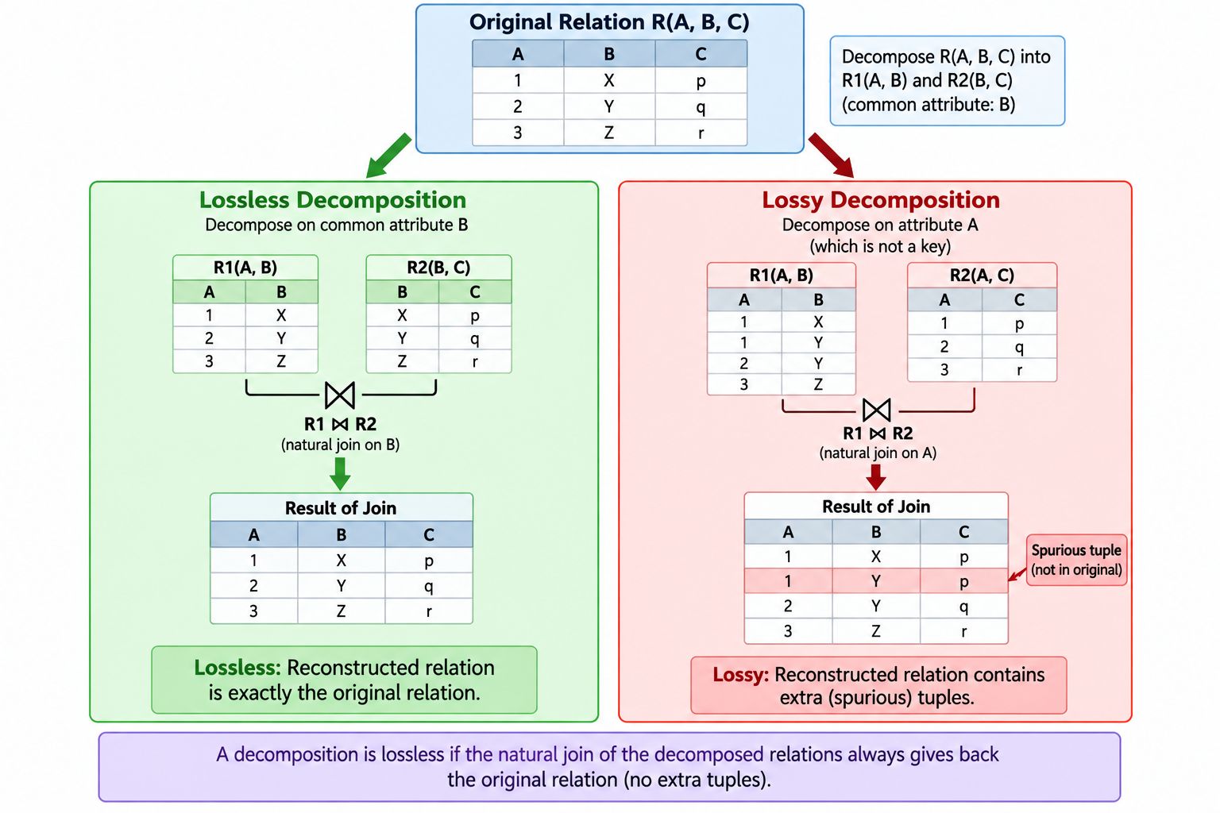

4.1 Lossy decomposition and spurious tuples
Lossy decomposition: The join of the decomposed relations does not correctly reproduce the original relation; it may create spurious tuples or lose information.
Spurious tuple: A tuple produced by joining decomposed relations even though that tuple was not present in the original relation.
For binary decomposition R → R1, R2:
Let X = R1 ∩ R2.
Lossless condition is satisfied if F logically implies X → R1
or F logically implies X → R2.
Equivalently, under the usual closure test, X+ must contain all attributes of R1 or all attributes of R2.

Closure form to remember: Compute (R1 ∩ R2)+ using the given functional dependencies. If it contains every attribute of R1 or every attribute of R2, the binary decomposition is lossless.

4.2 Worked mini-example
Given: R(A,B,C), F = {B → A}, decomposition R1(A,B), R2(B,C).
Common attributes = {B}
B+ = {B, A}
Since B+ contains all attributes of R1 = {A,B},
the decomposition is lossless.

Interpretation: The common attribute B functionally determines one whole component, so joining the components does not introduce arbitrary combinations for this decomposition.
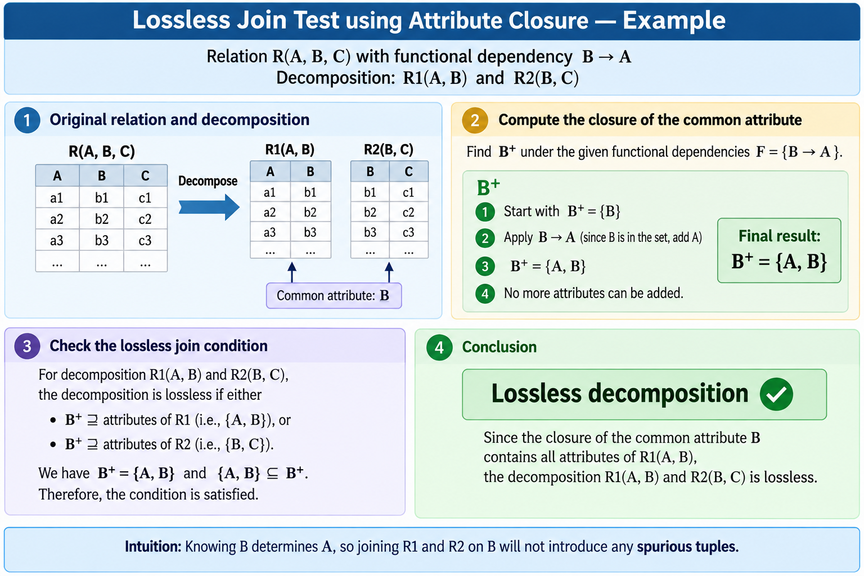

4.3 Exam Questions with Answers
Q11. What is lossless decomposition? [2 marks]
Answer: A decomposition is lossless when the natural join of the decomposed relations reproduces exactly the original relation, with no information loss and no spurious tuples.
Q12. Differentiate between lossless and lossy decomposition. [3 marks]
Answer: Lossless decomposition reconstructs the original relation correctly and does not create spurious tuples. Lossy decomposition fails to reconstruct the original relation correctly and may create spurious tuples or lose information.
Q13. What is a spurious tuple? [2 marks]
Answer: A spurious tuple is an incorrect tuple generated after joining decomposed relations that did not exist in the original relation.
Q14. State a condition for a binary decomposition R→R1,R2 to be lossless. [3 marks]
Answer: Let X=R1∩R2. If the functional dependencies imply X→R1 or X→R2, the binary decomposition is lossless. Using closure, X+ must contain all attributes of at least one component.
Q15. Given R(A,B,C), F={B→A}, R1(A,B), R2(B,C). Is the decomposition lossless? [3–5 marks]
Answer: Yes. The common attribute is B. Since B+={A,B} under F and this contains all attributes of R1, the decomposition is lossless.
Q16. Why is lossless join important in normalization? [3 marks]
Answer: Normalization decomposes relations to reduce redundancy, but the decomposition must preserve the information in the original relation. Lossless join guarantees that the split does not destroy the intended information or create false combinations.
5. Basic Properties of Transactions (ACID)
What is a transaction: A transaction is a logical unit of database work consisting of one or more operations that are treated as one coherent action. A transaction should either complete successfully as a whole or be rolled back completely if an error occurs.
Example: Transferring ₹500 from Account A to Account B involves debiting A and crediting B as one transaction.

Bank transfer example:
Read(A) → A = A - 5000 → Write(A)
Read(B) → B = B + 5000 → Write(B)
COMMIT

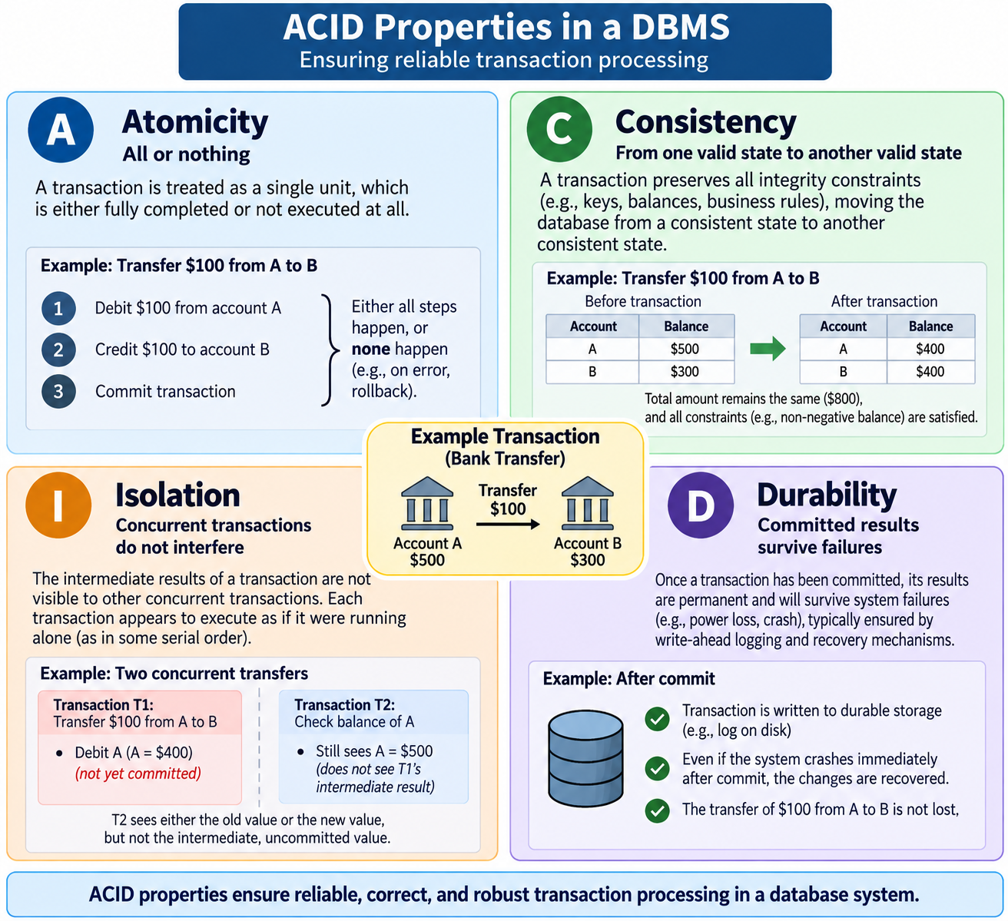

5.1 Atomicity
Meaning: All or nothing. If any required part of a transaction fails, the entire transaction is rolled back.
Example: If ₹5000 is deducted from A but the system crashes before crediting B, the DBMS undoes the transaction so that money is not lost.
5.2 Consistency
Meaning: A transaction moves the database from one valid state to another valid state, while preserving integrity constraints.
Example: A money transfer changes both account balances while preserving the required accounting rules.
5.3 Isolation
Meaning: Concurrent transactions should execute without interfering in a way that produces an incorrect result or exposes inappropriate intermediate states, according to the chosen isolation level.
Example: One transaction should not see another transaction's uncommitted balance change.
5.4 Durability
Meaning: Once a transaction is committed, its effects must survive a system crash or power failure.
Example: After an online payment is successfully committed, the payment record should remain available even after a server restart.
.

5.5 Exam Questions with Answers
Q17. What is a transaction? Explain ACID properties. [5 marks]
Answer: A transaction is a logical unit of work. Atomicity ensures all-or-nothing execution; Consistency preserves database rules; Isolation controls interference between concurrent transactions; Durability ensures committed changes survive failures.
Q18. Explain atomicity with a banking example. [3 marks]
Answer: In a transfer, debit and credit must be treated as one unit. If the debit succeeds but the credit fails, the transaction is rolled back so the database does not permanently keep only the debit.
Q19. Differentiate consistency and isolation. [3 marks]
Answer: Consistency concerns validity of database state and integrity constraints. Isolation concerns the interaction between concurrent transactions and prevents them from producing incorrect results or exposing inappropriate intermediate effects.
Q20. Which ACID property guarantees committed data survives a crash? [1 mark]
Answer: Durability.
Q21. Why is atomicity called “all-or-nothing”? [2 marks]
Answer: Because either all required operations of a transaction take effect, or none of them are retained after a failure.

6. Concurrency, Concurrency Problems and Serializability
What it is: Concurrency means multiple transactions execute during overlapping periods of time. A DBMS uses concurrency control to manage these transactions so that database access remains efficient, consistent, and correct.
Example: Two users may simultaneously update or read the same account, while the DBMS coordinates their operations to prevent incorrect results.
Why it is needed: Better throughput, CPU/resource utilization and responsiveness for many simultaneous users.
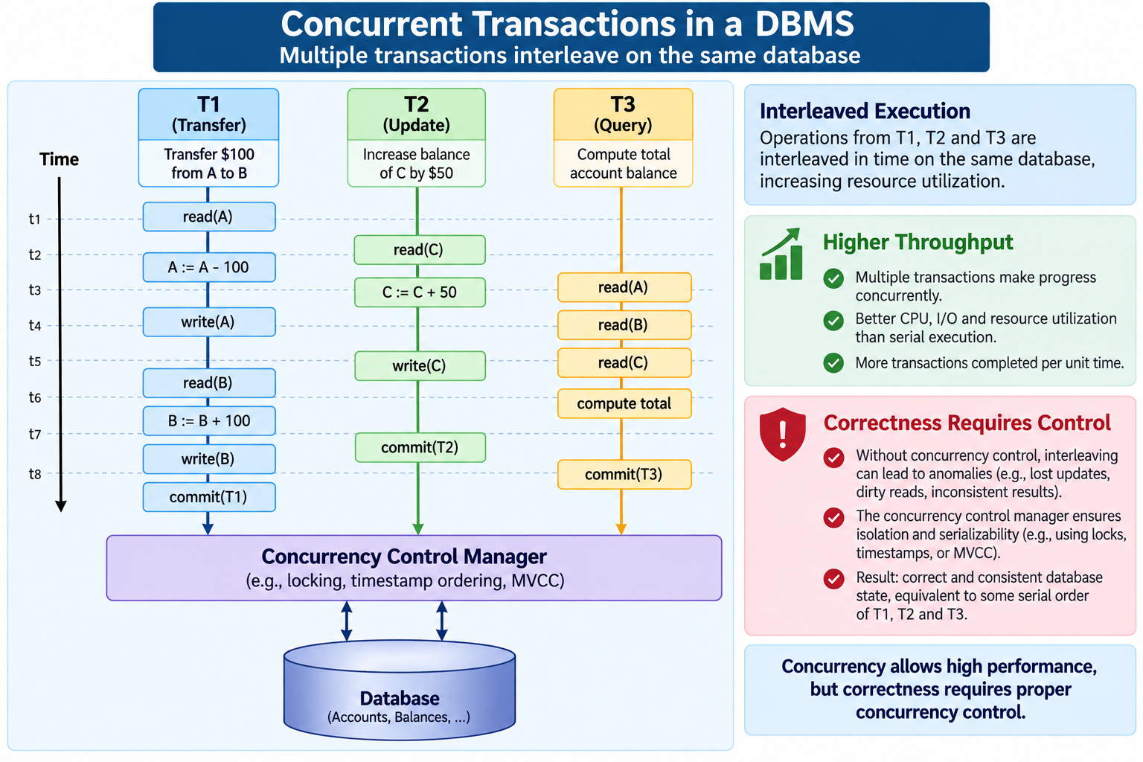

6.1 Major concurrency problems

Lost Update
Initial X = 1000
T1 reads X=1000
T2 reads X=1000
T1 writes X=900
T2 writes X=800 ← T1 update is overwritten

Core idea: A valid update made by one transaction is lost because another transaction writes based on an older value.

Dirty Read
Meaning: A dirty read occurs when one transaction reads data that has been modified by another transaction but not yet committed. If the first transaction later rolls back, the value that was read was invalid.
T1: writes X = 5000
T2: reads X = 5000
T1: ROLLBACK
T2 has read a value that was never committed.

Non-repeatable Read
Meaning: A non-repeatable read occurs when a transaction reads the same row twice but gets different values because another transaction modified and committed the row between the two reads.
T1: READ X → 100
T2: UPDATE X → 200 and COMMIT
T1: READ X → 200
Same row, different value within T1.

Phantom Read
Meaning: A phantom read occurs when a transaction executes the same query twice but gets a different set of rows because another transaction inserted, deleted, or modified rows that match the query condition.
T1: SELECT rows WHERE marks > 80 → 5 rows
T2: inserts another row with marks=90 and COMMIT
T1: repeats query → 6 rows
New matching row = phantom.

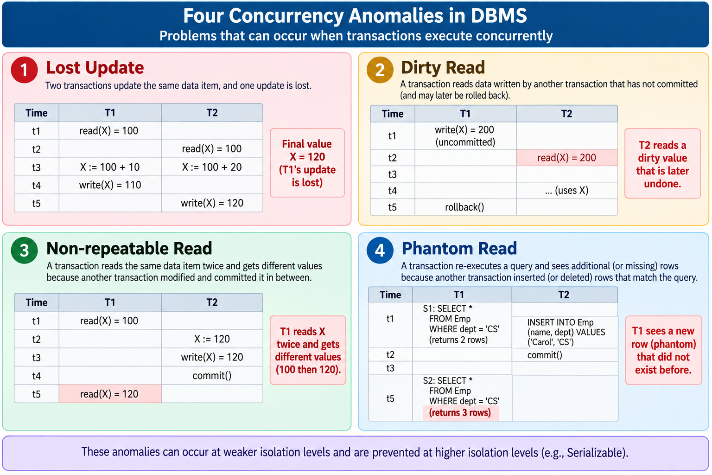

6.2 Locks
=> Shared Lock (S): Used for reading data. Multiple transactions can usually hold a shared lock on the same data item at the same time, as long as they are only reading.
Example: T1 and T2 can both read the same account balance using shared locks.

=> Exclusive Lock (X): Used for writing or modifying data. While an exclusive lock is held, other transactions cannot perform incompatible reads or writes on that data item.
Example: If T1 updates an account balance, it obtains an exclusive lock so that other transactions cannot modify the balance at the same time.
S-lock → read
X-lock → write
Compatibility idea: S with S is allowed; X conflicts with S and X.

6.3 Serializability
Definition: A concurrent schedule is serializable if its effect is equivalent to some valid serial order of the same transactions.
In other words, transactions may be interleaved, but the final result must be the same as if they had executed one after another.
Example: If an interleaved schedule of T1 and T2 produces the same result as the serial order T1 → T2, then the schedule is serializable.
Why it matters: Concurrency improves performance; serializability gives a correctness target by ensuring the concurrent result matches a safe serial execution.
Serial: T1 → T2
Concurrent schedule may interleave actions:
T1: R(A) W(A)
T2: R(B) W(B)
If the final effect is equivalent to a serial order, the schedule is serializable.
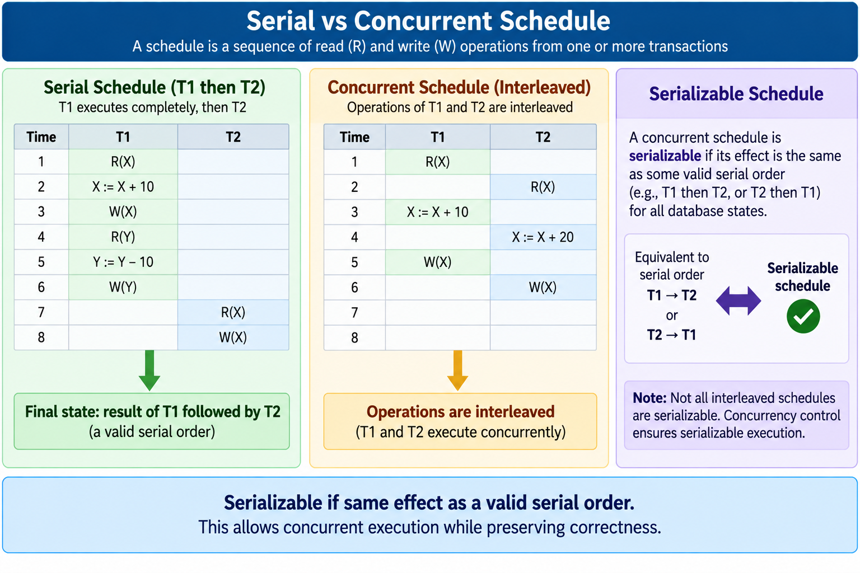

6.4 Exam Questions with Answers
Q22. What is concurrency in DBMS? Why is it needed? [3 marks]
Answer: Concurrency is overlapping execution of multiple transactions. It is needed for high throughput, better resource utilization and responsiveness when many users access a database.
Q23. Explain lost update, dirty read and phantom read. [5 marks]
Answer: Lost update: one update overwrites another. Dirty read: a transaction reads uncommitted data from another transaction. Phantom read: repeated execution of a condition-based query returns a changed set of rows because another transaction inserted/deleted matching rows.
Q24. What is a shared lock and what is an exclusive lock? [3 marks]
Answer: A shared lock permits reading and is compatible with other shared locks. An exclusive lock is used for writing and conflicts with shared and exclusive locks on the same item.
Q25. What is serializability and why is it important? [3 marks]
Answer: Serializability means a concurrent schedule has the same effect as some serial execution. It is important because it allows concurrency without sacrificing transaction-result correctness.
Q26. Given a schedule, what is the main idea for deciding serializability? [5 marks]
Answer: Identify conflicting read/write or write/write operations on the same data item, build the precedence/conflict relationships between transactions, and check whether the resulting precedence graph is acyclic. An acyclic graph indicates conflict serializability.

7. Logging Protocol and Recovery
What it is: Logging records the actions of transactions, including relevant old and new values, so the DBMS can recover the database correctly after a failure.
Example: If a transaction updates an account from ₹10,000 to ₹8,000, the log records the change so the DBMS can UNDO or REDO it during recovery.

Failure examples: Power failure, system crash, software error, transaction failure.
Example log record:
<T1, A, 1000, 800>
meaning: T1 changed A from old value 1000 to new value 800.

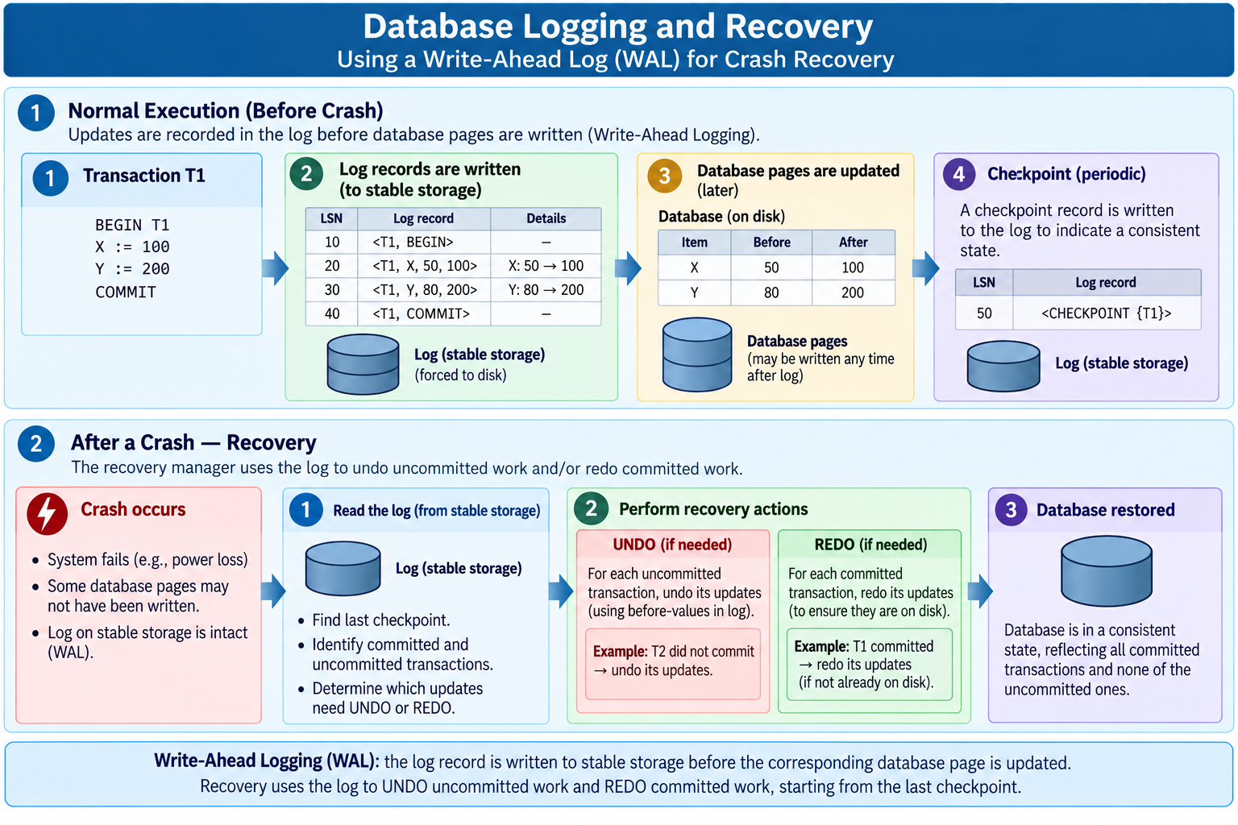

7.1 Write-Ahead Logging (WAL)
Core rule: Before a modified database page is written to stable storage, the corresponding log record describing the change must first be safely written to stable storage.
Purpose: WAL ensures that the DBMS has enough information to UNDO or REDO changes if a crash occurs.
Example: If T1 changes an account balance from ₹10,000 to ₹8,000, the log record for this change must be saved before the modified database page is saved to disk.

1. Prepare log record: <T1, A, old=1000, new=800>
2. Write log record to stable storage
3. Write modified database page when allowed
4. On crash, use the log to recover

Why: If the system crashes, the log contains enough history to determine which changes need to be undone or redone.

7.2 UNDO vs REDO
Point | UNDO | REDO
Purpose | Reverse a change | Reapply a change
Typical target | Incomplete/uncommitted work | Committed work whose effect must be restored
Use during recovery | Restore previous value | Ensure committed result is present
UNDO example:
<T1, A, 1000, 800> and no COMMIT before crash
→ restore A to 1000
REDO example:
<T1, A, 1000, 800>
<T1, COMMIT>
crash before the page is safely reflected
→ ensure A becomes 800 again

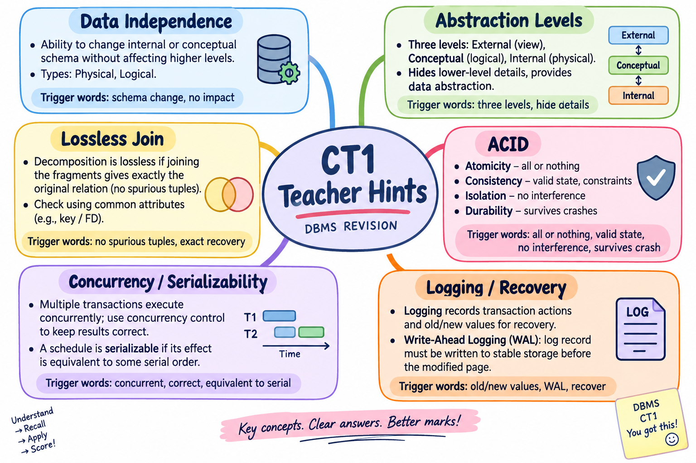7.3 Checkpoint
Meaning: A checkpoint is a recovery marker that helps limit how far back the recovery process needs to inspect the log, improving recovery efficiency.
Older log records → CHECKPOINT → newer log records → CRASH
↑
useful recovery reference

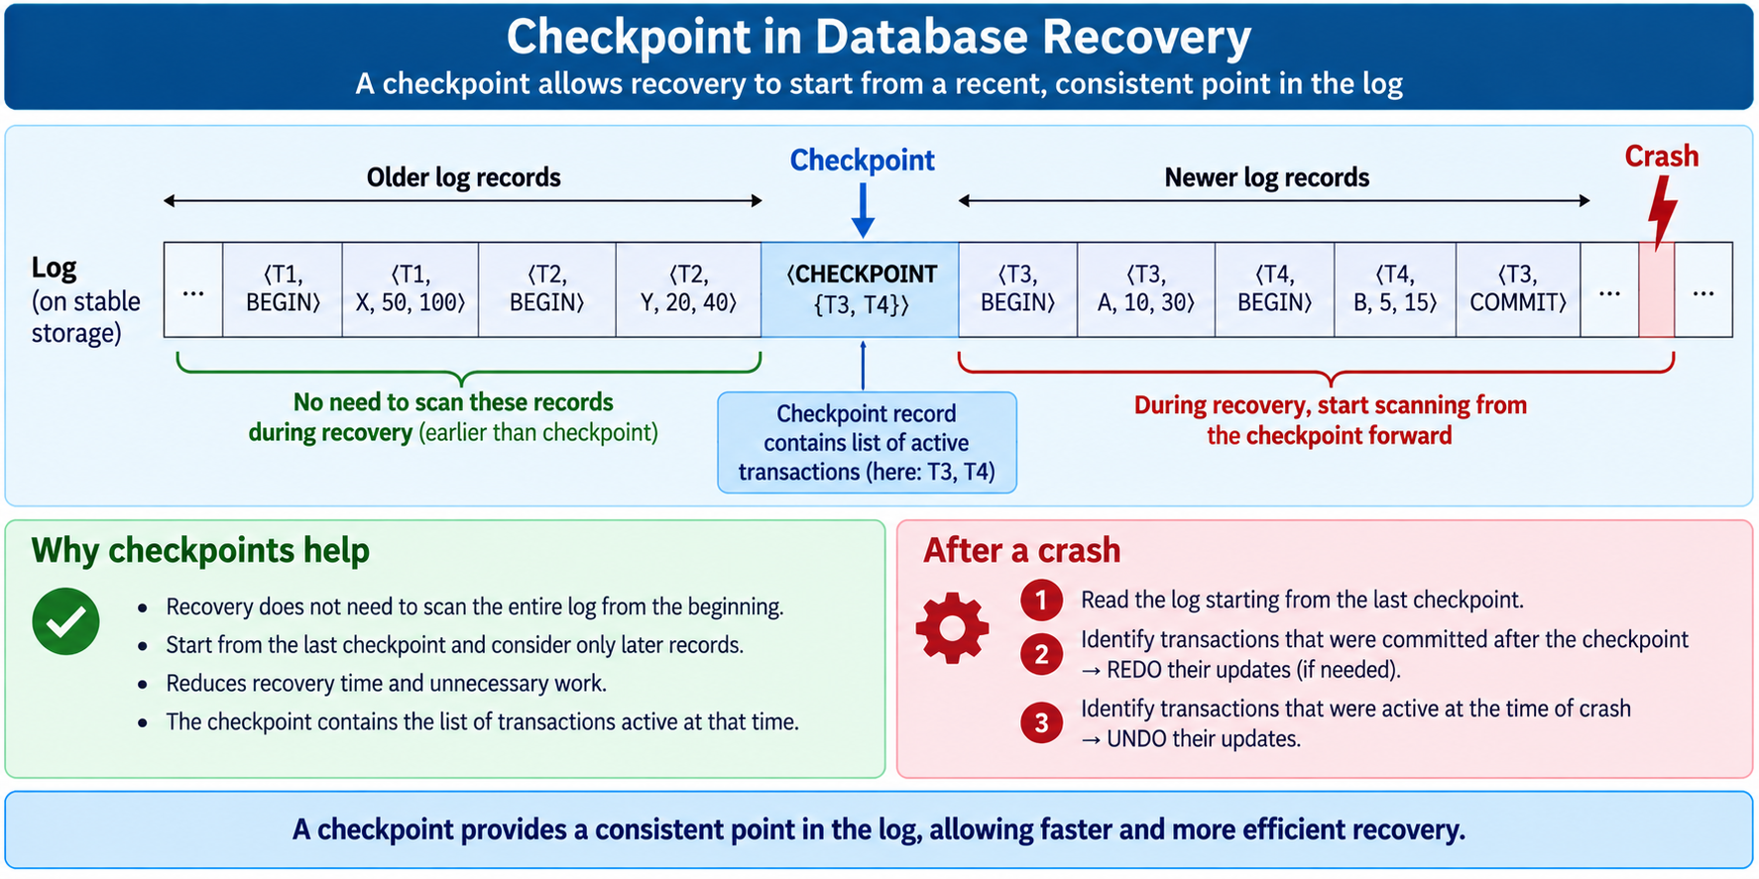

7.4 Worked log example
<T1, START>
<T1, A, 1000, 800>
<T1, B, 2000, 2200>
<T1, COMMIT>
Crash occurs after COMMIT.
T1 is committed, so recovery must preserve its effects; REDO may be required if its updates were not reflected safely on disk.

Uncommitted example: If the log ends with an update for T2 but no COMMIT before the crash, T2 is treated as incomplete and its effects may need UNDO.

7.5 Exam Questions with Answers
Q27. What is logging in DBMS? Why is it required? [3 marks]
Answer: Logging is maintaining a sequential record of transaction actions and relevant old/new values. It is required to recover the database after crashes and failures by determining which changes to undo or redo.
Q28. Explain Write-Ahead Logging (WAL). [5 marks]
Answer: WAL requires the relevant log record to reach stable storage before the modified database page is written to stable storage. This ensures that recovery information exists before the corresponding data change can become durable.
Q29. Differentiate between UNDO and REDO. [3 marks]
Answer: UNDO reverses changes of incomplete/uncommitted transactions. REDO reapplies changes of committed transactions when their effects may not yet be safely reflected on disk.
Q30. What is a checkpoint? [2 marks]
Answer: A checkpoint is a recovery marker that reduces recovery work by providing a useful reference point so the system does not have to examine the entire log from the beginning.
Q31. Given a log and a crash point, how do you decide UNDO/REDO? [5 marks]
Answer: Find which transactions have COMMIT records before the crash. Treat committed transactions as candidates for preserving/redoing their changes; treat incomplete transactions without COMMIT as candidates for UNDO. Follow the recovery algorithm/convention taught in class for the exact log format.

8. Mixed / Bright Exam Questions
Purpose: These are designed to test whether you can connect the teacher-hinted topics rather than only memorize definitions.
Q32. A DBMS adds an index without changing the table definition. Name the concept and the abstraction level involved. [3 marks]
Answer: The concept is physical data independence. The change occurs at the internal/physical level, while the conceptual schema remains unchanged.
Q33. A normalized relation is decomposed into R1 and R2. After joining R1 and R2, additional tuples appear that were absent before. What has gone wrong? [2 marks]
Answer: The decomposition is lossy; the extra tuples are spurious tuples created by the join.
Q34. Why are concurrency control and serializability related? [3 marks]
Answer: Concurrency allows transactions to overlap for performance. Serializability provides a correctness criterion ensuring the interleaved execution has the same effect as a valid serial execution.
Q35. A transaction updates two accounts and the server crashes after the first update. Which ACID property is primarily involved, and what recovery mechanism helps? [3 marks]
Answer: Atomicity requires the transaction to behave as all-or-nothing, and logging/recovery mechanisms can use the log to UNDO incomplete changes.
Q36. A transaction committed before a crash, but its data page was not safely persisted. What recovery action may be required? [2 marks]
Answer: REDO the committed transaction’s changes using the log so the committed state is restored.
Q37. Why does the three-level architecture support data independence? [3 marks]
Answer: Because it separates external views, the conceptual schema and internal storage, allowing changes at one level to be isolated from higher levels through mappings between the levels.
Q38. Compare data abstraction and data independence in one answer. [4 marks]
Answer: Data abstraction is about hiding unnecessary details and presenting appropriate views. Data independence is about changing one schema/storage level without forcing changes to a higher level. Abstraction is about visibility/simplification; independence is about isolation of changes.

9. One-Page Revision Sheet
Data Independence | Physical: internal→conceptual; Logical: conceptual→external.
Abstraction | External = user view; Conceptual = complete logical schema; Internal = physical storage.
Lossless Join | Decomposition must reconstruct original without spurious tuples. For binary split, use common-attribute closure test.
ACID | Atomicity = all-or-nothing; Consistency = valid state; Isolation = safe concurrency; Durability = survives commit + crash.
Concurrency | Overlapping transactions; watch Lost Update, Dirty Read, Non-repeatable Read, Phantom Read.
Locks | S-lock for read; X-lock for write; incompatible locks conflict.
Serializability | Concurrent schedule equivalent to some serial order; conflict graph acyclic → conflict-serializable.
Logging | Record transaction history; WAL before data page; UNDO incomplete work; REDO committed work when needed; checkpoints speed recovery.

