COA CT1 PART1
Part A — Class Test 1 (28/07/2026): Basics, ISA, Control Unit

Q1. Define the term Control Unit.
The Control Unit (CU) is the part of the CPU that manages and coordinates the activities of all other components — the ALU, registers, memory, and I/O devices. The CU itself does not perform any calculations; it only generates the timing and control signals that tell the rest of the hardware what to do and when to do it, based on the instruction currently being executed.
Functions of the Control Unit:
- Fetch the next instruction from memory using the Program Counter (PC).
- Decode the fetched instruction to determine the operation and operands.
- Generate and send control signals to the ALU, registers, and buses to carry out the operation.
- Maintain correct timing and sequencing of all these steps using the system clock.
There are two broad types of Control Unit design: Hardwired CU, which uses fixed logic gates and flip-flops and is very fast but difficult to modify, and Microprogrammed CU, which uses a small internal memory (control store) holding "microinstructions" and is slower but far easier to redesign or extend. A simple analogy: the CU acts like a traffic police officer at a junction — it does not move any vehicle itself, but it decides which vehicle (data) moves, on which road (bus), and at what moment.

Q2. Discuss any 3 types of memory used in a computer.
- RAM (Random Access Memory) — volatile, temporary storage that holds the currently running program and its data. It loses its contents when power is switched off. Example: 8 GB DDR4 RAM in a laptop. RAM itself is of two kinds: SRAM (Static RAM), which is fast and used for cache, and DRAM (Dynamic RAM), which is slower, cheaper, and used as main memory.
- ROM (Read Only Memory) — non-volatile, permanent storage. Its contents survive a power cut. It typically holds the BIOS/firmware needed to boot the computer before the operating system is loaded from disk.
- Cache Memory — a very fast, small memory placed between the CPU and RAM. It stores copies of frequently or recently used instructions/data so the CPU does not have to wait for the much slower main memory every time. It is organised in levels — L1 (smallest, fastest, closest to the core), L2, and L3 (largest, slightly slower, often shared between cores).
For a 5-mark answer, two more memory types are worth adding: Secondary Memory (SSD/HDD — large capacity, slower, non-volatile, used for permanent storage of files and programs) and Registers (the smallest and fastest memory, located inside the CPU itself, used to hold data currently being processed).

Q3. Basic components of the Instruction Execution Cycle.
Also called the Fetch–Decode–Execute cycle, this is the repeating sequence every instruction goes through.
- Fetch: The Program Counter (PC) holds the address of the next instruction. The CU fetches this instruction from memory into the Instruction Register (IR), and PC is incremented (PC = PC + 1) so it points to the next instruction.
- Decode: The CU decodes the opcode stored in the IR to determine which operation must be performed, and identifies the operands and the addressing mode used.
- Fetch Operands: If the instruction needs data from registers or memory, that data is fetched at this stage.
- Execute: The ALU performs the required arithmetic/logic operation, or data is simply moved between registers/memory as required.
- Store / Writeback: The result of the execution is written back to a register or memory location.
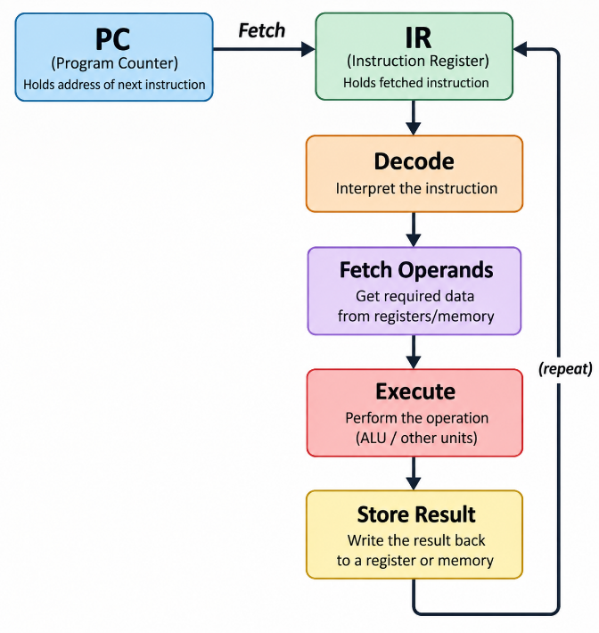
This cycle repeats continuously for every instruction of the program until the CPU is halted or powered off.

Q4. What is Instruction Set Architecture (ISA)?
The Instruction Set Architecture (ISA) is the interface, or boundary, between the software and the underlying hardware. It defines everything a programmer or compiler needs to know to write correct machine-level code, without needing to know how the hardware is actually built. ISA specifies:
- The set of instructions available (e.g. ADD, SUB, LOAD, STORE) and their formats.
- The number and type of registers, and how memory is addressed.
- Supported data types (integer, float, character) and the addressing modes available.
- How input/output operations are handled by the processor.
Common examples include x86 (used by Intel/AMD desktop processors), ARM (widely used in mobile phones and embedded devices), and RISC-V (an open, royalty-free ISA). It is important to note that the ISA does not specify how the processor is physically built internally — that implementation detail is called the microarchitecture (or computer organization), and two processors can share the same ISA while having very different internal organisations.

Q5. Any 3 common addressing modes with example.
An addressing mode defines the rule by which the actual operand of an instruction is located.
- Immediate — the operand value itself is present directly inside the instruction, so no memory access is needed to fetch it. Fast, used for constants. Example: MOV R1, #5 (R1 is loaded with the literal value 5).
- Direct (Absolute) — the instruction contains the actual memory address of the operand. Example: LOAD R1, [100] (loads the value stored at memory address 100 into R1).
- Register — the operand is held in a CPU register rather than in memory, which makes access very fast since no memory bus cycle is needed. Example: ADD R3, R1, R2 (R3 = R1 + R2, all registers).
- Indirect — the instruction contains the address of a location that itself holds the address of the actual operand (a pointer). Example: MOV R1, @R2 (R2 holds an address; the value at that address is loaded into R1).
- Indexed — the effective address is computed by adding a base address to the value of an index register; commonly used to access elements of an array or table.

Q6. Use of Implied, Immediate, Stack addressing mode.
- Implied Addressing — the operand is fixed and hidden as part of the operation itself, so the instruction does not need a separate address field at all. This saves bits in the instruction encoding. Example: CLC (clear carry flag) and RET (return, which implicitly uses the top of the stack) — the operand's location is understood implicitly by the instruction.
- Immediate Addressing — the operand's actual value is encoded directly inside the instruction word. It is the fastest way to supply a constant because there is no extra memory access; it is used whenever a program needs to load or compare against a fixed, known value. Example: MOV R1, #10 loads the constant 10 into R1.
- Stack Addressing — operands are always taken from the top of the stack using PUSH and POP, rather than being named explicitly in the instruction. This makes it a 0-address instruction format and is especially convenient for evaluating arithmetic expressions (postfix/RPN evaluation), because each operation simply pops its operands and pushes back the result. Example: PUSH A, PUSH B, ADD leaves A + B on top of the stack.

Q7. Registers initially 0. Find R1 after the sequence.
MOV R1, #6
MOV R2, #5
ADD R3, R1, R1
SUB R1, R3, R2
MULT R3, R1, R1
Step-by-step trace:
Start: R1=0, R2=0, R3=0

1. MOV R1,#6 -> R1 = 6
2. MOV R2,#5 -> R2 = 5
3. ADD R3,R1,R1 -> R3 = 6+6 = 12
4. SUB R1,R3,R2 -> R1 = 12-5 = 7
5. MULT R3,R1,R1 -> R3 = 7*7 = 49, R1 stays 7

Final: R1 = 7, R2 = 5, R3 = 49
Answer: R1 = 7

Q8. RTL method to describe an instruction using R1, R2.
RTL (Register Transfer Language) is used to describe, at the clock-pulse level, exactly how data moves between registers, memory, and the ALU during an instruction. Unlike a high-level statement such as "R1 = R1 + R2", RTL breaks the operation down into individual timed steps (T0, T1, T2, ...), each representing one clock pulse. Notation: "A <- B" means the contents of B are copied into A during that clock period; M[X] means the memory location at address X.
Example — ADD R1, R2 (meaning R1 = R1 + R2):
T0: MAR <- PC, PC <- PC + 1
T1: IR <- M[MAR], decode ADD
T2: A <- R1 (copy R1 into temp register A)
T3: B <- R2 (copy R2 into temp register B)
T4: R1 <- A + B (ALU adds A and B, result stored in R1)
Other examples:
- MOV R1, R2 => R1 <- R2 (a single, direct register transfer).
- LOAD R1, [X] => MAR <- X, then R1 <- M[MAR] (address is loaded into MAR first, then memory is read into R1).
Exam tip: always begin the RTL description with the fetch steps (MAR, PC, IR transfers), then show how operands are fetched into temporary registers if the ALU needs two inputs simultaneously, and finish with the execute/writeback step. Mentioning the temporary registers (A, B) explicitly earns extra marks because it shows understanding of the actual data path.

Q9. Instruction Cycle, Machine Cycle, and T-State.
This trio is commonly confused in exams. The easiest way to remember it is by thinking in terms of relative size, from smallest to largest:
- T-State (Clock Cycle) — the smallest unit of time in the CPU, equal to one clock pulse. It represents one tiny, indivisible operation — for example, placing an address on the bus, or one pulse of a memory read. T-states are labelled T1, T2, T3, T4, and so on.
- Machine Cycle (Bus Cycle) — a group of consecutive T-states needed to complete one bus operation, such as a Fetch, a Memory Read, a Memory Write, or an I/O Read/Write. For instance, the Fetch machine cycle typically spans T1 through T4 and is used to fetch the opcode from memory.
- Instruction Cycle — the complete Fetch + Decode + Execute sequence needed to process one full instruction. It is composed of several machine cycles, e.g. M1 (fetch) + M2 (memory read for operand) + M3 (execute/write).
T - T - T - T = 1 Machine Cycle (e.g. Fetch)
M1 + M2 + M3 = 1 Instruction Cycle
Concrete example — ADD R1, [100] might take:
M1 (Fetch, 4 T-states): get the opcode
M2 (Read, 3 T-states): read Memory[100]
M3 (Execute, 2 T-states): ALU add + store result

Instruction Cycle = M1 + M2 + M3 = 9 T-states total
Memory trick: T < M < I (a clock pulse is smaller than a bus operation, which is smaller than a full instruction).
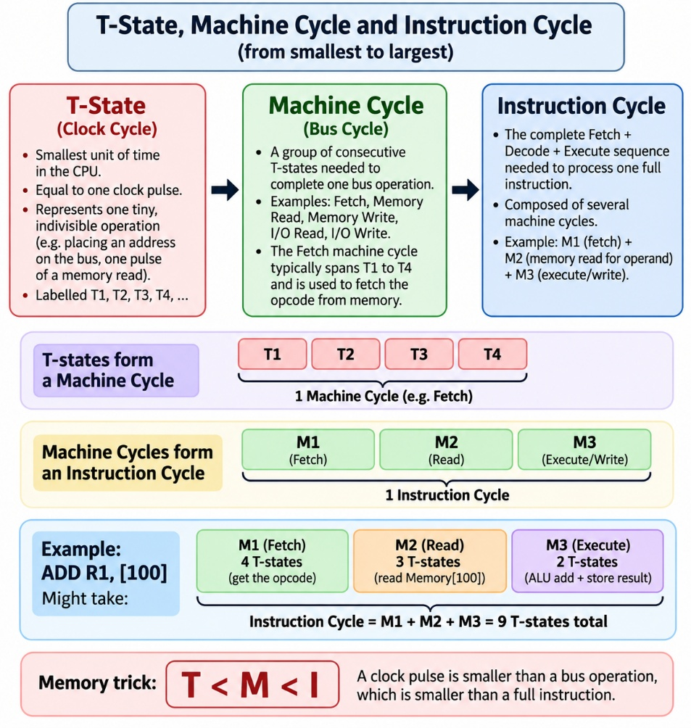

Q10. Compare Hardware vs Microprogrammed Control Unit.
Hardware (Hardwired) CU | Microprogrammed CU
Built using combinational logic gates and flip-flops | Built using a control memory (control store) holding microinstructions
Very fast, since control signals are generated directly by logic circuits | Comparatively slower, since each microinstruction must itself be fetched and decoded
Difficult to modify — requires rewiring/redesigning the hardware | Easy to modify — only the microprogram in control memory needs to be rewritten
Preferred in RISC processors, where the instruction set is simple | Preferred in CISC processors, where the instruction set is large and complex
Becomes very costly and complex to design as the instruction set grows | Remains relatively cheap and manageable even for a complex instruction set
Does not require any dedicated control memory | Requires a dedicated control memory to store microinstructions

Q11. Why is memory organized as a hierarchy?
The CPU operates at extremely high speed, while secondary storage (like a disk) is large in capacity but comparatively very slow. In practice no single memory technology can simultaneously be fast, large in capacity, and cheap — faster memory technologies (like SRAM) are always far more expensive per byte than slower ones (like magnetic disk). To get the best of all three properties, memory is therefore organized in layers, or a hierarchy: the layer closest to the CPU is the fastest, smallest, and most expensive per bit, while each layer further away is progressively slower, larger, and cheaper.
This hierarchy works efficiently because of the principle of locality of reference — programs tend to repeatedly access the same, or nearby, memory locations over short periods of time (temporal and spatial locality). This allows frequently used data to be kept in the fast upper levels (cache), so that, on average, the system achieves an access time close to that of the fastest cache while still offering the large capacity and low cost of disk storage.
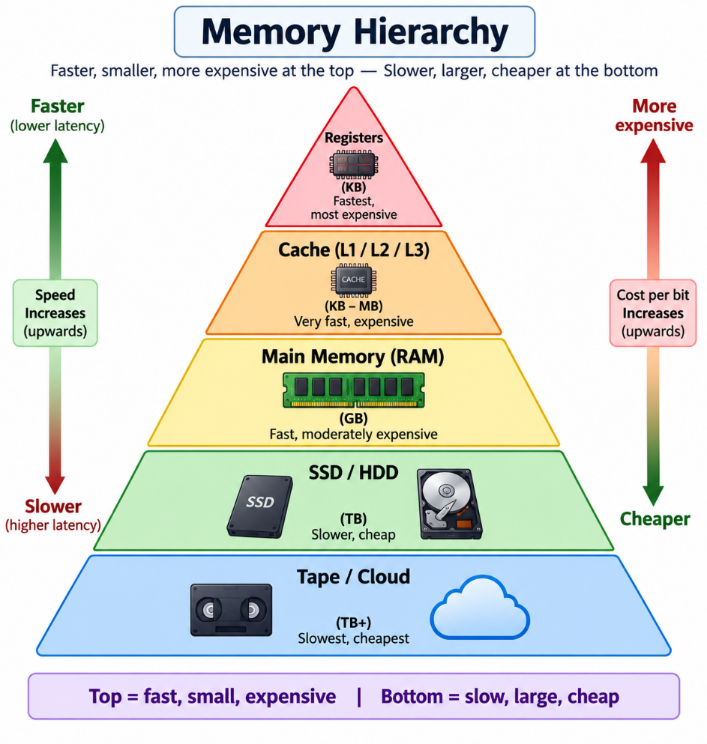
As a rule of thumb: the average access speed of the hierarchy approaches that of the cache, while its average cost per bit and total capacity approach that of the disk — giving the system a good balance of speed, size, and cost.

Q12. Advantages and disadvantages of RISC.
RISC stands for Reduced Instruction Set Computer. It is built around a small set of simple, fixed-length instructions, most of which execute in a single clock cycle, and it strictly follows a Load/Store architecture where only LOAD and STORE instructions may access memory — all other operations work purely on registers.
Advantages:
- Fast execution: since most instructions complete in a single cycle, RISC processors pipeline very efficiently, improving overall throughput.
- Simple hardware: the reduced and uniform instruction format leads to simpler control unit design, usually hardwired rather than microprogrammed.
- Lower power consumption: the simpler hardware makes RISC well suited to power-constrained devices — this is why ARM processors (RISC-based) dominate smartphones and embedded systems.
- Easier for compilers to optimise, since the instruction set is regular and predictable.
Disadvantages:
- A given task may require more instructions overall compared to CISC, since each instruction does less work.
- This can lead to larger compiled program (code) size.
- Requires a large register file and a sophisticated, optimising compiler to achieve good performance, since much of the complexity is pushed from hardware onto software.

Q13. LOAD and STORE architecture.
In a Load/Store architecture (used by virtually all RISC processors), only two instructions — LOAD and STORE — are permitted to access main memory. Every arithmetic and logic instruction must operate purely on values already held in CPU registers; if an operand is currently in memory, it must first be explicitly loaded into a register before it can be used.
Example sequence:
LOAD R1, [X] ; bring value at memory address X into R1
ADD R3, R1, R2 ; R3 = R1 + R2 (pure register operation)
STORE [Y], R3 ; write the result in R3 back to memory address Y
Advantages:
- Simplicity — the instruction set and the hardware data path stay simple and uniform.
- Efficient pipelining — since memory access is confined to just two instruction types, pipeline stages are easier to design and hazards are easier to manage.
Disadvantages:
- More instructions are needed overall to accomplish a task that a CISC machine might do in one memory-to-memory instruction.
- Requires a sufficiently large register file so that data can be kept in registers between the LOAD and the subsequent STORE.

Q14. Why is a stack not generally implemented using the processor's register file?
- Unknown/variable depth: function calls can nest arbitrarily deep, and interrupts can occur at any time, each needing stack space. A register file typically has only 16-32 entries, which is far too small to hold an arbitrarily deep call chain.
- Need for automatic addressing: a stack requires PUSH/POP operations where the address (the Stack Pointer, SP) is updated automatically with every operation. Registers, in contrast, need an explicit register name/address specified in every instruction — they don't auto-increment/decrement the way a stack needs to.
- Overflow risk: if a stack were confined to the register file, deep recursion or many nested calls would very quickly exhaust the available registers and overflow. Memory, on the other hand, offers megabytes to gigabytes of space, making overflow far less likely.
- Cost: registers are the most expensive and limited memory resource in the whole system; dedicating a large chunk of them permanently to a stack is not an efficient use of that resource.
For these reasons, the actual stack is implemented in main memory, with a single register (the Stack Pointer, SP) used to track the address of its current top. Some processors do cache the top one or two stack entries in dedicated fast registers purely as a performance optimisation, but the backing storage for the stack as a whole remains memory.

Q15. Role of the stack in a subroutine call.
The stack is essential for implementing subroutine (function) calls correctly, especially when calls can be nested or recursive. Its main roles are:
- Saving the return address: when a CALL instruction is executed, the current value of the Program Counter (the address of the instruction right after the call) is pushed onto the stack. When the subroutine finishes, the RET instruction pops this address back into the PC, so execution resumes exactly where it left off.
- Saving register values: registers that the subroutine will modify are often pushed onto the stack at the start of the subroutine and popped back (restored) at the end, so the calling routine's register values are not corrupted.
- Passing parameters and holding local variables: many calling conventions push the arguments of the subroutine onto the stack before the call, and the subroutine also uses stack space for its own local variables — together this region is called a stack frame.
- Supporting nesting and recursion: because each new call simply pushes a fresh stack frame on top of the previous one, subroutines can call other subroutines (or even call themselves recursively) to any depth the available stack memory allows, and each invocation keeps its own independent set of return address, saved registers, and local data.

Q16. Different types of ROMs.
- PROM (Programmable ROM) — can be written (programmed) once by the user after manufacture, using a special device; after that it cannot be changed.
- EPROM (Erasable PROM) — can be erased by exposing the chip to strong ultraviolet (UV) light through a small window on the package, and then reprogrammed. Erasure clears the entire chip, not individual bytes.
- EEPROM (Electrically Erasable PROM) — can be erased and rewritten electrically, byte by byte, without needing UV light or removal from the circuit, making it much more convenient than EPROM.
- Flash Memory — a fast variant of EEPROM that erases and writes data in larger blocks rather than a single byte at a time, giving higher speed. It is widely used in USB pen drives, SD cards, and SSDs.
- Mask ROM — the contents are permanently fixed into the chip at the time of manufacture itself (by the manufacturer's photomask) and can never be altered afterwards. It is the cheapest option when very large quantities of an identical, unchanging ROM are needed.
All five types share the key property of being non-volatile — they retain their stored data even when power is removed, unlike RAM.

Q17. Computer Organization vs Computer Architecture.
- Computer Architecture (the "WHAT") — describes the system from the programmer's point of view: the visible attributes such as the instruction set (ISA), available registers, addressing modes, and data types. It answers "what capabilities does this machine offer to software?" Example: whether a processor is x86 or ARM is an architectural distinction.
- Computer Organization (the "HOW") — describes how those architectural features are actually implemented in hardware — the design of the ALU, the pipeline structure, the size and levels of cache, and the actual data paths and control signals used. It answers "how is a given instruction, like ADD, physically carried out?"

The distinction matters because the same architecture can be realised through different organizations: an Intel i5 and an Intel i7, for example, both implement the same x86 architecture (the same instruction set is visible to software), but internally they differ in organization — different cache sizes, pipeline depths, and core counts — which is why their performance differs even though software written for one runs correctly on the other.
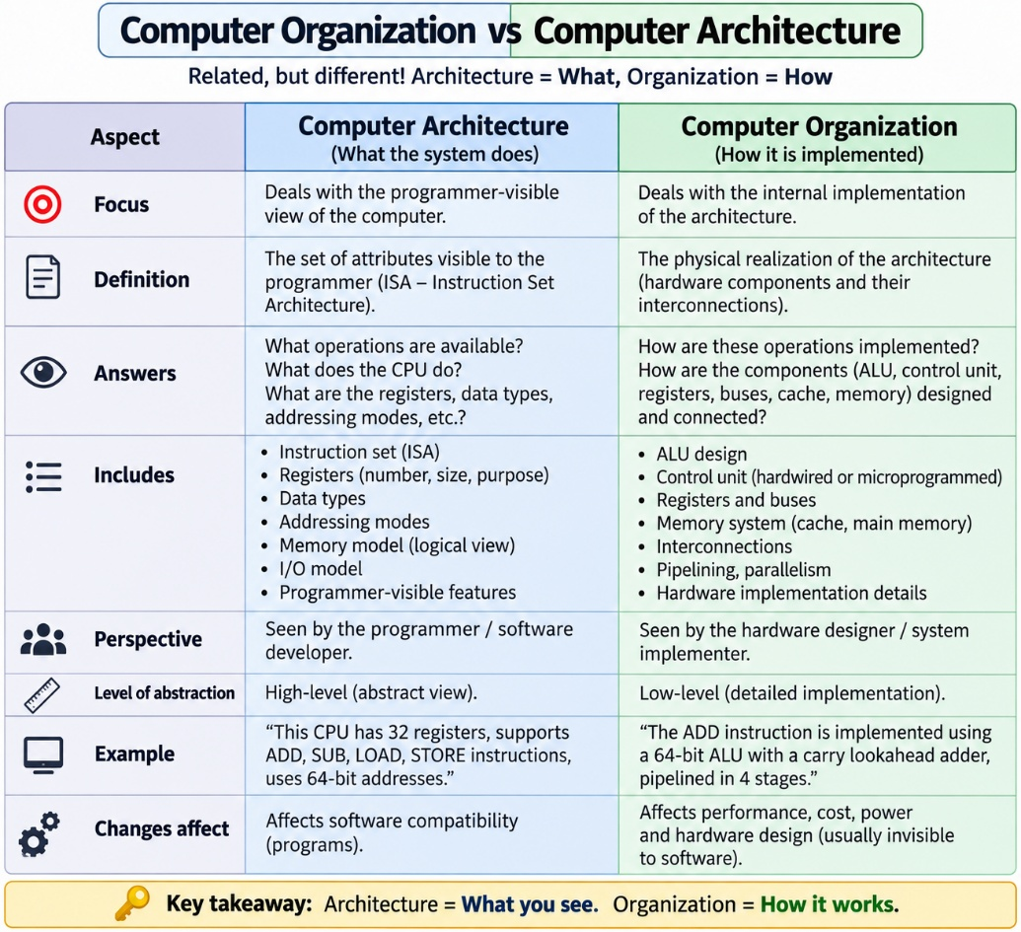

Q18. Block diagram of a digital computer.
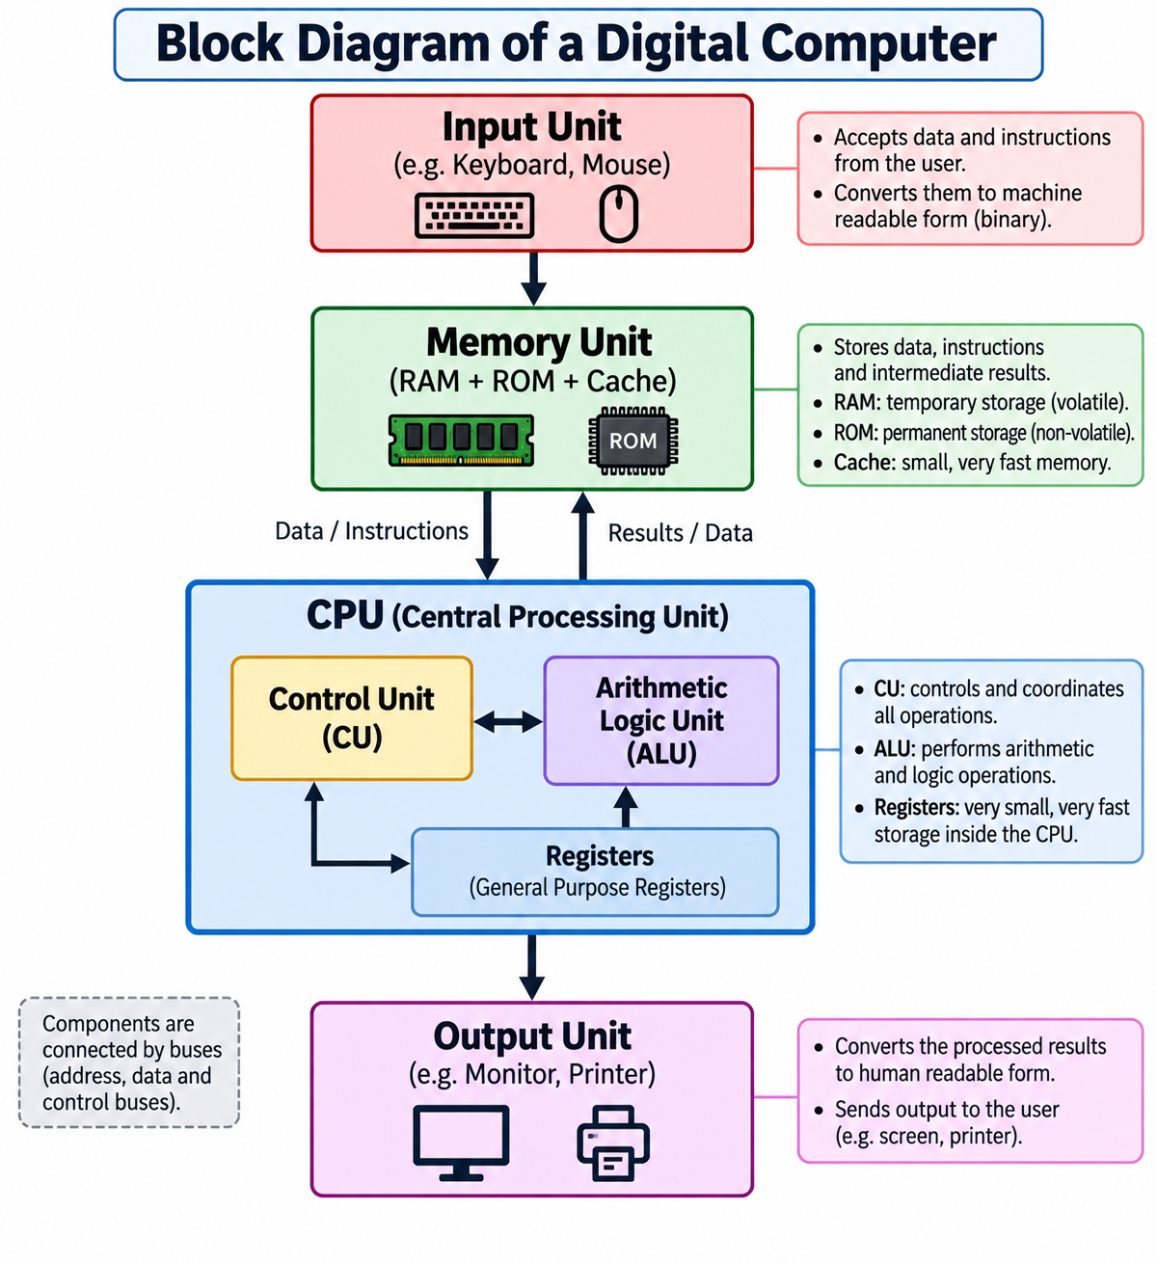
- Input Unit: accepts data and instructions from the outside world (e.g. keyboard, mouse) and converts them into a form the computer can process.
- Memory Unit: stores both the program instructions and the data being worked on, comprising RAM, ROM, and cache.
- Control Unit (CU): directs and coordinates the flow of instructions and data through the whole system.
- Arithmetic Logic Unit (ALU): performs all arithmetic (add, subtract) and logical (AND, OR, compare) operations.
- Registers: small, very fast storage locations inside the CPU used to hold data currently being processed.
- Output Unit: presents the processed results back to the user (e.g. monitor, printer).
- Buses: the set of electrical pathways (address, data, and control buses) that connect and allow communication between all of the above units.

Q19. 3, 2, 1, 0 address instruction formats.
- 3-address format — explicitly names three operand locations: two sources and one destination, e.g. ADD R3, R1, R2 (R3 = R1 + R2). It gives short, clear programs but each instruction needs more bits to encode three addresses.
- 2-address format — one of the operand fields serves as both a source and the destination, e.g. ADD R1, R2 (which means R1 = R1 + R2). This saves space compared to 3-address, but it destroys/overwrites one of the original input values.
- 1-address (Accumulator) format — uses a single, implicit accumulator register as one operand and as the destination; the instruction only needs to name the other operand explicitly, e.g. LOAD A (load value A into the accumulator) followed by ADD X (accumulator = accumulator + X).
- 0-address (Stack) format — uses the stack for both operands, so no address needs to be specified at all; operations simply pop their operands off the stack and push back the result, e.g. PUSH A, PUSH B, ADD leaves A + B on top of the stack. This is very compact but requires more instructions to move data on and off the stack.

Q20. RISC vs CISC.
RISC | CISC
Small number of simple instructions | Large number of complex instructions
Fixed instruction length, uniform format | Variable instruction length
Only LOAD/STORE instructions access memory | Many instructions can operate directly on memory
Large number of general-purpose registers | Comparatively fewer registers
Usually hardwired control unit | Usually microprogrammed control unit
Emphasis on fast, single-cycle execution and pipelining | Emphasis on doing more work per instruction, reducing instruction count
Examples: ARM, RISC-V, MIPS | Examples: Intel/AMD x86

Q21. Harvard vs Von Neumann Architecture
- Von Neumann: Uses ONE shared memory for both code (instructions) and data, connected to the CPU by a single bus. This is simple and cheap to build, but it creates a bottleneck — the CPU cannot fetch an instruction and read/write data at the same time, since both must travel over the same bus. This limitation is known as the "Von Neumann bottleneck."
- Harvard: Uses SEPARATE memories for code and data, each with its own dedicated bus. This allows the CPU to fetch the next instruction and access data simultaneously, giving faster parallel throughput. It is commonly used in microcontrollers (e.g., AVR, PIC) and inside modern CPU caches, which split into an instruction cache (I-cache) and a data cache (D-cache).
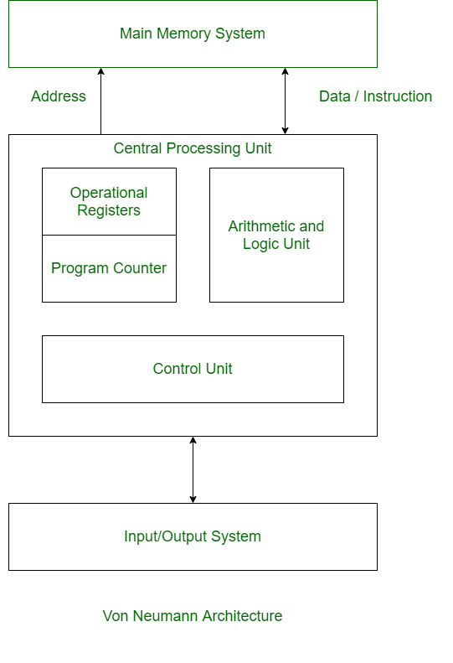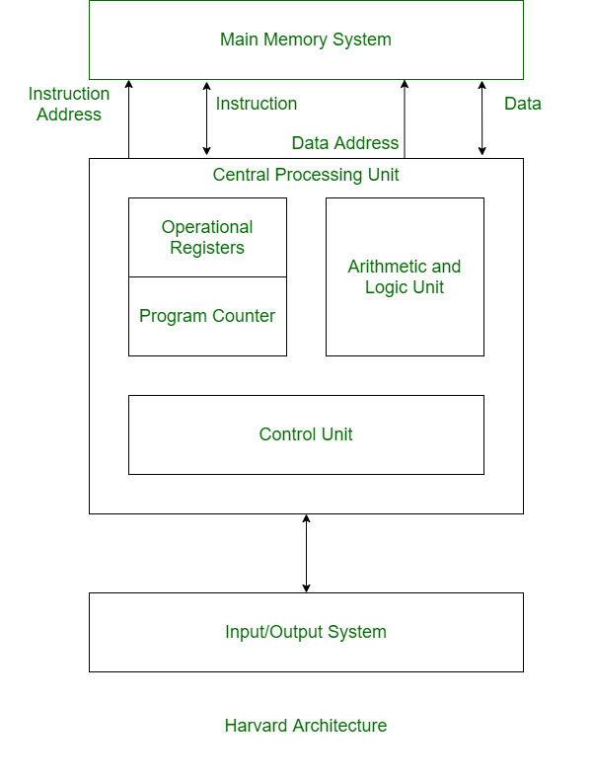
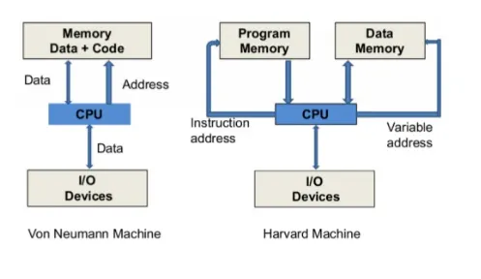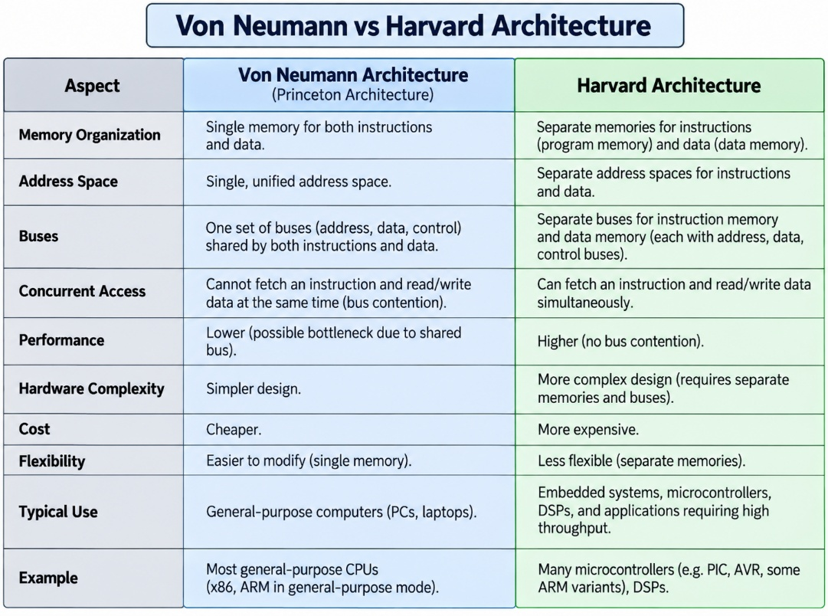
Modern PCs are a hybrid: from the outside (main RAM), they look like Von Neumann machines — one large unified memory holding both program and data. But internally, at the CPU cache level, they behave like Harvard machines because the L1 cache is split into separate instruction and data caches, letting the processor fetch instructions and data in parallel for speed, while still keeping a simple, uniform memory model for programmers.

