COA CT1 PART1
Part B - 26/08/2026

Q1. Fixed Point vs Floating Point
- Fixed point: The position of the decimal (binary) point is fixed at a pre-agreed location in the bit pattern. Arithmetic is fast and hardware is simple, but the representable range is small and precision is limited by the fixed number of fractional bits. Typical uses: digital signal processors (DSP), embedded control, and financial/money calculations where exact decimal behaviour matters. Example: 5.75 in a fixed 4-integer/4-fractional-bit format is 0101.11.
- Floating point: A number is represented as Mantissa × Base^Exponent (M × B^E), so the point can "float" to accommodate very large or very small magnitudes. This gives a huge dynamic range and is standardized by IEEE 754. It needs a floating-point unit (FPU) in hardware, and because only a finite number of mantissa bits are stored, rounding error is possible. Typical uses: scientific computing, graphics, engineering simulations. Example: 5.75 = 1.4375 × 2^2.
In short: fixed point trades range for speed and predictability, while floating point trades some precision/speed for a much larger usable range.

Q2. Overflow and Underflow
- Overflow: Happens when the result of an operation is too LARGE to fit in the number of bits available. Example: in 8-bit signed representation the maximum value is 127; computing 100 + 50 = 150 cannot be represented and wraps around to -106. It is detected in hardware by comparing the carry-in and carry-out of the most significant bit (MSB): if carry-in != carry-out, overflow has occurred, and this sets the overflow flag (V) in the status register. Fix: use a wider data width, or use saturating arithmetic that clamps to the maximum/minimum representable value instead of wrapping.
- Underflow has two distinct meanings depending on context:
- 1. Integer underflow: a borrow occurs because the true result is negative but is being stored in an unsigned type. Example: 0 − 1 in unsigned 8-bit arithmetic wraps around to 255.
- 2. Floating-point underflow: the true result is too SMALL in magnitude (very close to zero) to be represented as a normalized floating-point number, so it becomes zero or a denormal number. Example: 1e-40 / 1e10 in IEEE single precision underflows because the true mathematical result falls below the smallest representable normal value.

Q3. Ripple Carry Adder (RCA) vs Carry Lookahead Adder (CLA)
Ripple Carry Adder (RCA) | Carry Lookahead Adder (CLA)
Carry ripples from one full adder to the next, one bit at a time | Carry for every bit is computed in parallel using Generate (G) and Propagate (P) signals
Slow — delay grows linearly, O(n), with the number of bits | Fast — delay grows only logarithmically, O(log n), or is near-constant per block
Simple design, uses fewer gates | More complex design, uses many more gates
Suitable for small or low-speed circuits | Used in high-performance CPU ALUs where speed matters

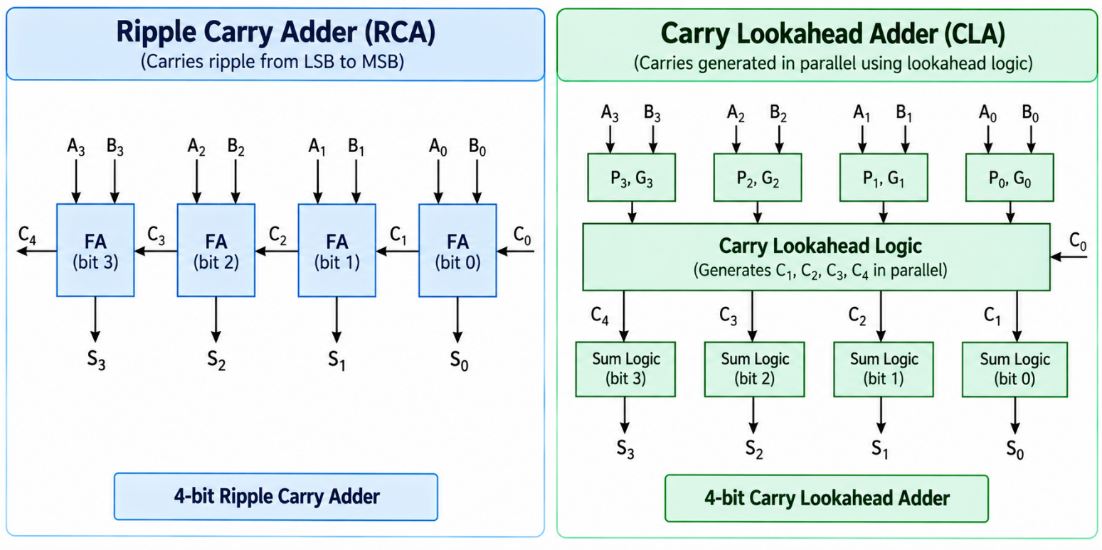
The core trade-off is speed versus hardware cost: RCA is cheap but its worst-case delay scales with word width because every stage must wait for the previous carry, while CLA pays extra gates up front so that the carries do not have to wait on each other.

Q4. Convert 10.625 to IEEE 754 Single and Double Precision
Step 1 — Convert to binary:
10 = 1010, 0.625 = 0.101 (0.5 + 0.125)
So 10.625 = 1010.101
Step 2 — Normalize to the form 1.xxxx x 2^e:
1010.101 = 1.010101 x 2^3
e = 3, mantissa bits = 010101...
Step 3a — Single precision (32-bit: 1 sign + 8 exponent + 23 mantissa, bias 127):
Sign = 0
Exp = 127+3 = 130 = 10000010
Mantissa = 010101 + 17 zeros (23 bits)
Bits: 0 | 10000010 | 01010100000000000000000
Hex = 0x412A0000
Step 3b — Double precision (64-bit: 1 sign + 11 exponent + 52 mantissa, bias 1023):
Sign = 0
Exp = 1023+3 = 1026 = 10000000010
Mantissa = 010101 + 46 zeros
Hex = 0x4025400000000000

Note the pattern: whatever the format, the procedure is always the same three steps — convert to plain binary, normalize so there is exactly one leading 1 before the point, then slot the sign, biased exponent, and mantissa bits into the fixed-width fields for that format.

Q5. Signed Magnitude vs 2's Complement
- Signed Magnitude: The most significant bit (MSB) is used purely as a sign flag (0 = positive, 1 = negative), and the remaining bits store the magnitude. Example (4-bit): +5 = 0101, −5 = 1101. This scheme has two representations of zero (+0 = 0000 and −0 = 1000), which wastes a bit pattern, and addition/subtraction need separate logic depending on the signs of the operands, making the hardware more complex.
- 2's Complement: A negative number is formed by inverting all bits of the positive number and adding 1. Example: −5 = 1011 (4-bit). This scheme has only one representation of zero, so no bit pattern is wasted, and — most importantly — the same adder circuit can be used for both addition and subtraction (subtraction is done by adding the 2's complement of the subtrahend). It also gives a slightly larger negative range: a 4-bit 2's complement number covers −8 to +7, compared to only −7 to +7 for signed magnitude. Because of these advantages, essentially all modern CPUs use 2's complement for signed integers.
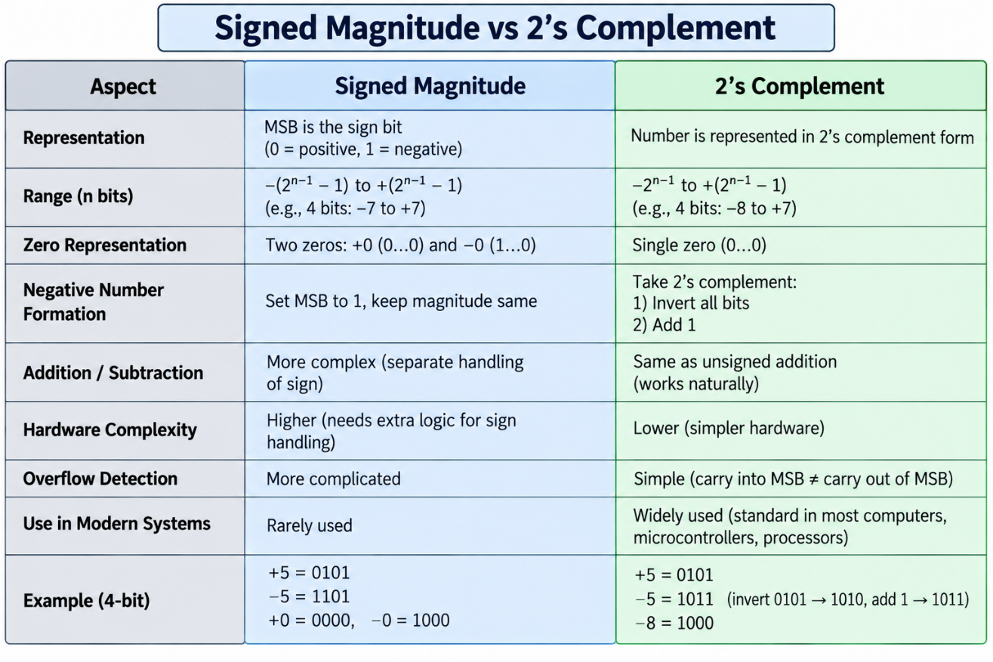

Q6. Any One Method of Binary Division — Restoring Division
Restoring division mimics long division in binary. Two registers A (accumulator, initially 0) and Q (holds the dividend/quotient) are shifted left together as a combined AQ pair, and M holds the divisor. At each step: (1) shift AQ left by one bit, (2) subtract M from A, (3) if the result in A is negative, restore A by adding M back and set the new quotient bit Q0 = 0; otherwise leave A as is and set Q0 = 1. This repeats once for every bit of the dividend.
Worked example: 7 ÷ 3 (0111 ÷ 0011), 4-bit:
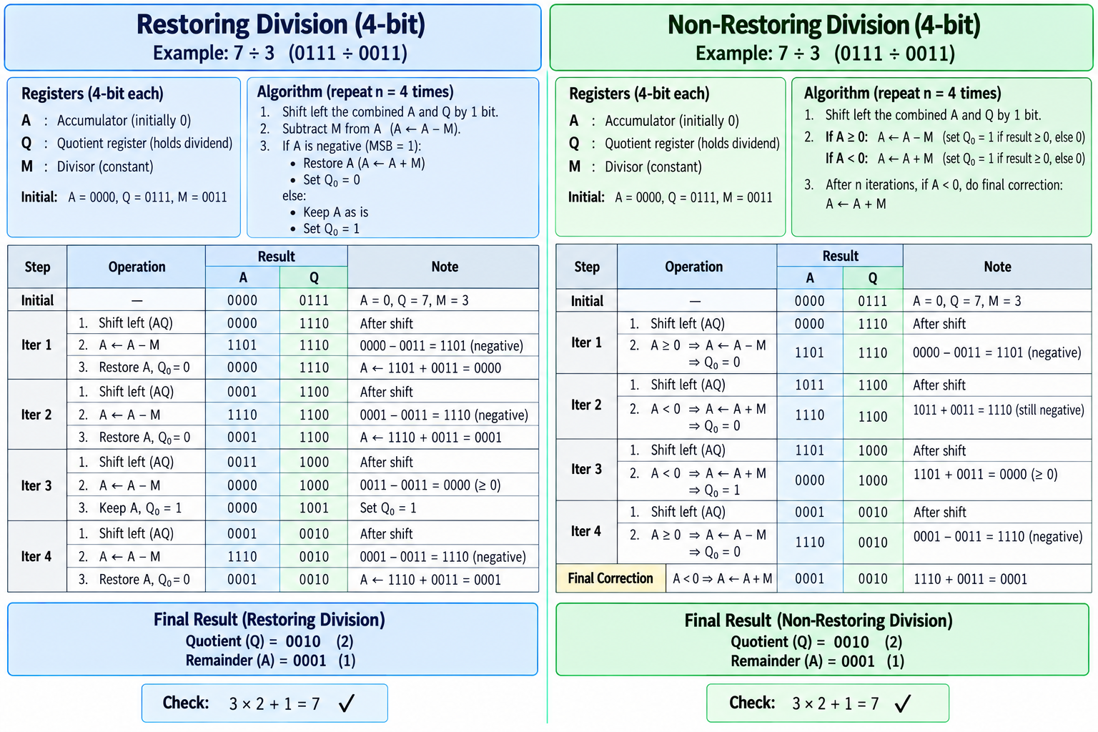
Non-restoring division is a faster variant: instead of restoring A immediately after a failed (negative) subtraction, it leaves A negative and simply adds M (instead of subtracting) in the next cycle, only applying one final correction at the end if needed. This removes the wasted "restore" step from every cycle where the trial subtraction failed.

Q7. NaN and +Infinity in IEEE 754
Single precision format = 1 sign bit + 8 exponent bits + 23 mantissa bits. When the exponent field is all 1s (255 in decimal for single precision), the value is treated as a special case rather than a normal number, decided by whether the mantissa is zero or not:

Exponent | Mantissa | Meaning
255 (all 1s) | 0 | Infinity. +INF = 0x7F800000, -INF = 0xFF800000. Produced by operations such as 1/0, or by overflow of a very large result.
255 (all 1s) | non-zero | NaN (Not a Number). Produced by undefined operations such as 0/0 or sqrt(-1). Comes in two flavours: Quiet NaN (propagates silently) and Signaling NaN (raises an exception).
0 | 0 | Zero, which can be signed (+0 or -0).
0 | non-zero | Denormal (subnormal) number — used to represent values smaller than the smallest normal number, at reduced precision.
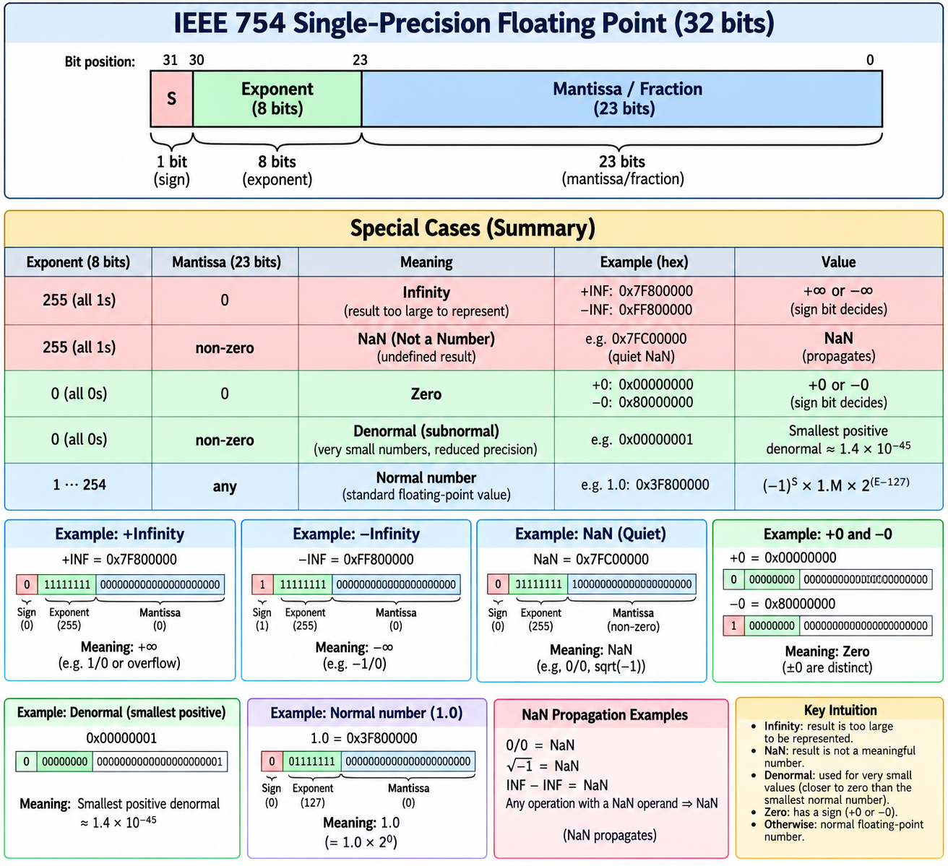
Intuition: Infinity means the true result is too big to be represented in this format, while NaN means the result is not a meaningful number at all. Any arithmetic operation that involves a NaN operand produces NaN as the result (NaN propagates), and even INF − INF is defined as NaN because that particular combination has no well-defined mathematical value.

Q8. 16-bit Custom Float (1 sign + 6 exponent + 9 mantissa) — Represent −1.6 x 10^63
Bias = 2^(6-1) - 1 = 31
Max usable biased exponent = 62 (63 is reserved for INF/NaN)
True max exponent = 62 - 31 = 31
Max representable magnitude ~ 2^32 ~ 4.29 x 10^9

Wanted value: 1.6 x 10^63 ~ 2^209 (since 10^63 ~ 2^209)
Needed exponent 209 is far greater than the max of 31
=> OVERFLOW, the value cannot be represented

Representation = -Infinity:
S = 1, E = 111111, M = 000000000
Bits: 1 111111 000000000 = 0xFC00
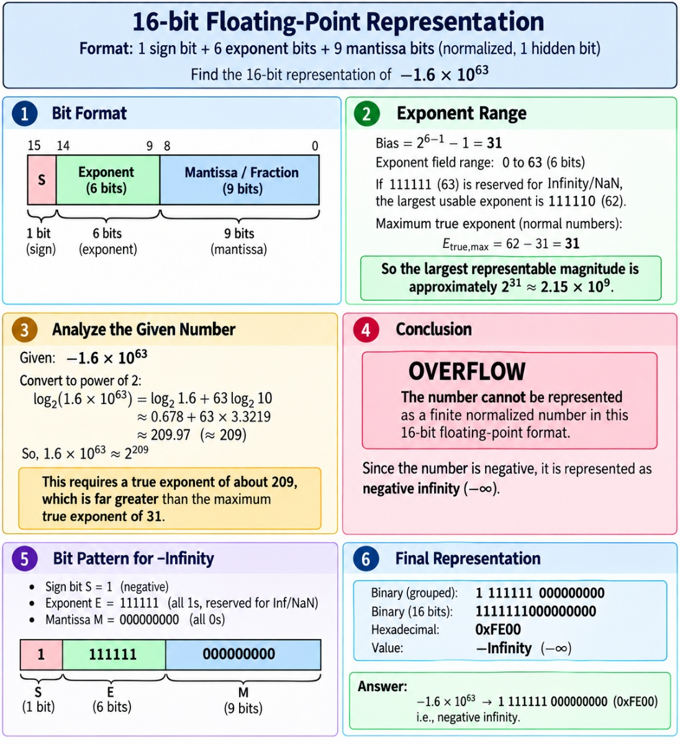

This question is really testing whether the range of a format has been checked before trying to encode a number into it. With only 6 exponent bits, this custom format simply cannot hold anything near 10^63 in magnitude, so the correct, fully-justified answer is that it overflows to −Infinity, and full marks require showing the bias calculation and the range comparison, not just the final bit pattern.
If the intended question was instead a small value such as −1.610^-63 (i.e. extremely close to zero, which would underflow) or a typo for a normal value like −1.6 ≈ −1.10011 x 2^0, the same procedure applies with S = 1, E = 31 = 011111, M = 100110... — always compute the bias, check the exponent fits the available range, and only then fill in the mantissa bits.

Q9. Best and Worst Case of Booth's Algorithm
Booth's algorithm examines each pair of bits (Q0, the current multiplier bit, and Q-1, the bit shifted out just before it) and uses that pair to decide whether to add, subtract, or just shift. Because a run of consecutive identical bits (all 0s or all 1s) needs no arithmetic operation at all — only shifting — Booth's algorithm can skip work compared to plain shift-and-add multiplication.
- Best case: The multiplier has long runs of 0s or 1s, so there are very few transitions between 0 and 1. Example: 01111000 needs only 2 add/subtract operations instead of the 4 that a naive shift-and-add approach would require, because the middle run of four 1s is handled with a single subtract at the start of the run and a single add at the end.
- Worst case: The multiplier alternates bit by bit, e.g. 01010101..., which means every single bit position causes a transition and therefore triggers an add or a subtract. In this case Booth's algorithm performs the same number of arithmetic operations as plain shift-and-add — or can even be marginally slower once its extra control overhead (checking Q-1, arithmetic shifting) is counted.
In modern hardware, Radix-4 (Booth-2) or Radix-8 (Booth-3) recoding examines 3 or 4 bits at a time instead of 2, which bounds the worst case and makes multiplication time much more predictable regardless of the bit pattern. For an exam answer, it is enough to draw one example bit string for the best case and one for the worst case, as shown above.

Q10. Finding the Value Represented in IEEE Single Precision Format
General method for decoding any 32-bit IEEE 754 single-precision pattern:
- 1. Split the 32 bits into three fields: Sign S (1 bit), biased Exponent E (8 bits), Mantissa M (23 bits).
- 2. Recover the true exponent: Exp_true = E_biased − 127.
- 3. Compute the value: Value = (−1)^S x 1.M x 2^Exp_true, where 1.M means placing an implicit leading 1 before the stored mantissa bits.
Worked example — decode 0x412A0000:
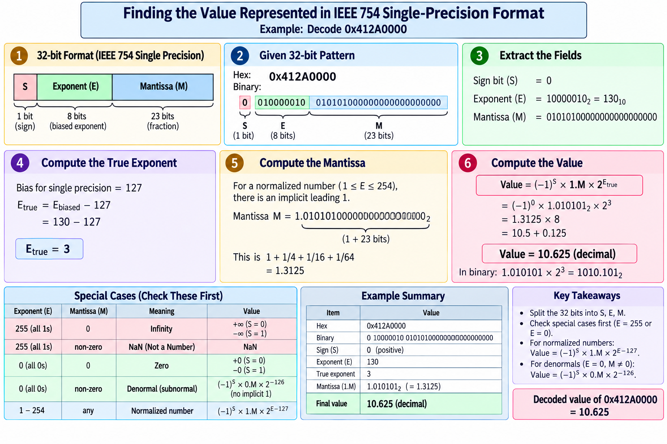
Two special cases must always be checked first, before applying the general formula above: if E = 255 and M = 0, the value is ±Infinity; if E = 255 and M ≠ 0, the value is NaN; and if E = 0, the value is either zero (if M = 0) or a denormal number (if M ≠ 0), computed without the implicit leading 1.

Q11. 4-bit Ripple Carry Adder
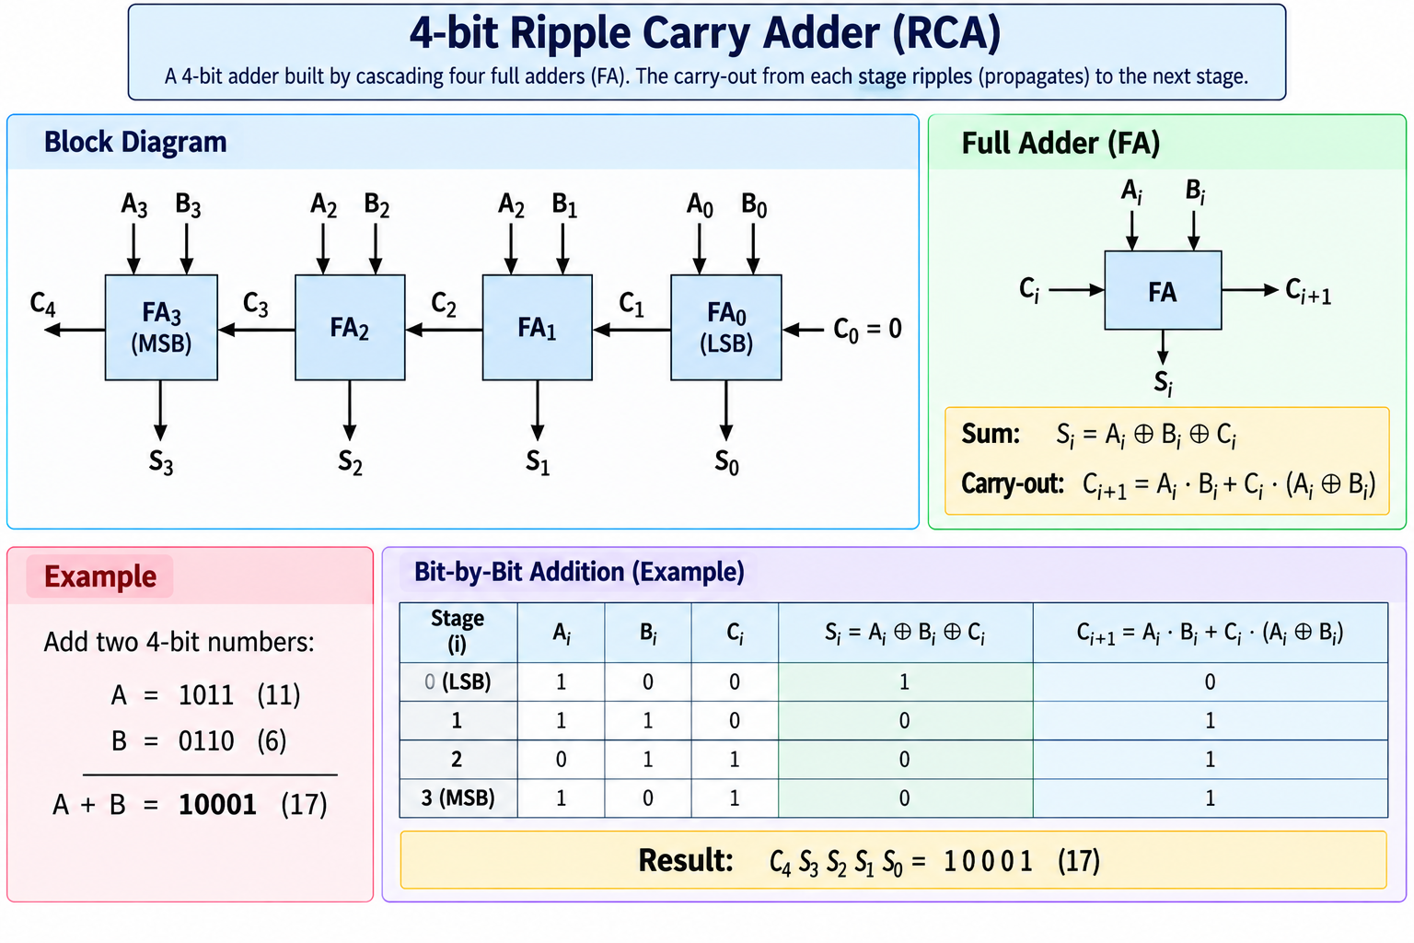
The carry has to physically ripple through the chain from FA0 up to FA3 before the final sum and carry-out (C4) are valid, so the total propagation delay is roughly 4 times the delay of a single full adder (about 2n gate levels for an n-bit adder). This design is simple to build and understand but becomes too slow for wide, high-speed additions, which is why CLA designs are preferred inside CPU ALUs (see Q24, Q37, Q38).

Q12. Flowchart for Booth Multiplication
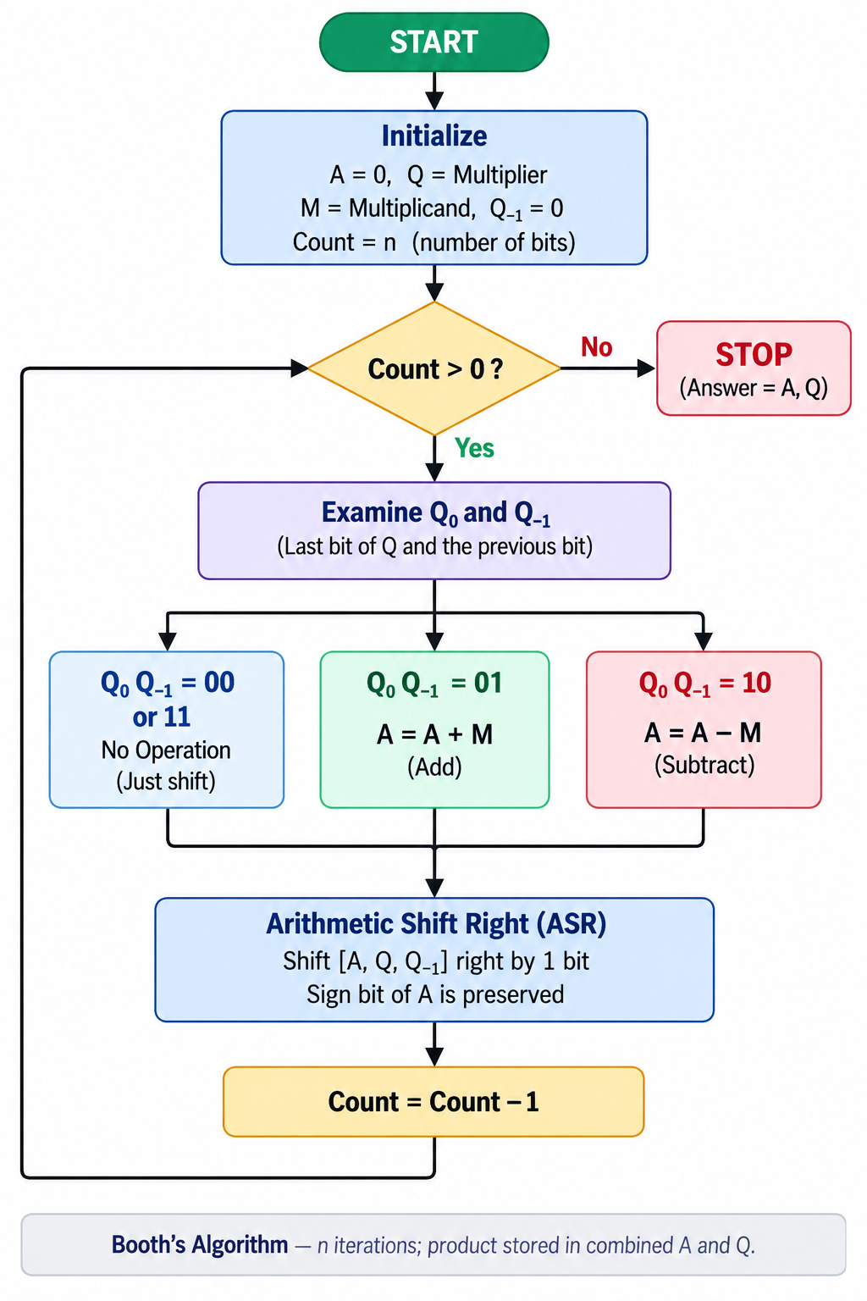
ASR stands for Arithmetic Shift Right, which shifts the combined A, Q, Q-1 register set one position to the right while preserving the sign bit of A (so negative partial products stay correctly signed). The loop runs exactly n times for two n-bit operands, after which the final product is held across the combined A and Q registers.

Q13. Solve 14 / 3 Using Restoring and Non-Restoring Division
14 = 1110, 3 = 0011, using 4-bit registers. Expected result: Quotient Q = 0100 (4), Remainder R = 0010 (2). Check: 3 x 4 + 2 = 14, which confirms the result.
Restoring division (A = 0000, Q = 1110, M = 0011):
Repeat the following 4 times (once per bit): shift the combined AQ register left by one bit, then compute A = A − M. If the result in A is negative, restore it by computing A = A + M and set the new quotient bit Q0 = 0; otherwise keep A as is and set Q0 = 1. After all 4 cycles, the result is Q = 0100 and A = 0010.
Non-restoring division (same starting values):
The only difference from the restoring method is that when A is negative, it is NOT restored immediately. Instead, the rule for the next cycle changes: if A ≥ 0, shift and then SUBTRACT M; if A < 0, shift and then ADD M. This avoids the wasted restore step. At the very end, if A is still negative, one final correction A = A + M is applied to obtain the true remainder. The final quotient and remainder come out the same as with restoring division, but with fewer arithmetic operations overall.
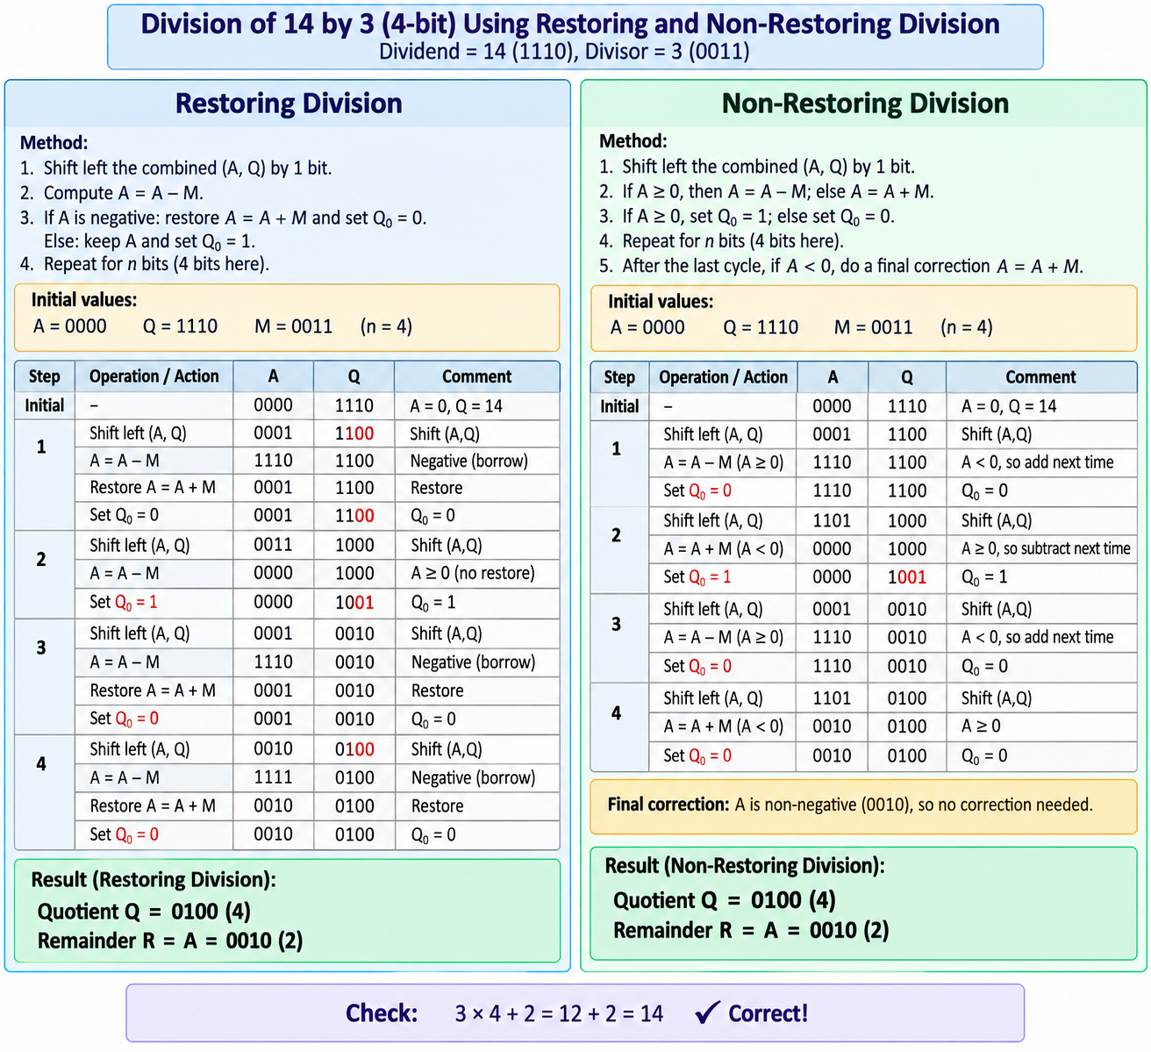

Q14. Booth's Algorithm: M = 0110 (6), Q = 0011 (3)
M = 0110, so −M (2's complement of M) = 1010, and n = 4 bits.
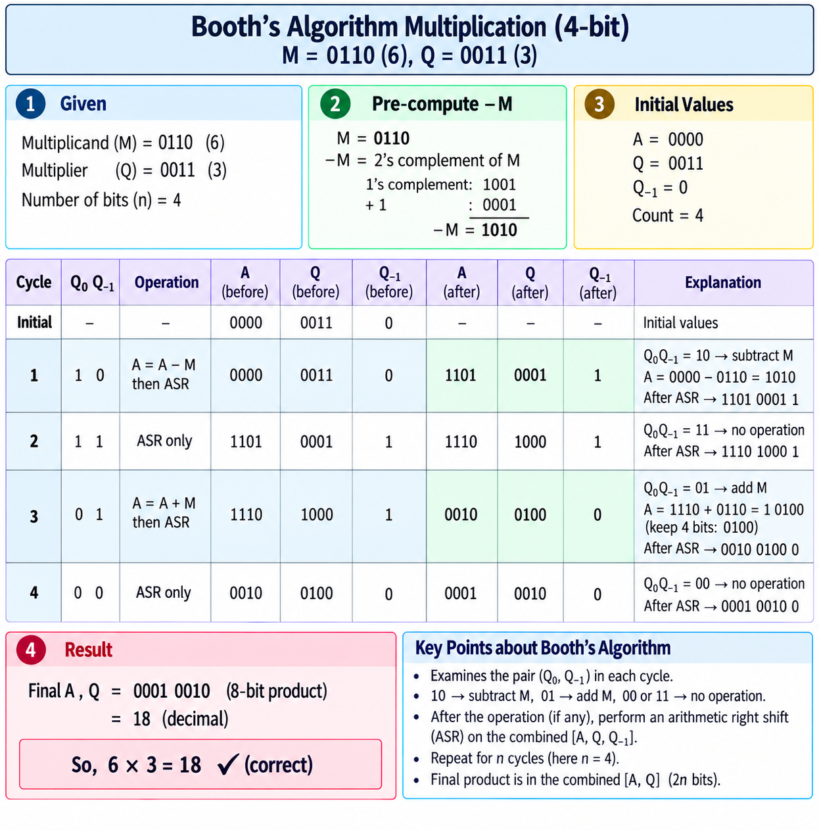

Q15. How Non-Restoring Division is Derived from Restoring Division
In restoring division, whenever a trial subtraction fails (the result is negative), one full cycle is effectively wasted: the algorithm adds M back to restore A, and then, on the very next cycle, it shifts and subtracts M again. Writing these two consecutive operations out algebraically reveals a shortcut:
Restoring (two steps): A = A + M (restore)
next cycle: A = 2A - M (shift then subtract)

Combine the two steps:
A = 2(A + M) - M = 2A + M

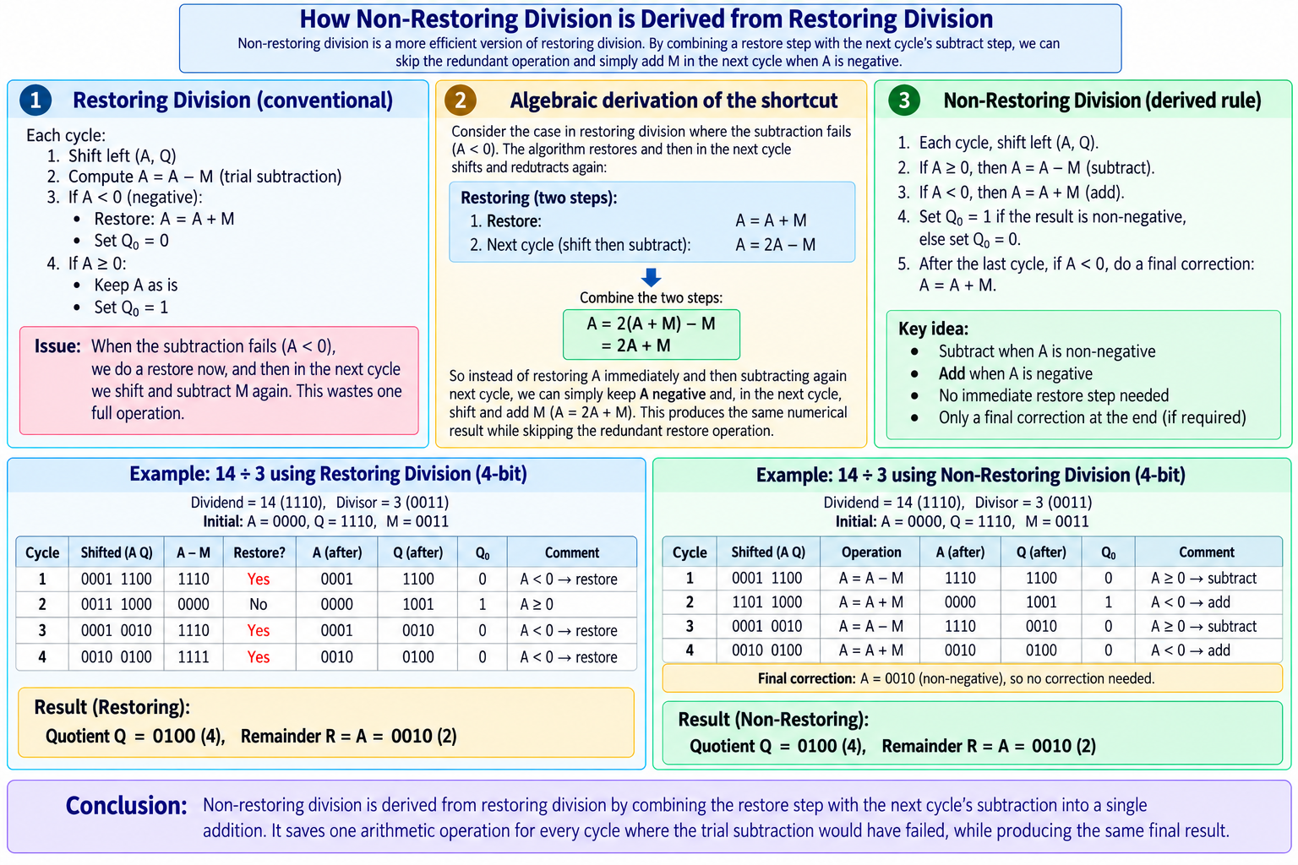
This shows that instead of restoring A immediately and then subtracting again next cycle, the algorithm can simply keep A negative and, on the very next cycle, shift and then ADD M (giving A = 2A + M) — which produces the identical numerical result while skipping the redundant restore operation. This is exactly the non-restoring rule: subtract when A is non-negative, add when A is negative, one operation saved for every cycle where the trial subtraction would otherwise have failed. The only extra requirement is a final correction step (adding M back) if A ends up negative after the last cycle, needed because no restore happened along the way. This makes the hardware only marginally more complex (one extra control multiplexer) while noticeably improving speed.

Q16. Propagation Delay and Its Reduction Using CLA
Propagation delay is the time taken for a change at a gate's input to produce a stable, correct change at its output. Every logic gate on a signal's path adds its own small delay (typically measured in nanoseconds), and the total delay of a circuit is determined by its longest, or "critical", path — the chain of gates that a signal must pass through from input to final output.
- In a Ripple Carry Adder, the carry signal must physically propagate through all n full adders, one after another, before the most significant sum bit and final carry-out are valid. This gives a total delay of roughly n x t_FA (about 2n gate levels for an n-bit adder). For a realistic 32-bit RCA, this works out to around 64 gate levels of delay — far too slow to meet a modern CPU's clock speed requirements.
- A Carry Lookahead Adder (CLA) instead computes all of the carries in parallel using Generate (G) and Propagate (P) signals, expressed as a 2-level AND-OR logic network, so the delay for a 4-bit CLA block is only about 2–3 gate levels and does not grow with n for that block size. For wider words (16, 32, 64 bits), designers chain or nest multiple CLA blocks hierarchically ("group" or "block" carry lookahead) to keep the overall delay low while controlling the gate-count explosion that a single flat CLA would otherwise require.

Q17. Why is CLA Called a Fast Parallel Adder?
A Carry Lookahead Adder is called a "fast parallel adder" because each carry bit is computed directly from the original input bits (A, B, and the initial carry-in C0) using Generate/Propagate equations, rather than waiting for the carry-out of the previous stage as a Ripple Carry Adder does. Because all the carries (C1, C2, C3, C4, ...) can therefore be produced at essentially the same time — in parallel — the overall addition delay becomes close to constant, O(1) for a given block size, instead of growing linearly with the number of bits, O(n), as it does for RCA. This means a 4-bit, 16-bit, or 32-bit CLA addition all complete in almost the same short amount of time. The trade-off for this speed is hardware cost: CLA requires substantially more logic gates than the simple, repeated full-adder structure of an RCA.

Q18. Carry Generation Equations for a 4-bit CLA
For each bit position i, two helper signals are defined from the two input bits:
- Generate: Gi = Ai . Bi — this bit position generates a carry on its own, regardless of any incoming carry.
- Propagate: Pi = Ai xor Bi — this bit position passes an incoming carry straight through to the next stage.
Given an initial carry-in C0, the carries for all four bit positions of a 4-bit CLA can then be written directly in terms of the original inputs (not in terms of each other), which is exactly why they can all be computed in parallel:
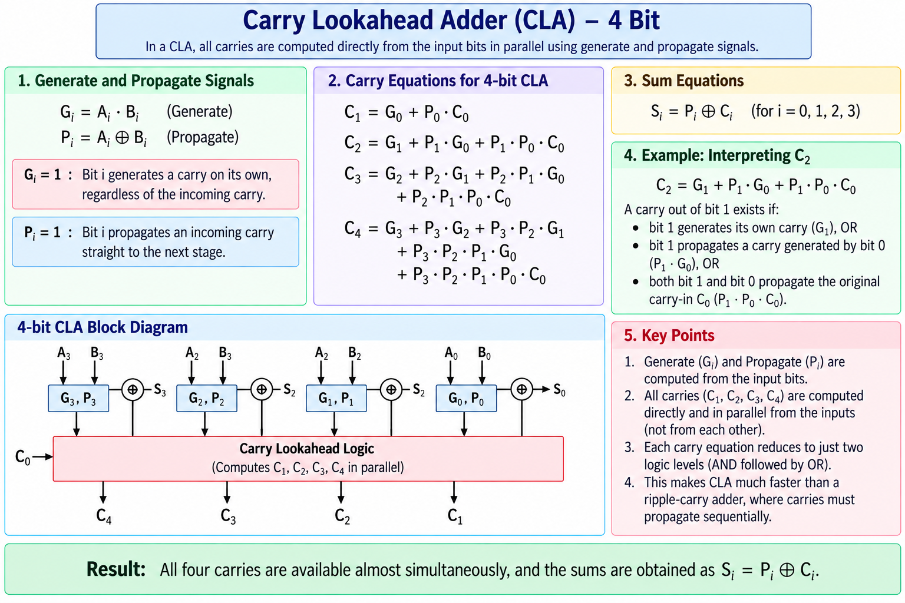
Every one of these carry equations reduces to just two logic levels (a layer of ANDs followed by a layer of ORs), so all four carries become available almost simultaneously. Reading C2 as an example: "a carry out of bit 1 exists if bit 1 generates its own carry, OR bit 1 propagates a carry generated by bit 0, OR both bit 1 and bit 0 propagate the original carry-in C0."

Q19. Deriving Gi and Pi from the Full Adder, and Their Use in Parallel Addition
The standard full-adder carry-out equation is: Ci+1 = Ai.Bi + Ci.(Ai + Bi). To simplify and generalize this, two new signals are defined: Gi = Ai . Bi (Generate) and Pi = Ai xor Bi (Propagate). Substituting these into the full-adder equation gives the compact recurrence:
Ci+1 = Gi + Pi . Ci
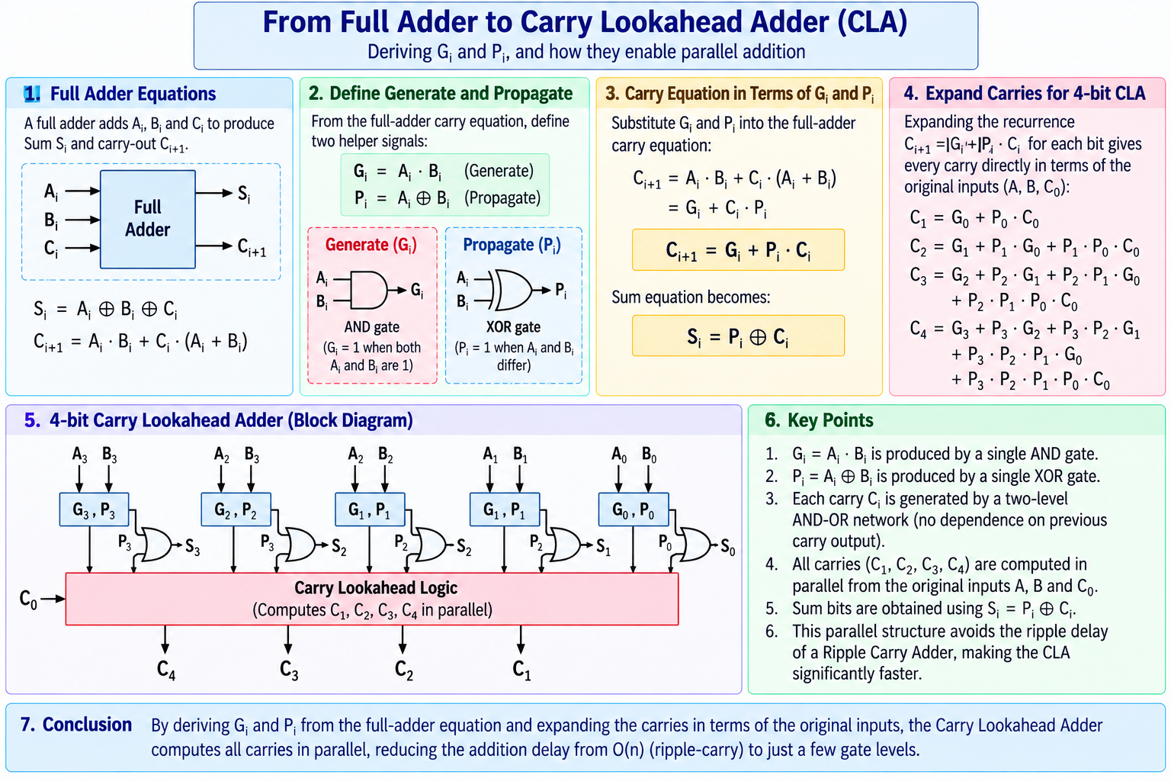
Expanding this recurrence out for each bit position (exactly as shown in Q39) removes the dependency on the previous stage's carry output and expresses every carry purely in terms of the original A, B inputs and C0. In hardware, Gi and Pi for each bit position can each be produced with a single gate (an AND gate and an XOR gate respectively), and every carry Ci is then generated by a 2-level AND-OR network, with a final XOR producing the sum bit Si = Pi xor Ci. This structure is inherently parallel because each Ci depends only on the original inputs A, B, and C0 — never on the output of a neighbouring full adder — which is precisely what allows a Carry Lookahead Adder to avoid the ripple delay of a Ripple Carry Adder.

Q20. Advantages and Disadvantages of Booth's Algorithm
Advantages:
- Requires fewer add/subtract operations whenever the multiplier contains long runs of consecutive 0s or 1s, since such runs can be skipped with pure shifting (see Q30).
- Handles signed numbers (in 2's complement) directly and correctly, without needing any separate sign-handling logic, unlike simple unsigned shift-and-add multiplication.
- Produces a regular, repetitive hardware structure (shift, compare Q0/Q-1, add or subtract), which is well suited to efficient VLSI implementation.
Disadvantages:
- Its worst case — an alternating bit pattern such as 0101... — causes an add or subtract at every single step, making it no faster (and sometimes marginally slower, due to extra control overhead) than plain shift-and-add multiplication.
- It needs extra hardware beyond a simple shift-add multiplier: an additional Q-1 flip-flop, control logic to examine bit pairs, and an arithmetic (sign-preserving) shifter.
- Its execution time is data-dependent and variable — the number of add/subtract operations needed depends on the actual bit pattern of the multiplier — which is undesirable in hardware pipelines that expect fixed, predictable timing. This variability is why modified forms such as Radix-4 (Booth-2) or Radix-8 (Booth-3) Booth recoding are used in practice, since they bound the worst case and give much more consistent multiplication time.

Exam Tips
- 1. For questions worth 5 marks, always draw a supporting figure/diagram plus 4–5 lines of explanation.
- 2. For numerical problems, always show a step-by-step working table, and clearly state the final quotient/remainder or the final hex value at the end.
- 3. Use the same section headings as the question paper for readability and easy cross-referencing by the examiner.

