SETUP DOCUMENT
Project Title:
Community-Aware Bridge-Centric Structural Disruption of Criminal Networks via Composite Centrality and Signed Network Analysis
GitHub Repository:
https://github.com/SayantanS01/CABCSDCNVCCSNA

1. System Requirements
Before running the project, ensure the following software is installed on your system.
Hardware Requirements
- Intel Core i5 Processor or above
- Minimum 8 GB RAM (16 GB recommended for large datasets)
- Minimum 5 GB free disk space
Software Requirements
- Windows 10 / 11, Linux, or macOS
- Python 3.8 or above
- Git
- Visual Studio Code (recommended, optional)
- PowerShell / Command Prompt / Terminal
Note:
This project is a Python-only research pipeline. No Node.js, npm, browser frontend, or backend server is required to run it.

2. Project Structure
The repository is organized as follows:
CABCSDCNVCCSNA/
|-- data/
| |-- raw/ # Raw dataset (e.g., soc-sign-epinions.txt)
| |-- processed/ # Cleaned and processed graph data
| |-- results/ # Output metrics, tables (CSV), and plots (PNG)
|-- src/
| |-- preprocessing/ # Dataset parsing and cleaning
| |-- graph/ # NetworkX graph construction
| |-- community/ # Signed Louvain community detection, bridge score
| |-- influence/ # Degree, Betweenness, SIP, Attack Score
| |-- attack/ # Targeted and random attack simulations
| |-- evaluation/ # LCC tracking and plot generation
| |-- main.py # Main execution pipeline
|-- requirements.txt # Python dependencies
|-- README.md # Project documentation
Fig 2.1 - Repository folder structure

3. Project Setup
Step 1: Clone the Repository
Open a terminal / command prompt and run:
git clone https://github.com/SayantanS01/CABCSDCNVCCSNA.git
cd CABCSDCNVCCSNA
Alternatively, download the repository as a ZIP file from GitHub and extract it into a folder.
Open the project folder in Visual Studio Code (optional, recommended for editing).
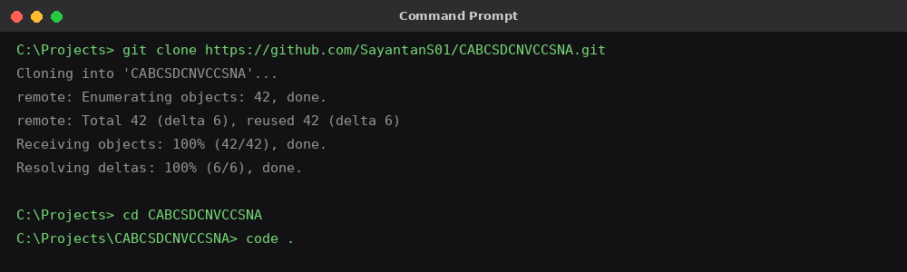
Fig 3.1 - Cloning the repository using Git

4. Create a Python Virtual Environment
It is recommended to use a virtual environment to keep dependencies isolated.
python -m venv venv

# Activate the environment
# Windows:
venv\Scripts\activate

# Linux / macOS:
source venv/bin/activate

5. Install Python Dependencies
Once the virtual environment is activated, install all required packages using the requirements file:
pip install -r requirements.txt
This installs the core dependencies used by the project:
- pandas
- networkx
- matplotlib
- python-louvain
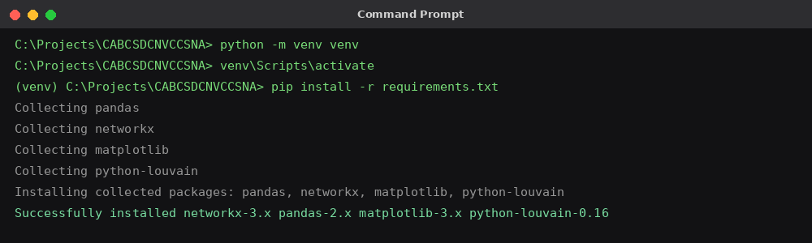
Fig 5.1 - Installing dependencies from requirements.txt

6. Dataset Setup
Place the raw dataset file (for example, soc-sign-epinions.txt) inside the data/raw/ directory before running the pipeline:
CABCSDCNVCCSNA/data/raw/soc-sign-epinions.txt
Note:
If the dataset is already included in the cloned repository, this step can be skipped.

7. Running the Project
Return to the project root directory and run the main pipeline script:
python src/main.py
The pipeline automatically performs the following steps in order:
- Dataset loading and preprocessing
- Signed directed graph construction using NetworkX
- Signed Louvain community detection
- Computation of Degree, Betweenness, Bridge Score, and Signed Influence Polarity (SIP)
- Computation of the Proposed Attack Score for every node
- Simulation of Proposed, Degree, Betweenness, and Random attack strategies
- Evaluation of LCC drop at each node-removal step
- Generation of result tables and comparison plots
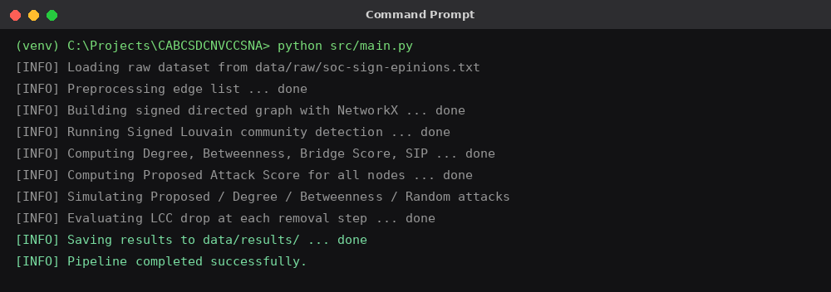
Fig 7.1 - Console output while running src/main.py

8. Generated Outputs
After successful execution, the following outputs are generated automatically inside the data/results/ directory:
- attack_ranking.csv - full list of nodes ranked by the proposed attack score
- proposed_attack_metrics.csv, degree_attack_metrics.csv, betweenness_attack_metrics.csv, random_attack_metrics.csv - structural metrics recorded at each removal step
- comparison_table.csv / average_performance_table.csv - aggregated performance metrics
- lcc_drop_comparison.png - line chart comparing LCC disruption across strategies
- full_attack_comparison.png - complete visual comparison of all attack strategies
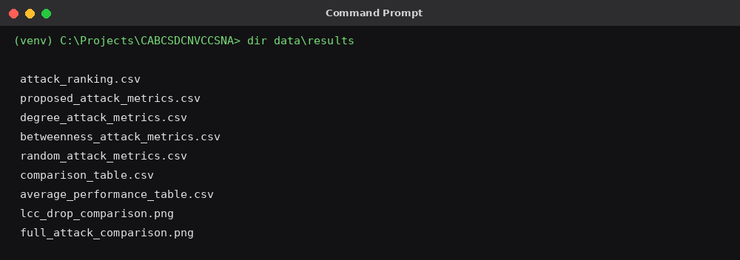
Fig 8.1 - Generated result files inside data/results/

Below is a sample of the kind of comparison plot generated by the evaluation module. Values shown are illustrative; your own dataset will produce the actual figures inside data/results/.
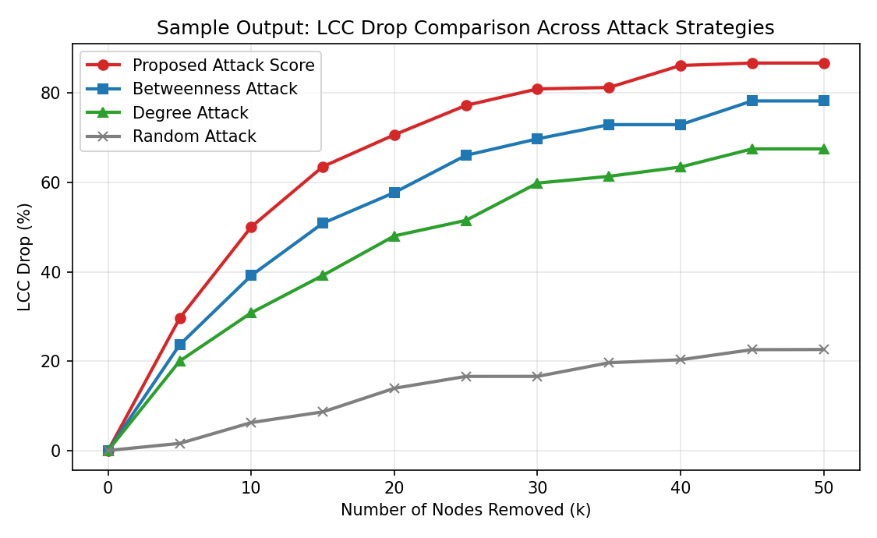
Fig 8.2 - Sample output: LCC Drop (%) vs. number of nodes removed, across attack strategies

9. Project Workflow
- Load and clean the raw signed-network dataset
- Construct the signed directed graph
- Detect communities using Signed Louvain and compute bridge scores
- Compute Degree, Betweenness, and Signed Influence Polarity for every node
- Combine all metrics into the Proposed Attack Score
- Simulate targeted and random node-removal attacks
- Track LCC size after each removal step
- Generate comparison tables and plots for evaluation

10. Project Modules Overview
- preprocessing/ - cleans the raw dataset and builds a structured edge list
- graph/ - constructs the signed directed graph using NetworkX
- community/ - Signed Louvain community detection and bridge score computation
- influence/ - computes Degree, Betweenness, SIP, and the Proposed Attack Score
- attack/ - simulates targeted (proposed / degree / betweenness) and random node removal
- evaluation/ - tracks LCC drop and generates comparison visualizations

11. Troubleshooting
If the project fails to run, check the following:
- Verify Python 3.8 or above is installed (python --version)
- Ensure the virtual environment is activated before installing packages
- Re-install dependencies: pip install -r requirements.txt
- Confirm the raw dataset file exists inside data/raw/
- Run the script from the project root directory so relative paths resolve correctly
- Delete and recreate the virtual environment if package conflicts occur

12. Project Execution Summary
git clone https://github.com/SayantanS01/CABCSDCNVCCSNA.git
cd CABCSDCNVCCSNA
python -m venv venv
venv\Scripts\activate (Windows)
pip install -r requirements.txt
python src/main.py
Once completed, all results (ranking tables, metric CSVs, and comparison plots) are available inside the data/results/ directory. The project is now ready for demonstration, evaluation, and further experimentation.
END OF DOCUMENT

