**HartCode Academy Pre-Work: Optional Project**

This is an optional (but **highly recommended**) project to practice hands-on coding after completion of the Pre-Work Pluralsight courses.

Please send your completed work (in a .zip file or link to a GitHub Repo) to [Rob Frenette](mailto:robert.frenette@thehartford.com) ([robert.frenette@thehartford.com](mailto:robert.frenette@thehartford.com)) by **EOD Fri, 6/21** for review / feedback.

You only need to create one page, and there is no JavaScript required.

Note: All images have been provided for your use (in the attached .zip file). The text for some page sections has been provided in the Appendix of this document.

**Screen-shot of the Web Page to produce:**

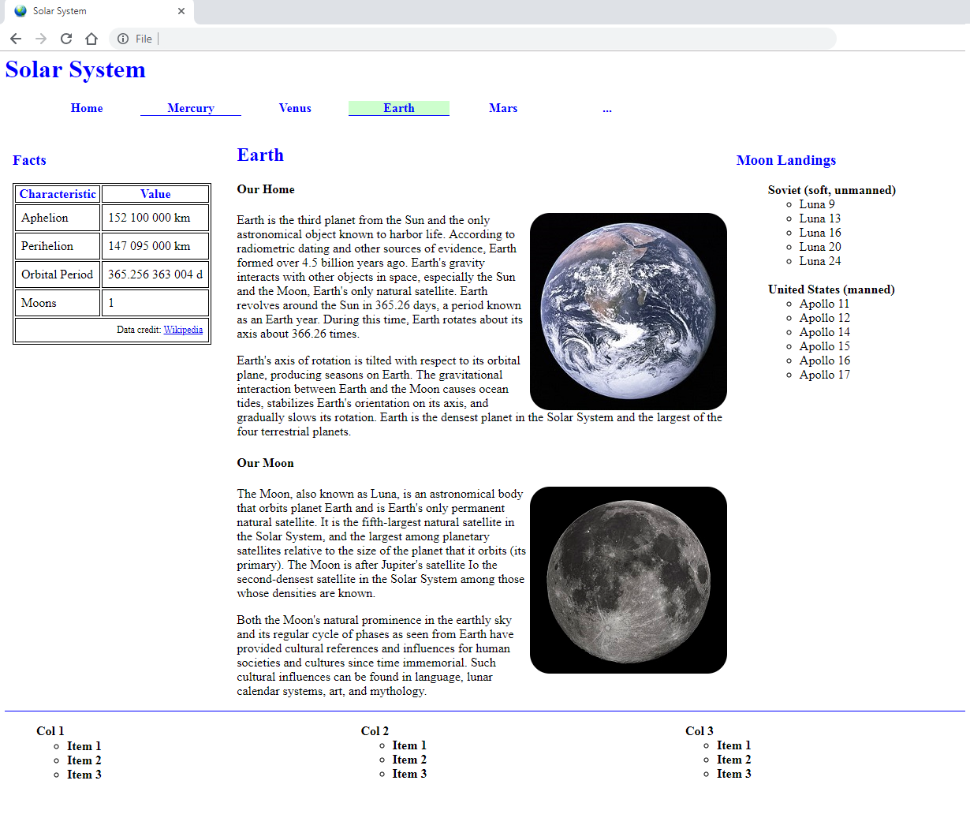

**Requirements:**

* You should use Semantic HTML5 tags for appropriate page sections: header, nav, aside, article, section, footer, …
* Your CSS should be in an external stylesheet and included in your HTML.
* You should show the image of the Earth (image name: favicon.ico) and the site name (Solar System) in the Browser tab, as displayed in the following screen-shot (outlined in red).

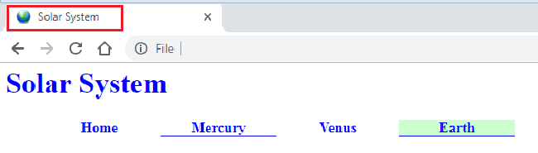

* Your menu (“Home”… “Earth”) should be comprised of an Unordered List (UL) of List Items (LI), and displayed as in the screen-shot above. The menu item text should be displayed in **blue**. The current page (ex: Earth) should have a different color background than the other menu items, and it should be underlined. The text of all menu items should underline when the mouse is moved over it (ex: Mercury), and the underline should be removed when the mouse exists the text (ex: Venus) – controlled through CSS.
* You should use appropriate HTML Heading tags (H1 – H6) for “Solar System”, “Facts”, “Earth”, “Moon Landings”, “Our Home” and “Our Moon” text. The “Solar System”, “Facts”, “Earth” and “Moon Landings” text should be displayed in **blue**.
* Both the “Facts” and “Moon Landings” sections of the page should take up 25% of the available page width. The “Earth” section, which contains the “Our home”, “Our Moon” and images (earth.jpg and moon.jpg) should take up 50% of the page width. Note that the images should be displayed with rounded corners – controlled by CSS.
* The “Facts” table should be constructed using proper HTML tags for the table, table header, table footer and table body.

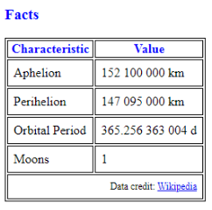

* The “Moon Landings” list should be comprised of nested Unordered Lists, with the bullet (dot) removed on the “Soviet” and “United States” labels.

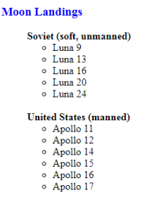

* The footer of the page should be separated from the main content using a horizontal rule (shown in **blue** in the following screen-shot). And the “Col1”, “Col2” and “col3” content should be comprised of nested Unordered Lists, with each section taking up 1/3 of the available page width.



**Appendix:**

Note: All content from [https://en.wikipedia.org](https://en.wikipedia.org/)

**Text for “Facts” table:**

Aphelion: 152 100 000 km

Perihelion: 147 095 000 km

Orbital Period: 365.256 363 004 d

Moons: 1

**Text for “Our Home”:**

Earth is the third planet from the Sun and the only astronomical object known to harbor life. According to radiometric dating and other sources of evidence, Earth formed over 4.5 billion years ago. Earth's gravity interacts with other objects in space, especially the Sun and the Moon, Earth's only natural satellite. Earth revolves around the Sun in 365.26 days, a period known as an Earth year. During this time, Earth rotates about its axis about 366.26 times.

Earth's axis of rotation is tilted with respect to its orbital plane, producing seasons on Earth. The gravitational interaction between Earth and the Moon causes ocean tides, stabilizes Earth's orientation on its axis, and gradually slows its rotation. Earth is the densest planet in the Solar System and the largest of the four terrestrial planets.

**Text for “Our Moon”:**

The Moon, also known as Luna, is an astronomical body that orbits planet Earth and is Earth's only permanent natural satellite. It is the fifth-largest natural satellite in the Solar System, and the largest among planetary satellites relative to the size of the planet that it orbits (its primary). The Moon is after Jupiter's satellite Io the second-densest satellite in the Solar System among those whose densities are known.

Both the Moon's natural prominence in the earthly sky and its regular cycle of phases as seen from Earth have provided cultural references and influences for human societies and cultures since time immemorial. Such cultural influences can be found in language, lunar calendar systems, art, and mythology.