**HTML / CSS Front-End Web Development Lab 1**

**Basic HTML5 Markup**

Starting with the attached HTML files…

* Create new GitHub Repo / Project
* Create Branch and add starter code
* Use [Semantic HTML5 Elements](https://www.w3schools.com/html/html5_semantic_elements.asp)
  + Use header, nav, footer, and main as appropriate
  + Consider article and section elements for content
* Use Semantic Table Elements
* Your HTML should validate ( <http://validator.w3.org/nu/> )
  + All errors must be fixed
  + Warnings are okay if you can explain why they are not being resolved
* **Do not** modify Form Elements or add CSS in this lab, just focus on Semantic Markup / page structure.
* Merge to Master
* Deploy to your local Apache Web Server

Home Page

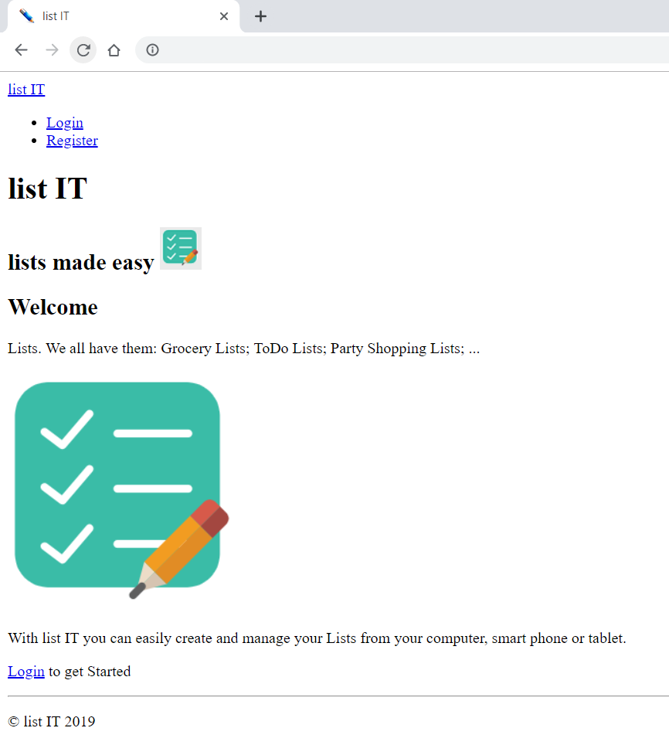

Register

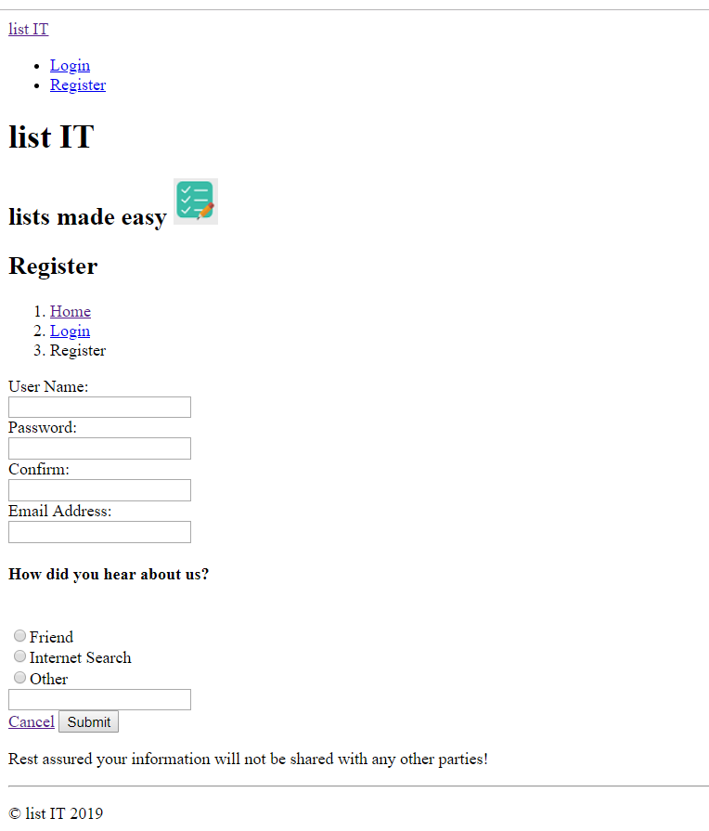

Login

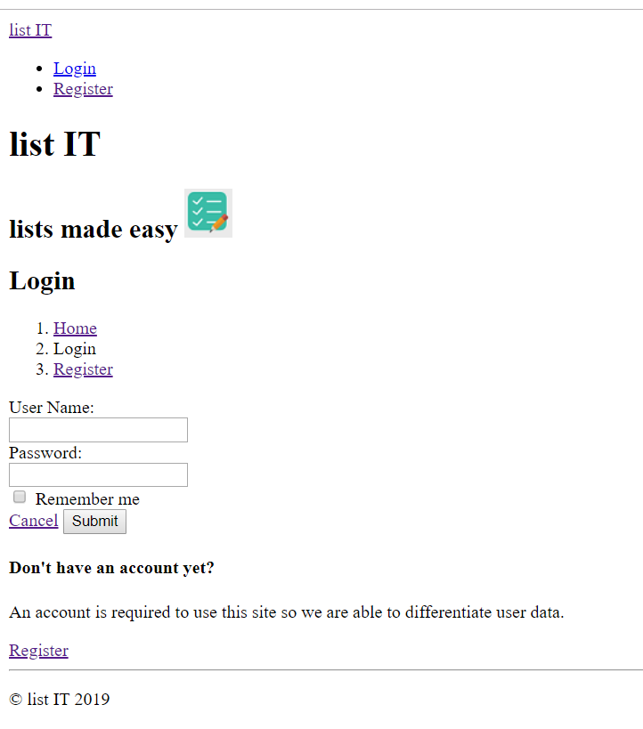

List Manaager

