**2NHABER.COM DEFECT REPORTSFormun Üstü**

**Test Reporter :** Mustafa SAYAR

**Test: HBR_HP_VDS_01 Defect Report**

**Summary :** Video in the media element is not displayed

**Description :** The media element shows no reaction despite attempting to see it. Existence of a video in the media element is the expected behavior. This issue needs attention to ensure a seamless and error-free order experience for users.

**Steps to Reproduce :**

1-Scroll Down to the end of HomePage

2-Click on the 1st video element

**Expected Result :** The user sees the video element successfully

**Actual Result :** Media element is not visible

**ScreenShots :**

metin, ekran görüntüsü, yazılım, multimedya yazılımı içeren bir resim

Açıklama otomatik olarak oluşturuldu

**Assignee :** 2NTECH

**Test: HBR_HP_VDS_03 Defect Report**

**Summary :** Video in the media element is not displayed

**Description :** The media element shows no reaction despite attempting to see it. Existence of a video in the media element is the expected behavior. This issue needs attention to ensure a seamless and error-free order experience for users.

**Steps to Reproduce :**

1-Scroll Down to the end of HomePage

2-Click on the 3rd video element

**Expected Result :** The user sees the video element successfully

**Actual Result :** Media element is not visible

**ScreenShots :**

metin, ekran görüntüsü, yazılım, multimedya yazılımı içeren bir resim

Açıklama otomatik olarak oluşturuldu

**Assignee :** 2NTECH

**Test: HBR_HP_BR_13 Cosmetic Bug Report**

**Summary :** No sign exist on scroll-top button

**Description :**The scroll-top button is functionally accurate. However, there is no indicator on it regarding to its purpose. This issue needs attention to ensure a seamless and user-friendly experience for users.

**Steps to Reproduce :**

1-Scroll Down to the end of HomePage

2-Click on the Scroll-Top button

**Expected Result :** The user sees the video element successfully

**Actual Result :** As expected

**Severity** **:** Cosmetic

**Priority :** Medium

**ScreenShots :**

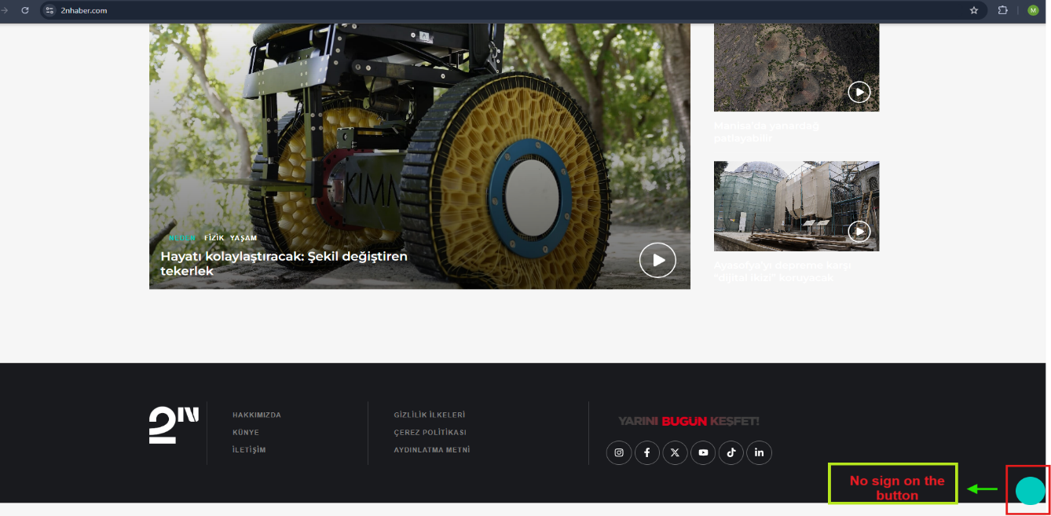

**Assignee :** 2NTECH

**Test: HBR_NB_13 Defect Report**

**Summary :** Social Media Buttons are not working properly

**Description :**Clicking on Social Media buttons on the news on NEDEN page causes the user to get redirected to the same page. Being directed to relevant social media page is the expected behavior. This issue needs attention to ensure a seamless and error-free order experience for users.

**Steps to Reproduce :**

1-Navigate to the Navbar on the HomePage

2-Hover the Pointer over NEDEN button

3-Click on the NEDEN button

4-Scroll down until KATEGORİNİN TÜM HABERLERİ section

5- Click on the first element

6-Click on the Facebook button on the left

**Expected Result :** The user is directed to the relevant social media page

**Actual Result :** The user is redirected to the same page on a new tab.

**ScreenShots :**

metin, ekran görüntüsü, web sitesi, yazılım içeren bir resim

Açıklama otomatik olarak oluşturuldu 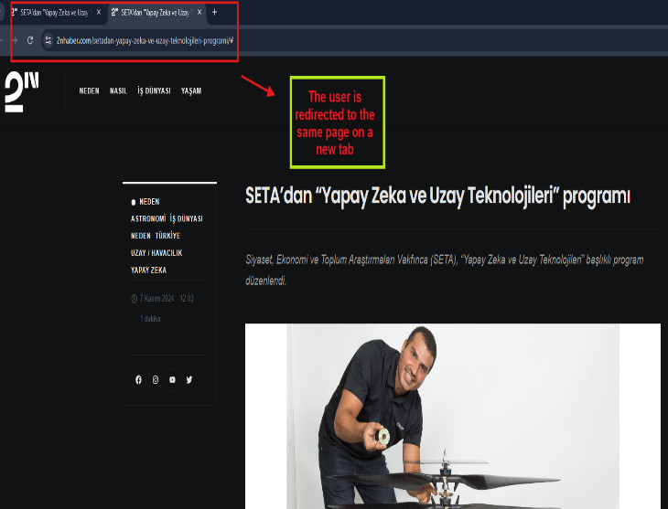

**Assignee :** 2NTECH

**Test: HBR_SB_03 Cosmetic Bug Report**

**Summary :** No sign exist on Search button

**Description :**The Search button is functionally accurate. However, there is no indicator on it regarding to its purpose. This issue needs attention to ensure a seamless and user-friendly experience for users.

**Steps to Reproduce :**

1-Navigate to the Search button on the HomePage

2-Click on Search button

3-Enter " İklim" to the Search Bar and press Enter

4-Navigate and click on the Search Bar

5-Enter "Savaş" to the Search bar and click on Search button

**Expected Result :** The user sees the related results successfully

**Actual Result :** As expected

**Severity** **:** Cosmetic

**Priority :** Medium

**ScreenShots :**

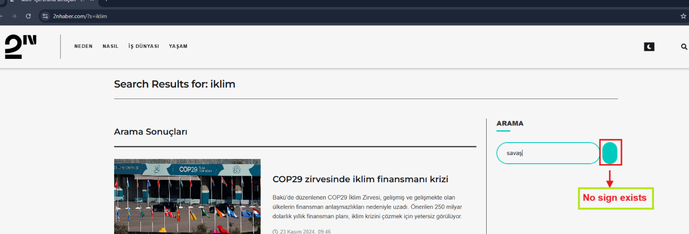

**Assignee :** 2NTECH

**Test: HBR_HM_04 Cosmetic Bug Report**

**Summary :** No sign exist on Social Media Buttons

**Description :**The social media buttons are functionally accurate. However, there is no indicator on it regarding to their purpose. This issue needs attention to ensure a seamless and user-friendly experience for users.

**Steps to Reproduce :**

1-Navigate to the Hamburger Menu button on the HomePage

2-Click on Hamburger Menu button

3-Scroll down to the Social Media buttons

4-Click on Instagram button

**Expected Result :** The user sees the video element successfully

**Actual Result :** As expected

**Severity** **:** Cosmetic

**Priority :** Medium

**ScreenShots :**

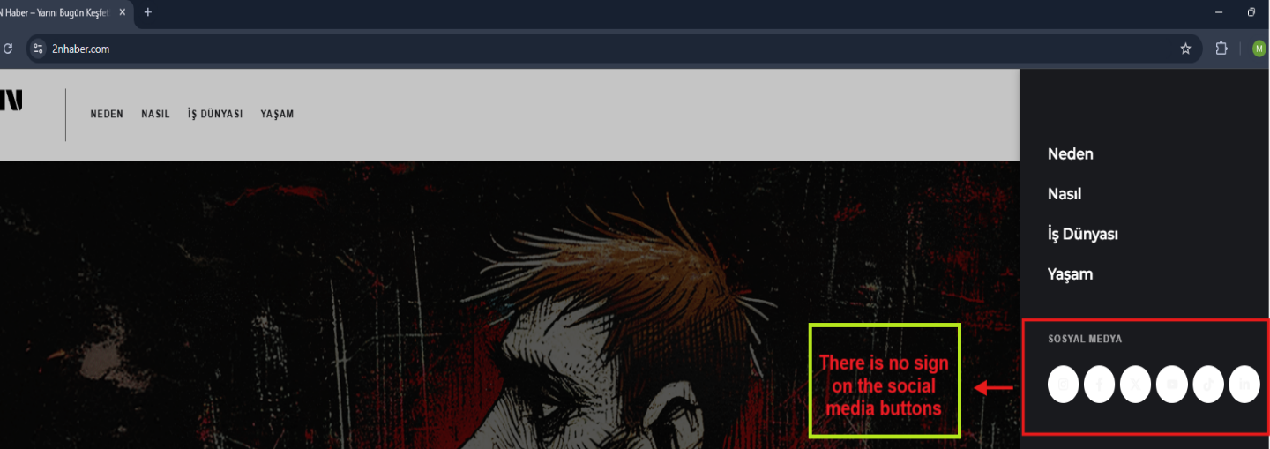

**Assignee :** 2NTECH

Formun Altı