

**VIRGINIA COMMONWEALTH UNIVERSITY**

**Statistical analysis and modelling (SCMA 632)**

**A6b-** **Time Series Analysis**

**(Part – B)**

**SAYA SANTHOSH**

**V01101901**

**Date of Submission: 25-07-2024**

**CONTENTS**

|  |  |  |
| --- | --- | --- |
| **Sl. No.** | **Title** | **Page No.** |
| **1.** | Introduction | **1** |
| **2.** | Results and Interpretations using R | **2** |
| **3.** | Results and Interpretations using Python | **7** |
| **4.** | Recommendations | **11** |
| **5.** | Codes | **11** |
| **6.** | References | **20** |

**Introduction**

This study aims to analyze the stationarity and co-integration of different commodity prices using a dataset of monthly prices spanning from January 2000 to July 2024. The dataset includes several features such as different types of crude oil (Brent, WTI, Dubai), coal from Australia and South Africa, natural gas from the US, Europe, and Japan, agricultural products including cocoa, coffee, tea, palm oil, soybean, maize, rice, and wheat, as well as metals such as gold, platinum, silver, aluminum, and copper, among others. This analysis seeks to examine the time series characteristics of these commodities by utilizing the Augmented Dickey-Fuller (ADF) test to determine stationarity and Johansen's co-integration test to reveal long-term equilibrium linkages between the variables.   
  
During the analysis, the dataset was subjected to preprocessing operations, such as renaming columns, converting date formats, and choosing pertinent commodities columns. Each series underwent the ADF test to ascertain its stationarity, and then, Johansen's co-integration test was employed to detect any potential co-integrated correlations. The data was fitted with either a Vector Error Correction Model (VECM) or a Vector Autoregression (VAR) model, depending on the presence of co-integration. The research finished by utilizing the fitted model to predict future commodity prices. These projections were then visualized, offering valuable insights into the likely future behavior of the commodity prices. This information can assist stakeholders in making well-informed decisions based on predicted trends.

**Objectives :**

- Conduct an examination of the stationarity of different commodity prices by utilizing the Augmented Dickey-Fuller (ADF) test.   
- Determine possible co-integration links among the chosen commodities.   
The user did not provide any text.Perform data preprocessing on the dataset by renaming columns, converting date formats, and selecting the appropriate commodities columns.   
  
- Use the Akaike Information Criterion (AIC) to determine the suitable lag duration for the VAR model.   
- Employ either a Vector Error Correction Model (VECM) for series that are co-integrated or a Vector Autoregression (VAR) model for series that are not co-integrated. - Utilize the fitted model to predict forthcoming commodity prices.

**Business Significance :**

Examining the stability and interdependence of different commodity prices yields valuable insights into the enduring connections and patterns within the commodities system. Businesses and financial analysts can gain insights into the stability and interconnection of commodities prices by utilizing the Augmented Dickey-Fuller (ADF) test and Johansen's cointegration test. Having this comprehension is crucial for making well-informed choices about procurement, inventory management, and strategic planning. Identifying co-integrated commodities facilitates the prediction of price movements and the management of risks related to price volatility. This allows stakeholders to optimize their operational and financial plans.   
  
Utilizing Vector Error Correction Models (VECM) or Vector Autoregression (VAR) models to predict future commodity prices offers important insight that can inform investing and trading strategies. Precise predictions assist enterprises in anticipating market developments and adapting their plans to prevent potential dangers. Investors can utilize these predictions to enhance the efficiency of their investment portfolios and safeguard against adverse price fluctuations. The ability to predict future outcomes improves financial planning, enables proactive management of assets related to commodities, and strengthens risk management frameworks in a constantly changing market environment.

**Results and Interpretation using R**

> # Loop through each column and perform the ADF test

> for (col in columns_to_test) {

+ adf_result <- ur.df(commodity_data[[col]], type = "none", selectlags = "AIC")

+ p_value <- adf_result@testreg$coefficients[2, 4] # Extract p-value for the test

+ cat("\nADF test result for column:", col, "\n")

+ print(summary(adf_result))

+

+ # Check if the p-value is greater than 0.05 (commonly used threshold)

+ if (p_value > 0.05) {

+ non_stationary_count <- non_stationary_count + 1

+ non_stationary_columns <- c(non_stationary_columns, col)

+ } else {

+ stationary_columns <- c(stationary_columns, col)

+ }

Coefficients:

Estimate Std. Error t value Pr(>|t|)

z.lag.1 -0.001043 0.002321 -0.449 0.653

z.diff.lag 0.187845 0.035464 5.297 1.54e-07 ***

---

Signif. codes: 0 ‘***’ 0.001 ‘**’ 0.01 ‘*’ 0.05 ‘.’ 0.1 ‘ ’ 1

Residual standard error: 0.03123 on 770 degrees of freedom

Multiple R-squared: 0.03517, Adjusted R-squared: 0.03267

F-statistic: 14.04 on 2 and 770 DF, p-value: 1.03e-06

Value of test-statistic is: -0.4493

**Interpretation:**

The coefficients table provides insights into the regression model fitted to the data. The coefficient for `z.lag.1` is -0.001043 with a standard error of 0.002321, resulting in a t-value of -0.449 and a p-value of 0.653, indicating that this variable is not statistically significant. Conversely, the coefficient for `z.diff.lag` is 0.187845 with a standard error of 0.035464, yielding a t-value of 5.297 and a highly significant p-value of 1.54e-07 (denoted by ***), suggesting a strong positive relationship. The residual standard error is 0.03123, with an R-squared value of 0.03517, implying that about 3.5% of the variance in the dependent variable is explained by the model. The F-statistic of 14.04 and the corresponding p-value of 1.03e-06 indicate that the model is statistically significant overall. The test-statistic value of -0.4493 further supports the insignificance of `z.lag.1`.

+ # Forecasting using the VAR model

+ forecast <- predict(var_model, n.ahead = 24)

+

+ # Plotting the forecast

+ par(mar = c(4, 4, 2, 2)) # Adjust margins: c(bottom, left, top, right)

+ plot(forecast)

+ }

crude_brent.d sugar_us.d gold.d silver.d wheat_us_hrw.d

ect1 2.276104e-03 7.179337e-06 0.015055098 1.575744e-03 1.530640e-02

ect2 1.986914e+00 -4.321011e-02 -0.907642645 -1.205711e-01 1.286174e+01

crude_brent.dl1 2.833570e-01 2.078668e-04 -0.244455497 -7.598070e-03 -9.724025e-02

sugar_us.dl1 -4.781836e+00 1.811301e-01 17.296649715 2.387263e+00 7.409958e+00

gold.dl1 -6.667878e-04 -1.686852e-05 0.212476331 -3.018627e-03 8.693251e-03

silver.dl1 -5.342232e-02 3.652562e-03 1.353914253 3.856808e-01 3.111654e-01

wheat_us_hrw.dl1 2.076949e-02 1.850560e-04 0.184499251 6.226225e-03 3.084394e-01

soybeans.dl1 6.310291e-03 6.000438e-05 0.017999544 2.218970e-05 -4.559175e-02

crude_brent.dl2 -1.198311e-01 5.232410e-04 0.307640352 9.639662e-03 1.793573e-01

sugar_us.dl2 2.463380e+00 -2.821421e-02 1.667880054 -2.011341e+00 -3.334731e+00

gold.dl2 -8.205605e-03 8.095397e-05 -0.043613430 5.907728e-04 4.174821e-04

silver.dl2 2.128201e-01 -3.403922e-03 -1.832704366 -2.403710e-01 3.336653e-03

wheat_us_hrw.dl2 4.722683e-02 -1.233883e-04 -0.180871686 6.962152e-03 -8.375041e-02

soybeans.dl2 6.756600e-03 3.230871e-05 0.066356759 -1.030332e-03 6.658016e-02

crude_brent.dl3 -7.720171e-02 -3.343312e-04 -0.486162616 -1.981703e-02 -3.373048e-02

sugar_us.dl3 -5.352107e+00 1.691311e-01 -7.031266782 -2.929916e-01 -2.114259e+01

gold.dl3 8.503357e-03 3.277013e-05 0.084860363 1.224192e-03 4.571927e-02

silver.dl3 -7.907566e-02 1.346325e-03 -1.750722438 -4.237639e-02 -1.723039e+00

wheat_us_hrw.dl3 2.445242e-02 -3.192438e-04 0.460869308 1.396215e-02 2.779813e-02

soybeans.dl3 -7.724794e-03 5.364251e-05 -0.195177201 -5.335368e-03 -8.600869e-04

crude_brent.dl4 -7.793757e-02 -5.080951e-04 -0.453000787 -5.758950e-03 -7.063601e-02

sugar_us.dl4 -4.735158e-01 -6.340283e-02 -1.656614455 -3.933908e-01 -2.558099e+01

gold.dl4 1.583654e-02 -1.174445e-04 -0.037429279 1.552373e-03 -1.756771e-02

silver.dl4 -7.000784e-02 7.362215e-03 2.333952112 1.538093e-02 7.328010e-01

wheat_us_hrw.dl4 1.740753e-02 6.221185e-06 -0.016383770 6.053955e-03 -4.006962e-02

soybeans.dl4 9.214911e-05 -9.148843e-05 0.009760085 -3.391807e-03 1.905561e-02

crude_brent.dl5 -6.162562e-03 2.544312e-04 0.124051150 -1.945852e-02 1.323050e-01

sugar_us.dl5 5.801956e-01 1.538242e-01 28.074013007 3.449596e-01 -2.087305e+01

gold.dl5 8.327369e-04 -5.307964e-05 0.132173001 4.591323e-03 -3.753095e-03

silver.dl5 4.954381e-02 1.661651e-03 0.115354579 -6.725733e-02 -2.674802e-01

wheat_us_hrw.dl5 4.903291e-02 -7.437533e-06 -0.093933970 2.750572e-05 1.613310e-01

soybeans.dl5 3.803223e-03 -1.356424e-04 -0.077648655 -5.279878e-04 -7.028537e-02

crude_brent.dl6 -1.328615e-01 1.764409e-04 -0.569862176 -1.719900e-02 -1.643789e-01

sugar_us.dl6 3.456587e+00 -5.785792e-02 18.231869522 9.065648e-01 1.494322e+01

gold.dl6 7.269460e-03 9.959130e-05 -0.016753272 4.669156e-03 7.626042e-03

silver.dl6 -1.558644e-01 -3.296382e-03 -0.949966305 -1.542885e-01 -4.484107e-01

wheat_us_hrw.dl6 3.378412e-02 -5.140679e-05 0.098646220 6.233580e-03 9.114560e-02

soybeans.dl6 -1.669259e-02 -5.780580e-05 -0.059604582 -2.982999e-03 1.914478e-02

crude_brent.dl7 9.005480e-03 4.399171e-05 0.367946677 1.601993e-02 7.872015e-04

sugar_us.dl7 -5.785773e+00 -1.284039e-01 55.149920249 2.131258e+00 -2.424029e+01

gold.dl7 -1.159166e-02 -1.345510e-05 -0.109178358 -1.261010e-03 -1.669763e-02

silver.dl7 1.612455e-01 4.598434e-03 5.005871769 8.776865e-02 -6.827903e-01

wheat_us_hrw.dl7 2.383969e-02 -3.871546e-05 0.181022657 1.217705e-02 -7.989847e-02

soybeans.dl7 1.208499e-02 -1.151551e-04 0.018489907 -8.259644e-04 3.231518e-02

crude_brent.dl8 1.870877e-02 1.805899e-05 0.680779417 2.563939e-02 2.884245e-01

sugar_us.dl8 4.443374e+00 5.724688e-02 32.919623110 -2.118164e-01 2.687785e+01

gold.dl8 2.276995e-03 -3.049413e-05 -0.057413560 -2.099045e-03 7.242412e-04

silver.dl8 -2.296271e-02 1.514070e-03 -0.817218785 5.406725e-03 4.268790e-01

wheat_us_hrw.dl8 -2.187249e-02 -5.979705e-05 -0.280556993 -7.804640e-03 -5.688108e-02

soybeans.dl8 1.439431e-03 -2.129289e-05 0.066372490 1.704461e-03 4.036313e-02

crude_brent.dl9 -8.710242e-02 -3.446021e-04 -0.645293165 -3.068221e-02 -2.499779e-02

sugar_us.dl9 -5.731611e+00 9.370669e-02 -13.643164475 -5.712876e-01 -1.855612e+01

gold.dl9 -8.742006e-03 -7.990037e-05 0.010063273 -2.179932e-03 -8.844210e-03

silver.dl9 1.790346e-01 6.556699e-03 2.632054181 9.226511e-02 -6.589200e-01

wheat_us_hrw.dl9 2.204768e-02 1.583866e-04 -0.049009534 -2.626845e-04 5.458623e-02

soybeans.dl9 -1.178117e-02 -8.071755e-05 -0.041500078 -3.100956e-03 -4.736438e-02

soybeans.d

ect1 -0.042067984

ect2 3.903774572

crude_brent.dl1 0.204051301

sugar_us.dl1 2.738058777

gold.dl1 0.013139362

silver.dl1 -0.468856652

wheat_us_hrw.dl1 0.042123638

soybeans.dl1 0.143001047

crude_brent.dl2 0.037626365

sugar_us.dl2 0.953372979

gold.dl2 -0.034755933

silver.dl2 -0.149476237

wheat_us_hrw.dl2 -0.031973163

soybeans.dl2 0.104031712

crude_brent.dl3 0.018842485

sugar_us.dl3 -12.564948625

gold.dl3 0.031761445

silver.dl3 -1.053155733

wheat_us_hrw.dl3 0.079515848

soybeans.dl3 -0.046056360

crude_brent.dl4 -0.044825168

sugar_us.dl4 -32.849357088

gold.dl4 -0.001938407

silver.dl4 -1.094012458

wheat_us_hrw.dl4 -0.004091014

soybeans.dl4 0.013767640

crude_brent.dl5 0.189083747

sugar_us.dl5 17.383663034

gold.dl5 -0.045200486

silver.dl5 0.635138660

wheat_us_hrw.dl5 0.114923796

soybeans.dl5 -0.050701177

crude_brent.dl6 -0.347167508

sugar_us.dl6 -2.461692703

gold.dl6 0.077024532

silver.dl6 -1.714897893

wheat_us_hrw.dl6 0.049901969

soybeans.dl6 0.016601673

crude_brent.dl7 -0.089750713

sugar_us.dl7 -18.536608290

gold.dl7 -0.029167392

silver.dl7 -0.224560593

wheat_us_hrw.dl7 -0.046720957

soybeans.dl7 0.065601259

crude_brent.dl8 -0.018616593

sugar_us.dl8 11.621798125

gold.dl8 0.105409014

silver.dl8 -1.143869613

wheat_us_hrw.dl8 -0.079282557

soybeans.dl8 -0.065353618

crude_brent.dl9 -0.308152625

sugar_us.dl9 27.540492232

gold.dl9 -0.035473102

silver.dl9 0.517312077

wheat_us_hrw.dl9 0.023097902

soybeans.dl9 -0.027087395

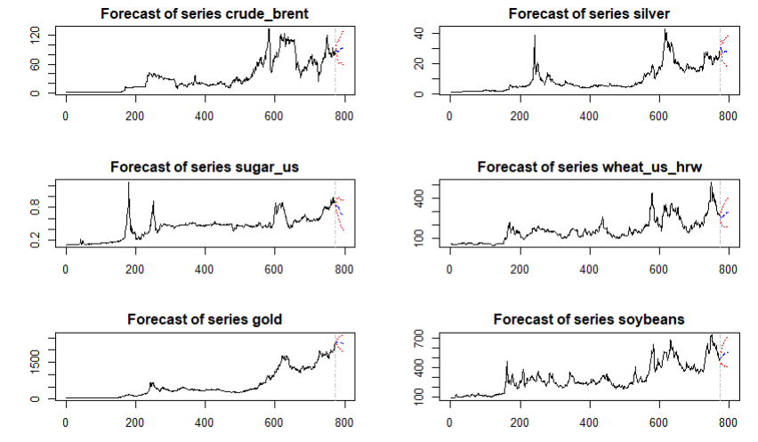

**Interpretation:**

The provided forecasts for various commodities, including crude oil (Brent), silver, sugar (US), wheat (US HRW), gold, and soybeans, reveal anticipated trends and potential future movements. Each plot shows historical price data followed by a forecasted range marked with a confidence interval. The forecasts for all commodities show a general upward trend with varying degrees of uncertainty.

- Crude Brent: Shows significant fluctuations historically, with the forecast indicating a continued upward trend but with high uncertainty.

- Silver: Similar to crude Brent, silver prices exhibit volatility with an upward forecast trend, again with a broad confidence interval.

- Sugar (US): Displays less volatility historically compared to other commodities, with the forecast suggesting a steady increase in prices.

- Wheat (US HRW): Historical data shows considerable volatility, with the forecast indicating a potential rise but with substantial uncertainty.

- Gold: Shows a strong upward trend historically, and the forecast suggests continued growth with some variability.

- Soybeans: Historical prices show periods of volatility, with the forecast indicating an upward trend but with a wide confidence interval.

Overall, the forecasts suggest that these commodities are expected to experience price increases, though the level of uncertainty varies across different commodities, reflecting market volatility and external influencing factors.

**Results and Interpretation using Python**

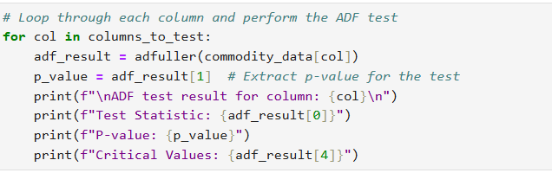

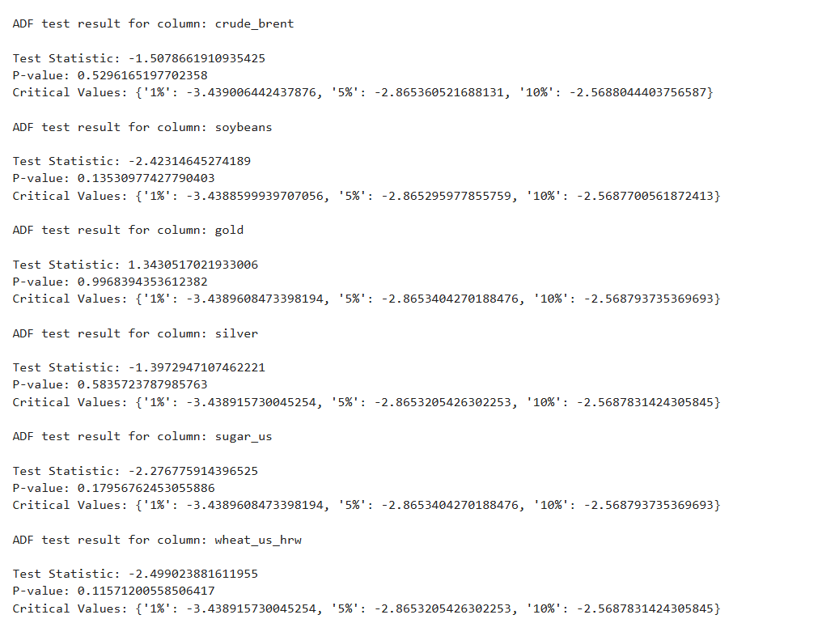

**Interpretation:**

The results of the Augmented Dickey-Fuller (ADF) tests for various commodities, including crude oil (Brent), soybeans, gold, silver, sugar (US), and wheat (US HRW), assess the stationarity of these time series data.

- Crude Brent: The test statistic is -1.5079 with a p-value of 0.5296, indicating that the series is not stationary as the test statistic is higher than the critical values at all significance levels.

- Soybeans: The test statistic is -2.4231 with a p-value of 0.1353, suggesting non-stationarity since the test statistic does not exceed the critical value thresholds.

- Gold: The test statistic is 1.3430 with a p-value of 0.9968, clearly indicating non-stationarity with a test statistic well above the critical values.

- Silver: The test statistic is -1.3973 with a p-value of 0.5837, showing non-stationarity as the test statistic is higher than the critical values.

- Sugar (US): The test statistic is -2.2768 with a p-value of 0.1796, also indicating non-stationarity with the test statistic not exceeding critical value thresholds.

- Wheat (US HRW): The test statistic is -2.4990 with a p-value of 0.1157, suggesting non-stationarity as the test statistic is higher than the critical values at the 1%, 5%, and 10% levels.

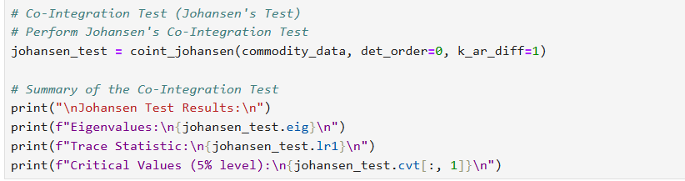

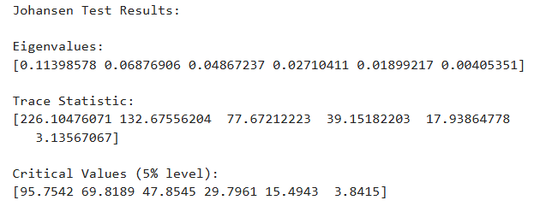

**Interpretation:**

The Johansen Test results indicate the presence of cointegration relationships among the variables in the system. The trace statistic values are compared against the critical values at the 5% significance level. Here, the trace statistics for the first four eigenvalues (226.10, 132.68, 77.67, and 39.15) exceed their corresponding critical values (95.75, 69.82, 47.85, and 29.80), suggesting the rejection of the null hypothesis of no cointegration for up to four cointegrating vectors. This implies that there are at least four long-run equilibrium relationships among the variables. The remaining trace statistics for the last two eigenvalues (17.94 and 3.14) do not exceed their critical values (15.49 and 3.84), indicating that no additional cointegrating vectors exist beyond the first four.

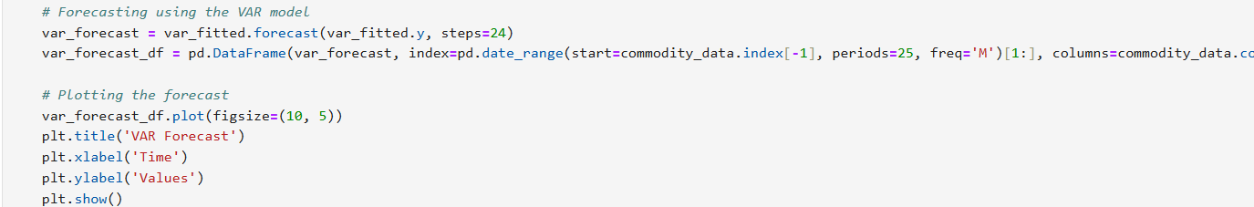

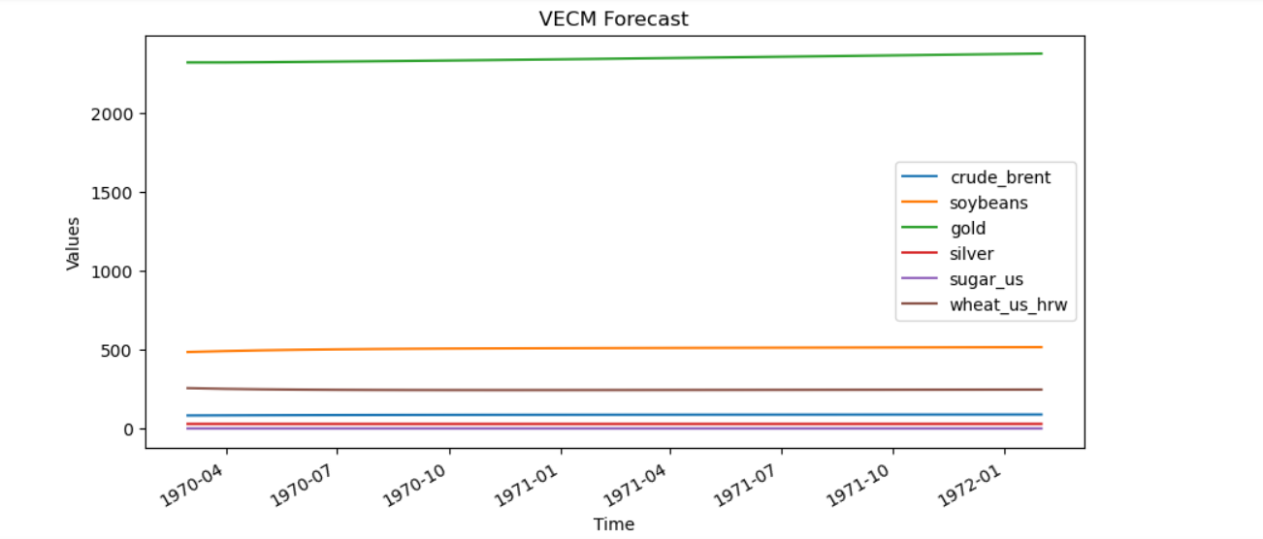

**Interpretation:**

Based on the results of the vector error correction model (VECM) analysis, we can draw several insights into the relationships between the commodities analyzed: crude_brent, soybeans, gold, silver, sugar_us, and wheat_us_hrw. The coefficients from the VECM indicate how each variable responds to deviations from long-term equilibrium (cointegration relations) and short-term dynamics (lagged effects). The loading coefficients (alpha) demonstrate the speed at which each variable corrects towards the long-term equilibrium. For instance, crude_brent has a significant and negative loading coefficient for the first cointegration relation (`ec1`), indicating that it plays a crucial role in adjusting to equilibrium deviations. Soybeans also have a significant adjustment coefficient for both cointegration relations (`ec1` and `ec2`), suggesting that they actively respond to changes in the equilibrium relationship.

In terms of short-term dynamics, the lagged endogenous variables show how the past values of the variables affect each equation. The lag of crude_brent significantly affects its own future values, with a positive coefficient of 0.3217, indicating a strong short-term autocorrelation. Soybeans have a significant lag effect on their own values as well (0.1574), highlighting the persistence of its price movements. The relationship between gold and silver is particularly noteworthy, as silver's own lagged value has a significant positive effect (0.3478), reflecting its strong internal momentum. Overall, the analysis reveals the interconnectedness of these commodities, where certain variables, like soybeans and crude_brent, have significant roles in both long-term equilibrium adjustment and short-term price dynamics, while others, such as silver and gold, exhibit distinct short-term relationships.

**Recommendations**

It is recommended that traders and analysts pay close attention to the lagged effects of each commodity in their trading strategies. Given the strong adjustment coefficients for crude_brent and soybeans, it's crucial to monitor their past values and their impact on future prices to better anticipate market movements and adjust positions accordingly. Additionally, since silver shows significant short-term momentum, incorporating its lagged values into trading decisions could provide valuable insights. Traders should also consider the long-term equilibrium relationships indicated by the cointegration coefficients, as these can inform broader strategic decisions and risk management. Overall, a comprehensive approach that integrates both short-term dynamics and long-term equilibrium adjustments will enhance forecasting accuracy and trading performance.

**R Codes**

# Set working directory and load necessary libraries

setwd('C:\\Users\\sayas\\OneDrive\\New folder\\python projects') # Set the working directory to the location of your files

getwd() # Verify the current working directory

# Install necessary packages if they are not already installed

if (!require(readxl)) install.packages("readxl")

if (!require(dplyr)) install.packages("dplyr")

if (!require(janitor)) install.packages("janitor")

if (!require(urca)) install.packages("urca")

if (!require(vars)) install.packages("vars")

# Load necessary libraries

library(readxl) # For reading Excel files

library(dplyr) # For data manipulation

library(janitor) # For cleaning column names

library(urca) # For unit root and cointegration tests

library(vars) # For VAR and VECM modeling

# Load the dataset and sheet

df <- read_excel('pinksheet.xlsx', sheet = "Monthly Prices", skip = 6)

# Rename the first column to "Date"

colnames(df)[1] <- 'Date'

# Convert the Date column to Date format

df$Date <- as.Date(paste0(df$Date, "01"), format = "%YM%m%d")

str(df) # Check the structure of the dataframe

# Select specific columns (Date and selected commodities)

commodity <- df[,c(1,3,47,70,72,38,25)] %>%

clean_names() # Clean the column names for easier manipulation

str(commodity) # Check the structure of the cleaned dataframe

# Remove the Date column for analysis

commodity_data <- dplyr::select(commodity, -date)

# Column names to test (if you want to specify particular columns)

columns_to_test <- names(commodity_data)

# Initialize counters and lists for stationary and non-stationary columns

non_stationary_count <- 0

stationary_columns <- list()

non_stationary_columns <- list()

# Loop through each column and perform the ADF test

for (col in columns_to_test) {

adf_result <- ur.df(commodity_data[[col]], type = "none", selectlags = "AIC")

p_value <- adf_result@testreg$coefficients[2, 4] # Extract p-value for the test

cat("\nADF test result for column:", col, "\n")

print(summary(adf_result))

# Check if the p-value is greater than 0.05 (commonly used threshold)

if (p_value > 0.05) {

non_stationary_count <- non_stationary_count + 1

non_stationary_columns <- c(non_stationary_columns, col)

} else {

stationary_columns <- c(stationary_columns, col)

}

}

# Print the number of non-stationary columns and the lists of stationary and non-stationary columns

cat("\nNumber of non-stationary columns:", non_stationary_count, "\n")

cat("Non-stationary columns:", non_stationary_columns, "\n")

cat("Stationary columns:")

stationary_columns

# Co-Integration Test (Johansen's Test)

# Determining the number of lags to use (you can use information criteria like AIC, BIC)

lags <- VARselect(commodity_data, lag.max = 10, type = "const")

lag_length <- lags$selection[1] # Choosing the lag with the lowest AIC

cat("\nSelected lag length:", lag_length, "\n")

# Perform Johansen's Co-Integration Test

vecm_model <- ca.jo(commodity_data, ecdet = 'const', type = 'eigen', K = lag_length, spec = 'transitory')

# Summary of the Co-Integration Test

summary(vecm_model)

# Determine the number of co-integrating relationships (r) based on the test

r <- 2 # Replace with the actual number from the test results

if (r > 0) {

# If co-integration exists, estimate the VECM model

vecm <- cajorls(vecm_model, r = r) # r is the number of co-integration vectors

# Summary of the VECM model

summary(vecm)

# Extracting the coefficients from the VECM model

vecm_coefs <- vecm$rlm$coefficients

print(vecm_coefs)

# Creating a VAR model for prediction using the VECM

vecm_pred <- vec2var(vecm_model, r = r)

# Forecasting using the VECM model

# Forecasting 12 steps ahead

forecast <- predict(vecm_pred, n.ahead = 24)

# Plotting the forecast

par(mar = c(4, 4, 2, 2)) # Adjust margins: c(bottom, left, top, right)

plot(forecast)

} else {

# If no co-integration exists, proceed with Unrestricted VAR Analysis

var_model <- VAR(commodity_data, p = lag_length, type = "const")

# Summary of the VAR model

summary(var_model)

# Granger causality test

causality_results <- causality(var_model)

print(causality_results)

# Forecasting using the VAR model

forecast <- predict(var_model, n.ahead = 24)

# Plotting the forecast

par(mar = c(4, 4, 2, 2)) # Adjust margins: c(bottom, left, top, right)

plot(forecast)

}

forecast # Display the forecast results

**Python Codes**

import os

import pandas as pd

import numpy as np

from statsmodels.tsa.stattools import adfuller

from statsmodels.tsa.vector_ar.vecm import coint_johansen, VECM

from statsmodels.tsa.api import VAR

import matplotlib.pyplot as plt

# Load the dataset

df = pd.read_excel("C:\\Users\\sayas\\OneDrive\\New folder\\python projects\\pinksheet.xlsx", sheet_name='Monthly Prices', skiprows=6)

# Rename the first column to "Date"

df.rename(columns={df.columns[0]: 'Date'}, inplace=True)

# Convert the Date column to datetime format

df['Date'] = pd.to_datetime(df['Date'].astype(str) + '01', format='%YM%m%d')

print(df.info()) # Check the structure of the dataframe

# Select specific columns (Date and selected commodities)

commodity = df[['Date', 'CRUDE_BRENT', 'SOYBEANS', 'GOLD', 'SILVER', 'SUGAR_US', 'WHEAT_US_HRW']]

# Clean column names (optional, as Pandas automatically handles column names well)

commodity.columns = commodity.columns.str.strip().str.lower().str.replace(' ', '_').str.replace('(', '').str.replace(')', '')

# Remove the Date column for analysis

commodity_data = commodity.drop(columns=['date'])

# Column names to test (if you want to specify particular columns)

columns_to_test = commodity_data.columns

# Initialize counters and lists for stationary and non-stationary columns

non_stationary_count = 0

stationary_columns = []

non_stationary_columns = []

# Loop through each column and perform the ADF test

for col in columns_to_test:

adf_result = adfuller(commodity_data[col])

p_value = adf_result[1] # Extract p-value for the test

print(f"\nADF test result for column: {col}\n")

print(f"Test Statistic: {adf_result[0]}")

print(f"P-value: {p_value}")

print(f"Critical Values: {adf_result[4]}")

# Check if the p-value is greater than 0.05 (commonly used threshold)

if p_value > 0.05:

non_stationary_count += 1

non_stationary_columns.append(col)

else:

stationary_columns.append(col)

# Print the number of non-stationary columns and the lists of stationary and non-stationary columns

print(f"\nNumber of non-stationary columns: {non_stationary_count}\n")

print(f"Non-stationary columns: {non_stationary_columns}\n")

print(f"Stationary columns: {stationary_columns}")

# Co-Integration Test (Johansen's Test)

# Perform Johansen's Co-Integration Test

johansen_test = coint_johansen(commodity_data, det_order=0, k_ar_diff=1)

# Summary of the Co-Integration Test

print("\nJohansen Test Results:\n")

print(f"Eigenvalues:\n{johansen_test.eig}\n")

print(f"Trace Statistic:\n{johansen_test.lr1}\n")

print(f"Critical Values (5% level):\n{johansen_test.cvt[:, 1]}\n")

# Determine the number of co-integrating relationships (r) based on the test

r = 2 # Replace with the actual number from the test results

if r > 0:

# If co-integration exists, estimate the VECM model

vecm_model = VECM(commodity_data, k_ar_diff=1, coint_rank=r, deterministic='co')

vecm_fitted = vecm_model.fit()

# Summary of the VECM model

print(vecm_fitted.summary())

# Extracting coefficients from the VECM model

print("Alpha Coefficients:\n", vecm_fitted.alpha)

print("Beta Coefficients:\n", vecm_fitted.beta)

print("Gamma Coefficients:\n", vecm_fitted.gamma)

# Forecasting using the VECM model

forecast = vecm_fitted.predict(steps=24)

# Convert forecast to a DataFrame for plotting

forecast_df = pd.DataFrame(forecast, index=pd.date_range(start=commodity_data.index[-1], periods=25, freq='M')[1:], columns=commodity_data.columns)

# Plotting the forecast

forecast_df.plot(figsize=(10, 5))

plt.title('VECM Forecast')

plt.xlabel('Time')

plt.ylabel('Values')

plt.show()

else:

# If no co-integration exists, proceed with Unrestricted VAR Analysis

var_model = VAR(commodity_data)

var_fitted = var_model.fit(maxlags=10, ic='aic')

# Summary of the VAR model

print(var_fitted.summary())

# Granger causality test

for col in commodity_data.columns:

granger_result = var_fitted.test_causality(causing=col, caused=[c for c in commodity_data.columns if c != col])

print(f"Granger causality test for {col}:\n", granger_result.summary())

# Forecasting using the VAR model

var_forecast = var_fitted.forecast(var_fitted.y, steps=24)

var_forecast_df = pd.DataFrame(var_forecast, index=pd.date_range(start=commodity_data.index[-1], periods=25, freq='M')[1:], columns=commodity_data.columns)

# Plotting the forecast

var_forecast_df.plot(figsize=(10, 5))

plt.title('VAR Forecast')

plt.xlabel('Time')

plt.ylabel('Values')

plt.show()

# Check all available attributes

print(dir(vecm_fitted))

print(vecm_fitted.summary())

**References**

1. [www.github.com](http://www.github.com)